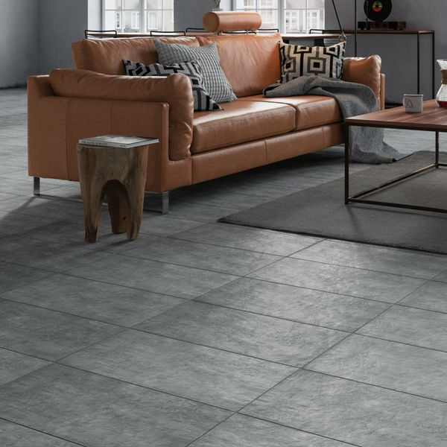

Courtyard Moonlight Orchid: <https://www.wallsandfloors.co.uk/courtyard-slate-moonlight-orchid-slate-effect-tiles>

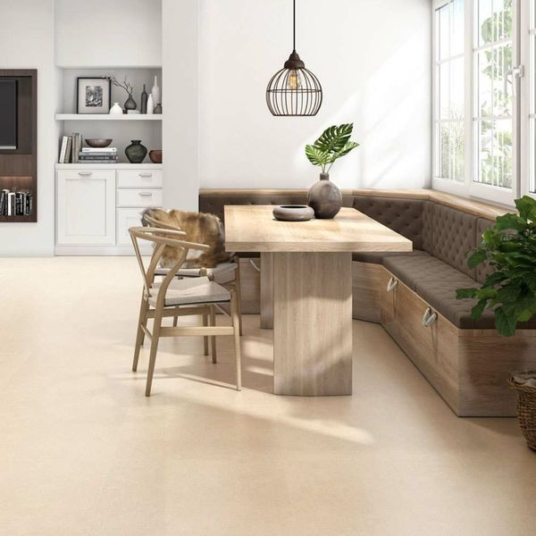

Karlon Sand Beige Tiles: <https://www.wallsandfloors.co.uk/karlon-sand-beige-tiles>

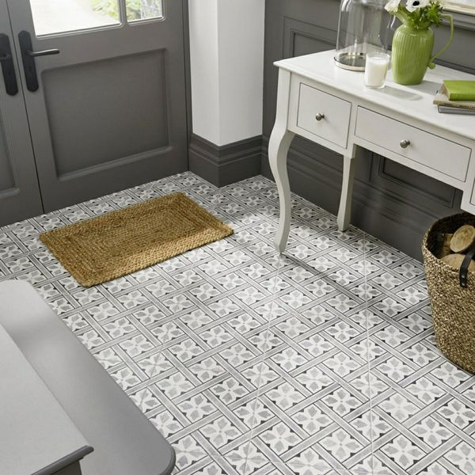

Mr Jones Charcoal Tiles: <https://www.wallsandfloors.co.uk/mr-jones-charcoal-tiles>

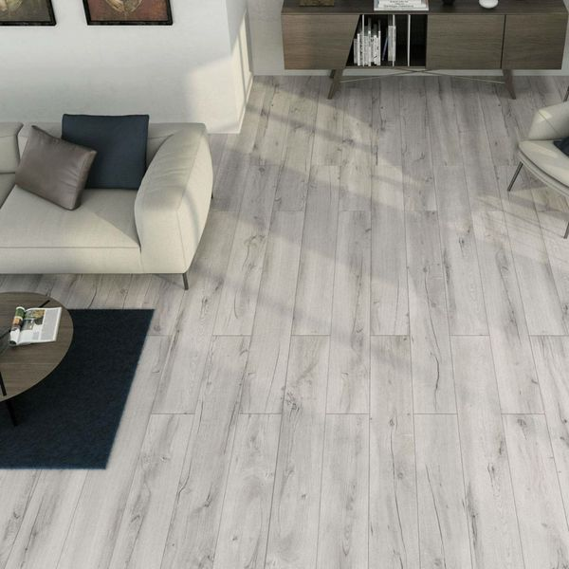

Muniellos Grey Anti-Slip: <https://www.wallsandfloors.co.uk/grey-900x150-anti-slip-tiles>

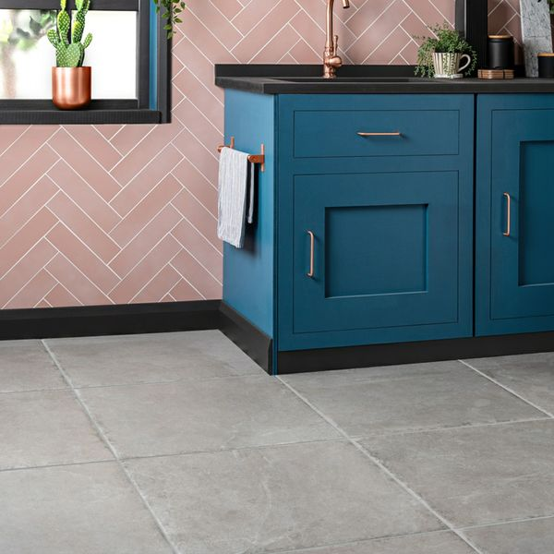

Witton Grey Stone: <https://www.wallsandfloors.co.uk/witton-grey>

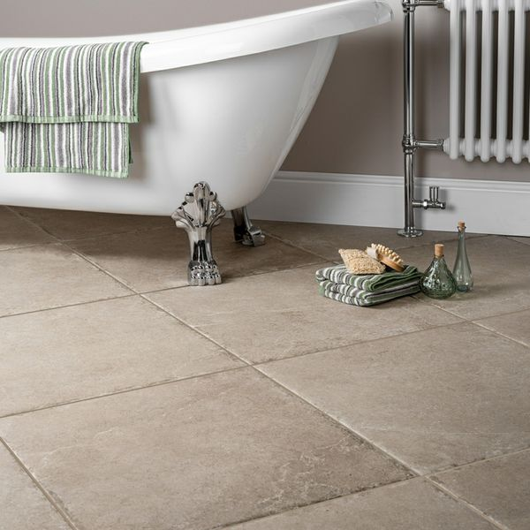

Witton Noce Stone: <https://www.wallsandfloors.co.uk/witton-noce>