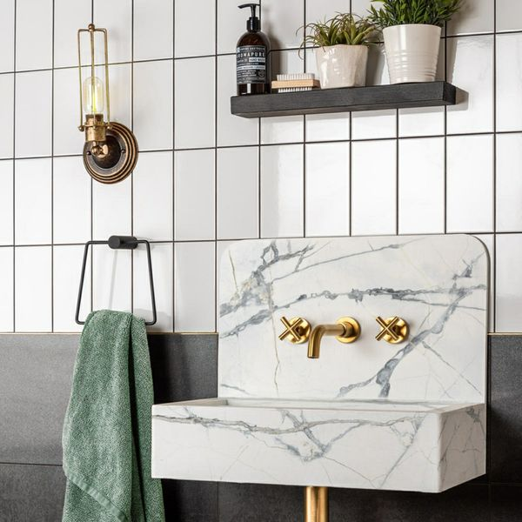**Flat Whitechapel White Gloss Tiles:**

## **Product Description**

A popular white brick shaped wall tile in a gloss finish. The ceramic Brick 200x100 Tiles are suitable for all living areas walls, order Flat Whitechapel White Gloss 200x100 Tiles samples online with free delivery. Inspired by the London underground subway tiles, we recommend using the Flat Whitechapel White Gloss 200x100 Tiles to create a superb contemporary wall feature, order Brick 200x100 Tiles online with nationwide fast delivery.

**Please Note**  
As of April 2020 this product has been updated using our new and improved manufacturing process. If you are trying to match a previous purchase please contact our customer service team on 01536 314730 for further assistance.

## **Product Info**

* Product ID: 7579
* Tiles Per SQM: 50
* Sale by: Per SQM
* Size: 100x200x7mm
* Weight: 0.28 KG
* Material Type: Ceramic
* Finish: Gloss
* Colour: White
* Suitability: Walls
* Grade: No
* Rectified Edge: No
* Underfloor Heating: No
* Thickness (mm): 7