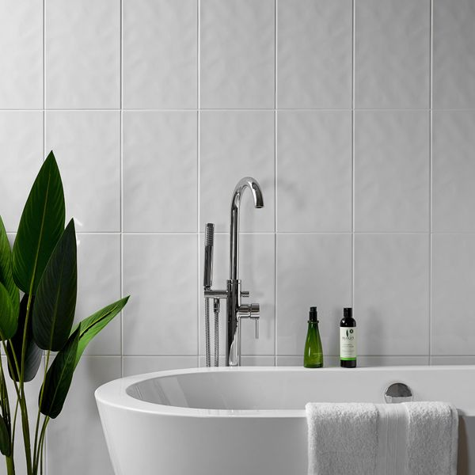**Innocence White Bumpy Gloss Tiles:**

## **Product Description**

A classic bumpy white tile in a gloss finish. The ceramic white tiles are ideal for creating a blank canvas on bathroom walls. Order Bumpy White 400x250 samples online with free delivery.

## **Product Info**

* Product ID: 13337
* Tiles Per SQM: 10
* Sale by: Per SQM
* Size: 250x400x6mm
* Weight: 1.10 KG
* Material Type: Ceramic
* Finish: Gloss
* Colour: White
* Suitability: Walls
* Grade: No
* Rectified Edge: No
* Underfloor Heating: No
* Thickness (mm): 6