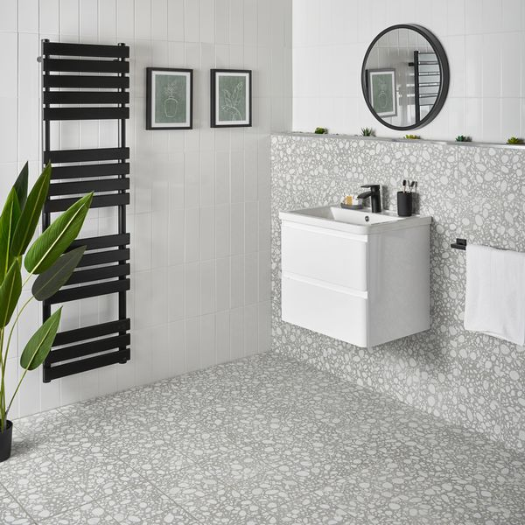**Linear White Gloss Brick Tiles:**

## **Product Description**

Add a shimmering new look to your bathroom, kitchen and en suite walls with the simple addition of these White Gloss Linear Tiles. A member of our Linear Tiles selection, they have an elongated brick shape with a surface surface and glitzy gloss finish. White in colour, they're perfect for brightening up any interior space. Create a stylish splashback or piece together a larger tiling display. If you'd like to take a closer look before placing a full order, buy a sample tile.

## **Product Info**

* Product ID: 13920
* Tiles Per SQM: 33.333333333333
* Sale by: Per SQM
* Size: 300x100x7mm
* Weight: 0.40 KG
* Material Type: Ceramic
* Finish: Gloss
* Colour: White
* Suitability: Walls
* Grade: No
* Rectified Edge: No
* Underfloor Heating: No
* Thickness (mm): 7