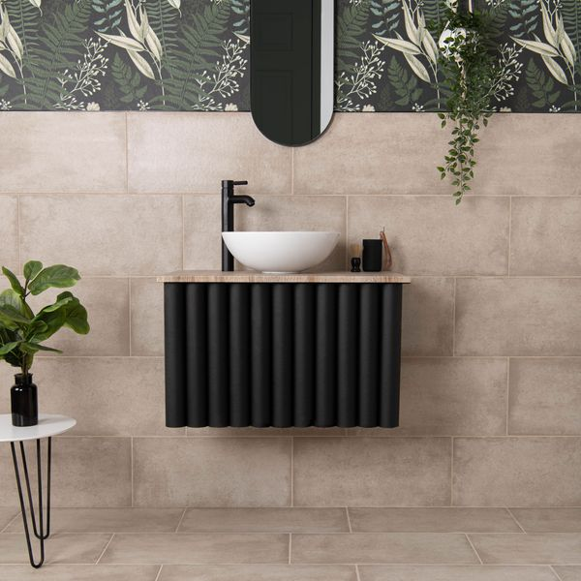**Samphire Matt Beige Tiles:**

## **Product Description**

Create a natural interior space with our Samphire Beige Stone Effect Porcelain Tiles. Made from durable porcelain, they feature a mottled stone effect design that embodies the modern, yet rustic feel that’s so popular in interior design. The tiles’ textured surface and natural matt finish are reminiscent of natural stone, forming a simple, elegant look in your home that’s made to last.

**What’s special about these tiles?**

> Soft beige hue  
> Naturalistic textured surface  
> Durable and hardwearing  
> Long lasting and easy to clean

## **Product Info**

* Product ID: 45697
* Tiles Per SQM: 5.6115463177033
* Sale by: Per SQM
* Size: 298x598x8mm
* Weight: 3.30 KG
* Material Type: Porcelain
* Finish: Matt
* Colour: Beige/Ivory
* Suitability: Floors, Walls
* Area Of Usage: Internal
* Grade: 4
* Rectified Edge: No
* Underfloor Heating: Yes
* Thickness (mm): 8