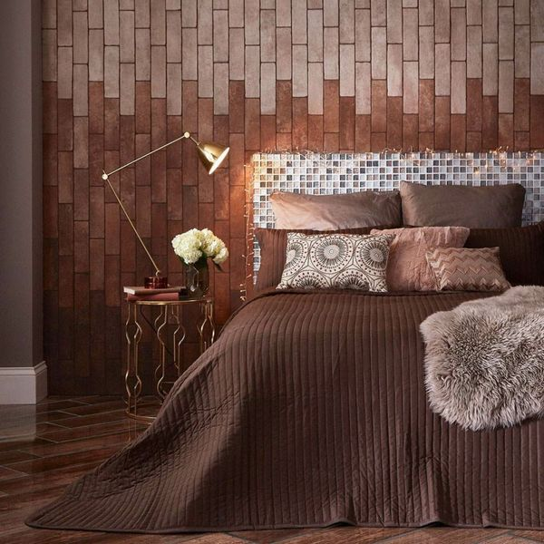**Bourbon Brown Brick Tiles:**

## **Product Description**

Introduce these Bourbon Brown Brick Tiles into your home to achieve the sought-after modern industrial look! Designed in a light colour with a concrete effect design, these durable porcelain tiles have a rustic, aged appearance and a natural, matt finish for a striking effect in your home.

**What's special about these tiles?**

> Rustic, brown tone

> Thick, durable porcelain

> Industrial concrete design

> Modern, matt finish

Try before you buy

Want to take a closer look at these tiles before placing a full order? Order a sample tile! Samples come full size and with Free Delivery, and they're a great way to get a feel for a tile's size, colour and texture. You can even see how it looks on the wall or floor in your chosen space.

## **Product Info**

* Product: ID36139
* Tiles Per SQM: 53.333333333333
* Sale by: Per SQM
* Size: 75x250x10mm
* Weight: 0.51 KG
* Material Type: Porcelain
* Finish: Matt
* Colour: Brown
* Suitability: Floors, Walls
* Grade: 4?
* Rectified Edge: Yes
* Underfloor Heating: Yes
* Anti Slip Grade: R10 / 10-19 Degrees
* Thickness (mm): 10