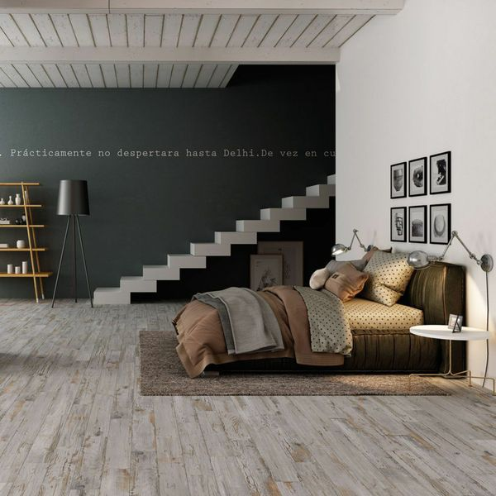**Grey Tempera Chevron Wood Tiles:**

## **Product Description**

Create a striking statement floor in your home this season with these Grey Tempera Chevron Wood Tiles. These wood effect tiles have a faded painted design; allowing you to create an aged, characterful look in your bathroom, kitchen, living area or hallway. Made from durable porcelain, they have a matt finish, with a chevron design in a mix of white, brown and grey hues. For a closer look, why not order a sample?

## **Product Info**

* Product: ID15655
* Tiles Per SQM: 2.4691358024691
* Sale by: Per SQM
* Size: 450x900x9mm
* Weight: 9.98 KG
* Material Type: Porcelain
* Finish: Matt
* Colour: Grey
* Suitability: Floors, Walls
* Grade: 4
* Rectified Edge: No
* Underfloor Heating: Yes
* Thickness (mm): 9