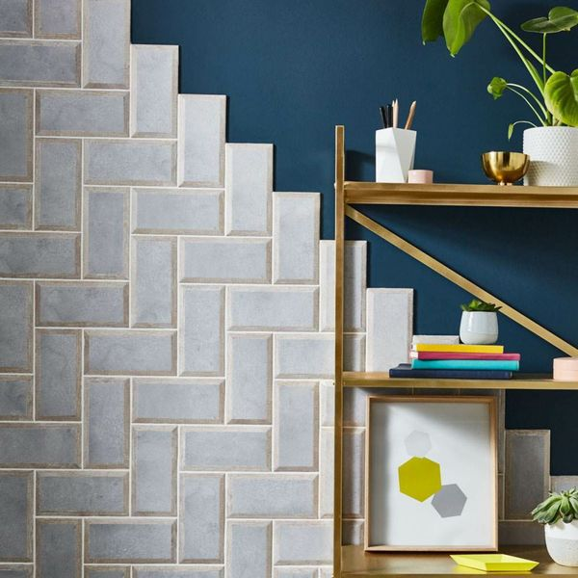**Mixx Concrete Oak Wood Tiles:**

## **Product Description**

Part of our exclusive range of Mixx Metro Tiles, these stunning Mixx Concrete Oak Wood Tiles perfectly encapsulate the mixed materials trend. You've seen brick-shaped bevelled metro wall tiles before, but never like this! Their face has a realistic concrete effect, but their bevelled edge has an oak effect look; alive with woodgrain! They're made from ceramic, so they're perfect for transforming the wall spaces throughout your home.

**What's special about these tiles?**

> Ideal for creating the mixed materials trend

> Gorgeous combination of concrete and oak design

> Definitive bevelled edge

> Compact brick-shaped design

> Naturalistic matt finish

> Perfect for experimenting with different layouts

## **Product Info**

* Product ID: 38603
* Tiles Per SQM: 50
* Sale by: Per SQM
* Size: 100x200mm
* Weight: 0.34 KG
* Material Type: Ceramic
* Finish: Matt
* Colour: Grey
* Suitability: Walls
* Grade: No
* Rectified Edge: No
* Underfloor Heating: No
* Thickness (mm): 7