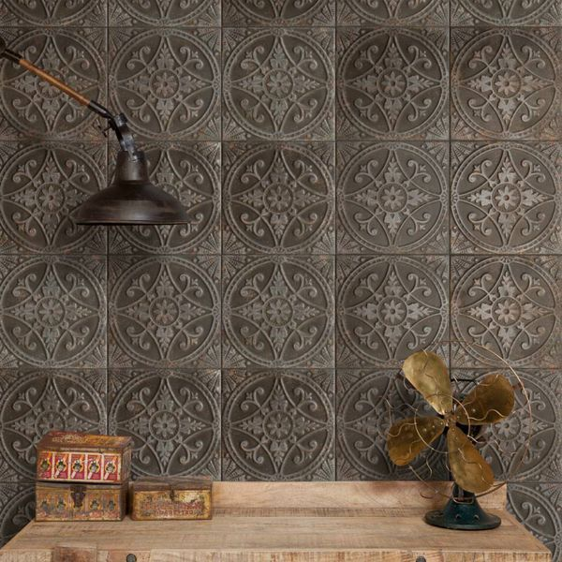**Pressed Patina Steel Tiles:**

## **Product Description**

Inject a characterful new look into your home with our stylish Pressed Patina Steel Tiles. They have a metallic look with a striking period design; ideal for creating a charming, aged, vintage look in a bathroom or kitchen. Made from ceramic, they can be used to transform the wall spaces throughout your home. For a closer look, order a sample tile.

## **Product Info**

* Product ID: 24745
* Tiles Per SQM: 9.1827364554637
* Sale by: Per SQM
* Size: 330x330x9.5mm
* Weight: 2.21 KG
* Material Type: Ceramic
* Finish: Matt
* Colour: Brown
* Suitability: Floors, Walls
* Grade: 4
* Rectified Edge: No
* Underfloor Heating: Yes
* Thickness (mm): 9.5