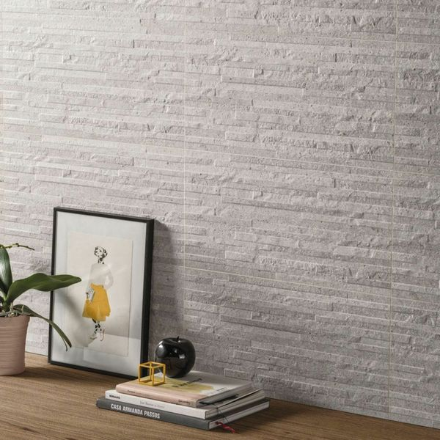**Troverta Muretto Ash Tiles:**

## **Product Description**

These Troverta Muretto Ash 60x30 Tiles have a textured split face look in a stone effect design. This makes them ideal for creating a characterful staggered wall space, They’re made from ceramic and have a matt finish typical of natural stone.

**What's special about these tiles?**

> Realistic limestone effect design  
> Textured split face effect design  
> Made from long-lasting ceramic  
> Naturalistic matt finish

**Take a closer look**

Want to take a closer look at these tiles before placing a full order? Why not order a sample tile? We send samples out with free delivery! They're the perfect way to see what a tile looks like in position in your home.

## **Product Info**

* Product ID: 43325
* Tiles Per SQM; 5.5555555555556
* Sale by: Per SQM
* Size: 300x600x8mm
* Weight: 2.58 KG
* Material Type: Ceramic
* Finish: Matt
* Colour: Grey
* Suitability: Walls
* Grade: No
* Rectified Edge: No
* Underfloor Heating: No
* Thickness (mm): 8