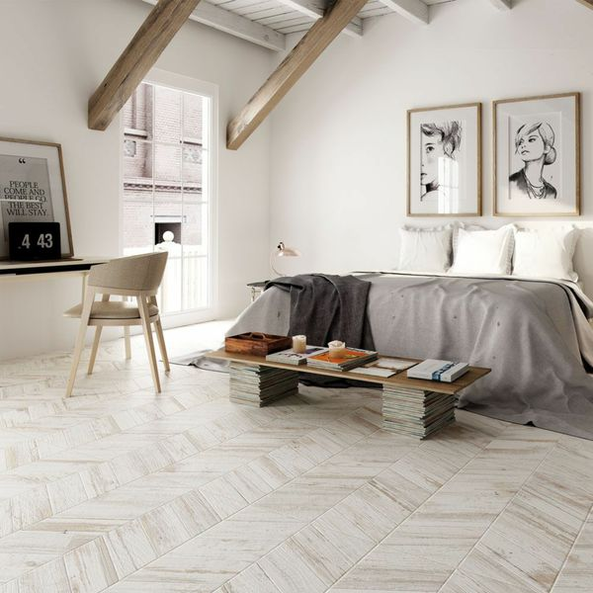**White Wash Chevron Wood Tiles:**

## **Product Description**

The charming rustic 'cabin' look is a popular design trend right now. Invite it into your home with these stylish White Wash Chevron Wood Tiles. These wood effect wall and floor tiles have a faded painted design, which is ideal for creating an aged-look, characterful floor space in your bathroom, kitchen, living area, hallway or bedroom. They're made from durable porcelain and have a matt finish. For a closer look, order a sample.

## **Product Info**

* Product ID: 15652
* Tiles Per SQM: 2.4691358024691
* Sale by: Per SQM
* Size: 450x900x9mm
* Weight: 9.98 KG
* Material Type: Porcelain
* Finish: Matt
* Colour: White
* Suitability: Floors, Walls
* Grade: 4
* Rectified Edge: No
* Underfloor Heating: Yes
* Thickness (mm): 9