**Linear White Matt Brick Tiles:**

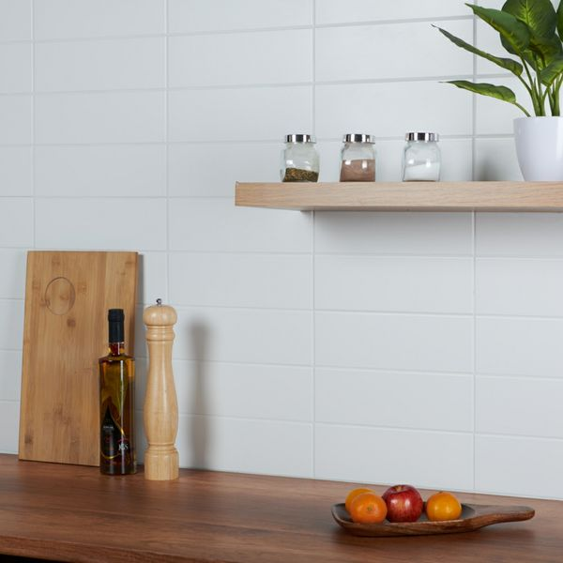

## **Product Description**

Want to brighten up an interior area this season? These White Matt Linear Tiles are just what the doctor ordered. 300x100mm in size, these brick-shaped tiles are perfect for transforming bathroom and kitchen wall spaces. They have a flat surface, with a subtle matt finish. They belong to our range of stylish Linear Tiles. Want to try before you buy? Order yourself a sample tile. Samples come full-size and with Free Delivery!

## **Product Info**

* Product ID: 13921
* Tiles Per SQM: 33.333333333333
* Sale by: Per SQM
* Size: 300x100x7mm
* Weight: 0.40 KG
* Material Type: Ceramic
* Finish: Matt
* Colour: White
* Suitability: Walls
* Grade: No
* Rectified Edge: No
* Underfloor Heating: No
* Thickness (mm): 7

**Flat Chalk Farm White Matt Tiles:**

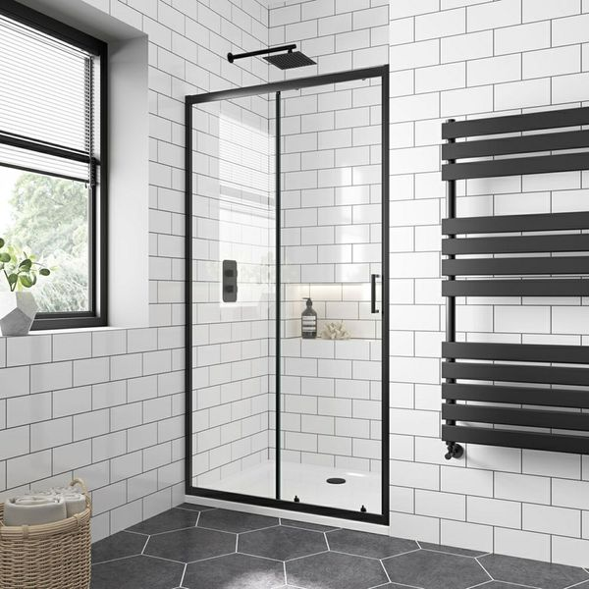

## **Product Description**

Create a blank canvas in your kitchen or bathroom with these Flat Chalk Farm White Matt 200x100 Tiles. These flat-faced metro tiles are perfect for bringing a fresh, stylish and modern look into your home. White in colour, they act as a bright, blank background - great for accessorising with utensils, hanging signs, etc.

**What's so special about these tiles?**

> Subtle matt finish

> Highly versatile shape - perfect for different layouts

> Timeless white colour - perfect for classic kitchens and bathrooms

> Use with coloured grouts for unique looks

## **Product Info**

* Product ID: 13637
* Tiles Per SQM: 50
* Sale by: Per SQM
* Size: 100x200x7mm
* Weight: 0.28 KG
* Material Type: Ceramic
* Finish : Matt
* Colour: White
* Suitability: Walls
* Grade: No
* Rectified Edge: No
* Underfloor Heating : No
* Thickness (mm): 7

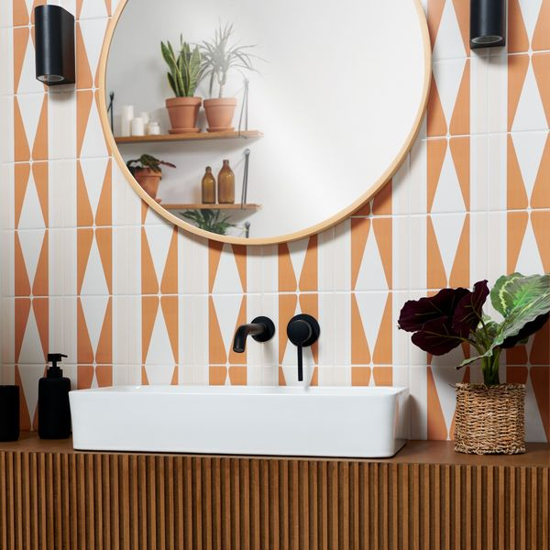**Marmalade Rene Pick n’ Mix Gloss Tiles:**

## **Product Description**

Looking for something a bit different to liven up your home? Our Marmalade Rene Pick n’ Mix Gloss Tiles feature a soft geometric design in sun-drenched shades of orange and cream. These tiles are designed to be moved around in different styles so that you can create a unique look for your home! Made from durable ceramic, these square-shaped tiles have a shimmering gloss finish that catches the light for a space-enhancing look.

**What’s special about these tiles?**

> Sunny shades of orange

> Durable ceramic

> Shimmering gloss finish

> Soft geometric pattern

> Can be turned to create different designs

## **Product Info**

* Product ID: 45096
* Tiles Per SQM: 44.444444444444
* Sale by: Per SQM
* Size: 150x150x8mm
* Weight: 0.28 KG
* Material Type: Ceramic
* Finish: Gloss
* Colour: Brown
* Suitability: Walls
* Rectified Edge: No
* Underfloor Heating: Yes
* Thickness (mm): 8

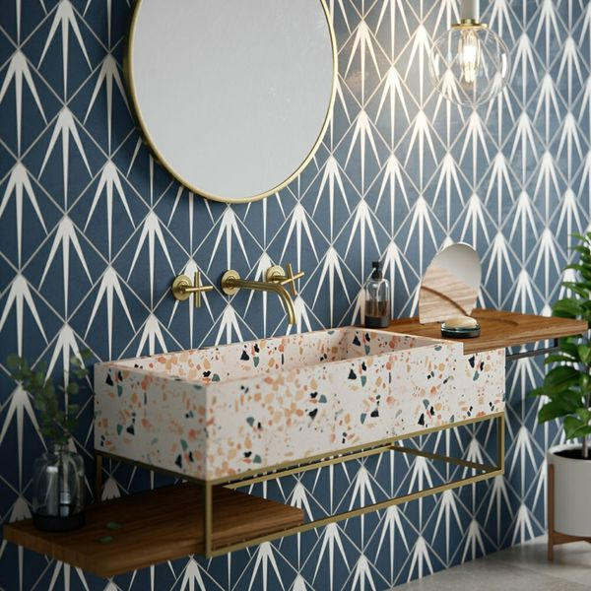**Gatsby Marine Tiles:**

## **Product Description**

With their ornate encaustic appearance, our Gatsby Tiles are perfect for creating a statement wall or floor space in your home. Turn the tiles in different directions to create a multitude of captivating patterns.

**What's special about these tiles?**

> Sought after patterned design

> Perfect for creating a bespoke statement

> Ideal for use on a wall or floor

## **Product Info**

* Product ID: 44604
* Tiles Per SQM: 25
* Sale by: Per SQM
* Size: 200x200x8mm
* Weight: 0.74 KG
* Material Type: Porcelain
* Finish: Matt
* Colour: Blue
* Suitability: Floors, Walls
* Grade: 3
* Rectified Edge: No
* Underfloor Heating: Yes
* Thickness (mm): 8

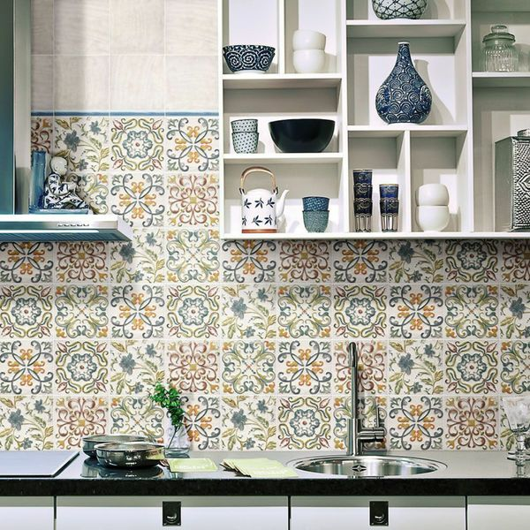**Lucy Floweret Decor Tile:**

## **Product Description**

Create a stylish new look in your kitchen or bathroom by introducing these captivating Lucy Floweret Ceramic Gloss Decor. As part of our selection of vintage Magisterial Chelsea tiles, they come in 5 different designs, which are distributed randomly to ensure a good mix. They consist of an off-white background with decorative floral-esque scrolls in a mix of blue, green, orange and red. They have a shimmering gloss finish. To take a closer look, why not order a sample tile?

## **Product Info**

* Product ID: 13612
* Tiles Per SQM: 44.444444444444
* Sale by: Per SQM
* Size: 150x150x7mm
* Weight: 0.31 KG
* Material Type: Ceramic
* Finish: Gloss
* Colour: Multicolour
* Suitability: Walls
* Grade: No
* Rectified Edge: No
* Underfloor Heating: No
* Document: [View All Designs](https://m2.wallsandfloors.co.uk/media/amasty/amfile/attach/DocumentLucy%20Tile%20PDF1405523786.pdf)
* Thickness (mm): 7