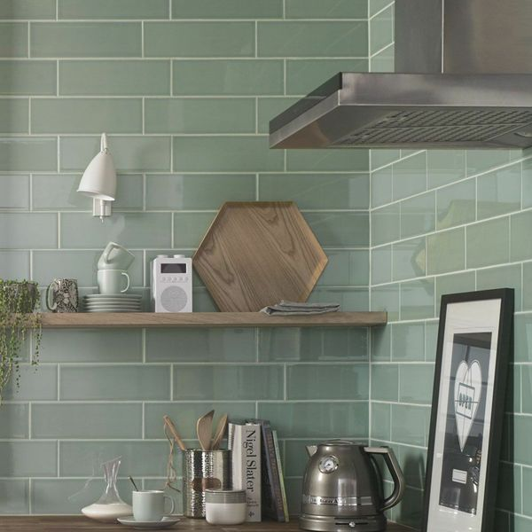**Aquarelle Pistachio Green Tiles:**

## **Product Description**

Refresh your kitchen or bathroom without Pistachio Tiles. These brick shaped ceramic wall tiles are perfect for creating a splashback or feature wall in a herringbone design. They have a gloss finish and have a smooth shadow glaze around the edge of the tile which gives a subtle bevelled illusion that allows for a characterful, shabby chic display.

**What's special about these tiles?**

> Shadow glaze around edging to make the tiles 'pop'

> Gorgeous on-trend green tone

> Brick shape for unlimited layout options

> Shimmering gloss finisg

> Wipe-clean surface, perfect for splashbacks

## **Product info**

* Product ID: 15404
* Tiles Per SQM: 33.333333333333
* Sale by: Per SQM
* Size: 300x100x5mm
* Weight: 0.42 KG
* Material Type: Ceramic
* Finish: Gloss
* Colour: Green
* Suitability: Walls
* Grade: No
* Rectified Edge: No
* Underfloor Heating: No
* Thickness (mm): 5