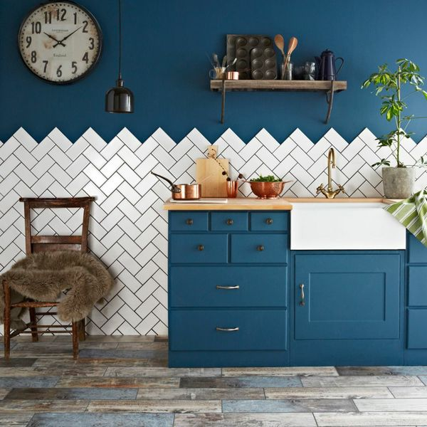**Bastille White Smooth Crackle Mini Metro Tiles:**

## **Product Description**

A classic white flat brick shaped wall tile with a unique gloss crackle glaze finish. These ceramic Bastille White Crackle Metro Tiles are ideal for kitchen or bathroom walls. For a closer look, order a sample online with free delivery! Inspired by the 1920's Parisian Metro System we recommend using the Bastille Tiles to create a superb retro kitchen wall feature.

Before grouting, it is compulsory to seal with [LTP Crackle Glaze](https://www.wallsandfloors.co.uk/catrangetiles/tile-preparation/ltp-cleaning-tile-protecting-tiles/ltp-crackle-glaze-protector/17640/). This prevents the grout from discolouring the tile, and helps to prevent water from penetrating the tile. However, in areas where water is directly hitting the tile, such as in a shower, we strongly recommend in addition applying&n...

Read More +

## **Product info**

* Product: ID11339
* Tiles Per SQM: 88.888888888889
* Sale by: Per SQM
* Size: 150x75x7mm
* Weight: 0.16 KG
* Material Type: Ceramic
* Finish: Gloss
* Colour: White
* Suitability: Walls
* Grade: No
* Rectified Edge: No
* Underfloor Heating: No
* Thickness (mm): 7