**Cedar Green Rustic Metro Tiles:**

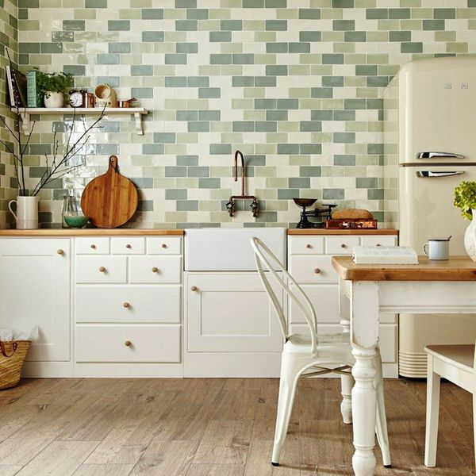

## **Product Description**

A pale green/grey brick shaped tile with a slighlty textured finish creating a rustic effect.

## **Product info**

* Product ID 12175
* Tiles Per SQM 88.888888888889
* Sale by Per SQM
* Size 150x75x7mm
* Weight 0.16 KG
* Material Type Ceramic
* Finish Gloss
* Colour Green
* Suitability Walls
* Grade No
* Rectified Edge No
* Underfloor Heating No
* Thickness (mm) 7