**Innocence Smooth Gloss White Wall Tiles:**

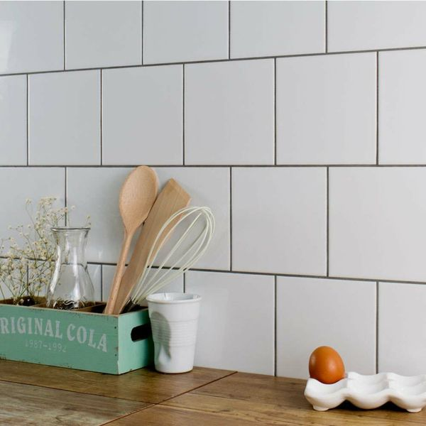

## **Product Description**

A classic smooth white tile with a gloss finish. The ceramic white tiles are ideal for creating a blank canvas on bathroom walls, order Smooth White 150x150 samples online with free delivery. Made from ceramic, these tiles are perfect for creating a fresh, bright look on the wall spaces throughout your home. They work particularly well in a bathroom, or when used as a refreshing kitchen splashback. Decorating with white not only brightens up a room but also makes the interior space seem larger.

**What's special about these tiles?**

> Bright white colour  
> Versatile square shape  
> Shimmering gloss finish  
> Durable ceramic construction

## Product info

* Product ID: 13336
* Tiles Per SQM: 44.444444444444
* Sale by: Per SQM
* Size: 150x150x4mm
* Weight: 0.20 KG
* Material Type: Ceramic
* Finish: Gloss
* Colour: White
* Suitability: Walls
* Grade: No?
* Rectified Edge: No
* Underfloor Heating: No
* Thickness (mm): 4