**Innocence Smooth Gloss White Wall Tiles:**

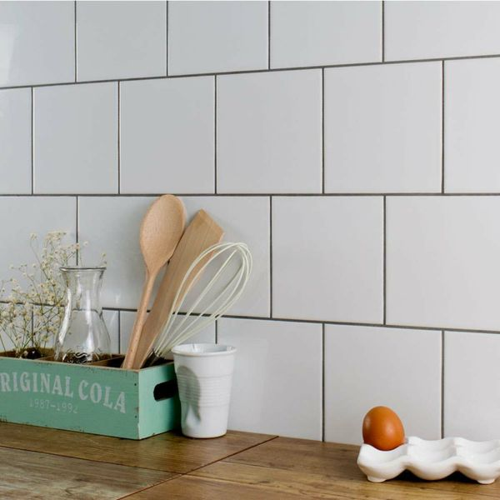

## **Product Description**

A classic smooth white tile with a gloss finish. The ceramic white tiles are ideal for creating a blank canvas on bathroom walls, order Smooth White 150x150 samples online with free delivery. Made from ceramic, these tiles are perfect for creating a fresh, bright look on the wall spaces throughout your home. They work particularly well in a bathroom, or when used as a refreshing kitchen splashback. Decorating with white not only brightens up a room but also makes the interior space seem larger.

**What's special about these tiles?**

> Bright white colour  
> Versatile square shape  
> Shimmering gloss finish  
> Durable ceramic construction

## Product info

* Product ID: 13336
* Tiles Per SQM: 44.444444444444
* Sale by: Per SQM
* Size: 150x150x4mm
* Weight: 0.20 KG
* Material Type: Ceramic
* Finish: Gloss
* Colour: White
* Suitability: Walls
* Grade: No?
* Rectified Edge: No
* Underfloor Heating: No
* Thickness (mm): 4

**Cedar Green Rustic Metro Tiles:**

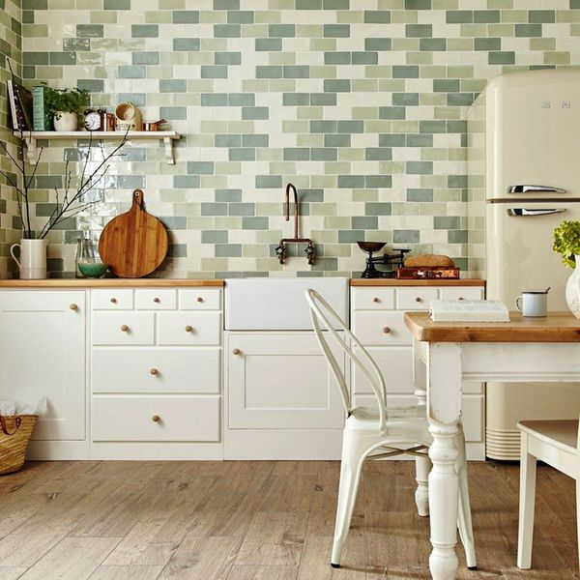

## **Product Description**

A pale green/grey brick shaped tile with a slighlty textured finish creating a rustic effect.

## **Product info**

* Product ID 12175
* Tiles Per SQM 88.888888888889
* Sale by Per SQM
* Size 150x75x7mm
* Weight 0.16 KG
* Material Type Ceramic
* Finish Gloss
* Colour Green
* Suitability Walls
* Grade No
* Rectified Edge No
* Underfloor Heating No
* Thickness (mm) 7

**Bastille White Smooth Crackle Mini Metro Tiles:**

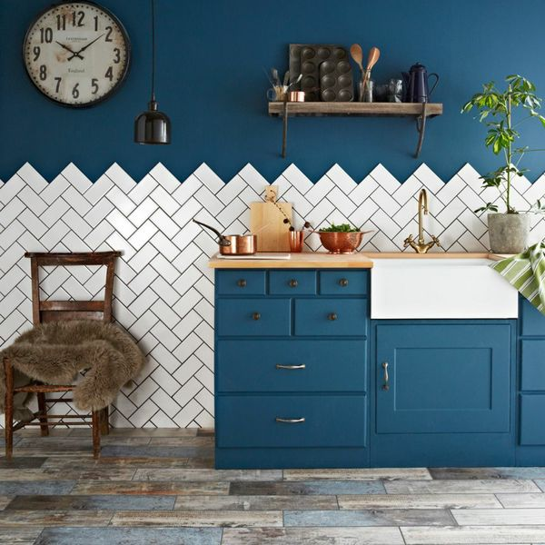

## **Product Description**

A classic white flat brick shaped wall tile with a unique gloss crackle glaze finish. These ceramic Bastille White Crackle Metro Tiles are ideal for kitchen or bathroom walls. For a closer look, order a sample online with free delivery! Inspired by the 1920's Parisian Metro System we recommend using the Bastille Tiles to create a superb retro kitchen wall feature.

Before grouting, it is compulsory to seal with [LTP Crackle Glaze](https://www.wallsandfloors.co.uk/catrangetiles/tile-preparation/ltp-cleaning-tile-protecting-tiles/ltp-crackle-glaze-protector/17640/). This prevents the grout from discolouring the tile, and helps to prevent water from penetrating the tile. However, in areas where water is directly hitting the tile, such as in a shower, we strongly recommend in addition applying&n...

Read More +

## **Product info**

* Product: ID11339
* Tiles Per SQM: 88.888888888889
* Sale by: Per SQM
* Size: 150x75x7mm
* Weight: 0.16 KG
* Material Type: Ceramic
* Finish: Gloss
* Colour: White
* Suitability: Walls
* Grade: No
* Rectified Edge: No
* Underfloor Heating: No
* Thickness (mm): 7

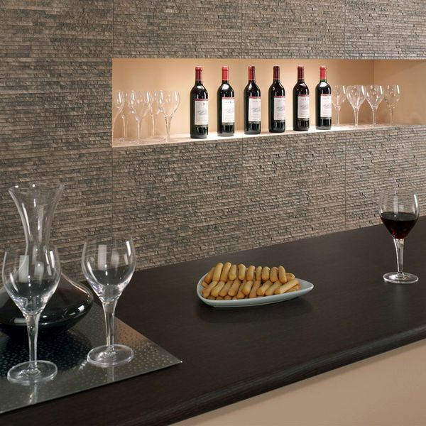**Waterfall Textured Marron Split Face Tiles:**

## **Product Description**

Brown-grey in colour, these Marron Tiles have a striking multi-levelled waterfall effect design. They're inspired by Stratum Tiles, but are just a fraction of the price. The thin stone effect strips are sloped to give the appearance of steps. They are perfect for adding character and definition to bland wall spaces, and are great for inviting the natural look into your home. To get the full effect, we recommend ordering a sample tile.

## **Product info**

* Product ID: 13249
* Tiles Per SQM: 5.7603686635945
* Sale by: Per SQM
* Size: 560x310x10mm
* Weight: 3.57 KG
* Material Type: Porcelain
* Finish: Matt
* Colour: Brown
* Suitability: Walls
* Grade: 4
* Rectified Edge: No
* Underfloor Heating: No
* Thickness (mm): 10

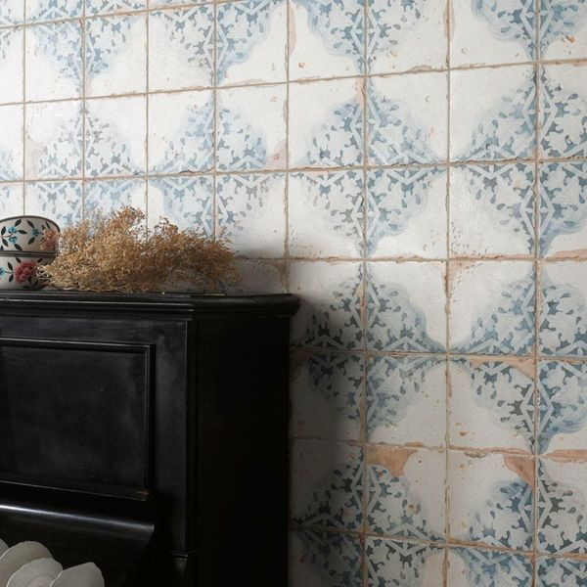**Vecchio Diamante Indigo Tiles:**

## **Product Description**

Inject some character into your home this season with these charming Vecchio Diamante Indigo Tiles. With a vintage blue and white decorative patterned design, they have an aged, antique look, and a scored surface. The scored grid that crosses the face of this tile is grouted into; creating the illusion of four separate tiles. To keep this groutline consistent, we recommend using 2mm spacers around the outside of the tiles. Made from ceramic, these tiles have a matt finish, and can be used to transform both wall and floor spaces throughout the home. For the full effect, order a sample tile.

## **Product info**

* Product ID: 24738
* Tiles Per SQM: 9.1827364554637
* Sale by: Per SQM
* Size: 330x330x9.5mm
* Weight: 2.21 KG
* Material Type: Ceramic
* Finish: Matt
* Colour: Multicolour
* Suitability: Floors, Walls
* Grade: 4
* Rectified Edge: No
* Underfloor Heating: Yes
* Thickness (mm): 9.5

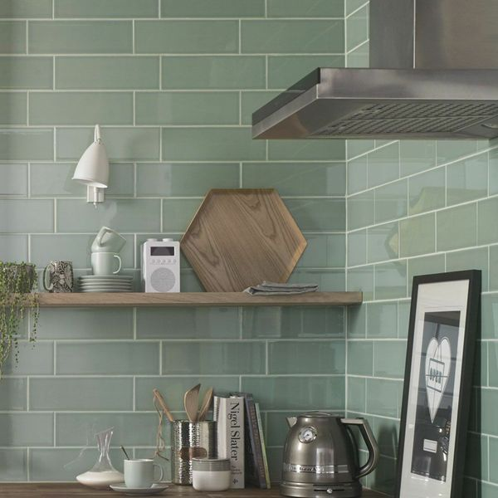**Aquarelle Pistachio Green Tiles:**

## **Product Description**

Refresh your kitchen or bathroom without Pistachio Tiles. These brick shaped ceramic wall tiles are perfect for creating a splashback or feature wall in a herringbone design. They have a gloss finish and have a smooth shadow glaze around the edge of the tile which gives a subtle bevelled illusion that allows for a characterful, shabby chic display.

**What's special about these tiles?**

> Shadow glaze around edging to make the tiles 'pop'

> Gorgeous on-trend green tone

> Brick shape for unlimited layout options

> Shimmering gloss finisg

> Wipe-clean surface, perfect for splashbacks

## **Product info**

* Product ID: 15404
* Tiles Per SQM: 33.333333333333
* Sale by: Per SQM
* Size: 300x100x5mm
* Weight: 0.42 KG
* Material Type: Ceramic
* Finish: Gloss
* Colour: Green
* Suitability: Walls
* Grade: No
* Rectified Edge: No
* Underfloor Heating: No
* Thickness (mm): 5