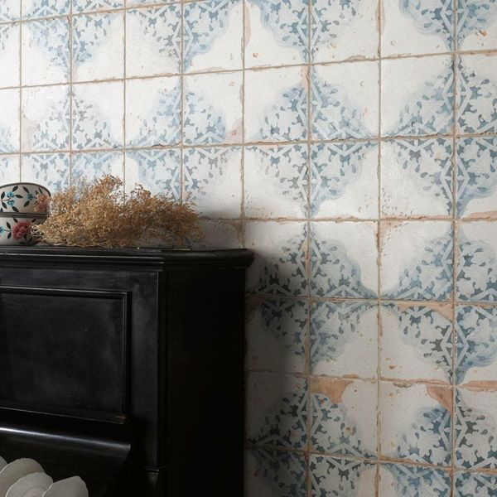**Vecchio Diamante Indigo Tiles:**

## **Product Description**

Inject some character into your home this season with these charming Vecchio Diamante Indigo Tiles. With a vintage blue and white decorative patterned design, they have an aged, antique look, and a scored surface. The scored grid that crosses the face of this tile is grouted into; creating the illusion of four separate tiles. To keep this groutline consistent, we recommend using 2mm spacers around the outside of the tiles. Made from ceramic, these tiles have a matt finish, and can be used to transform both wall and floor spaces throughout the home. For the full effect, order a sample tile.

## **Product info**

* Product ID: 24738
* Tiles Per SQM: 9.1827364554637
* Sale by: Per SQM
* Size: 330x330x9.5mm
* Weight: 2.21 KG
* Material Type: Ceramic
* Finish: Matt
* Colour: Multicolour
* Suitability: Floors, Walls
* Grade: 4
* Rectified Edge: No
* Underfloor Heating: Yes
* Thickness (mm): 9.5