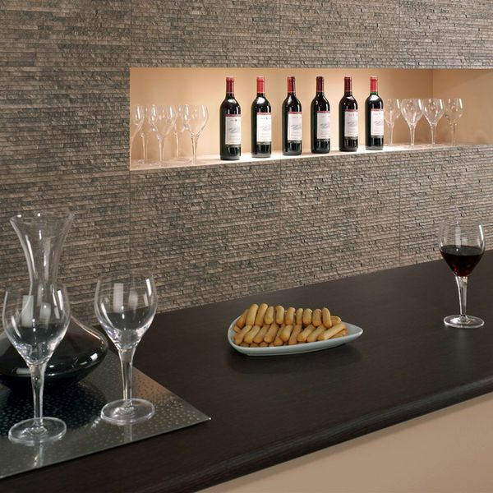**Waterfall Textured Marron Split Face Tiles:**

## **Product Description**

Brown-grey in colour, these Marron Tiles have a striking multi-levelled waterfall effect design. They're inspired by Stratum Tiles, but are just a fraction of the price. The thin stone effect strips are sloped to give the appearance of steps. They are perfect for adding character and definition to bland wall spaces, and are great for inviting the natural look into your home. To get the full effect, we recommend ordering a sample tile.

## **Product info**

* Product ID: 13249
* Tiles Per SQM: 5.7603686635945
* Sale by: Per SQM
* Size: 560x310x10mm
* Weight: 3.57 KG
* Material Type: Porcelain
* Finish: Matt
* Colour: Brown
* Suitability: Walls
* Grade: 4
* Rectified Edge: No
* Underfloor Heating: No
* Thickness (mm): 10