**Ruvido Tribal Stone Hexagon Tiles:**

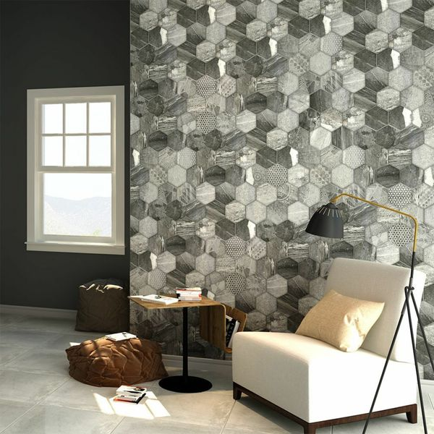

## **Product Description**

A medley of interesting tribal-esque designs printed on a soft stone effect backing, these Tribal Stone Tiles are perfect for introducing a unique floor area into your home. They depict the illusion of 8 individual hexagonal pieces - divided with a faux groutline. Made from durable porcelain, they are perfect for use on all floor area throughout the home. They have a soft matt finish.

The colour of grout used is down to your own personal taste, but one recommendation might be to use our [Mapei Ultracolour Plus 113 Tile Grout](https://www.wallsandfloors.co.uk/catrangetiles/tile-grouts/mapei-grouts/mapei-ultracolour-plus-113-grout/16723/).

## **Product Info**

* Product ID 14325
* Tiles Per SQM 6.36
* Sale by Per SQM
* Size 450x450x9mm
* Weight 3.23 KG
* Material Type Porcelain
* Finish Matt
* Colour Grey
* Suitability Floors, Walls
* Grade 4
* Rectified Edge No
* Underfloor Heating Yes
* Thickness (mm) 7

**Placid Marble Effect Tiles:**

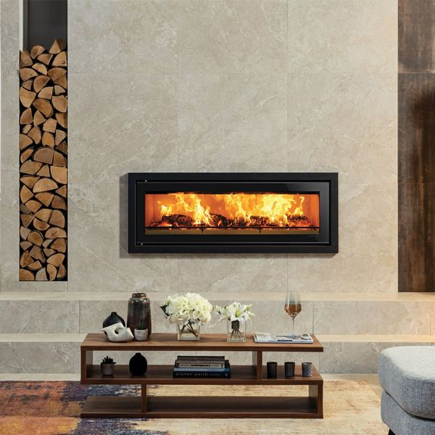

## **Product Description**

Alive with strong veining, these Boketto Placid Marble Effect Tiles have multiple variations to help give the naturalistic variance offered by natural marble. They consist of a cream and beige background and have a soft matt finish, which is perfect for creating a tranquil backdrop. They're made from durable porcelain, so they're long-lasting and hard-wearing.

## **Product Info**

* Product ID: 40281
* Tiles Per SQM: 1.7777777777778
* Sale by: Per SQM
* Size: 750x750x11mm
* Weight: 14.33 KG
* Material Type: Porcelain
* Finish: Matt
* Colour: Beige/Ivory
* Suitability: Floors, Walls
* Grade: 4?
* Rectified Edge: Yes
* Underfloor Heating: Yes
* Thickness (mm): 11

**Stacked Sand Stone Effect Tiles:**

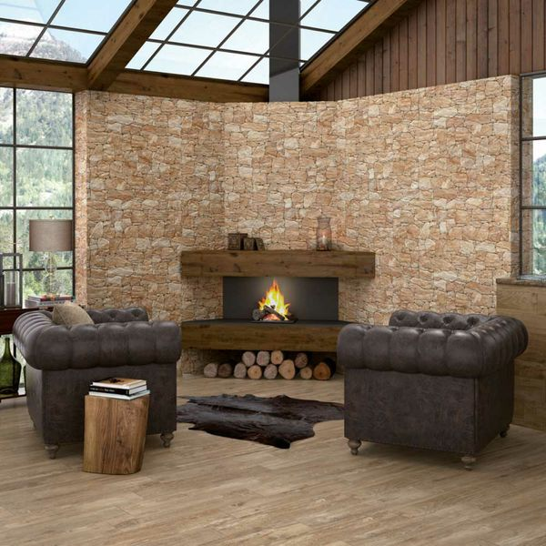

## **Product Description**

Reinvent the wall spaces through your home with these Stacked Sand Stone Effect Tiles. They allow you to create the illusion of a stacked dry wall; the kind you might find in a country farmhouse. They're perfect for creating a feature wall in a bathroom, kitchen, living area, or even outside in the garden. Made from porcelain, they have a textured surface and a matt finish. For a grout that matches the faux groutlines contained within these tiles, try our [Ultracolour Plus 114 Antracita Tile Grout](https://www.wallsandfloors.co.uk/catrangetiles/tile-grouts/mapei-grouts/mapei-ultracolour-plus-114-grout/16724/). They're suitable for use on both internal and external wall spaces.

## **Product Info**

* Product ID: 15313
* Tiles Per SQM: 4.6200046200046
* Sale by: Per SQM
* Size: 650x333x10mm
* Weight: 4.20 KG
* Material Type: Porcelain
* Finish: Matt
* Colour: Beige/Ivory
* Suitability: Walls
* Grade: 4
* Rectified Edge: No
* Underfloor Heating: No
* Thickness (mm): 10

**Oaken Teal Oxidised Hexagon Tiles:** 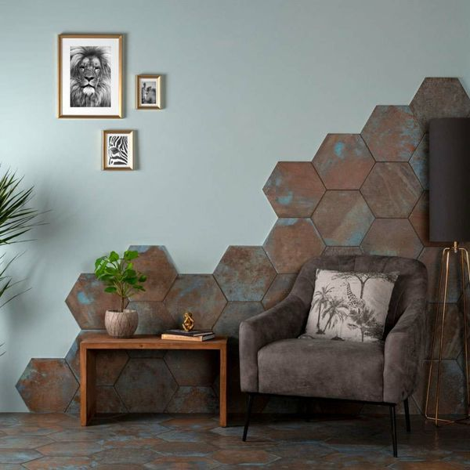

## **Product Description**

For a characterful new look in your home, introduce these Oaken Hexagon Tiles to the wall and floor spaces. They have a weathered rusty look; like oxidised metal - perfect for bringing a reclaimed industrious look into a bathroom, kitchen or living area! Create a statement floor or feature wall.

**What's special about these tiles?**

> Characterful oxidised look

> Perfect for an industrial scheme

> Trendy hexagonal shape

> Made from durable porcelain

> Suitable for walls and floors

> Can be used with underfloor heating

**Take a closer look**

Want to take a closer look at these tiles before placing a full order? Why not order a sample tile? We send samples out with free delivery! They're the perfect way to see what a tile looks like in position in your home.

## **Product Info**

* Product ID: 43852
* Tiles Per SQM: 14.310684840116
* Sale by: Per SQM
* Size: 280x333x9mm
* Weight: 1.33 KG
* Material Type: Porcelain
* Finish: Matt
* Colour: Brown
* Suitability: Floors, Walls
* Grade: 3
* Rectified Edge: No
* Underfloor Heating: Yes
* Thickness (mm): 9

**Mimosa Marble Valley White Gold Tiles:** 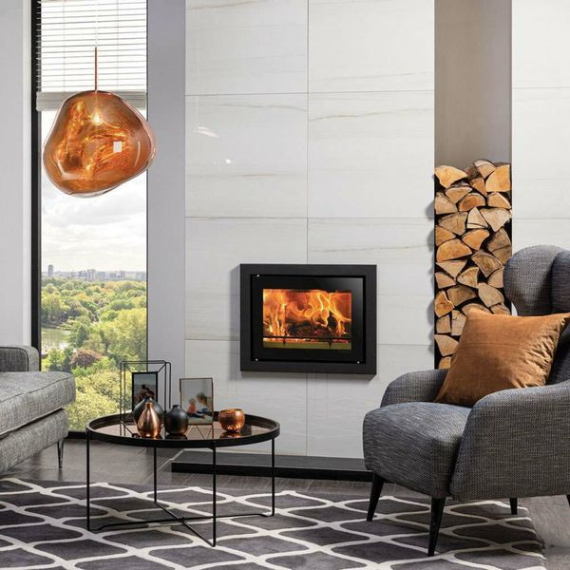

## **Product Description**

These Mimosa Marble Valley White Gold 60x60 Tiles are perfect for introducing a lavish and exclusive look into your interior spaces. They're inspired by one of Italy's finest marbles, Lasa, which is quarried in the Lasa Valley. Made from porcelain, they're hard-wearing and long-lasting, with a rich deep glaze. Their gentle golden veinings run across the white backdrop in gorgeous stripes.

**What's special about these tiles?**

> Realistic marble effect design

> Inspired by one of Italy's finest marbles

> Gorgeous golden veining

> Made from durable porcelain

> Shimmering polished finish

**Try before you buy**

If you'd like to take a closer look, why not order a sample tile? Samples are a great way to get a feel for a tile's true colour and texture, and you can see how it looks in your chosen room!

## **Product Info**

* Product ID: 38477
* Tiles Per SQM: 2.7777777777778
* Sale by: Per SQM
* Size: 600x600x10mm
* Weight: 7.68 KG
* Material Type: Porcelain
* Finish: Polished
* Colour: White
* Suitability: Floors, Walls
* Grade: 5
* Rectified Edge: Yes
* Underfloor Heating: Yes
* Document: [View All Designs](https://m2.wallsandfloors.co.uk/media/amasty/amfile/attach/Mimosa_Marble_Valley_White_Gold_60x60_Tiles.pdf),[Technical Data Sheet](https://m2.wallsandfloors.co.uk/media/amasty/amfile/attach/Walls-and-Floors-schluter-dilex-BWB.pdf)
* Thickness (mm): 10

**Isidora Pacific Thick Splitface Effect Tiles:** 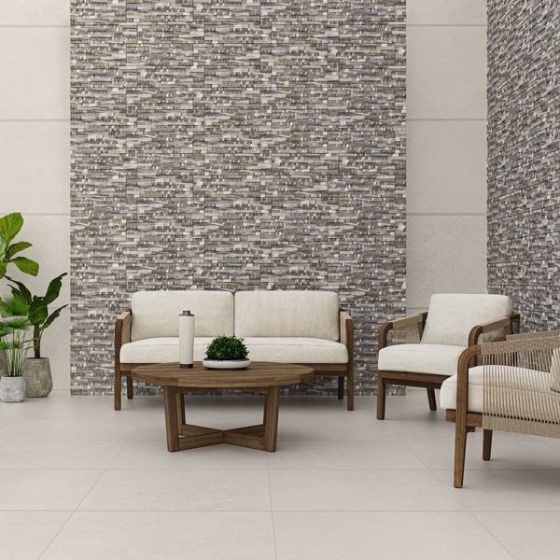

## **Product Description**

Add depth and character to any space with our Isidora Pacific Thick Splitface Effect Tiles. Designed to emulate linear strips of stone, these tiles feature a mottled mix of grey and sea green with a rippled, wave-like effect and a light shimmer across the surface. A low maintenance alternative to natural split face tiles, these stunning staggered porcelain tiles have a rugged, multi-levelled surface, providing a sleek, contemporary look in your home.

**What’s special about these tiles?**

> Rustic three-dimensional surface

> Gentle sparkle effect

> Sleek contemporary aesthetic

> Durable porcelain

> Striking characterful look

## **Product Info**

* Product ID: 801526
* Tiles Per SQM: 11.31221719457
* Sale by: Per SQM
* Size: 170x520x14mm
* Weight: 2.04 KG
* Material Type: Porcelain
* Finish: Matt
* Colour: Grey
* Suitability: Walls
* Area Of Usage: Internal, External
* Grade: No
* Rectified Edge: No
* Underfloor Heating: No
* Thickness (mm): 14