**Medici Plus Natural Porcelain Paving Slabs:**

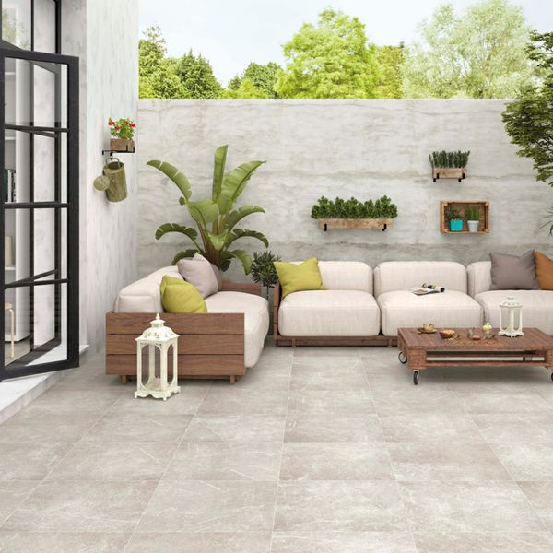

## **Product Description**

Transform your garden into a relaxing and functional space with the simple addition of these Medici Plus Natural 60x60 Tiles. Made from 20mm porcelain, these tiles are durable, long-lasting and frost-proof, and they have a stone effect look, which is alive with delicate veining and fossilising. They offer a warm blend of natural beiges, creating a variety of tones. 20mm Paving Trims?

**What's special about these tiles?**

> 20mm thick durable porcelain

> Realistic stone effect design

> Long lasting and frostproof

> Perfect for creating a stylish patio space

**Have you seen our selection of Norcross Rock-Tite products? They're perfect for fixing and completing outdoor projects!**

## **Product INFO**

* Product ID44179
* Tiles Per SQM 2.8246592754749
* Sale by Per SQM
* Size 595x595x20mm
* Weight 13.75 KG
* Material Type Porcelain
* Finish Matt
* Colour Grey
* Suitability Floors
* Area Of Usage External
* Grade 4
* Rectified Edge Yes
* Underfloor Heating Yes
* Anti Slip Grade R11 / 12 Degrees
* Document [20mm Installation Guide](https://m2.wallsandfloors.co.uk/media/amasty/amfile/attach/20mm-installation-guide_4.pdf),[Cleaning and Protection Guide](https://m2.wallsandfloors.co.uk/media/amasty/amfile/attach/ltp_-_walls_floors_-_external_porcelain_-_cleaning_and_protection_guide_-_april_2020.pdf)
* Thickness (mm) 20

**Mist Chalk Concrete Effect Porcelain Paving Slabs:**

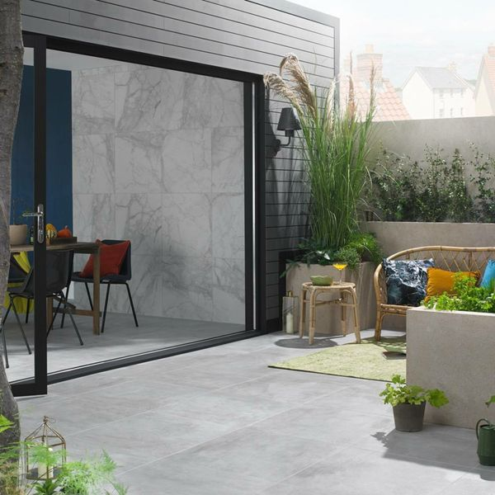

## **Product Description**

Create a contemporary space in your garden with our Mist Chalk Concrete Effect Porcelain Paving Slabs. Perfect for emulating a natural look, these concrete effect slabs are designed in a pale white hue with a matt, textured surface. Perfectly suited to the Industrial trend, these stunning slabs can be paired with their interior counterpart for a seamless indoor/outdoor look!

**What’s special about these tiles?**

> Stylish concrete effect design

> 20mm thick durable porcelain

> Perfect for an industrial look

> Naturalistic matt, anti-slip finish

> Frostproof and long-lasting

## **Product INFO**

* Product ID: 801504
* Tiles Per SQM: 2.8437447568456
* Sale by: Per SQM
* Size: 593x593x20mm
* Weight: 15.50 KG
* Material Type: Porcelain
* Finish: Matt
* Colour: Grey
* Suitability: Floors, Walls
* Area Of Usage: External
* Grade: 4
* Rectified Edge: Yes
* Underfloor Heating: Yes
* Anti Slip Grade: R10 / 19-27 Degrees
* Document: [20mm Installation Guide](https://m2.wallsandfloors.co.uk/media/amasty/amfile/attach/20mm-installation-guide_4.pdf),[Cleaning and Protection Guide](https://m2.wallsandfloors.co.uk/media/amasty/amfile/attach/ltp_-_walls_floors_-_external_porcelain_-_cleaning_and_protection_guide_-_april_2020.pdf)
* Thickness (mm): 20

**Vesuvius Charcoal Split Face Effect Tiles:**

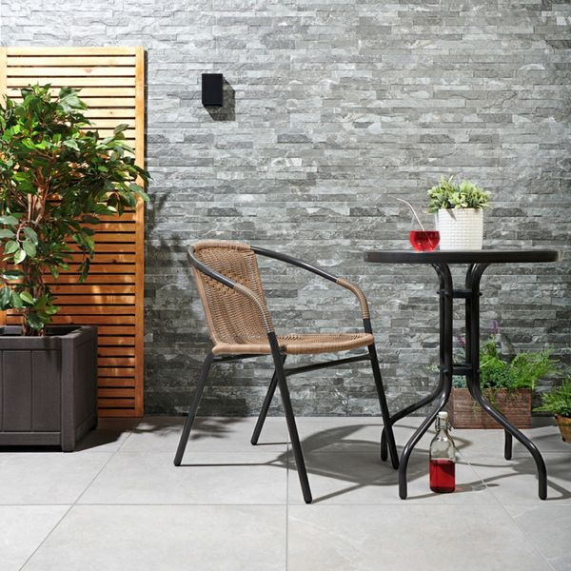

## **Product Description**

Create a contemporary wall display in your home with these Charcoal Tiles. Part of our [**Vesuvius Split Face Effect Tiles**](https://www.wallsandfloors.co.uk/wall-tiles/vesuvius-split-face-effect-tiles) range, it has a multi-levelled slate-effect surface. Unlike our natural slate Splitface Mosaic Tiles, it's suitable for external applications; as well as shower areas and wet rooms.

**What's special about these tiles?**

> Realistic slate effect design  
> Characterful textured surface  
> Perfect for use inside and outside the home

## **Product Info**

* Product ID: 12321
* Tiles Per SQM: 5.5555555555556
* Sale by: Per SQM
* Size: 600x300x10mm
* Weight: 3.67 KG
* Material Type: Porcelain
* Finish: Matt
* Colour: Grey
* Suitability: Walls
* Area Of Usage: External
* Grade: 4
* Rectified Edge: No
* Underfloor Heating: No
* Thickness (mm): 10

**Sherwood Natural Wood Effect Porcelain Paving Slabs:** 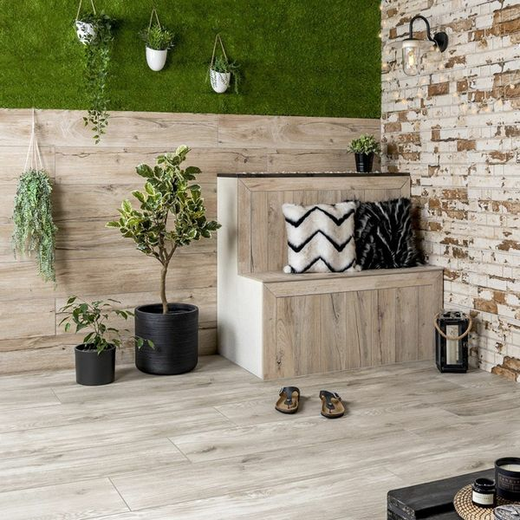

## **Product Description**

Have a look at our Sherwood Natural Wood Effect Tiles. Made from porcelain with a matt finished and a realistic wood grain finish, these tiles are perfect for outdoor use as they are 20mm thick. Our first range of external 20mm porcelain; perfect for a low maintenance decking area in your garden. Abundant with the natural knots and grain of real wood flooring available in 3 great shades, be it more contemporary greys or natural oaky wood, our Sherwood collection harmoniously works with all things outdoors.

Have you tried our [20mm Paving Slab Trims](https://www.wallsandfloors.co.uk/20mm-paving-slab-trims)? **What's special about these tiles?**

> Gorgeous natural wood colour

> Seamless appearance with wooden inspiration to create a natural space

> R11 anti-slip

> Durable porcelain, suitable for outside

**Have you seen our selection of Norcross Rock-Tite products? They're perfect for fixing and completing outdoor projects!**

## **Product INFO**

* Product ID: 44426
* Tiles Per SQM: 2.8366782497695
* Sale by: Per SQM
* Size: 295x1195x20mm
* Weight: 15.60 KG
* Material Type: Porcelain
* Finish: Matt
* Colour: Beige/Ivory
* Suitability: Floors
* Area Of Usage: External
* Rectified Edge: No
* Underfloor Heating: Yes
* Anti Slip Grade: R11 / 35 Degrees
* Document: [20mm Installation Guide](https://m2.wallsandfloors.co.uk/media/amasty/amfile/attach/20mm-installation-guide_4.pdf),[Cleaning and Protection Guide](https://m2.wallsandfloors.co.uk/media/amasty/amfile/attach/ltp_-_walls_floors_-_external_porcelain_-_cleaning_and_protection_guide_-_april_2020.pdf)
* Thickness (mm): 20

**Rustic Masonry Dove White Brick Effect Tiles:** 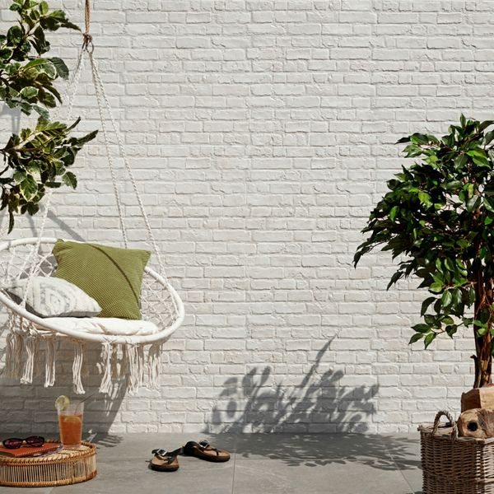

## **Product Description**

Create some rustic industrial charm in your home this season with these Dove White Painted Brick Effect Tiles. They have a realistic brick effect design; ideal for injecting an industrial or farmhouse look into a bathroom, kitchen, living area or bedroom. They have a textured, staggered design, to help capture the likeness of a rustic rural wall.

What's special about these tiles?

> White-washed brick effect

> Matt finish

> Durable porcelain body

> Textured look, perfect for wall design and casting intricate shadows

> 15 different variations for a realistic finish

Try before you buy

If you'd like to take a closer look, why not order a sample tile? Samples are a great way to get a feel for a tile's true colour and texture, and you can see how it looks in your chosen room!

## **Product INFO**

* Product ID: 15209
* Tiles Per SQM: 5.7603686635945
* Sale by: Per SQM
* Size: 310x560x10mm
* Weight: 3.85 KG
* Material Type: Porcelain
* Finish: Matt
* Colour: White
* Suitability: Walls
* Grade: 4
* Rectified Edge: No
* Underfloor Heating: No
* Thickness (mm): 10

**Leinz Sion Patterned Porcelain Paving Slabs:** 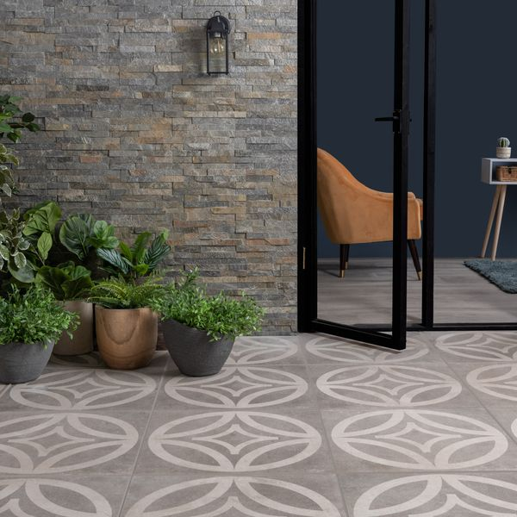

## **Product Description**

Designed with a contemporary geometric pattern on a speckled, dark grey stone effect base, these Leinz Sion Patterned Porcelain Paving Slabs are great for creating a statement look in your outdoor space. The curved, modern lines create a smooth and simple geometric design for a characterful look. These stunning tiles are the perfect choice for the popular garden trends, zoning and outdoor rugs - especially when paired with the original plain tiles from the range.

Have you seen our [20mm Paving Slab Trims](https://www.wallsandfloors.co.uk/20mm-paving-slab-trims)?

**What’s special about these tiles?**

> Durable porcelain construction

> Long-lasting and easy to clean

> Speckled, dark grey hue with modern, geometric design

> Perfect for the popular zoning and outdoor rug trends

> R11 anti-slip surface

## **Product INFO**

* Product ID: 45052
* Tiles Per SQM: 2.8246592754749
* Sale by: Per SQM
* Size: 595x595x20mm
* Weight: 13.70 KG
* Material Type: Porcelain
* Finish: Matt
* Colour: Grey
* Suitability: Floors
* Area Of Usage: External
* Grade: 4
* Rectified Edge: Yes
* Underfloor Heating: Yes
* Anti Slip Grade: R11 / 35 Degrees
* Document: [20mm Installation Guide](https://m2.wallsandfloors.co.uk/media/amasty/amfile/attach/20mm-installation-guide_4.pdf),[Cleaning and Protection Guide](https://m2.wallsandfloors.co.uk/media/amasty/amfile/attach/ltp_-_walls_floors_-_external_porcelain_-_cleaning_and_protection_guide_-_april_2020.pdf)
* Thickness (mm): 20