Lab 6: Securing a Web Application
Github: https://github.com/ThienDuong-1207/Advanced_Java_Programming/tree/main/Lab6_Adv_Java

The guide “Securing a Web Application” shows how to build a simple web application with basic login security using Spring Security. It begins by creating a small web app that has a home page and a greeting page. Then the guide adds security so that the greeting page is only visible if the user signs in. The purpose of the guide is to teach developers how to protect web pages using Spring Security. In particular, it explains how to configure URL-paths, custom login pages, and an in-memory user store. For example, the configuration allows “/” and “/home” to be publicly available, while all other paths require authentication. A user “user” with password “password” and role “USER” is configured in memory.
Result:
Once the application starts up, point your browser to http://localhost:8080. You should see the home page, as the following image shows:
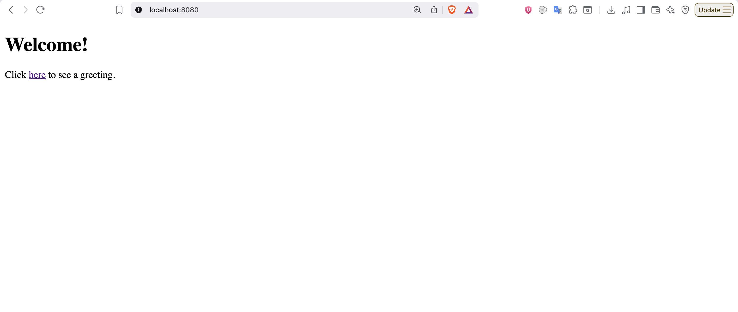
When you click on the link, it attempts to take you to the greeting page at /hello. However, because that page is secured and you have not yet logged in, it takes you to the login page, as the following image shows:
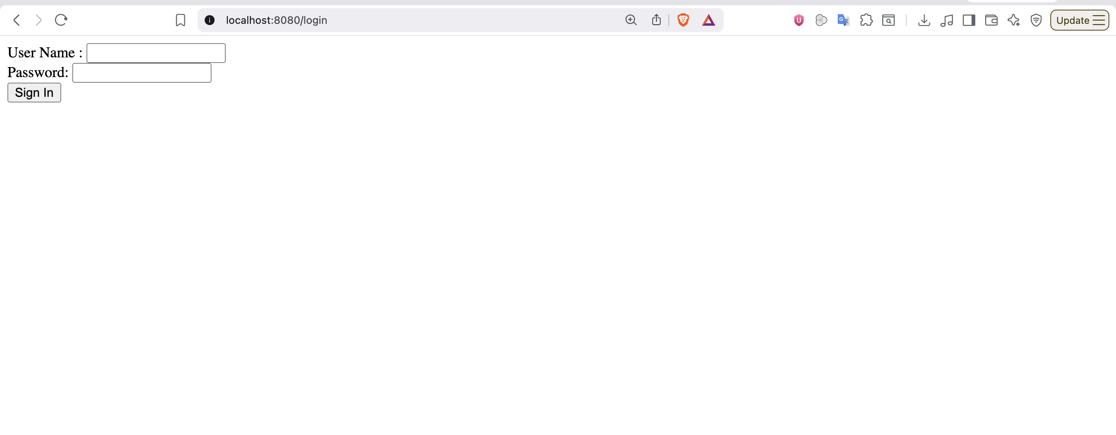

At the login page, sign in as the test user by entering user and password for the username and password fields, respectively. It navigate to hello page.
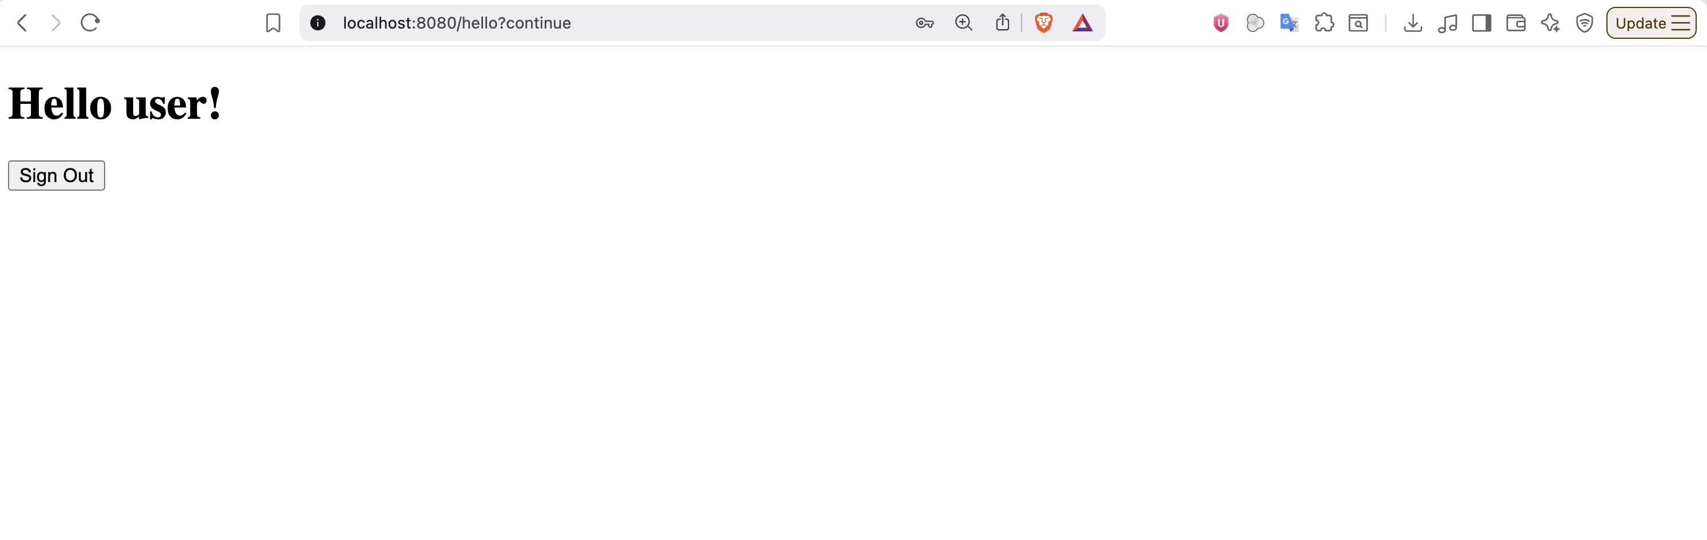

And when clicking Sign out button, it will show a message.
