Course: Advanced Java Programming
Class: 251_72ITDS30103_01
Lecturer: Nguyen Tri Hai, Ph.D.
Student: Duong Chi Thien – 2374802010468

Lab 7:
Github:
Objective
You will build a RESTful API using Spring Boot and Java that allows full CRUD (Create, Read, Update, Delete) operations on a simple domain entity.
Tasks
Complete the following tutorial: https://hevodata.com/learn/spring-boot-rest-api/
Result:
I don’t use MySQL Driver because I don’t download the MySQL but I have SQL server so on the dependencies name MS SQL Server Driver
After following tutorial:

First, I use the method GET to check data
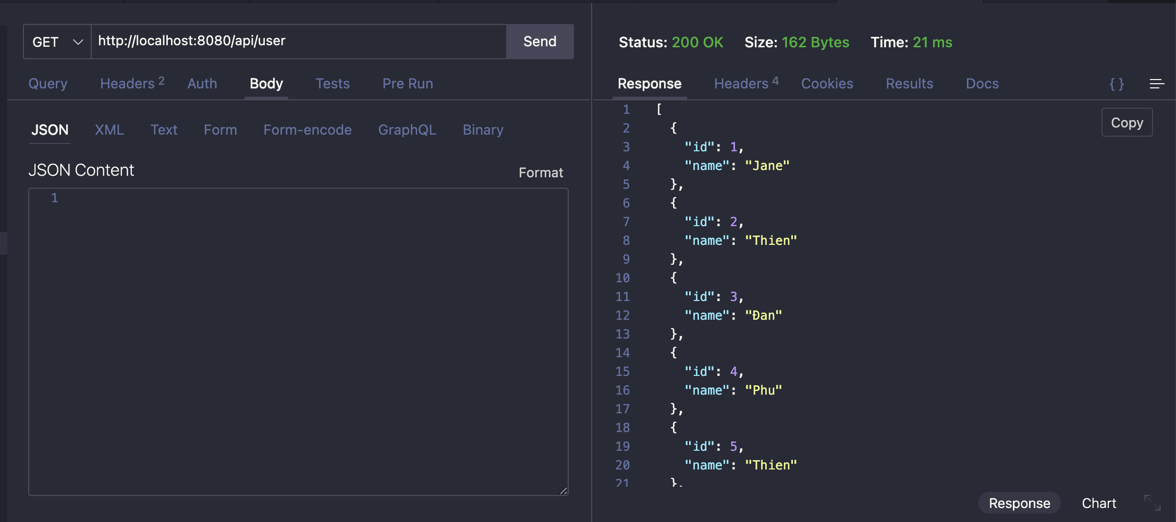

So here in the http://localhost:8080/api/users has data
Now I use the method POST to add another data
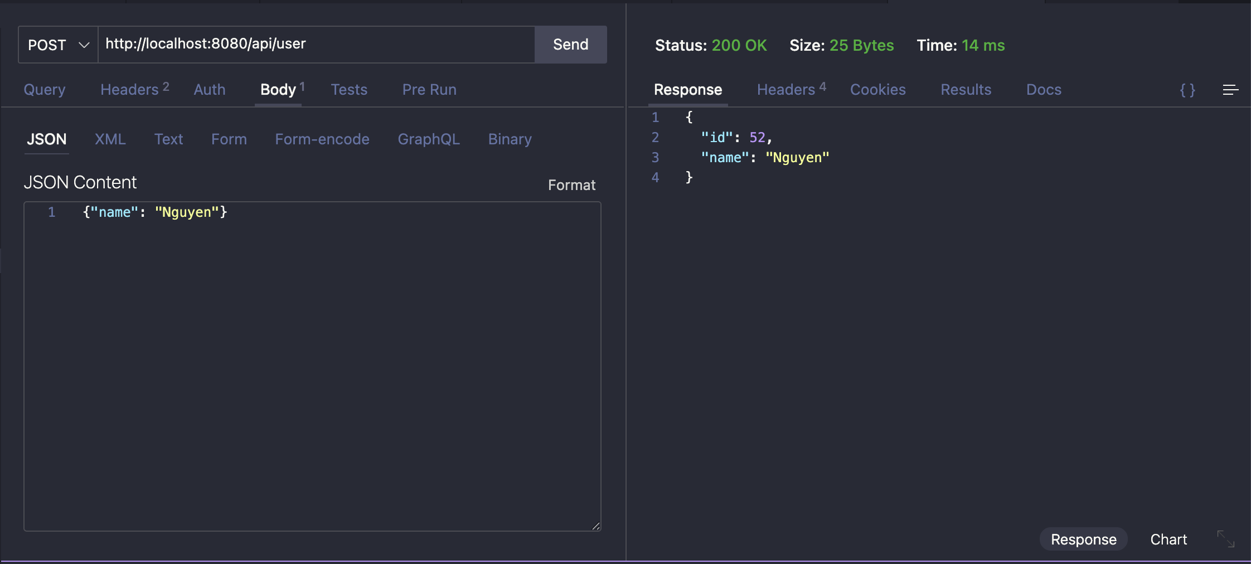

Then I use the method GET again to see all data or view data in User table.
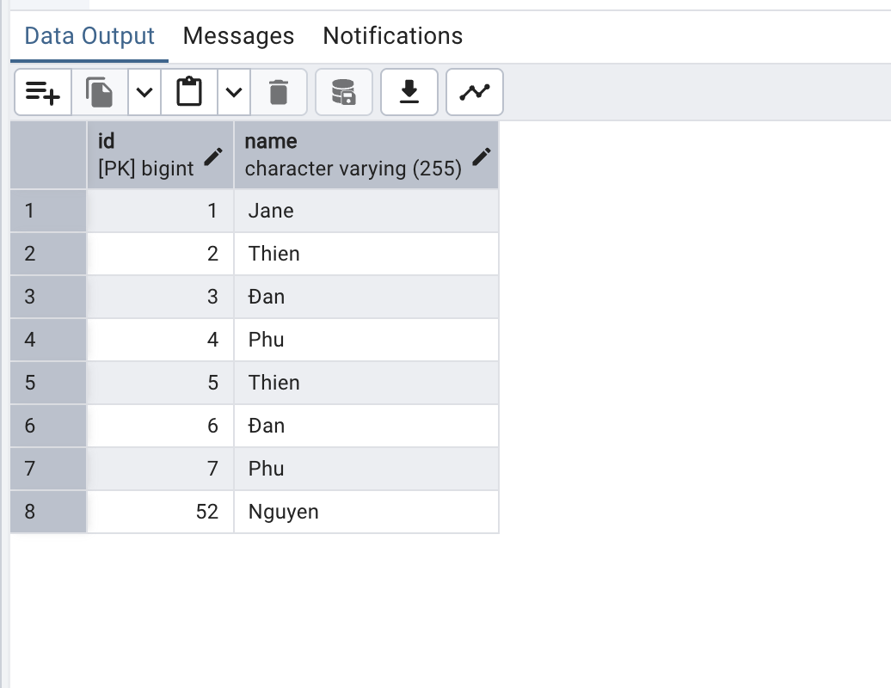

Now I use the method DELETE to delete user id 52
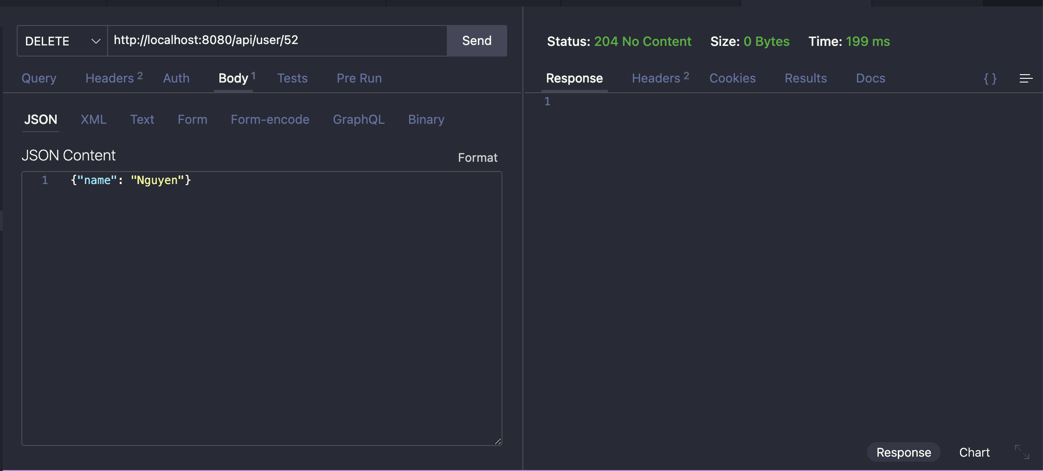

Then I use the method GET again to see id user = 52 and the status is “404 Not Found”

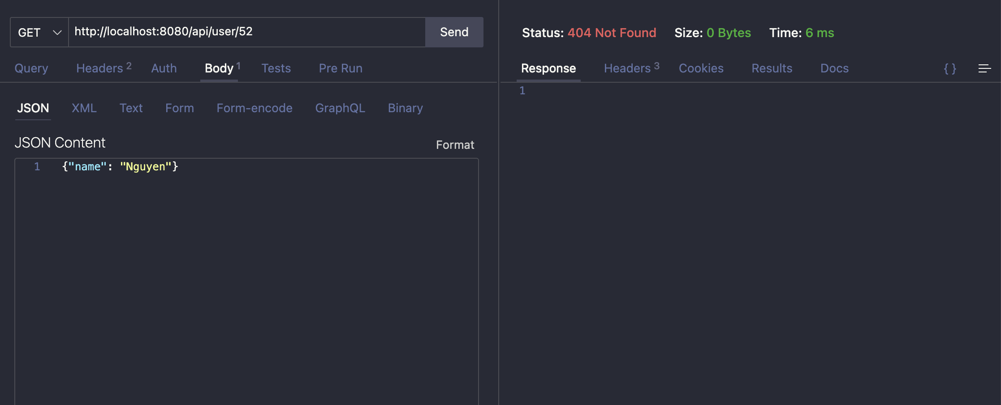
Finally, I use the PUT method to update use Id = 7 has name “Phu” to “Nguyen”

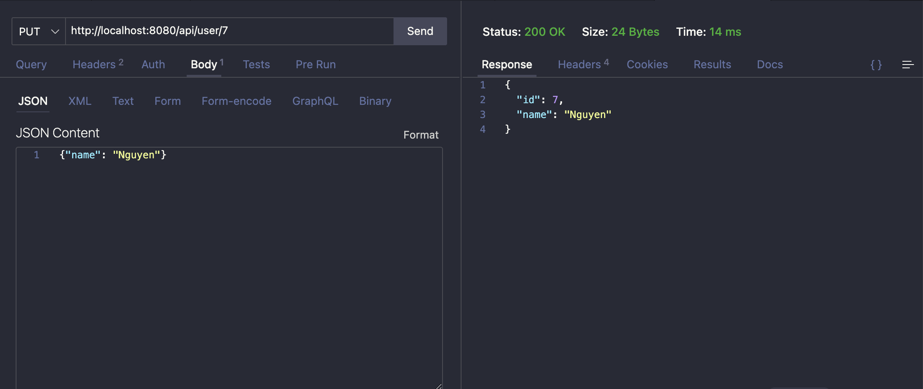
I use GET method to see all data
