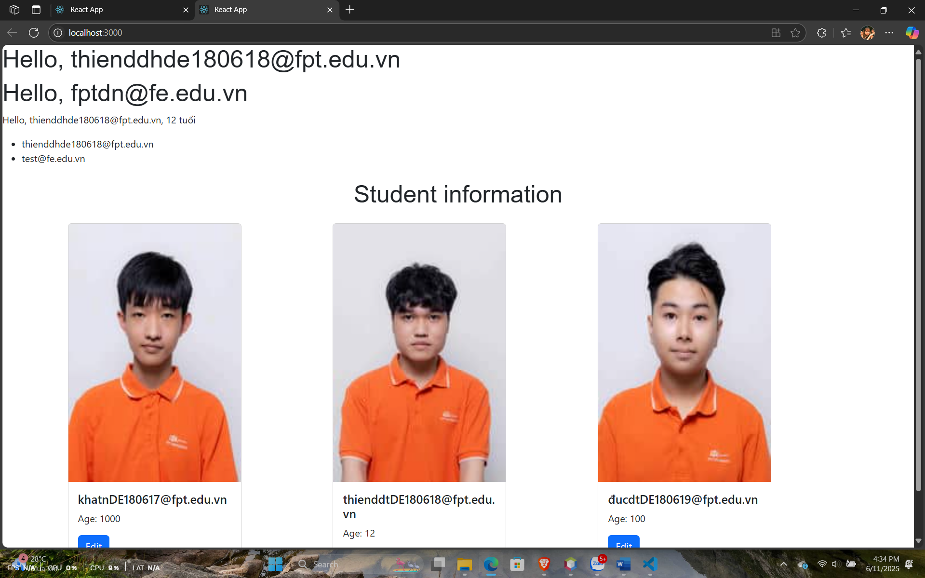

// NameList.js

const NameList = ({ names }) => {

  return (

    <div>

      <ul>

        {names.map((name, index) => (

          <li key={index}>{name}</li>

        ))}

      </ul>

    </div>

  );

};

export default NameList;

import React from "react";

import { Card, Button } from "react-bootstrap";

const StudentCard = ({ student }) => {

  return (

    <Card style={{ width: "18rem" }} className="mb-4">

      <Card.Img

        variant="top"

        src={student.avatar}

        alt={`${student.name}'s avatar`}

      />

      <Card.Body>

        <Card.Title>{student.name}</Card.Title>

        <Card.Text>Age: {student.age}</Card.Text>

        <Button variant="primary">Edit</Button>

      </Card.Body>

    </Card>

  );

};

export default StudentCard;

// UserProfile.js

const UserProfile = ({ user }) => (

  <div>

    <p className="custom-text">

      Hello, {user.name}, {user.age} tuổi

    </p>

  </div>

);

export default UserProfile;

// Welcome.js

const Welcome = ({ name }) => {

  return <h1>Hello, {name}</h1>;

};

export default Welcome;

// App.js

import "./App.css";

import { Container, Row, Col } from "react-bootstrap";

import Welcome from "./components/Welcome";

import UserProfile from "./components/UserProfile";

import NameList from "./components/NameList";

import StudentCard from "./components/StudentCard";

import 'bootstrap/dist/css/bootstrap.min.css';

function App() {

  const userData = { name: "thienddhde180618@fpt.edu.vn", age: 12 };

  const namesList = ["thienddhde180618@fpt.edu.vn", "test@fe.edu.vn"];

  const students = [

    { name: "khatnDE180617@fpt.edu.vn", age: 1000, avatar: "/images/student1.jpg" },

    { name: "thienddtDE180618@fpt.edu.vn", age: 12, avatar: "/images/student2.jpg" },

    { name: "đucdtDE180619@fpt.edu.vn", age: 100, avatar: "/images/student3.jpg" },

  ];

  return (

    <>

      <Welcome name="thienddhde180618@fpt.edu.vn" />

      <Welcome name="fptdn@fe.edu.vn" />

      <UserProfile user={userData} />

      <NameList names={namesList} />

      <Container>

        <h1 className="my-4 text-center">Student information</h1>

        <Row>

          {students.map((student, index) => (

            <Col key={index} sm={12} md={4}>

              <StudentCard student={student} />

            </Col>

          ))}

        </Row>

      </Container>

    </>

  );

}

export default App;