EX01:ASP.NET Core Web Application with Razor
Step 1: Modify the Menu in _Layout.cshtml
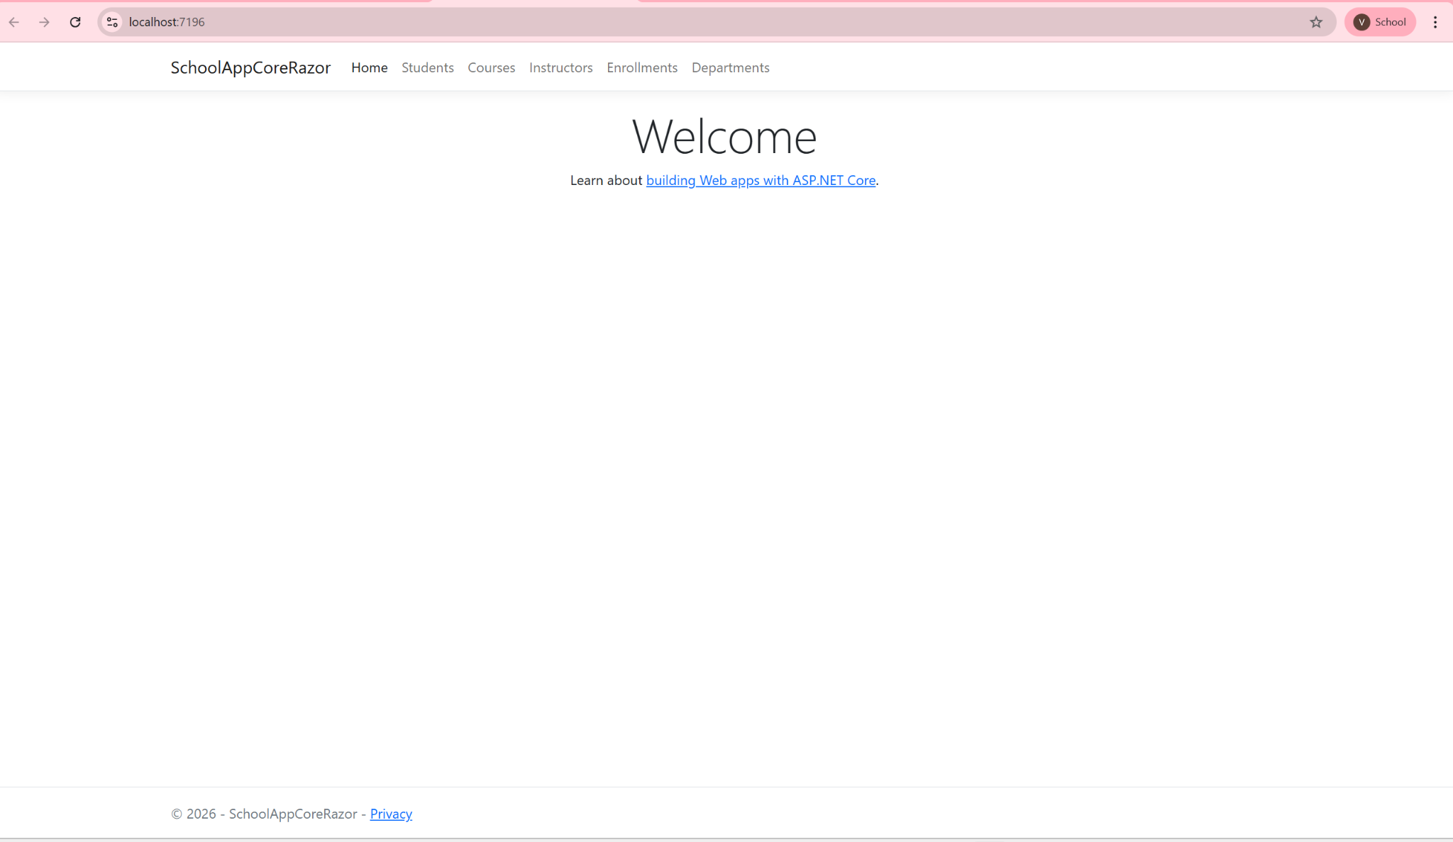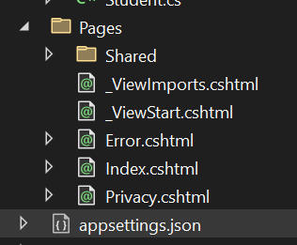

Step 2: Defining the Data Models
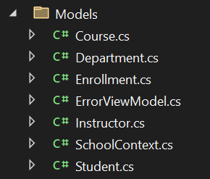

Step 3: Creating the Database
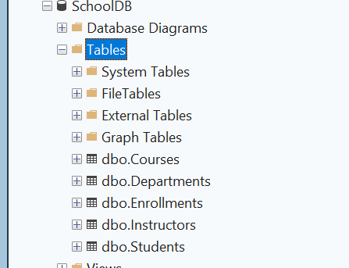

Step 4: Creating the Initial Migration and Updating the Database
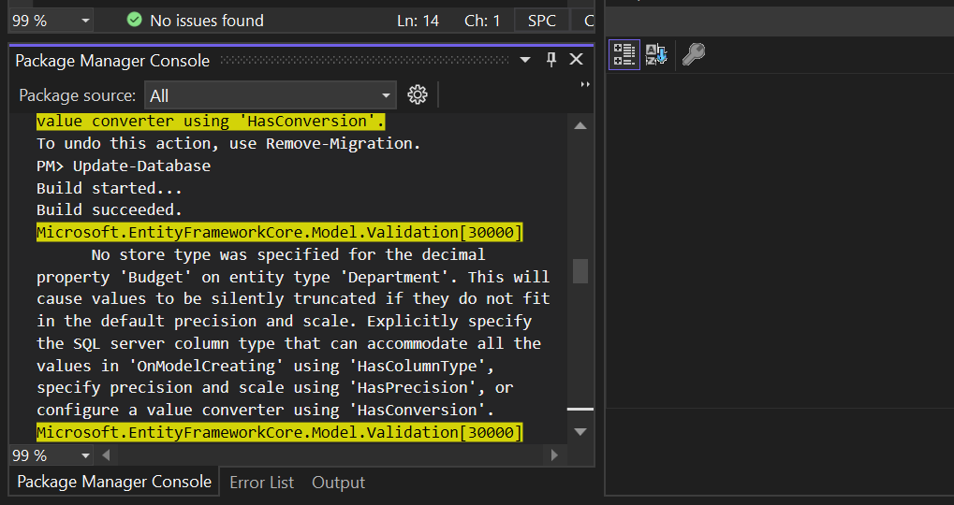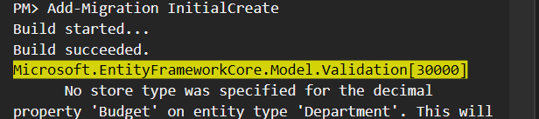

Step 5: Creating Razor Pages
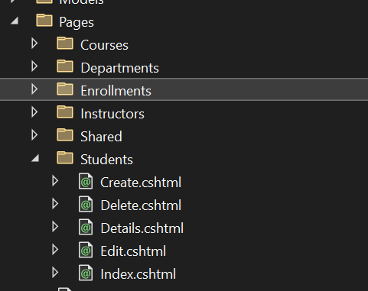
Step 6: Testing the Application
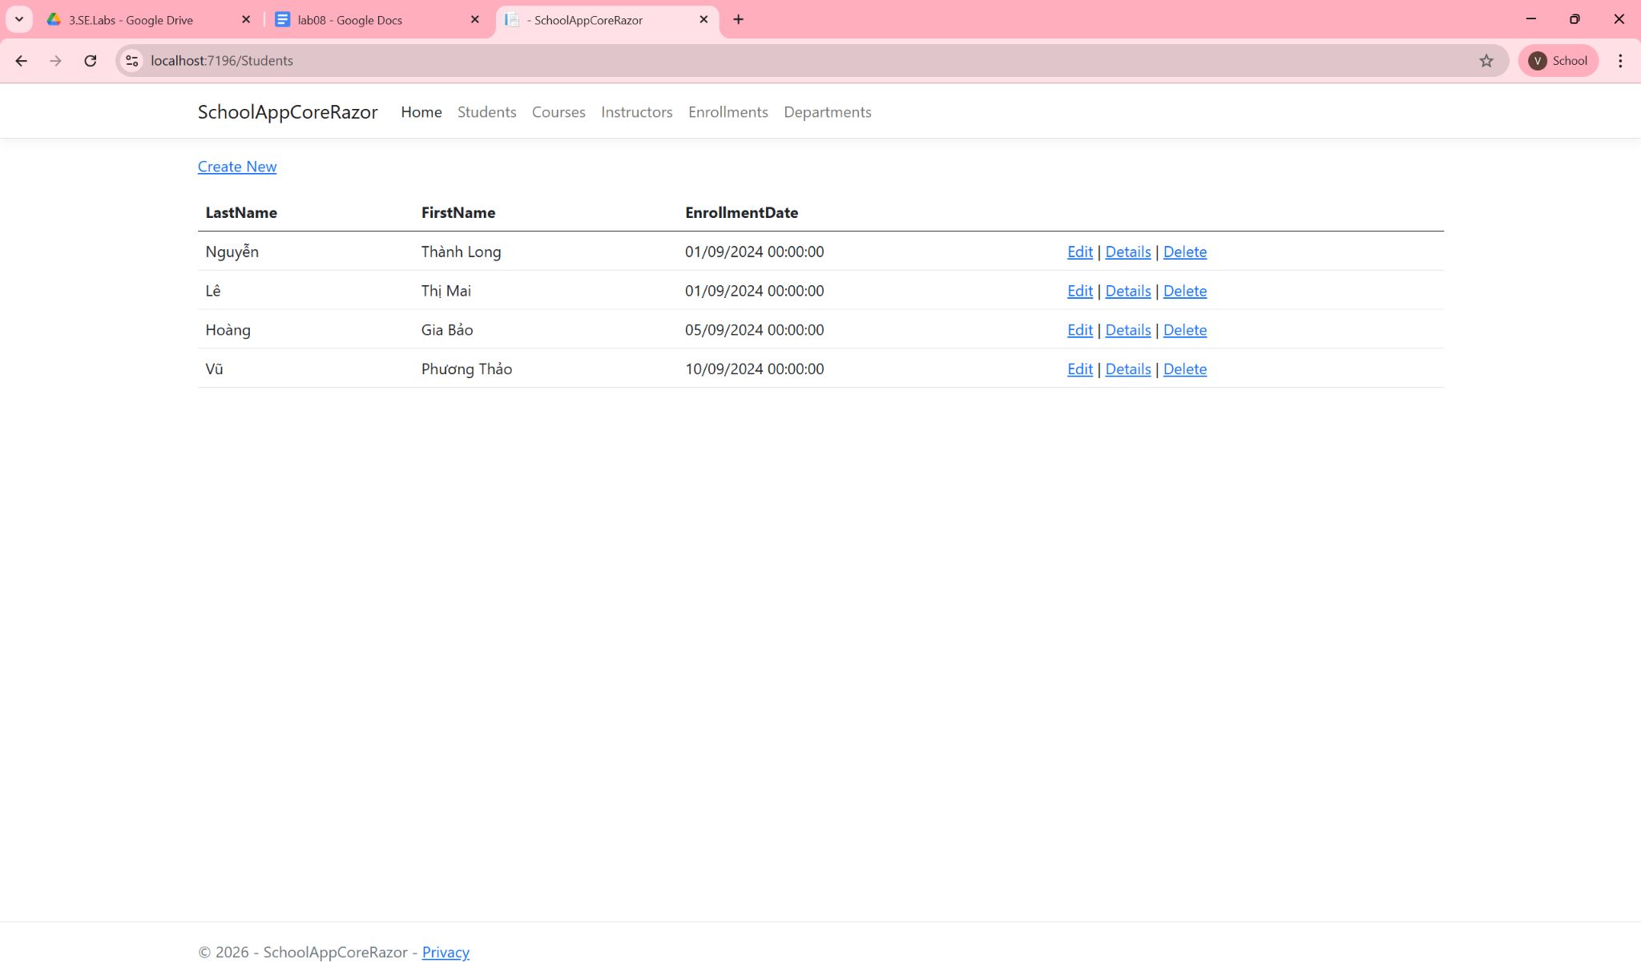
Step 7 : Custom the dropdown in the combo box displays
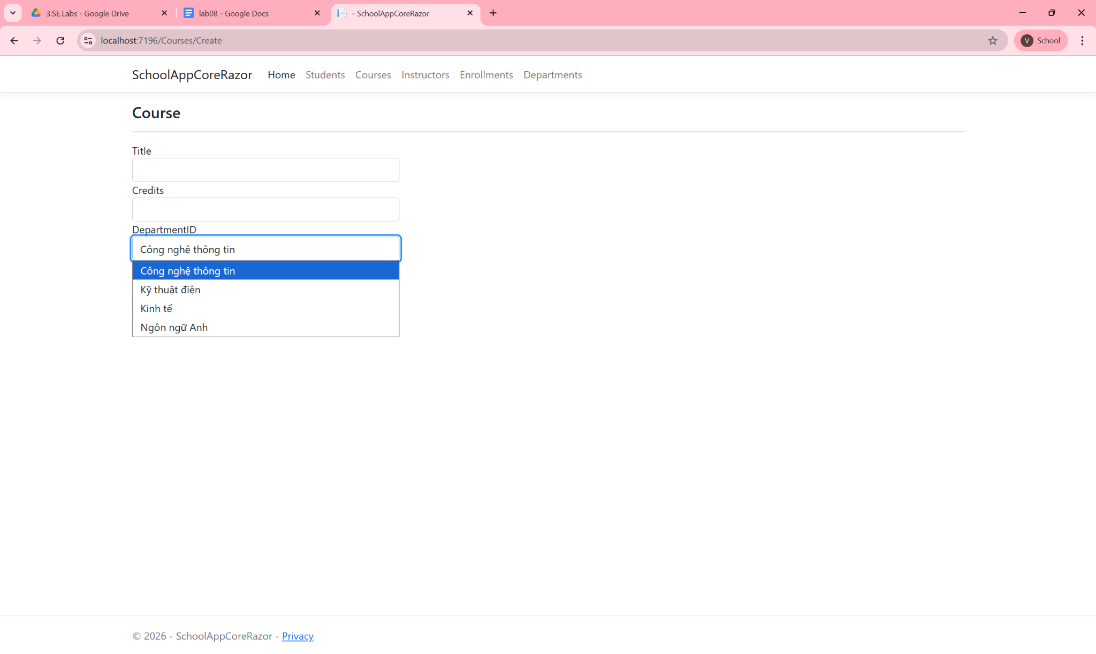

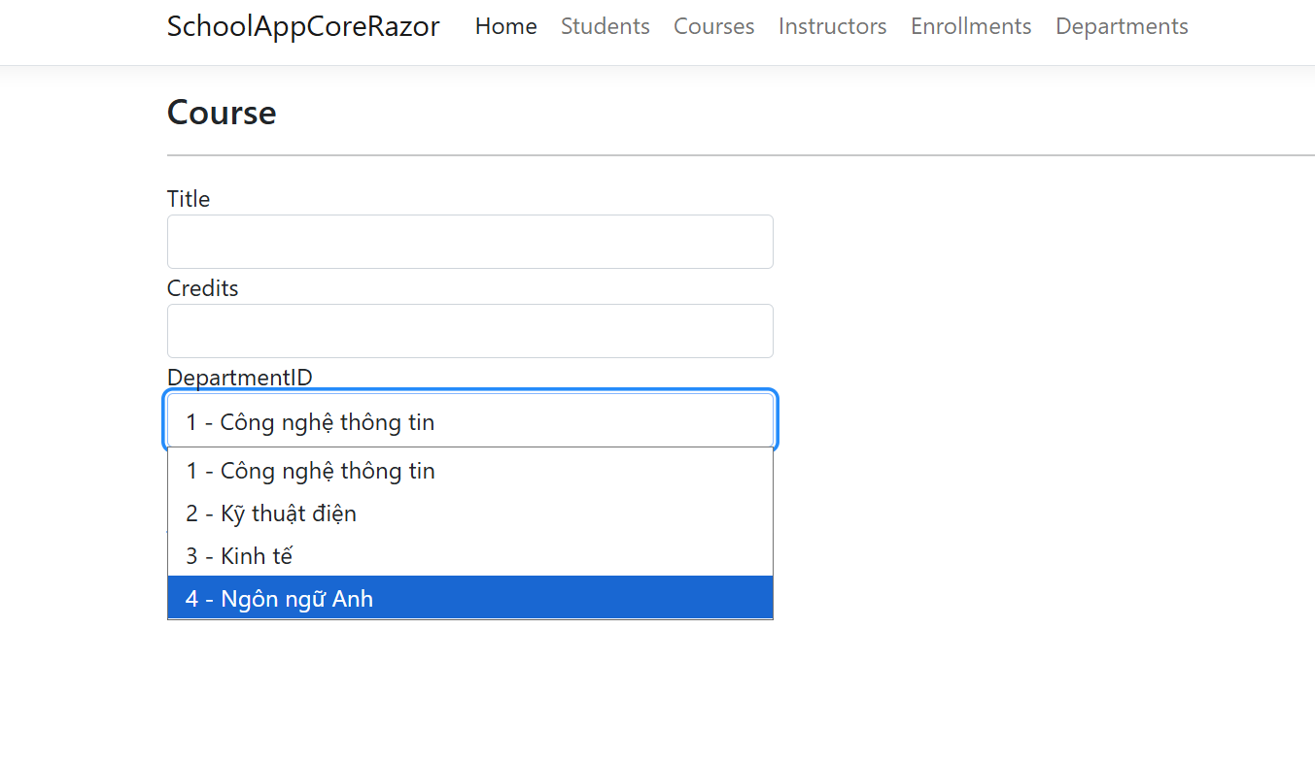
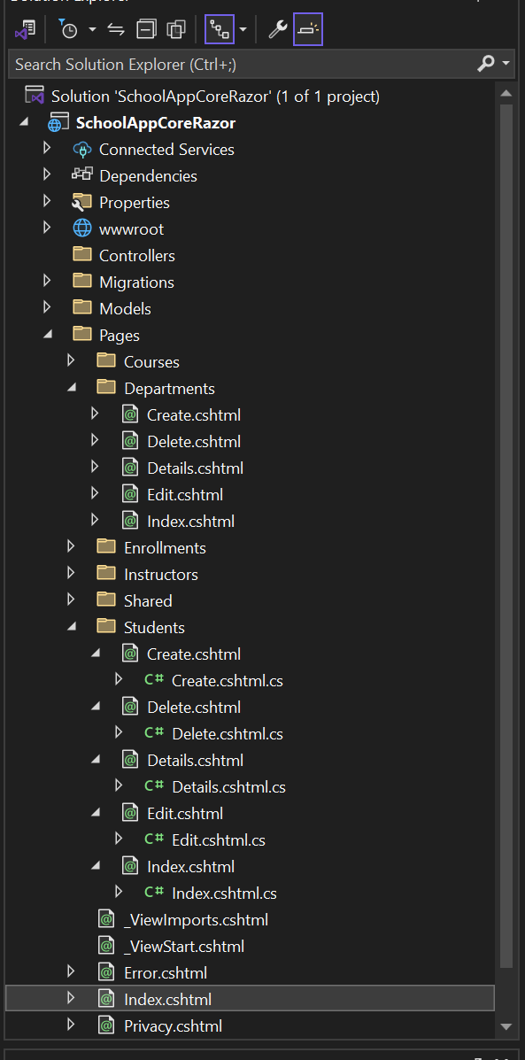
EX02:ASP.NET Core Web Application - MVC
Step 1: Modify the Menu in _Layout.cshtml
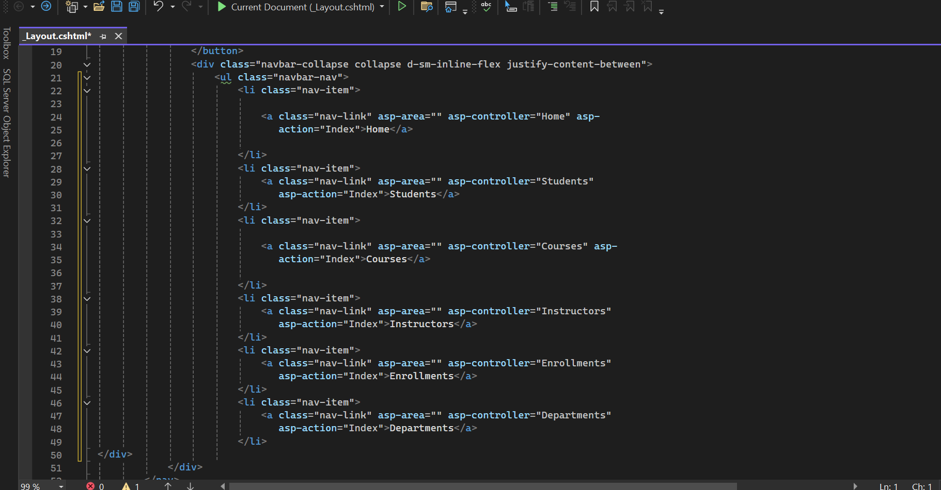
Step 2: Defining the Data Models

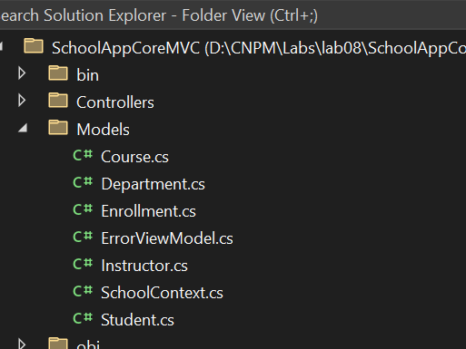
Step 4: Creating the DbContext
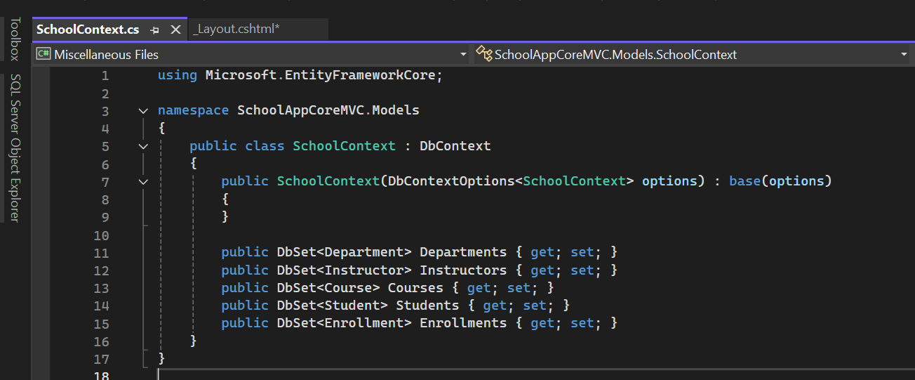

Step 5: Configuring the Database Connection

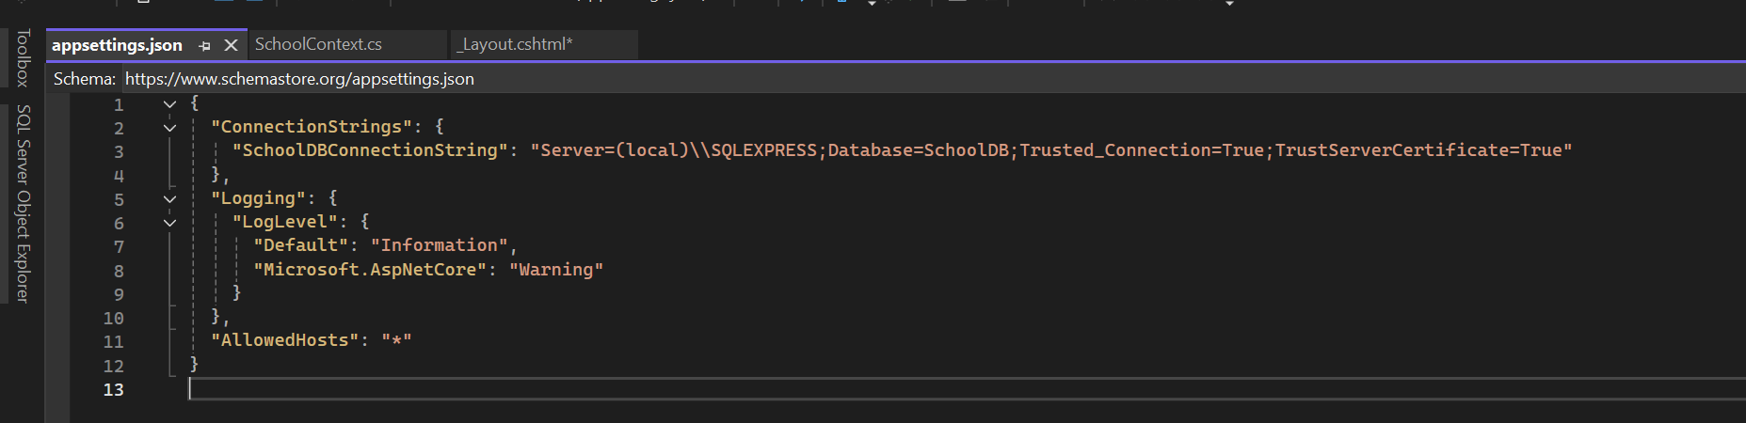
Step 6: Creating the Initial Migration and Updating the Database
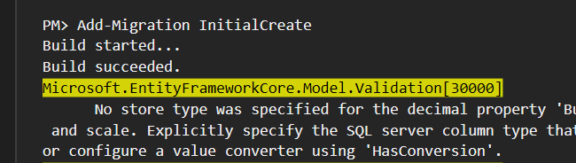
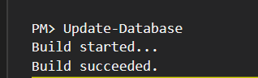
Step 7: Creating Controllers and Views
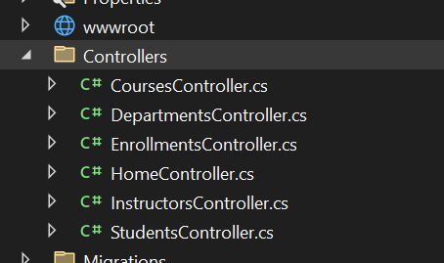

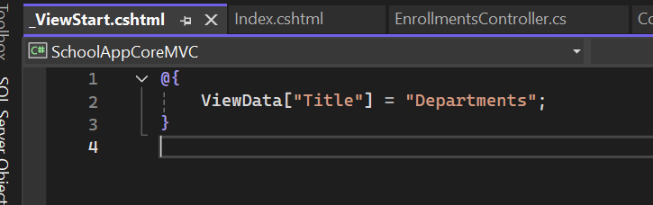

Step 8: Testing the Application
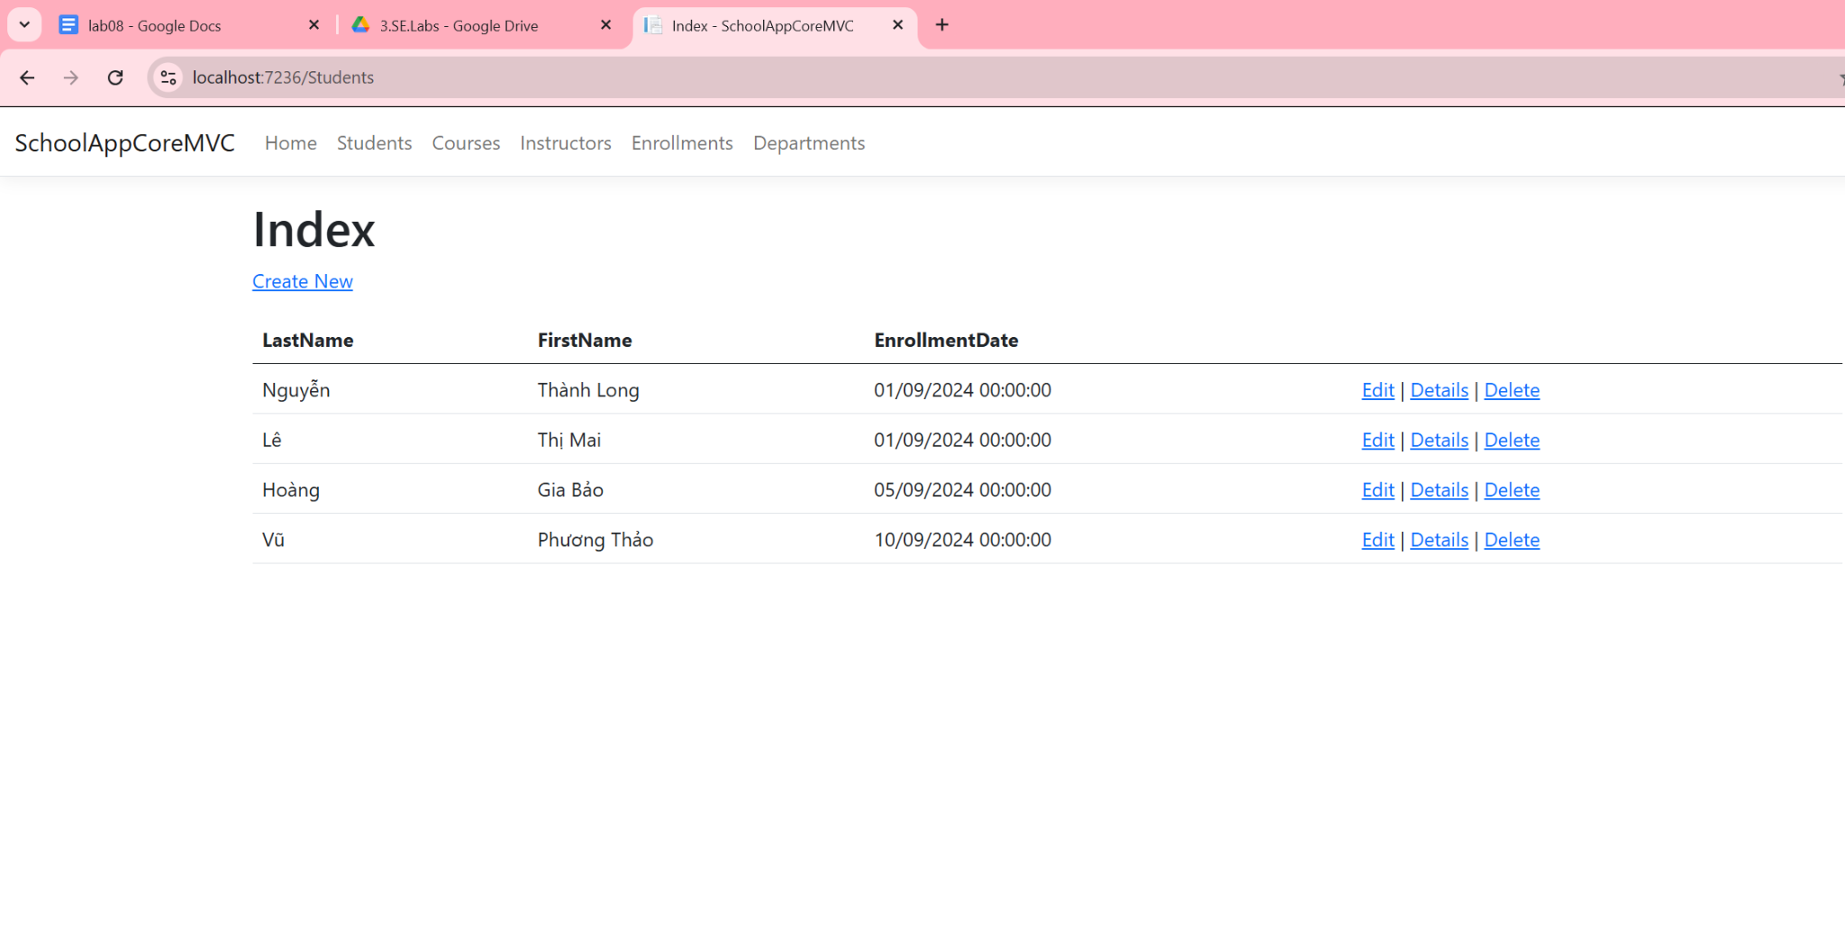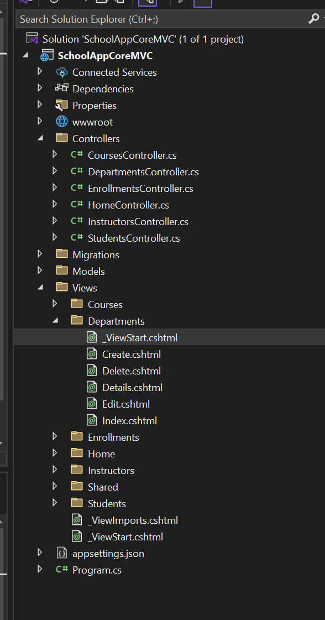
Exercise 3: Upload Projects to GitHub
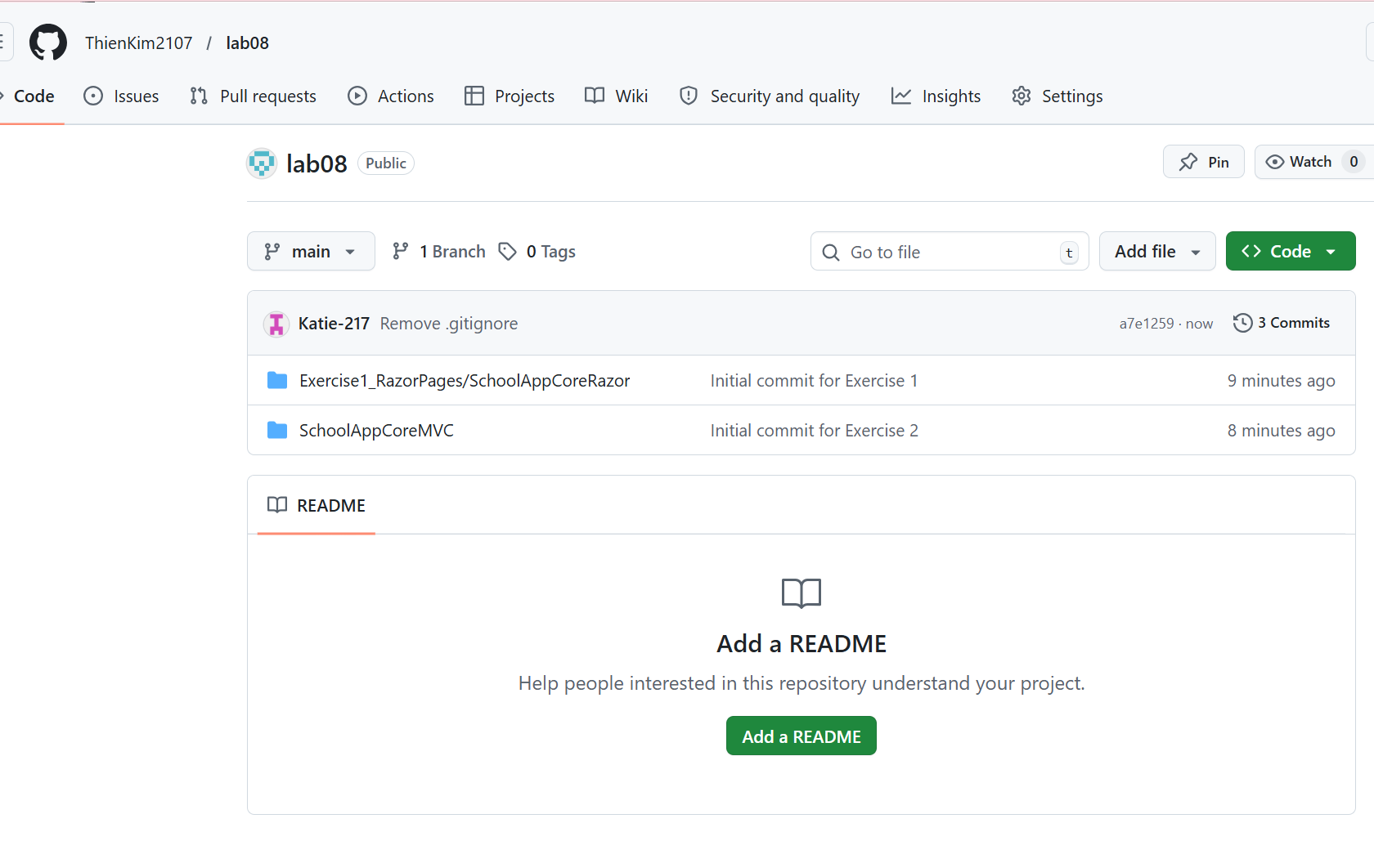
Link: https://github.com/ThienKim2107/lab08

