

**<<BAKERY SHOP>>**

**Software Design Document**

– Da Nang, Oct 2022 –

Table of Contents

I. Software Design Document 2

1. System Design 2

1.1 System Architecture 2

1.2 Package Diagram 3

2. Database design 5

3. Detail design 7

3.1. Class Diagram 7

3.2. Class Specification 7

4 Sequence Diagram 12

4.1 Register 12

4.2 Login 12

4.3 Search 13

4.4 Update Product 13

4.5 Update Post 14

4.6 View Profile 15

4.7 Cancel order 15

4.8 Create an Order 15

4.9 Update an Order 16

4.10 Get a List of Product 17

4.11 Get Product Detail 18

4.12 Add Product 19

4.13 Get Post List 20

4.14 Get Post Detail 21

# I. Software Design Document

## 1. System Design

### 1.1 System Architecture

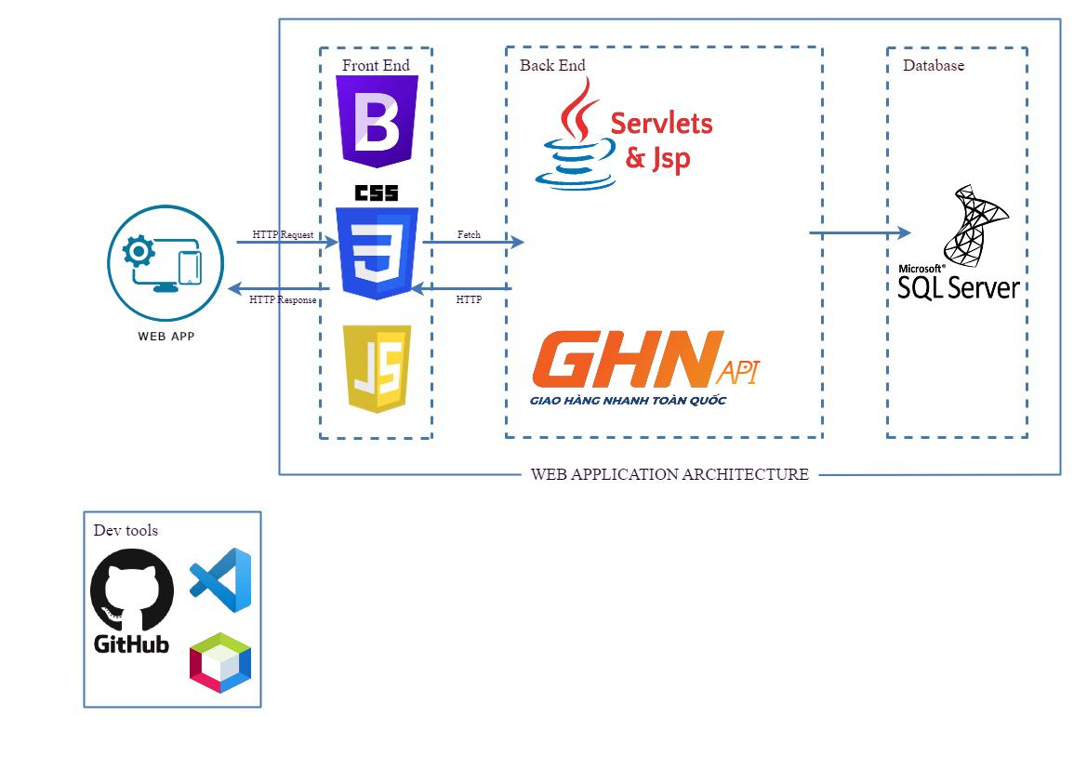

***System architecture component description***

|  |  |  |
| --- | --- | --- |
| No | Component | Description |
| 01 | Web app | This is BakeryShop web app |
| 02 | CSS | This is used to style and layout web pages |
| 03 | Bootstrap | This is CSS framework |
| 04 | Javascript | This is use for form validation and fetching to API |
| 05 | Servlet & JSP | This is used for extending the capabilities of the Web server |
| 06 | GHN API | This is for taking address of Da Nang by fetching |
| 07 | SQL Server | This is used for managing and storing information |
| 08 | Github | This is one of the deploy-enable app which sets a connection to app service deployment. |
| 09 | VSCode | This is for front-end developer |
| 10 | Netbean | This is for hosting tomcat server and compiler of the source |

### 1.2 Package Diagram

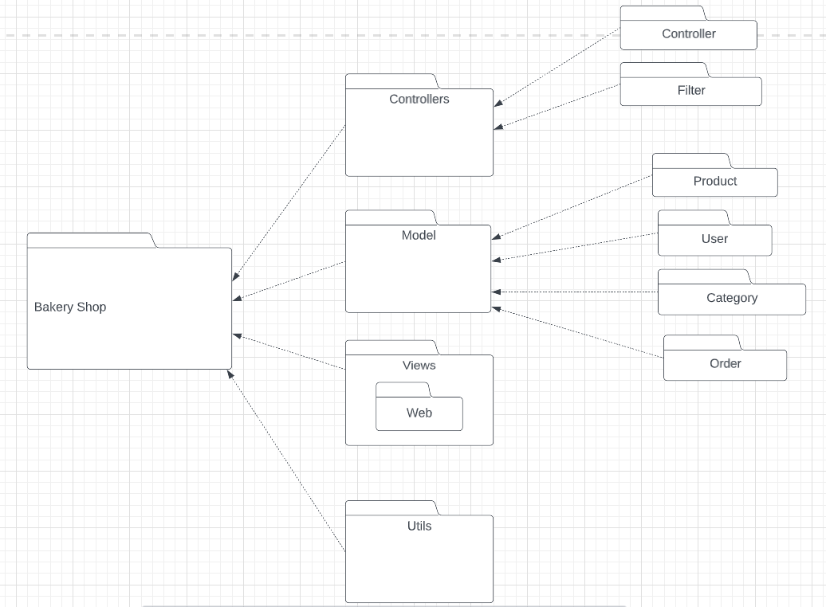

Click [here](https://lucid.app/lucidchart/3d5a0d8d-e2a2-4900-863f-10bc12f8762a/edit?viewport_loc=-388%2C-40%2C2384%2C1090%2C0_0&invitationId=inv_01d9c068-38d9-4aa8-8fd6-ffdc152f6c67) to view full diagram.

***Package descriptions***

|  |  |  |
| --- | --- | --- |
| Number | Package | Description |
| 1 | Controllers | This package contains all controllers for this MVC2 project and authentication or dispatcher filters  Servlet Naming convention: Naming with camelCase and starting with a verb. |
| 2 | Views | This package contains all views (HTML,CSS,JS,JSP file) for this project  HTML/CSS/JS/JSP file naming convention: first letter is a lowercase letter, using camelCase naming |
| 3 | Model | This package contains all products , users class for this project.  Naming convention: first letter is a lowercase letter, the name is using camelCase naming  This package .java files which allow developers to skip writing DAOs for their persistence objects when they usingJDBC. |
| 4 | Utils | (Utils) This package contains DBcontext.java file which is a bridge connection between database and programming. |

## 2. Database design

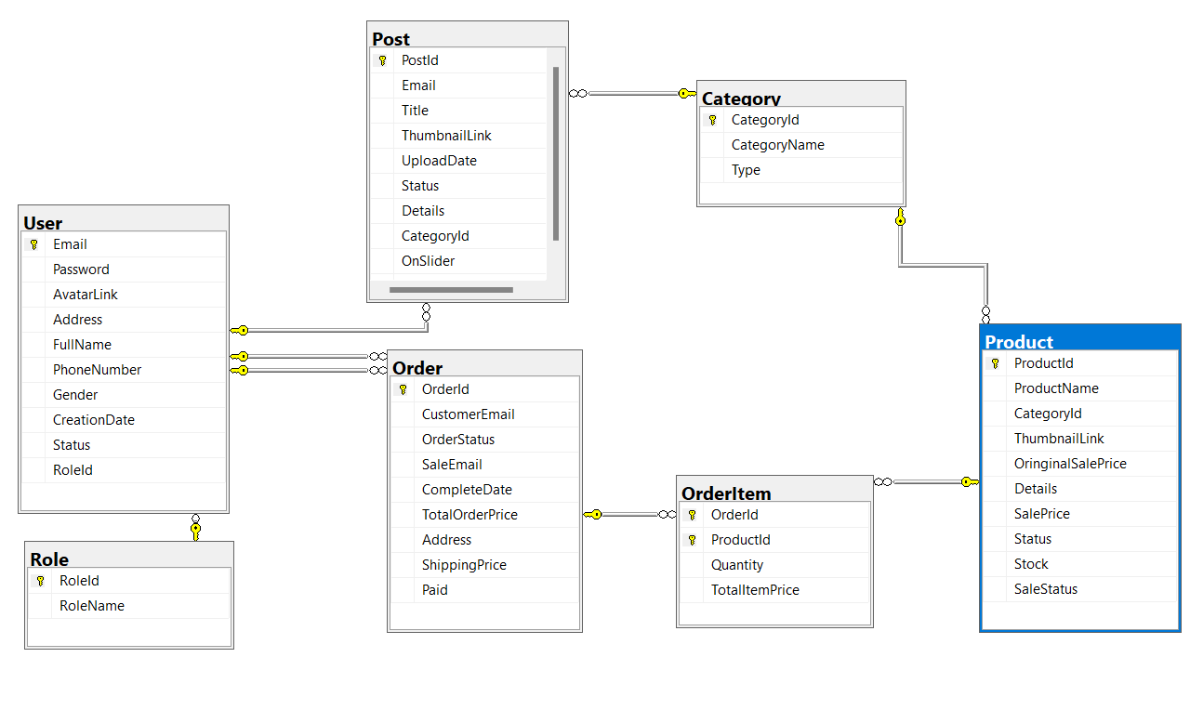

***Table descriptions***

|  |  |  |
| --- | --- | --- |
| **No** | **Table** | **Description** |
| 01 | User | Email: The User’s Email  Password: The User’s account password  AvatarLink: Link to this account’s Avatar  Address: The Customer’s Address  FullName: The Customer’s Full name  PhoneNumber: The Customer’s Phone number  Gender: The Customer’s Gender  CreationDate: Date when this account’s created  Status: The User Account’s status  RoleId: Id of the User’s role  - Primary keys: Email  - Foreign keys: RoleId |
| 02 | Role | RoleId: Role’s Id  Name: Role’s Name  - Primary keys: RoleId |
| 03 | Post | PostId: Post’s Id  Email: Email of the Post’s author  Title: Post’s title  Thumbnail Link: Link to the Post’s Thumbnail  Date: Date when Post is first created.  Status: Post’s status  Detail: Content of the Post  CategoryID: ID of the Post’s Category  UpdateDate: Date of the most recent time Post is updated  - Primary keys: PostId  - Foreign keys: Email, CategoryID |
| 04 | Category | CategoryId: Category’s Id  Name: Category’s Name  Type: Category’s Type  - Primary keys: CategoryId |
| 05 | Product | ProductId: Product’s Id  Name: Product’s Name  CategoryId: Id of the Product’s Category  Thumbnail Link: Link to the Product’s Thumbnail  OriginalSalePrice: The Product’s original price  Details: Product’s information  SalePrice: The Product’s price after apply Sale  Status: Product’s Status  Sale Status: Product is on Sale or not  Stock: The amount of Product still in Stock.  - Primary keys: ProductId  - Foreign keys: CategoryID |
| 06 | Order | OrderId: Order’s Id  Date: Date when Order is created  CustomerEmail: The customer of this Order’s Email  Status: Order’s Status  SaleEmail: Email of Sale in charge of this Order  CompleteDate: Date when Order is completed.  TotalOrderPrice: Price of the Order  Address: Order’s shipping address.  - Primary keys: OrderId  - Foreign keys: CustomerEmail, SaleEmail |
| 07 | OrderItem | OrderItemId: Id of the Order this item belongs to  ProductId: This item’s Id  Quantity: This item’s quantity  TotalOrderItemPrice: Total Price of the Order Item.  - Primary keys: OrderItemId |

## 3. Detail design

### 3.1. Class Diagram

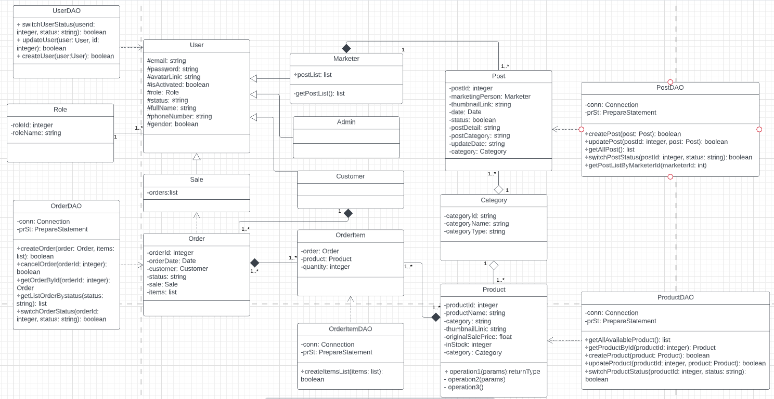

Click [here](https://lucid.app/lucidchart/7ce26ae8-d0e6-4265-a535-65ecc4545932/edit?viewport_loc=-625%2C260%2C2987%2C1366%2C0_0&invitationId=inv_c2e26259-7f13-4b96-8539-86bfe5c3d5e5) to view full diagram

### 3.2. Class Specification

#### 3.2.1 UserDAO

|  |  |  |
| --- | --- | --- |
| **No** | **Method** | **Description** |
| *01* | *switchUserStatus* | *- Input: user Id (integer) , status (String)*  *- Output: User corresponding to user Id will have his/her current status switched to given status*  *- Description: This method  execute query to update a user’s status* |
| *02* | *createUser* | *- Input: user (User instance)*  *- Output: A boolean value determines if a new user is inserted into User table in the database successfully*  *- Description: This method execute query to insert a new user to database* |
| *03* | *updateUser* | *- Input: user (User instance) , id (integer)*  *- Output: A boolean value determines if an existing user is modified successfully*  *- Description: This method execute query to update information of a user having id equal to given id parameter* |

#### 3.2.2 PostDAO

|  |  |  |
| --- | --- | --- |
| **No** | **Method** | **Description** |
| *01* | *createPost* | *- Input: post (Post instance)*  *- Output: a boolean value determine if a post is created successfully*  *- Description: This method execute query to create a new post in the database* |
| *02* | *updatePost* | *- Input: post (Post instance), id (integer)*  *- Output: A boolean value determine if a post associated with the parameter id is updated*  *- Description: This method execute query to update a post having corresponding id* |
| *03* | *getAllPost* | *- Input: None*  *- Output: A list containing all post in the database*  *- Description: This method execute query to get all post exist in the database, store those on the list the return* |

#### 3.2.3 OrderDAO

|  |  |  |
| --- | --- | --- |
| **No** | **Method** | **Description** |
| *01* | *createOrder* | *- Input: customer (Customer instance) , items (list of OrderItem instance)*  *- Output: A boolean value determine if an order is created successfully*  *- Description: This method execute query to insert an order as well as the list of order items corresponding to that order into database* |
| *02* | *cancelOrder* | *- Input: order id (integer)*  *- Output: A boolean value determine if an order is removed from the database*  *- Description: This method execute query to remove an order having similar id from database* |
| *03* | *getOrderById* | *- Input: order id (integer)*  *- Output: An order having similar order id*  *- Description: This method execute query to get an order with corresponding id* |
| *04* | *getListOrderByStatus* | *- Input: status (string)*  *- Output: An order list having similar status*  *- Description: This method execute query to get any order having given status, store as an array then return* |
| *05* | *getAllOrders* | *- Input: None*  *- Output: A list containing all orders  stored in the database*  *- Description: This method execute query to get all existing orders in the database, store as an array then return* |
| *06* | *switchOrderStatus* | *- Input: orderId(integer), status (string)*  *- Output: A boolean value determine if an order’s status is modified successfully*  *- Description: This method execute query to replace the current status of an order having the same id as the orderId parameter by a new status* |

#### 3.2.4 ProductDAO

|  |  |  |
| --- | --- | --- |
| **No** | **Method** | **Description** |
| *01* | *getAvailableProducts* | *- Input: none*  *- Output: The list of available products*  *- Description: This method execute query to get a list of available product, which exist in the database and have positive number for quantity* |
| *02* | *getProductById* | *- Input: productId (integer)*  *- Output: A product object having similar id*  *- Description: This method execute query to get a product according to the id parameter from the database, then return to client* |
| *03* | *createProduct* | *- Input: product (Product instance)*  *- Output: a boolean value determine if a product is created successfully*  *- Description: This method execute query to create a new product in the database* |
| *04* | *updateProduct* | *- Input: product(Product instance), id (integer)*  *- Output: A boolean value determine if a product associated with the parameter id is updated*  *- Description: This method execute query to update a product having corresponding id* |
| *05* | *switchProductStatus* | *- Input: id (integer) , status (string)*  *- Output: A particular product’s status is modified*  *- Description: This method execute query to replace a product’s current status by a new status* |

#### 3.2.5 OrderItemDAO

|  |  |  |
| --- | --- | --- |
| ***No*** | ***Method*** | ***Description*** |
| *01* | *createItemsList* | *-Input: List of OrderItem Instance*  *- Output: A boolean value indicate that creation is successful*  *- This method execute query to create a list of order items in the database* |

## 4 Sequence Diagram

### 4.1 Register

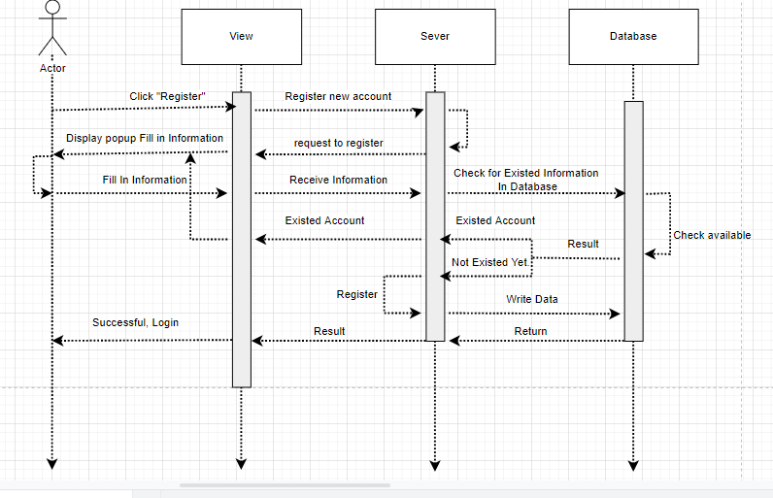

### 4.2 Login

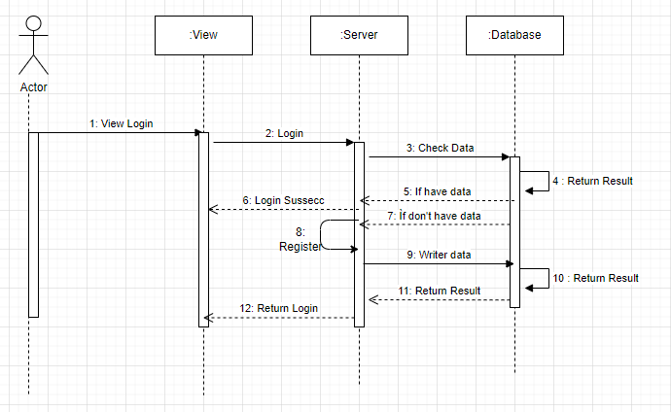

### 4.3 Search

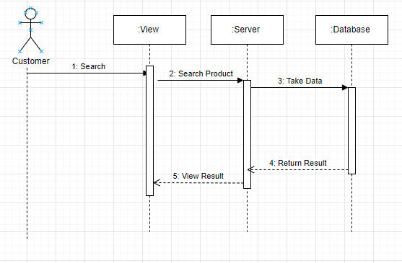

### 4.4 Update Product

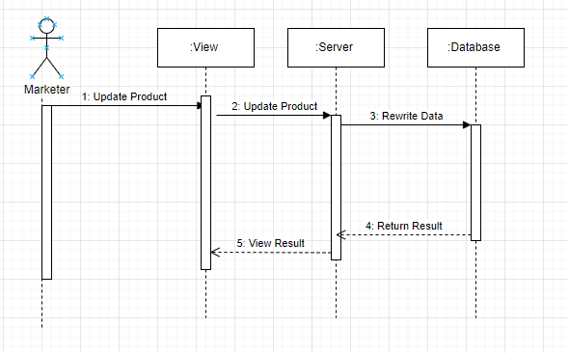

### 4.5 Update Post

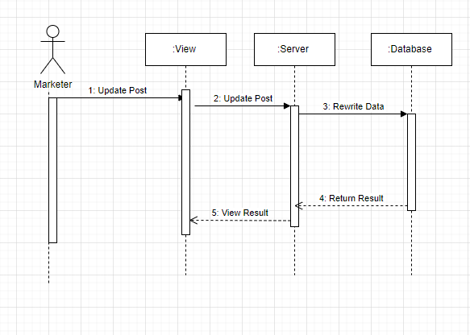

### 4.6 View Profile

### 4.7 Cancel order

### 4.8 Create an Order

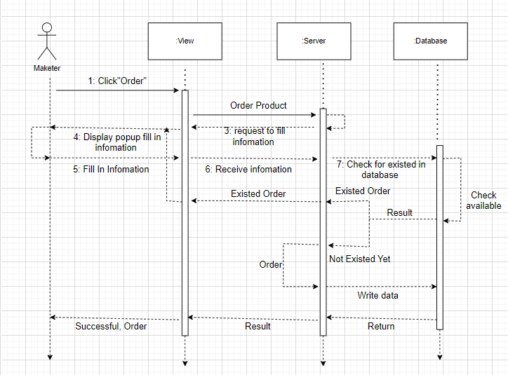

### 4.9 Update an Order

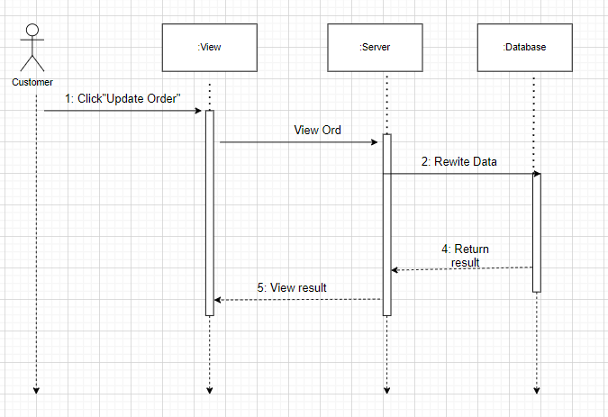

### 4.10 Get a List of Product

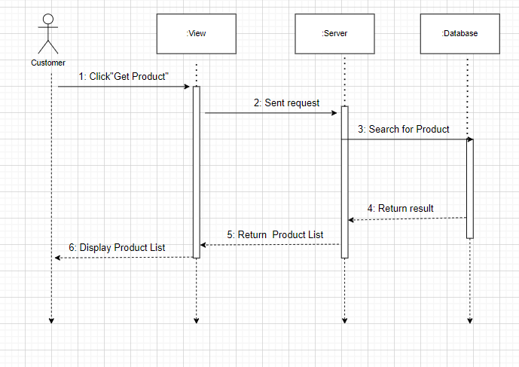

### 4.11 Get Product Detail

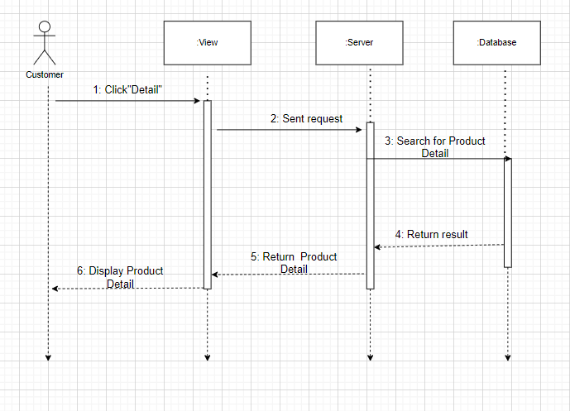

### 4.12 Add Product

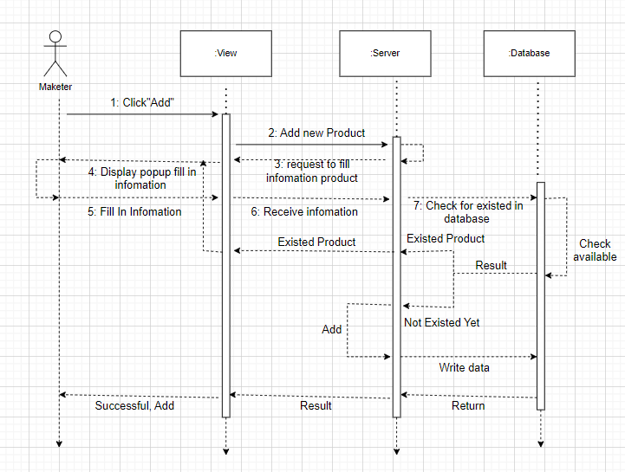

### 4.13 Get Post List

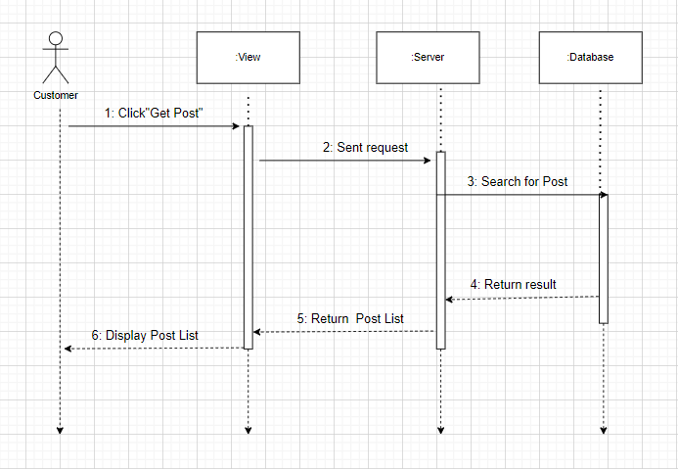

### 4.14 Get Post Detail

