

**<<BAKERY SHOP>>**

**Software Requirement Specification**

– Da Nang, September 2022 –

Table of Contents

1.Overview 2

1.1 Introduction 2

1.2. User Requirements: 3

*1.2.1 Actors: 3*

*1.2.2 Use cases: 3*

2. Functional requirements 8

2.1 System functional overview 8

*2.1.1. Screen Flow 8*

*2.1.2 Screen Detail 8*

*2.1.3 Authorization Table 11*

*2.1.4 Non-screen functions 15*

*2.1.5 Common Requirement 15*

2.2. Common Features 15

*2.2.1. Login 15*

*2.2.2. Register an account 17*

*2.2.3. Logout 18*

*2.2.4 Update user’s profile 20*

*2.2.5 Change password 21*

2.3 Guest Features 23

*2.3.1. Get a list of available products 23*

*2.3.2. Get a product’s detail* *28*

2.4. Customer Features 29

*2.4.1. Create a new order 29*

*2.4.2. Cancel an order 31*

*2.4.3. Get a list of User’s orders 33*

*2.4.4. Get an order’s detail 34*

2.5. Marketing Features 36

*2.5.1. Add a new product 36*

*2.5.2. Update a product 38*

*2.5.3. Add a new post 39*

*2.5.4. Update a post 41*

*2.5.5. Get a list of Sliders 43*

*2.5.6. Add new post to slider 44*

*2.5.7. Remove post from slider 46*

*2.5.8. Get a list of Customer accounts 47*

*2.5.9. Get a Customer details 49*

*2.5.10. Get Marketing statistic 50*

2.6. Sale Feature 52

*2.6.1. Get a list of all orders 52*

*2.6.2. Get an order’s detail 53*

*2.6.3. Change status of an assigned order 55*

*2.6.4. View Sale statistic 56*

2.7. Admin’s Account management 58

*2.7.1. Add new account 58*

*2.7.2. Get a list of all user account 60*

*2.7.3. Get a User account’s detail 61*

*2.7.4. Activate/Deactivate a user account 63*

*2.7.5. View Admin statistic 65*

3. Non-Functional requirements 67

*3.1 External Interfaces 67*

*3.2 Quality Attributes 67*

4. Requirement appendix: 68

# 1.Overview

## 1.1 Introduction

Nowadays, the Internet is playing an important role in our society, together with the Internet-connected devices. As a matter of fact,the Online Market has grown remarkably in recent years, the number of Brands started to sell on the Internet has grown remarkably. Despite that the internet is virtual, it helps a lot of brands to mark up the market share and helps the customer to approach the product much easier instead of going to the retail office.

Our project is developed for an online shopping system - web which supports a shop or a chain of stores to manage, market and sell merchandise on the Internet. In our supposed system, there are 6 authenticated types of user:

a. Guest: Unregistered Users.

b. Customer: Registered Users, who can be actual customers or can be potential customers.

c. Marketing: Marketing Staff who are in the Marketing Department.

d. Sale: Sale members who are in the Sales Department.

e. Admin: the manager who acts as the administrator and monitoring the whole system.

f. Web owner: The shop owner who can view Bakery Shop’s statistic and charts

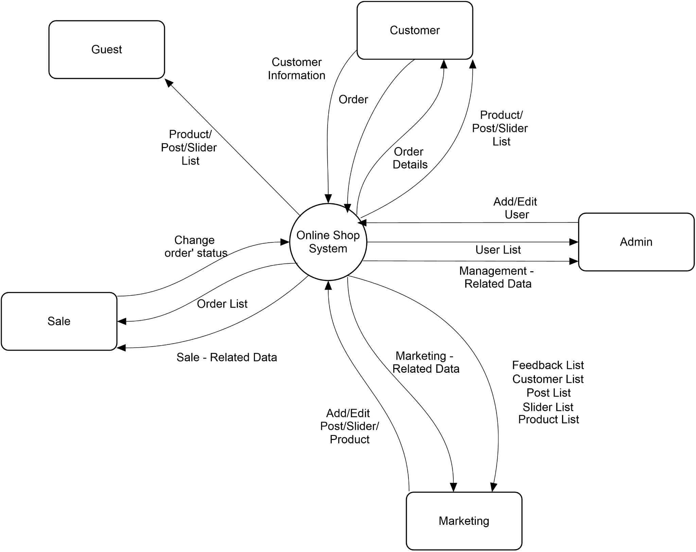

## 

## 1.2. User Requirements:

### 1.2.1 Actors:

| # | Actor | Description |
| --- | --- | --- |
| 1 | Guest | Unregistered users who can only use basic function for guest |
| 2 | Customer | Registered users, who can be actual customers or can be potential customers |
| 3 | Marketer | Marketing staff who are in the Marketing Department and responsible for product, slider, post related data |
| 4 | Sale | Sale members who are in the Sales Department and responsible for managing order |
| 5 | Admin | The user who acts as the administrator and monitoring the whole system |
| 6 | Web owner | The shop owner who can view Bakery Shop’s statistic and charts |

### 1.2.2 Use cases:

#### 1.2.2.1 Diagrams:

### 

#### 1.2.2.2 Sale:

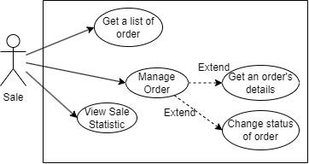

#### 1.2.2.3 Admin:

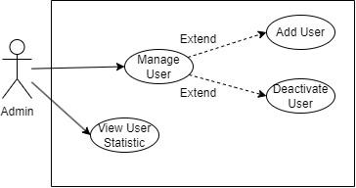

#### 1.2.2.4 Marketer

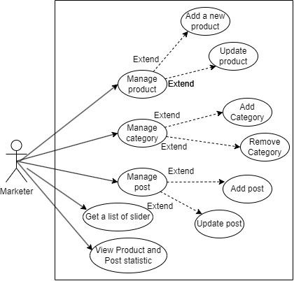

#### 1.2.2.5 Web-Owner:

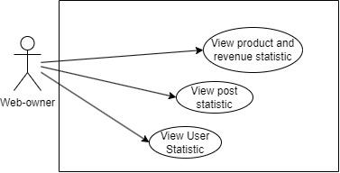

#### 1.2.2.6 Descriptions

| **ID** | **Use Case** | **Actors** | **Use Case Description** |
| --- | --- | --- | --- |
| UC-1 | Login | Guest, Customer, Sale, Marketer, Admin | When actors want to login into the system. |
| UC-2 | Register | Guest | When actors want to Register new account. |
| UC-3 | Logout | Guest, Customer, Sale, Marketer, Admin | When actors want to logout of system |
| UC-4 | Update user information | Customer, Sale, Marketer, Admin | When the user request to update their profile |
| UC-5 | Change password | Customer, Sale, Marketer, Admin | When the user requests to change their password. |
| UC-6 | Get a list of available product | Guest | When the user requests to view all products |
| UC-7 | Get a product’s detail | Guest | When an actor wants to see detailed information of the specific product. |
| UC-8 | Create a new order | Customer | When the actor wants to buy a product from the shop. |
| UC-9 | Cancel an order | Customer | When the actor wants to cancel the order created earlier and has not been confirmed by the salesperson. |
| UC-10 | Get a list of user’s order | Customer | When a customer wants to view their submitted orders. |
| UC-11 | Get an order’s detail | Customer | When the actor want to view detailed information of a specific order which belongs to the corresponding user |
| UC-12 | Add product | Marketer | When the actor wants to create a product. |
| UC-13 | Update product | Marketer | When the actor wants to update/activate/deactivate a product. |
| UC-14 | Add post | Marketer | When the actor wants to create a post. |
| UC-15 | Update post | Marketer | When the actor wants to update/activate/deactivate a post. |
| UC-16 | Get a list of sliders | Marketer | When the actor wants to view all sliders |
| UC-17 | Remove post | Marketer | When the actor wants to remove post from slider |
| UC-18 | Add category | Marketer | When the actor wants to add category. |
| UC-19 | Remove category | Marketer | When the actor wants to remove category |
| UC-20 | View marketing statistic | Marketer | When the actor login, they can view marketing statistics and chart on the marketing dashboard |
| UC-21 | Get a list of all orders | Sale | When an actor wants to view all orders |
| UC-22 | Get an order’s detail | Sale | When an actor wants to view detailed information of a specific order. |
| UC-23 | Change status of order | Sale | When actor wants to changes an order’s status |
| UC-24 | View sale statistic | Sale | When actor login, they can view Sale statistic and chart on the Sale dashboard |
| UC-25 | Add new account | Admin | When an actor wants to add a new account to the system. |
| UC-26 | Get a list of all user account | Admin | When an actor wants to view all users on the system. |
| UC-27 | Get a user account’s detail | Admin | When actor wants to view a detail information of a specific user’s account |
| UC-28 | Activate/Deactivate a user account | Admin | When actor wants to activate/deactivate a specific user’s account |
| UC-29 | View Admin statistic | Admin | When actor login, they can view the user statistic on the admin dashboard |
| UC-30 | View user statistic | Web owner | When actor login, they can view the user statistic on the web owner dashboard |
| UC-31 | View product and revenue statistic | Web owner | When actor login, they can view product statistic and revenue chart on the web owner dashboard |
| UC-32 | View post statistic | Web owner | When actor login, they can view post statistic on the web owner dashboard |

# 2. Functional requirements

## 2.1 System functional overview

### 2.1.1. Screen Flow

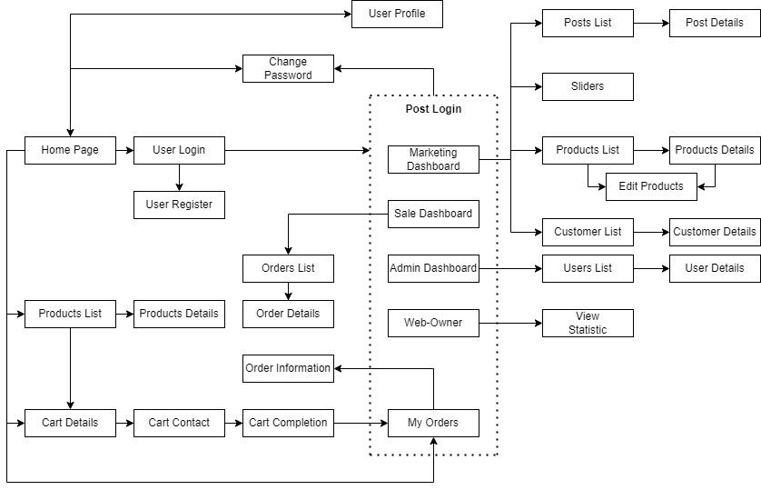

### 2.1.2 Screen Detail

| No. | Feature | Screen | Description |
| --- | --- | --- | --- |
| 1 | Starting Page | Home Page | -Show sliders, hot posts, featured products + the sider with the latest posts, static contacts/links  -Show slider, post, product information |
| 2 | Show Shared Post List | Post List | -Show the posts in pages + the sider with the post search box, post categories, the latest posts, and static contacts/links  -Show post information |
| 3 | Show details of the selected Shared Post | Post Details | -Show post details + the sider with the post search box, post categories, static contacts/links |
| 4 | Show Active Products List | Product Lists | -Show the products in pages + the sider with the product search box, product categories, the latest products, and static contacts/links;  -Show product information |
| 5 | Show details of the selected Product | Product Details | -Show product details + the sider with the product search box, product categories, the latest products, and static contacts/links |
| 6 | Show details of the user carts | Cart Details | -Show the cart details with list of the user's chosen products and the total order price + the sider with the product search box, product categories, the latest products, and static contacts/links  -The user can edit Cart |
| 7 | Edit Order receiver information | Cart Contact | -Show the list of user chosen product, the total order price and the receiver information + the sider with the product search box, product categories, the latest products, and static contacts/links  - Users can edit/change the receiver information and submit orders. |
| 8 | Order Completion Confirmation | Cart Completion | -This page show the cart completion notes + the sider with the product search box, product categories, the latest products, and static contacts/links  - The customer/user would receive the order confirmation via his/her phone number. |
| 9 | Login to system | User Login | -This is a pop-up screen which allows the user to enter email & password to login |
| 10 | Register new user into the System | User Register | -This is a pop-up screen which allows the user to register to the system |
| 11 | Change User Password | Change Password | -This is a pop-up screen which allows the user to change password |
| 12 | View & Edit User Profile | User Profile | -This is a pop-up screen which allows the user to edit profile information |
| 13 | View Summited Orders | My Orders | -Show the list of user's orders in pages + the sider with the product search box, product categories, the latest products, and static contacts/links |
| 14 | View User’ Orders Details | Order Information | -Show the order details + the sider with the product search box, product categories, the latest products, and static contacts/links |
| 15 | View Marketing Related Data | MKT Dashboard | -Show statistics of posts, products, customers & the trend of new customers |
| 16 | View & Edit existing Posts | MKT Post List | -Show the paginated list of posts  -Marketing can edit or add new posts |
| 17 | View & Edit Details of existing Posts | MKT Post Details | -Show detailed post information  -Marketing can edit detail of each post |
| 18 | View & Edit existing Sliders | MKT Sliders | -Show the paginated list of sliders  -Marketing can add new or remove Sliders |
| 19 | View & Edit existing Products | MKT Product List | -Show the paginated list of products  -Marketing can edit or add new Products |
| 20 | View & Edit Details of existing Products | MKT Products Details | -Show detailed product information  -Marketing can edit detail of each product |
| 21 | View existing Customers | MKT Customer List | -Show the paginated list of customers / contacts. |
| 22 | View Details of existing Customers | MKT Customer Details | -Show detailed customer/contact information |
| 23 | View Sale - related Data | Sale Dashboard | -Show the trend of success/total orders, and the revenues trends |
| 24 | View existing Orders | Sale Orders List | -Show the list of orders paginated |
| 25 | View & Edit the Status of existing assigned Orders | Sale Order Details | -Show the order details  -Sale can change the status of their assigned order |
| 26 | View Management - related Data | Admin Dashboard | -Show statistics of new orders, revenues, customers & the trend of order counts |
| 27 | View existing Users | User List | -Show the paginated list of registered users  -From each user, the admin can choose to view its details  -The admin can create a new user account. |
| 28 | View & Edit Details of existing Users | User Details | -Show detailed user information  -The Admin can update user’s status |
| 29 | View Marketing, Sale, Management related data | Web owner Dashboard | -Show statistics of posts, products, customers & the trend of new customers  -Show the trend of success/total orders, and the revenues trends  -Show statistics of new orders, revenues, customers & the trend of order counts |
| 30 | View & Edit Details of existing Users | User Details | -Show detailed user information  -The Web owner can update user’s status |

### 2.1.3 Authorization Table

| Screen | Guest | Customer | Sale | Marketing | Admin | Web-owner |
| --- | --- | --- | --- | --- | --- | --- |
| Home Page | X | X |  |  |  |  |
| Product Lists | X | X |  |  |  |  |
| Product Details | X | X |  |  |  |  |
| Cart Details |  | X |  |  |  |  |
| - Edit Cart |  | X |  |  |  |  |
| Cart Contact |  | X |  |  |  |  |
| - Change receiver information |  | X |  |  |  |  |
| - Submit order |  | X |  |  |  |  |
| Cart Completion |  | X |  |  |  |  |
| User login | X |  |  |  |  |  |
| User Register | X |  |  |  |  |  |
| Change Password |  | X | X | X | X | X |
| User profile |  | X | X | X | X | X |
| - Update user’s profile |  | X | X | X | X | X |
| My Orders |  | X |  |  |  |  |
| Order Information |  | X |  |  |  |  |
| Marketing Dashboard |  |  |  | X |  |  |
| - View Marketing data |  |  |  | X |  |  |
| Marketing Post List |  |  |  | X |  |  |
| - View Post List |  |  |  | X |  |  |
| - Add new post |  |  |  | X |  |  |
| Marketing Post Details |  |  |  | X |  |  |
| - View post details |  |  |  | X |  |  |
| - Update post details |  |  |  | X |  |  |
| Marketing Slider |  |  |  | X |  |  |
| - View all existing slider |  |  |  | X |  |  |
| - Add / remove a post from slider |  |  |  | X |  |  |
| Marketing Product List |  |  |  | X |  |  |
| - View product list |  |  |  | X |  |  |
| - Add a new product |  |  |  | X |  |  |
| Marketing Product details |  |  |  | X |  |  |
| - View product details |  |  |  | X |  |  |
| - Update product details |  |  |  | X |  |  |
| Marketing Customer List |  |  |  | X |  |  |
| - View customer list |  |  |  | X |  |  |
| Marketing Customer details |  |  |  | X |  |  |
| - View customer’s details |  |  |  | X |  |  |
| - Update customer’s details |  |  |  | X |  |  |
| Sale Dashboard |  |  | X |  |  |  |
| - View the trend of success/total orders, and the revenues trends |  |  | X |  |  |  |
| Sale Orders List |  |  | X |  |  |  |
| - View assigned orders |  |  | X |  |  |  |
| - View all orders |  |  | X |  |  |  |
| Sale Orders Details |  |  | X |  |  |  |
| - View assigned order’s details |  |  | X |  |  |  |
| - View all order’s details |  |  | X |  |  |  |
| - Update assigned order’s status |  |  | X |  |  |  |
| Admin Dashboard |  |  |  |  | X | X |
| - View statistics of new orders, revenues, customers & the trend of order counts |  |  |  |  | X | X |
| User List |  |  |  |  | X | X |
| - View user list |  |  |  |  | X | X |
| User Details |  |  |  |  | X | X |
| - View user’s details |  |  |  |  | X | X |
| - Update User’s status |  |  |  |  | X | X |
| Error Page | X | X | X | X | X | X |
| - Navigate to corresponding home page / dashboard | X | X | X | X | X | X |

### 2.1.4 Non-screen functions

| No. | Feature | Description |
| --- | --- | --- |
| 1 | User Authentication | The function is used to determine whether one user exists and be able to access the resources on the system or not. |
| 2 | User Authorization | The function is used to check the user’s role before redirecting them to an appropriate dashboard so that they can access appropriate resources on the system. |

## 

### 2.1.5 Common Requirement

* Users need to login to make an order
* Users can cancel orders that are not yet confirmed by Sale.
* The order will be automatically assigned to the salesperson with the least assigned orders at that moment.
* User’s password will be encrypted.

## 2.2. Common Features

### 2.2.1. Login

| UC ID and Name: | **UC-01. Login** |
| --- | --- |

| Primary Actor: | All actor | Secondary Actor: | Bakery Shop |
| --- | --- | --- | --- |
| Description: | Users want to login into the website | | |
| Trigger: | Users clicks on the “Login” button | | |
| Preconditions: | None | | |
| Postconditions: | None | | |
| Normal Flow: | 1. User visits Bakery Shop original homepage  2. User clicks “Login” button and Bakery Shop returns the information filling page  3. User fills in email and password  4. The system checks the email and password entered in the database.  5. The system returns the home page display corresponding to each role of the registered account. | | |
| Exceptions | Wrong email or password | | |
| Priority | High | | |
| Frequency | User wants to login into the website | | |
| Business Rules | BR-06 | | |
| Mockup |  | | |

### 2.2.2. Register

| UC ID and Name: | **UC-02. Register** |
| --- | --- |

| Primary Actor: | All actor | Secondary Actor: | Bakery Shop |
| --- | --- | --- | --- |
| Description: | User wants to register on the Bakery Shop system | | |
| Trigger: | User requests to register an account. | | |
| Preconditions: | None | | |
| Postconditions: | None | | |
| Normal Flow: | 1. User visits Bakery Shop original homepage  2. User clicks “Login” button then user clicks “Sign up new Account” or clicks on Sign up button and Bakery Shop returns the information filling page  3. User fills in email, password and personal information  4. The system checks the email and password if it is duplicated.  5. The system returns the home page. | | |
| Exceptions | Duplicated email or password | | |
| Priority | High | | |
| Frequency | User wants to login into the website | | |
| Business Rules | BR-03, BR-14, BR-04 | | |
| Mockup |  | | |

### 2.2.3. Logout

| UC ID and Name: | **UC-03. Logout** |
| --- | --- |

| Primary Actor: | All actor | Secondary Actor: | Bakery Shop |
| --- | --- | --- | --- |
| Description: | Users want to logout Bakery Shop system | | |
| Trigger: | User wants to logout the Bakery Shop system. | | |
| Preconditions: | User is logged in to Bakery Shop | | |
| Postconditions: | None | | |
| Normal Flow: | 1. User clicks the Logout button icon next to the ava icon on the navigation bar | | |
| Exceptions | None | | |
| Priority | High | | |
| Frequency | User wants to logout Bakery Shop | | |
| Business Rules | None | | |
| Mockup |  | | |

### 2.2.4. Update user information

| UC ID and Name: | **UC-04. Update user information** |
| --- | --- |

| Primary Actor: | All actor | Secondary Actor: | Bakery Shop |
| --- | --- | --- | --- |
| Description: | User wants to update their personal information | | |
| Trigger: | User access the information editing page by clicking on the Profile button on the navigation bar | | |
| Preconditions: | User is logged in to Bakery Shop | | |
| Postconditions: | None | | |
| Normal Flow: | 1. User clicks on the Profile button on the navigation bar  2.The screen returns to the personal information editing screen.  3. User changes the information they want  4. The system compares, checks, and overwrites new information in the database  5. The system returns the successful result screen. | | |
| Exceptions | None | | |
| Priority | High | | |
| Frequency | User changes personal information in the Bakery Shop system | | |
| Business Rules | BR-01 | | |
| Mockup |  | | |

### 2.2.5 Change password

| UC ID and Name: | **UC-05. Change password** |
| --- | --- |

| Primary Actor: | All actor | Secondary Actor: | Bakery Shop |
| --- | --- | --- | --- |
| Description: | User wants to change his/her password | | |
| Trigger: | User wants to change their password | | |
| Preconditions: | User is logged in to Bakery Shop | | |
| Postconditions: | None | | |
| Normal Flow: | 1. User clicks on the Profile button on the navigation bar  2.The screen returns to the personal information editing screen.  3. User clicks on the Change password button  4. User fill in the old and new password and confirm password  5. The system compares, checks, and overwrites new information in the database  6. The system returns the successful result screen. | | |
| Exceptions | None | | |
| Priority | High | | |
| Frequency | User wants to change his/her password | | |
| Business Rules | BR-05 | | |
| Mockup |  | | |

## 2.3 Guest Features

### 2.3.1. Get a list of available products

| UC ID and Name: | **UC-06. Get a list of available products** |
| --- | --- |

| Primary Actor: | Guest | Primary Actor: | BakeryShop |
| --- | --- | --- | --- |
| Description: | When guest click on view all button, the system will show a picture, original price, sale price (if any) and name of the product | | |
| Trigger: | Guest click button “View all” | | |
| Preconditions: | None | | |
| Postconditions: | None | | |
| Normal Flow: | 1.Guest clicks on the “View all” button on the homepage  2. The display screen returns the home screen with all products | | |
| Exceptions | None | | |
| Priority | Low | | |
| Frequency | Guest want to view all products | | |
| Business Rules | None | | |
| Mockup |  | | |

### 2.3.2. Get a product’s detail

| UC ID and Name: | **UC-07. Get a product’s detail** |
| --- | --- |

| Primary Actor: | Guest | Primary Actor: | BakeryShop |
| --- | --- | --- | --- |
| Description: | When guest clicks on a specific product in the list displayed on the screen | | |
| Trigger: | Guest click specific product in the list displayed on the screen | | |
| Preconditions: | None | | |
| Postconditions: | None | | |
| Normal Flow: | 1.Guest clicks on any products on the homepage  2. The display screen returns the details of the product | | |
| Exceptions | None | | |
| Priority | Low | | |
| Frequency | Guest want to view the details of the product | | |
| Business Rules | None | | |
| Mockup |  | | |

## 2.4. Customer Features

### 2.4.1. Create a new order

| UC ID and Name: | **UC-08. Create new order** |
| --- | --- |

| Primary Actor: | Customer | Secondary Actor: | Bakery Shop website |
| --- | --- | --- | --- |
| Description: | The function is used to create a new order record in the database | | |
| Trigger: | The function is triggered when a customer clicks on the “Add to cart” button on the Cart Contact screen. If the user is not logged in, the Login page will pop-up and require the user to login | | |
| Preconditions: | None | | |
| Postconditions: | None | | |
| Normal Flow: | 1.Customer click to add to cart  2. Fill in the address information  3.Customer clicks on the Purchase button  4. System will return to the result screen | | |
| Exceptions | None | | |
| Priority | High | | |
| Frequency | Guest want to order | | |
| Business Rules | none | | |
| Mockup |  | | |

### 

### 2.4.2. Cancel an order

| UC ID and Name: | **UC-09. Cancel an order** |
| --- | --- |

| Primary Actor: | Customer | Secondary Actor: | Bakery Shop website |
| --- | --- | --- | --- |
| Description: | The function is used to update the status of the corresponding order record from the database when the user confirms to perform the action. | | |
| Trigger: | The function is triggered when a customer requests to cancel the submitted order given it hasn’t been confirmed by the salesperson. | | |
| Preconditions: | None | | |
| Postconditions: | None | | |
| Normal Flow: | 1.Customer click on Cart  2.Customer choose cancel an order  3.Customer clicks on “Ok”  4. System will return to the result screen | | |
| Exceptions | None | | |
| Priority | High | | |
| Frequency | Customer want to cancel an order | | |
| Business Rules | BR-09 | | |
| Mockup |  | | |

### 2.4.3. Get a list of User’s orders

| UC ID and Name: | **UC-10. Get a list of User’s orders** |
| --- | --- |

| Primary Actor: | Customer | Secondary Actor: | BakeryShop website |
| --- | --- | --- | --- |
| Description: | The function is used to query for a list of submitted orders created by the corresponding customer from the database and display it on the screen. The system will show the order’s Date, total Price and Status. | | |
| Trigger: | The function is triggered when a customer requests to view his/her submitted orders. | | |
| Preconditions: | None | | |
| Postconditions: | None | | |
| Normal Flow: | 1.Customers ordered to the system  2.Staff Click “Manage Order” to display “Pending Order”  3.The approval staff all checked by clicking on “Approved”  4.Click “Approved Order” to check the order information and select the “Delivery” button to proceed with the delivery  5.Select “Deliver Order”click “Complete Order” to complete the order | | |
| Exceptions | None | | |
| Priority | High | | |
| Frequency | The system will query the database for the order of the corresponding user and display it on the screen | | |
| Business Rules | None | | |
| Mockup |  | | |

### 2.4.4. Get an order’s detail

| UC ID and Name: | **UC-011. Get an order’s detail** |
| --- | --- |

| Primary Actor: | Customer | Secondary Actor: | BakeryShop website |
| --- | --- | --- | --- |
| Description: | The function is used to query for detailed information of a specific order which belongs to the corresponding user from the database. The system will display the products and their thumbnails, quantity along with the Date, total price and status of the order | | |
| Trigger: | The function is triggered when customer clicks on a specific order in the list displayed on the screen | | |
| Preconditions: | None | | |
| Postconditions: | None | | |
| Normal Flow: | 1.Customers ordered to the system  2..Staff Click “Manage Order” to display “Pending Order” and check the order details by selecting the detail button  3 approval staff are checked by clicking "Detail" Button to review the order and then click on the "approved" button  4. Click "Approved orders" to check the order information and select the "Delivery" button to conduct delivery  5.Select “Deliver Order”click “Complete Order” to complete the order | | |
| Exceptions | None | | |
| Priority | High | | |
| Frequency | The system will query the database for all detailed information of a specific order | | |
| Business Rules | None | | |
| Mockup |  | | |

## 2.5. Marketing Features

### 2.5.1. Add a new product

| UC ID and Name: | **UC-12. Add a new product** |
| --- | --- |

| Primary Actor: | Marketer | Primary Actor: | BakeryShop |
| --- | --- | --- | --- |
| Description: | When the Marketer wants to add new product | | |
| Trigger: | Marketer click on “Add” button | | |
| Preconditions: | The Marketer is logged in. | | |
| Postconditions: | POST-1.Marketer is logged in successfully | | |
| Normal Flow: | 1. Marketer clicks “Manage product ” button on navbar Bakery Shop returns product page 2. Marketer clicks “Add” button and Bakery Shop returns add table 3. Fill in the information of product 4. Marketer clicks on the “Save” button 5. The system add new information in the database 6. System will return to the product page | | |
| Exceptions | None | | |
| Priority | Low | | |
| Frequency | Marketer want to Add a new product into the website | | |
| Business Rules | BR-10 | | |
| Mockup |  | | |

### 2.5.2. Update a product

| UC ID and Name: | **UC-13. Update a product** |
| --- | --- |

| Primary Actor: | Marketer | Primary Actor: | BakeryShop |
| --- | --- | --- | --- |
| Description: | When the Marketer wants to update a product | | |
| Trigger: | Marketer editing by clicking on the “Update” button | | |
| Preconditions: | The Marketer is logged in. | | |
| Postconditions: | POST-1.Marketer is logged in successfully | | |
| Normal Flow: | 1. Marketer clicks “Manage product ” button on navbar and Bakery Shop returns product page   2. Maketerclicks on the Update Button on the page product  3.The screen returns to the product information  4. Marketer changes the information of product they want  5. The system compares, checks, and overwrites new information in the database  6. The system returns the successful result screen. | | |
| Exceptions | None | | |
| Priority | Low | | |
| Frequency | Marketer want to update a product on the website | | |
| Business Rules | BR-01, BR-10 | | |
| Mockup |  | | |

## 

### 2.5.3. Add post

| UC ID and Name: | **UC-14. Add post** |
| --- | --- |

| Primary Actor: | Marketer | Primary Actor: | BakeryShop |
| --- | --- | --- | --- |
| Description: | When the Marketer wants to add new post | | |
| Trigger: | Marketer click on “Add” button | | |
| Preconditions: | The Marketer is logged in. | | |
| Postconditions: | POST-1.Marketer is logged in successfully | | |
| Normal Flow: | 1. Marketer clicks “Post product ” button on navbar Bakery Shop returns post page 2. Marketer clicks “Add” button and Bakery Shop returns add table 3. Fill in the information of new post 4. Marketer clicks on the “Save” button 5. The system add new information in the database 6. System will return to the post page | | |
| Exceptions | None | | |
| Priority | Low | | |
| Frequency | Marketer want to Add a new post into the website | | |
| Business Rules | BR-10 | | |
| Mockup |  | | |

### 2.5.4. Update post

| UC ID and Name: | **UC-15. Update post** |
| --- | --- |

| Primary Actor: | Marketer | Primary Actor: | Bakery Shop |
| --- | --- | --- | --- |
| Description: | When the Marketer wants to update a post | | |
| Trigger: | Marketer editing by clicking on the “Update” button | | |
| Preconditions: | The Marketer is logged in. | | |
| Postconditions: | POST-1.Marketer is logged in successfully | | |
| Normal Flow: | 1. Marketer clicks “Manage product ” button on navbar and Bakery Shop returns product page 2. Marketer clicks on the Update Button on the page post 3. The screen returns to the post information 4. Marketer changes the information of post they want 5. The system compares, checks, and overwrites new information in the database 6. The system returns the successful result screen | | |
| Exceptions | None | | |
| Priority | Low | | |
| Frequency | Marketer want to update a post on the website | | |
| Business Rules | BR-10 | | |
| Mockup |  | | |

### 

### 2.5.5. Get a list of Sliders

| UC ID and Name: | **UC-16. Get a list of Sliders** |
| --- | --- |

| Primary Actor: | Marketer | Primary Actor: | Bakery Shop |
| --- | --- | --- | --- |
| Description: | When the Marketer wants to view all sliders | | |
| Trigger: | Guest click button “Slider” | | |
| Preconditions: | The Marketer is logged in. | | |
| Postconditions: | POST-1.Marketer is logged in successfully | | |
| Normal Flow: | 1.Guest clicks on the “Slider” button on the homepage  2. The system will display all Slider | | |
| Exceptions | None | | |
| Priority | Low | | |
| Frequency | Marketer When the Marketer wants to view all slides on the website | | |
| Business Rules | None | | |
| Mockup |  | | |

### 2.5.6. Remove post

| UC ID and Name: | **UC-17. Remove post** |
| --- | --- |

| Primary Actor: | Marketer | Primary Actor: | Bakery Shop |
| --- | --- | --- | --- |
| Description: | When the Marketer wants to remove post from slider | | |
| Trigger: | Marketer click button “-” on slider | | |
| Preconditions: | The Marketer is logged in. | | |
| Postconditions: | POST-1.Marketer is logged in successfully | | |
| Normal Flow: | 1. Marketer clicks “- ” button on slider 2. Bakery Shop returns post table 3. Marketer clicks on the “-” button on the post want remove 4. Marketer clicks on the “Save” button 5. The system add new information in the database 6. System will return to the home page | | |
| Exceptions | None | | |
| Priority | Low | | |
| Frequency | Marketer want to remove post from slider on the website | | |
| Business Rules | BR-10 | | |
| Mockup |  | | |

### 2.5.7. Add Category

| UC ID and Name: | **UC-18. Add Category** |
| --- | --- |

| Primary Actor: | Marketer | Primary Actor: | Bakery Shop |
| --- | --- | --- | --- |
| Description: | When the Marketer wants to add new category | | |
| Trigger: | Marketer click on “Add” button | | |
| Preconditions: | The Marketer is logged in. | | |
| Postconditions: | POST-1.Marketer is logged in successfully | | |
| Normal Flow: | 1. Marketer clicks “Manage Category” button on navbar Bakery Shop returns post page 2. Marketer clicks “Add” button and Bakery Shop returns add table 3. Fill in the information of new post 4. Marketer clicks on the “Save” button 5. The system add new information in the database 6. System will return to the post page | | |
| Exceptions | None | | |
| Priority | Low | | |
| Frequency | Marketer want to Add a new post into the website | | |
| Business Rules | BR-10 | | |
| Mockup |  | | |

### 2.5.8. Remove Category

| UC ID and Name: | **UC-19. Remove Category** |
| --- | --- |

| Primary Actor: | Marketer | Primary Actor: | Bakery Shop |
| --- | --- | --- | --- |
| Description: | When the Marketer wants to remove Category | | |
| Trigger: | Marketer click button “Delete” on Mange Category page | | |
| Preconditions: | The Marketer is logged in. | | |
| Postconditions: | POST-1.Marketer is logged in successfully | | |
| Normal Flow: | 1. Marketer clicks on Manage Category page 2. Bakery Shop returns post table 3. Marketer click button “Delete” on category want removeThe system add new information in the database 4. System will return to the home page | | |
| Exceptions | None | | |
| Priority | Low | | |
| Frequency | Marketer want to remove Category | | |
| Business Rules | BR-10 | | |
| Mockup |  | | |

### 

### 2.5.9. View Marketing statistic

| UC ID and Name: | **UC-20. View marketing statistic** |
| --- | --- |

| Primary Actor: | Marketer | Primary Actor: | Bakery Shop |
| --- | --- | --- | --- |
| Description: | When the Marketer wants to get Marketing statistic | | |
| Trigger: | Marketer Login | | |
| Preconditions: | The Marketer is logged in. | | |
| Postconditions: | POST-1.Marketer is logged in successfully | | |
| Normal Flow: | 1. Marketer login into the system 2. Marketing statistic will show on the Marketer’s home page | | |
| Exceptions | None | | |
| Priority | Low | | |
| Frequency | When Marketer login, they can view marketing statistics and chart on the marketing dashboard | | |
| Business Rules | None | | |
| Mockup |  | | |

## 2.6. Sale Feature

### 2.6.1. Get a list of all orders

| UC ID and Name: | **UC-21. Get a list of all orders** |
| --- | --- |

| Primary Actor: | Sale | Primary Actor: | Bakery Shop |
| --- | --- | --- | --- |
| Description: | When an actor wants to get a list of all orders | | |
| Trigger: | Sale click button “Manage Order” | | |
| Preconditions: | None | | |
| Postconditions: | None | | |
| Normal Flow: | 1. Salesperson logged in the system 2. Sale clicks on the “Manage Order” button on the homepage 3. The system will show the list of order’s which include “Email”, “Date”, and “Status” | | |
| Exceptions | None | | |
| Priority | High | | |
| Frequency | Sale want to show the list of orders | | |
| Business Rules | None | | |
| Mockup |  | | |

### 2.6.2. Get an order’s detail

| UC ID and Name: | **UC-22. Get an order’s detail** |
| --- | --- |

| Primary Actor: | Sale | Primary Actor: | Bakery Shop |
| --- | --- | --- | --- |
| Description: | When an actor wants to get an order’s detail | | |
| Trigger: | Sale click on a specific order in the list displayed on the screen | | |
| Preconditions: | None | | |
| Postconditions: | None | | |
| Normal Flow: | 1. Salesperson logged in the system. 2. Salesperson clicks on the specific order in the list of orders. 3. The system will display the products and their thumbnails, quantity along with the Date, total price and status of the order | | |
| Exceptions | None | | |
| Priority | High | | |
| Frequency | Sale want to show the specific of orders | | |
| Business Rules | None | | |
| Mockup |  | | |

### 

### 2.6.3. Change status of order

| UC ID and Name: | **UC-23. Change status of order** |
| --- | --- |

| Primary Actor: | Sale | Primary Actor: | Bakery Shop |
| --- | --- | --- | --- |
| Description: | When Sale requests to change an Order's status. | | |
| Trigger: | When Sale requests to change an Order's status. | | |
| Preconditions: | None | | |
| Postconditions: | None | | |
| Normal Flow: | 1. Salesperson logged in the system. 2. On the Sale Homepage, salesperson clicks on the Manage Order button on the side bar. 3. Sale clicks change the status order buttons. 4. The system will verify the Sale’s choice. If the user chooses “Yes”, the system will then update the status of the corresponding order record in the database. Otherwise, the system would do nothing. | | |
| Exceptions | None | | |
| Priority | High | | |
| Frequency | Sale want to change the status of order | | |
| Business Rules | BR-13, BR-11 | | |
| Mockup |  | | |

### 2.6.4. View Sale statistic

| UC ID and Name: | **UC-24. View Sale statistic** |
| --- | --- |

| Primary Actor: | Sale | Primary Actor: | Bakery Shop |
| --- | --- | --- | --- |
| Description: | When Sale want to view statistic | | |
| Trigger: | When the Sale employee login, they can view marketing statistics and chart on the Sale dashboard | | |
| Preconditions: | None | | |
| Postconditions: | None | | |
| Normal Flow: | 1. When salesperson logged in the system.  2. The system will show sales related data, calculate and then display the result on the Sale dashboard. | | |
| Exceptions | None | | |
| Priority | High | | |
| Frequency | Sale want to request system to calculate and generate statistical records on screen | | |
| Business Rules | None | | |
| Mockup |  | | |

## 

## 2.7. Admin’s Account management

### 2.7.1. Add new account

| UC ID and Name: | **UC-25. Add new account** |
| --- | --- |

| Primary Actor: | Admin | Primary Actor: | Bakery Shop |
| --- | --- | --- | --- |
| Description: | Admin want to add new account | | |
| Trigger: | Admin wants to add new account and clicks on the Add new account button | | |
| Preconditions: | Admin is logged in to Bakery Shop | | |
| Postconditions: | None | | |
| Normal Flow: | 1. Admin login into Bakery Shop  2. Admin clicks on the Manage User button on the Dashboard table.  3. Admin clicks on the Add new account button  4. Admin fills in new account information, role and status  5. Admin presses Save button to add new account into system and database | | |
| Exceptions | None | | |
| Priority | High | | |
| Frequency | Admin want to add a new account | | |
| Business Rules | BR-08 | | |
| Mockup |  | | |

### 2.7.2. Get a list of all user account

| UC ID and Name: | **UC-26. Get a list of all user account** |
| --- | --- |

| Primary Actor: | Admin | Primary Actor: | Bakery Shop |
| --- | --- | --- | --- |
| Description: | Admin want to view list of all user account | | |
| Trigger: | Admin requests to view the list of all users on the system. | | |
| Preconditions: | Admin is logged in to Bakery Shop | | |
| Postconditions: | None | | |
| Normal Flow: | 1. Admin login into Bakery Shop  2. Admin clicks on the Manage User button on the Dashboard table.  3. The list of all user will be automatically generated on the screen | | |
| Exceptions | None | | |
| Priority | High | | |
| Frequency | Admin want to view list of all user account | | |
| Business Rules | None | | |
| Mockup |  | | |

### 2.7.3. Get a User account’s detail

| UC ID and Name: | **UC-27. Get a user account’s detail** |
| --- | --- |

| Primary Actor: | Admin | Primary Actor: | Bakery Shop |
| --- | --- | --- | --- |
| Description: | Admin want to view detailed information of a specific account | | |
| Trigger: | Admin want to view detailed information of a specific account | | |
| Preconditions: | Admin is logged in to Bakery Shop | | |
| Postconditions: | None | | |
| Normal Flow: | 1. Admin login into Bakery Shop  2. Admin clicks on the Manage User button on the Dashboard table.  3. The list of all user will be automatically generated on the screen  4. Admin clicks on the Pen icon on the right side of the Role Id column  5. The system will return the selected account’s detailed information | | |
| Exceptions | None | | |
| Priority | High | | |
| Frequency | Admin want to view detailed information of a specific account | | |
| Business Rules | None | | |
| Mockup |  | | |

### 2.7.4. Activate/Deactivate a user account

| UC ID and Name: | **UC-28. Activate/Deactivate a user account** |
| --- | --- |

| Primary Actor: | Admin | Primary Actor: | Bakery Shop |
| --- | --- | --- | --- |
| Description: | Admin want to Activate/Deactivate a user account | | |
| Trigger: | Admin want to Activate/Deactivate a user account | | |
| Preconditions: | Admin is logged in to Bakery Shop | | |
| Postconditions: | None | | |
| Normal Flow: | 1. Admin login into Bakery Shop  2. Admin clicks on the Manage User button on the Dashboard table.  3. The list of all user will be automatically generated on the screen  4. Admin clicks on the Activate button if the admin wants to activate an account. On the other hand, admin clicks on the Deactivate button | | |
| Exceptions | None | | |
| Priority | High | | |
| Frequency | Admin want to Activate/Deactivate a specific account | | |
| Business Rules | BR-12 | | |
| Mockup |  | | |

### 

### 2.7.5. View Admin statistic

| UC ID and Name: | **UC-29. View Admin Statistic** |
| --- | --- |

| Primary Actor: | Admin | Primary Actor: | Bakery Shop |
| --- | --- | --- | --- |
| Description: | Admin want to view statistic of admin | | |
| Trigger: | Admin want to view statistic of admin | | |
| Preconditions: | Admin is logged in to Bakery Shop | | |
| Postconditions: | None | | |
| Normal Flow: | 1. Admin login into Bakery Shop  2. The result screen will be generated on the Admin Homepage | | |
| Exceptions | None | | |
| Priority | High | | |
| Frequency | Admin want to view statistic of admin | | |
| Business Rules | None | | |
| Mockup |  | | |

### 

## 2.8. Web owner Feature

### 2.8.1. View user statistic

### 

| UC ID and Name: | **UC-30. View user statistic** |
| --- | --- |

| Primary Actor: | Web owner | Primary Actor: | Bakery Shop |
| --- | --- | --- | --- |
| Description: | Web owner want to view user statistic | | |
| Trigger: | Web owner click post statistic button | | |
| Preconditions: | The Web owner is logged in. | | |
| Postconditions: | POST-1.Web owner is logged in successfully | | |
| Normal Flow: | 1. Web owner login into the system 2. Click user statistic button 3. User statistic will show on the Web owner home page | | |
| Exceptions | None | | |
| Priority | High | | |
| Frequency | Web owner want to view user statistic | | |
| Business Rules | None | | |
| Mockup |  | | |

### 2.8.2. View product and revenue statistic

### 

| UC ID and Name: | **UC-31. View product and revenue statistic** |
| --- | --- |

| Primary Actor: | Web owner | Primary Actor: | Bakery Shop |
| --- | --- | --- | --- |
| Description: | Web owner want to product and revenue statistic | | |
| Trigger: | Web owner click product and revenue statistic button | | |
| Preconditions: | The Web owner is logged in. | | |
| Postconditions: | POST-1.Web owner is logged in successfully | | |
| Normal Flow: | 1. Web owner login into the system 2. Click product and revenue statistic button 3. product and revenue statistic will show on the Web owner home page | | |
| Exceptions | None | | |
| Priority | High | | |
| Frequency | Web owner want to view product and revenue statistic | | |
| Business Rules | None | | |
| Mockup |  | | |

### 2.8.3. View post statistic

### 

| UC ID and Name: | **UC-32. View post statistic** |
| --- | --- |

| Primary Actor: | Web owner | Primary Actor: | Bakery Shop |
| --- | --- | --- | --- |
| Description: | Web owner want to view post statistic | | |
| Trigger: | Web owner click post statistic button | | |
| Preconditions: | The Web owner is logged in. | | |
| Postconditions: | POST-1.Web owner is logged in successfully | | |
| Normal Flow: | 1. Web owner login into the system 2. Click post statistic button 3. Post statistics will show on the Web owner home page | | |
| Exceptions | None | | |
| Priority | High | | |
| Frequency | Web owner want to view post statistic | | |
| Business Rules | None | | |
| Mockup |  | | |

# 

# 3. Non-Functional requirements

### 3.1 External Interfaces

#### 3.1.1 User Interface

1. User friendly interface

2. Easy to use for the first time

3. Ask to confirm before any important action

#### 3.1.2 Software Interface

1. Microsoft SQL

2. Java Servlet

#### 3.1.3 Hardware Interface

N/A

### 3.2 Quality Attributes

#### 3.2.1 Usability

1. Engagement: Friendly and suitable for new users.

2. Error Tolerance: High. Each input field would have its own individual validation.

3. Effectiveness: High

#### 3.2.2 Reliability

1. Available: Always

2. Mean time between failure: 3 months

#### 3.2.3 Performance

1. Response time for a transaction (average, maximum): (1.16s, 1.16s)

2. Throughput: 1000/s

3. Capacity: standard.

#### 3.2.4 Design Constraints

1. Time constraints: Complete on time

2. Cost constraints: Cost for domain and server

3. Network constraints: Web app should be deployed to allow users to manipulate online

4. Maintenance constraints: Easy to extend or update in the future

#### 3.2.5 Supportability

1. Clean code

2. Readable

3. Maintainable

# 4. Requirement appendix:

| ID | Rule Definition |
| --- | --- |
| BR-01 | When asked to select/add/upload necessary information, if one of the attributes/information is missing, the system will not submit and ask to fill it out |
| BR-02 | Guest can view the product normally, but to purchase the product, you have to log in |
| BR-03 | When registering an account, confirm the password must match the password entered above |
| BR-04 | The new username registered by the guest/created by the admin cannot match the username available in the database (the system displays a message that “This username is already in use, please enter another username” ) |
| BR-05 | When changing password, the new password must not match with current password |
| BR-06 | If User fail to login 5 times, the System will temporarily disable account |
| BR-07 | All new accounts created by guest have a role starting with Customer |
| BR-08 | Only the admin has the right to create an account with specific role |
| BR-09 | Customer can cancel their submitted order 1 hour before the sale accept the order |
| BR-10 | Marketers can only activate or deactivate a product, categories and post. |
| BR-11 | Salesperson can cancel the order if the address is not proper |
| BR-12 | Admin can only activate or deactivate an user account |
| BR-13 | Salesperson have to go through all steps in Manage Order life cycle to complete an customer’s order |
| BR-14 | When a Guest registers a new account, the default role is User. |
| BR-15 | If User has a problem with a website or system, User can mail to the Admin with information in the footer. |
| BR-16 | Every product has sale price, when the product is on sale, the price will be on discount |