* C -> F

Begin   
 Input C  
 F = (9*C)/5+32  
 Print F

End  
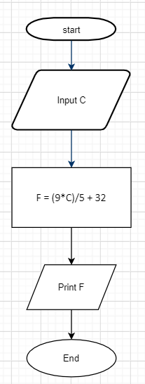

_______________________________

* F -> C  
  Begin

Input F  
 C = (F-32_/1,8

Print C  
End

