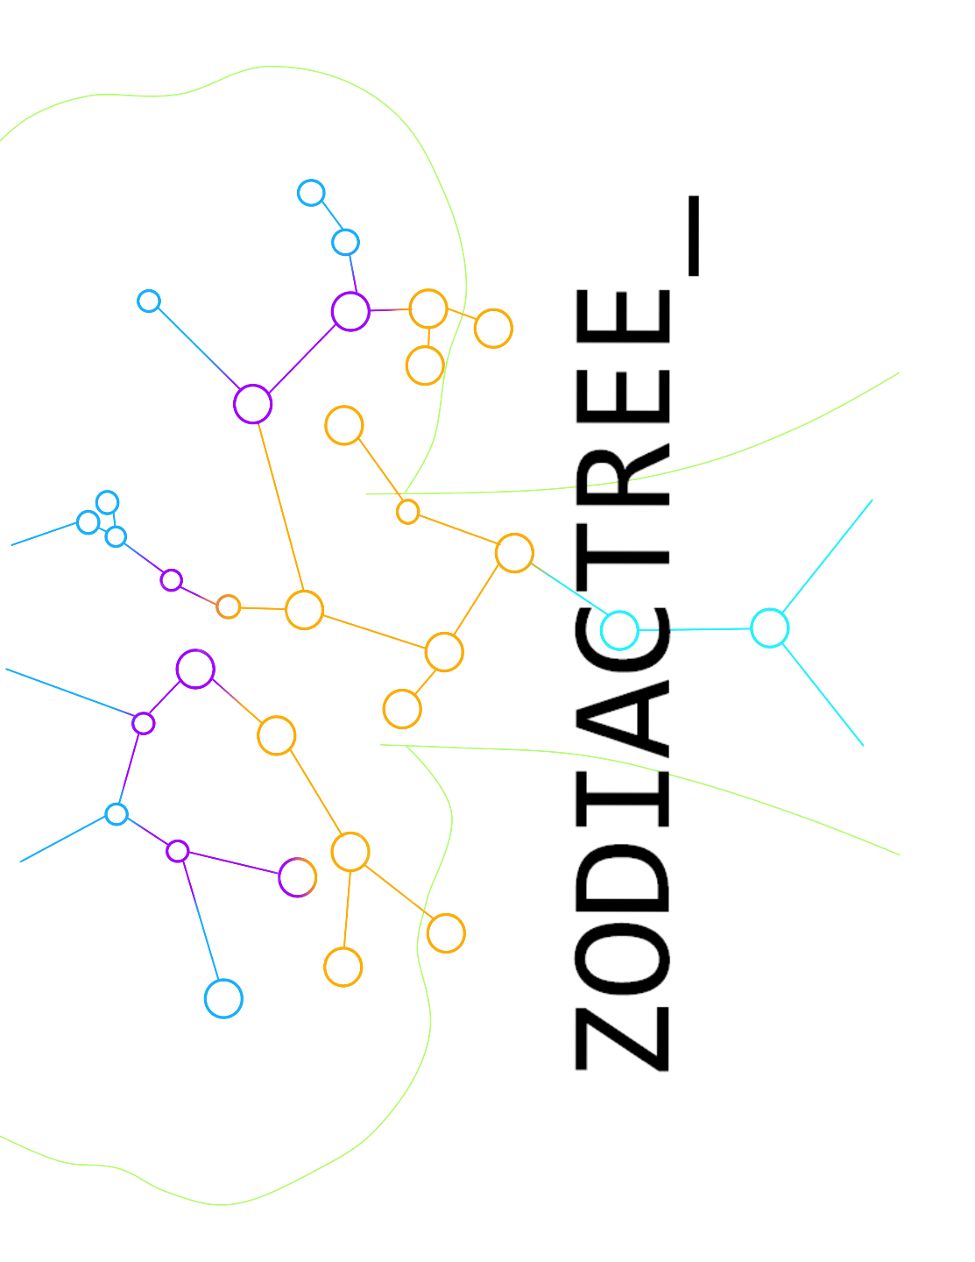

Team members David Wan

Matthew Lau

Shifeng Jin

Ryan Young

Junzhi ‘Jackson’ Chen

TABLE OF CONTENTS

Meet the Team …………………………………………………………...........

David Wan ………………………………………………………………. 3

Matthew Lau ……………………………………………………………. 4

Shifeng Jin ……………………………………………………………. 5

Ryan Young ……………………………………………………………. 6

Junzhi ‘Jackson’ Chen ………………………………………………… 7

Our Strength ….………………………………………………………………… 8

Our goal ……………………………………………………………………….. 9

David Wan

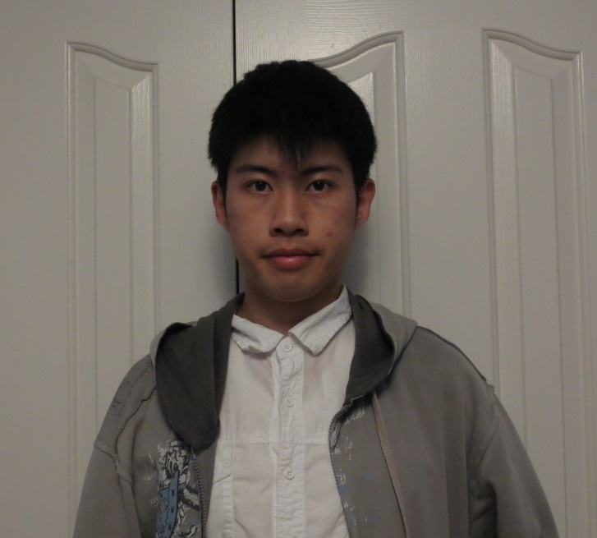

David Wan is a third year Computer Science specialist student at the University of Toronto. His goal is to become deeply entrenched in the world of video game programming and design. He specializes in C++ development whilst having Java and MySQL as an off-hand skill for home IT jobs.

Developing memorable and enjoyable video games for millions to enjoy and making his mark on pop culture is what David is all about. He spends numerous hours of his days with Unreal Engine 4, a powerful game engine that is utilized by indie game developers and triple-A game studios alike. In fact, Unreal Engine is the backbone of his own game dubbed ‘Project Artemis’.

And when he’s not busy hammering away in Unreal Engine, he’s constantly challenging himself and pushing the boundaries of his own abilities. Whether it be hackathons or self-given programming challenges, David is always looking for ways to optimize his performance in game programming and design.

Matthew Lau

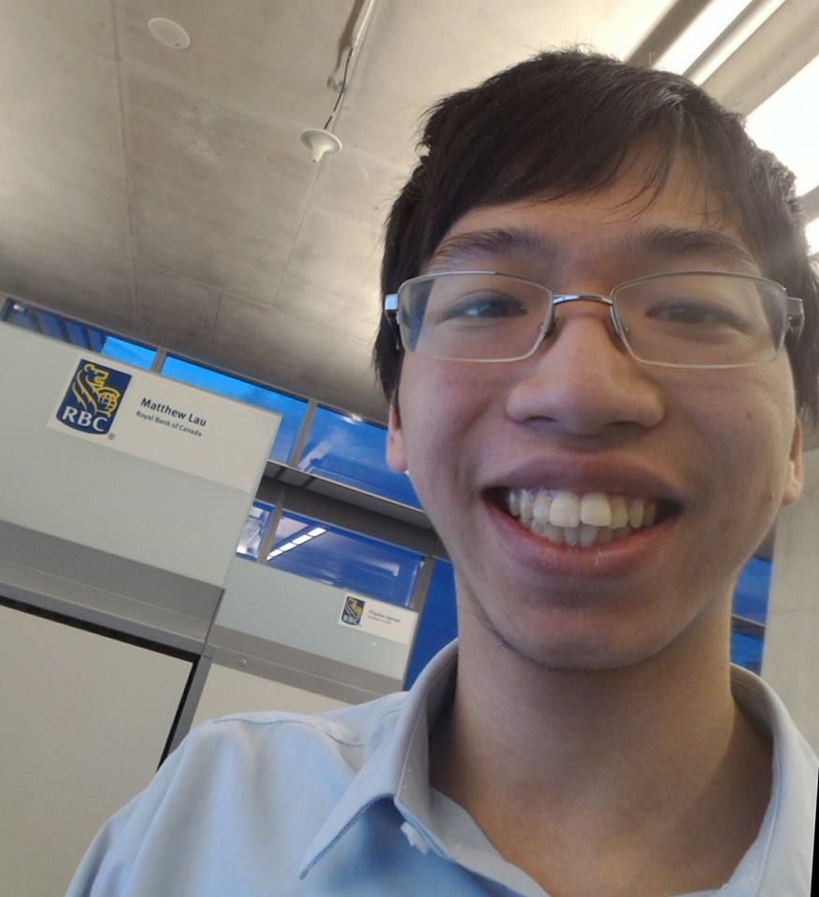

Matthew Lau is a fourth year Computer Science Co-op undergraduate at the University of Toronto Scarborough. He is specializing in Software Engineering. He graduated with honors from Richmond Green Secondary School in 2014.

Matthew has significant experience developing in C# and Java. He has experienced web development using ASP.Net and Struts 2 in a professional environment and is knowledgeable in SQL. He is fantastic at testing as well.

Matthew has great communication skills from discussing projects during meetings and show excellent time management skill from working on tasks with sensitive deadlines. He is creative in his ideas for projects and is great at solving problems when they arise.

Matthew has completed several work-terms at RBC Capital Markets as a Technical Systems Analyst. He has done development for several departments including: Operations IT, Shared Services IT, and Central Funding.

Matthew follows new technology and peripherals through technology focused video publishers. He also has an interest in the early to mid-20th century.

Shifeng Jin

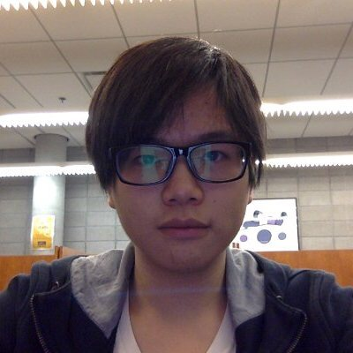

Shifeng Jin is currently in his third year of University of Toronto Scarborough’s Computer Science Co-op Specialist Program. Specializing in Software Engineering, he has been through several dedicated courses where he developed adequate understandings on how to program with Java, python, C, and SQL.

He also has a deep understanding of algorithm design and data structures. He also has a year of work experience within an IT department of the Ministry of Health, where he built his skill set on web technologies including Nginx, Node.js, Angular.js, React.js and API management, and learned some of the best practices when utilizing Docker and Cloud Foundry Platform.

And additionally, during his work period, he followed closely with a web application project team from the development phase into the production phase, where he was being fully attentive in detail, cooperative in tasking and productive in troubleshooting deployment related issues.

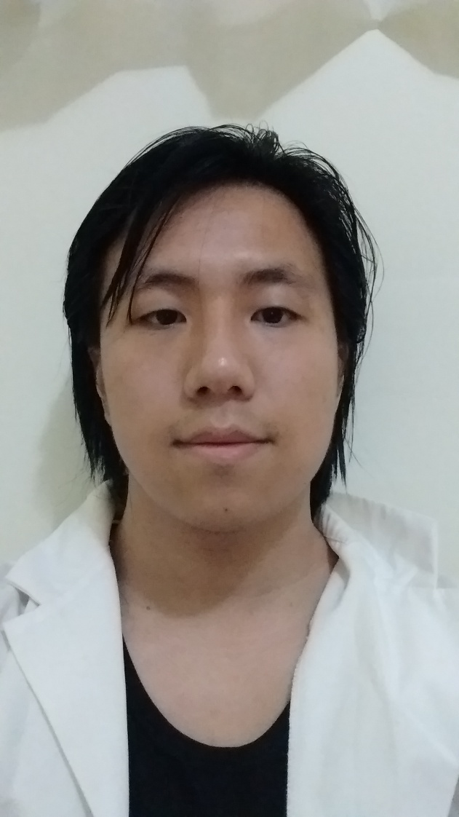Ryan Young

As a third-year computer science student from the University of Toronto, Ryan Young is an inquisitive and diligent worker that thrives in both solo and group environments. With strong programming, software development and teamwork skills, Ryan finds great interest in working with and developing entertainment based software and programs, particularly video games.

Ryan is well versed in Java, C, and python, and is always looking to add new languages to his repertoire. Ryan also has experience in web design and SQL, as well as experience in digital sound creation and editing.

Ryan has both great management and communication skills, taking pride in his understanding and mastery of the English language. Ryan also boasts immense creativity, believing that most challenges should be faced with a flexible and open mind.

When not working on small projects, Ryan enjoys relaxing with a book, immersing himself in pop culture, or playing video games.

Junzhi ‘Jackson’ Chen

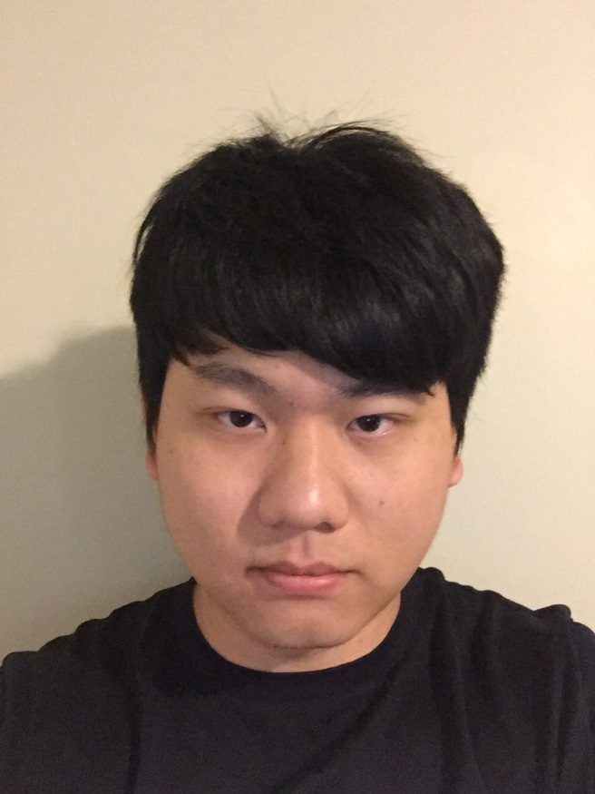

Junzhi Chen is a third year Computer Science student at the University of Toronto Scarborough who is specializing in the Information Systems stream. As a Computer Science specialist student, Junzhi Chen has taken several dedicated courses that develop the core skills of a computer scientist such as data structure analysis and program testing. Such courses utilize a wide array of languages such as, Java, Python, C, assembly languages, HTML and CSS.

Junzhi Chen is fluent in Mandarin Chinese and English. He also has domestic and international experience. His powerful communication skills, creativity, enthusiasm and meticulous nature has served him well throughout his Computer Science career. Junzhi Chen has a year of work experience in web design and maintaining Career Path Association’s website with his team. During this period, he learned HTML, CSS and participated in brainstorming sessions with other members of the IT team to come up with innovative ideas for the website. He is also experienced in SVN and developing Android applications such as a bank system with his teammates.

Our Strength

Our goal