Software Architecture and Design Specification
Project: Insurance Workflow Automation System (2/4-wheeler and Personal Health Insurance)

1. Introduction

1.1 Purpose
This document specifies the architecture and design of the Insurance Workflow Automation System described in SRS v1.2. It explains how the 25 functional requirements, 7 non-functional requirements and 8 security requirements are realised by components, interfaces, data stores and message flows, and why the main design choices were made.

1.2 Scope
Covers the web application for customers and insurers: plan management, quotes, applications, rule-based underwriting, payment and policy issuance, renewal, cancellation with refund, claims with duplicate detection, notifications, dashboards, reports and audit logging for two-wheeler, four-wheeler and personal health insurance.
Not covered: program source code, real integrations (the payment gateway, KYC service and email/SMS service are simulated behind adapter interfaces), hardware, and agents or brokers.

1.3 Audience
Developers, QA engineers who will write the Software Test Plan, security reviewers, instructors and evaluators, and future maintenance teams.

1.4 Definitions
Term | Meaning
ADR | Architecture Decision Record: a short record of one design decision, its reason and its status.
API / REST | Application Programming Interface; REST is the HTTP/JSON style used between the Web UI and the server.
JWT | JSON Web Token: a signed token that proves who the user is and which role they have.
RBAC | Role-Based Access Control: what a user may do depends on their role.
STRIDE | Threat model: Spoofing, Tampering, Repudiation, Information disclosure, Denial of service, Elevation of privilege.
Idempotency key | A unique value sent with a payment so that repeating the request cannot charge twice.
IDV, KYC, SRS, STP, RTM | As defined in SRS section 1.4; STP is the Software Test Plan and RTM the Requirements Traceability Matrix.
TLS, PCI-DSS | TLS: encryption of data in transit. PCI-DSS: card-data security standard; this system never stores card data.

2. Document Overview

2.1 How to use this document
Section 3 gives the architecture: goals, the component diagram, a description of every component and interface, the architecture pattern with ADRs, the technology stack, risks, traceability and the security architecture. Section 4 gives the design: key data and state models, four UML sequence diagrams, API definitions, error handling, logging, monitoring and UX. Developers should read sections 3.3, 3.4 and 4.3; testers should read 3.8, 4.2 and 4.3.

2.2 Related Documents
- SRS v1.2: source of all requirement IDs, use cases (UC-01 to UC-28) and business rules (underwriting 4.4.1, renewal 4.6.1, refund 4.6.2, claim states 4.7.1).
- STP (Software Test Plan): will use the endpoints in section 4.3 and the flows in section 4.2 to derive test cases.
- RTM: SRS section 8; the Design Spec IDs (DS-...) used there are the rows of the traceability table in section 3.8 of this document.

3. Architecture

3.1 Goals & Constraints
Goals:
- G1 Automation: run the whole insurance workflow, from quote to claim settlement, with rule-based decisions and minimal manual work.
- G2 Security: protect KYC, health and payment-related data (SRS 5.1).
- G3 Reliability and availability: 99% monthly availability, daily backup (INS-NF-003, 004).
- G4 Performance: a quote in 5 seconds or less for 500 concurrent users (INS-NF-001, 002).
- G5 Modularity: four developers can build modules in parallel, and simulated services can be replaced by real ones without changing business code.
- G6 Traceability and audit: every requirement maps to a component, and every key decision is logged.
Constraints:
- C1 Two weeks and four people, so the architecture must be simple enough to explain and build.
- C2 Payment gateway, KYC service and email/SMS service are simulated (SRS assumptions A-01 to A-03).
- C3 Card data is never stored; payment is delegated to the gateway (PCI-DSS scope kept minimal).
- C4 Insurance rules are simplified for academic purposes (SRS A-05).
- C5 The UI must work in current Chrome, Firefox, Edge and Safari on screens 360 px wide and above.

3.2 Stakeholders & Concerns
Stakeholder | Concerns
Customer | Safe personal data, fast quotes, simple screens, clear status of applications and claims
Insurer Admin | Flexible plan and premium rules, cancellation review, sales and claim statistics
Underwriter | Clear queue of referred applications with all data on one screen
Claims Officer | Clear claim workflow, duplicate flags, document requests
System Admin | User and insurer management, audit log, reports, backups
Developers | Modularity, clear interfaces, parallel work in a team of four
QA / Test team | Testability, stable APIs, traceability from requirement to test case
Evaluators / Instructor | Complete, consistent documents; sound architecture rationale
Regulators (simulated) | Audit trail, data protection, correct refund and claim handling

3.3 Component (UML) Diagram
The component diagram on the next page shows the four layers (presentation, API, business services, data), the thirteen components, the interfaces they provide (ball) and require (socket or dashed arrow), and the three external systems. Table 3.4a describes each component and Table 3.4b lists every interface, including the links that are left out of the picture for readability (IAuditLog and the Scheduler call to IClaimService).

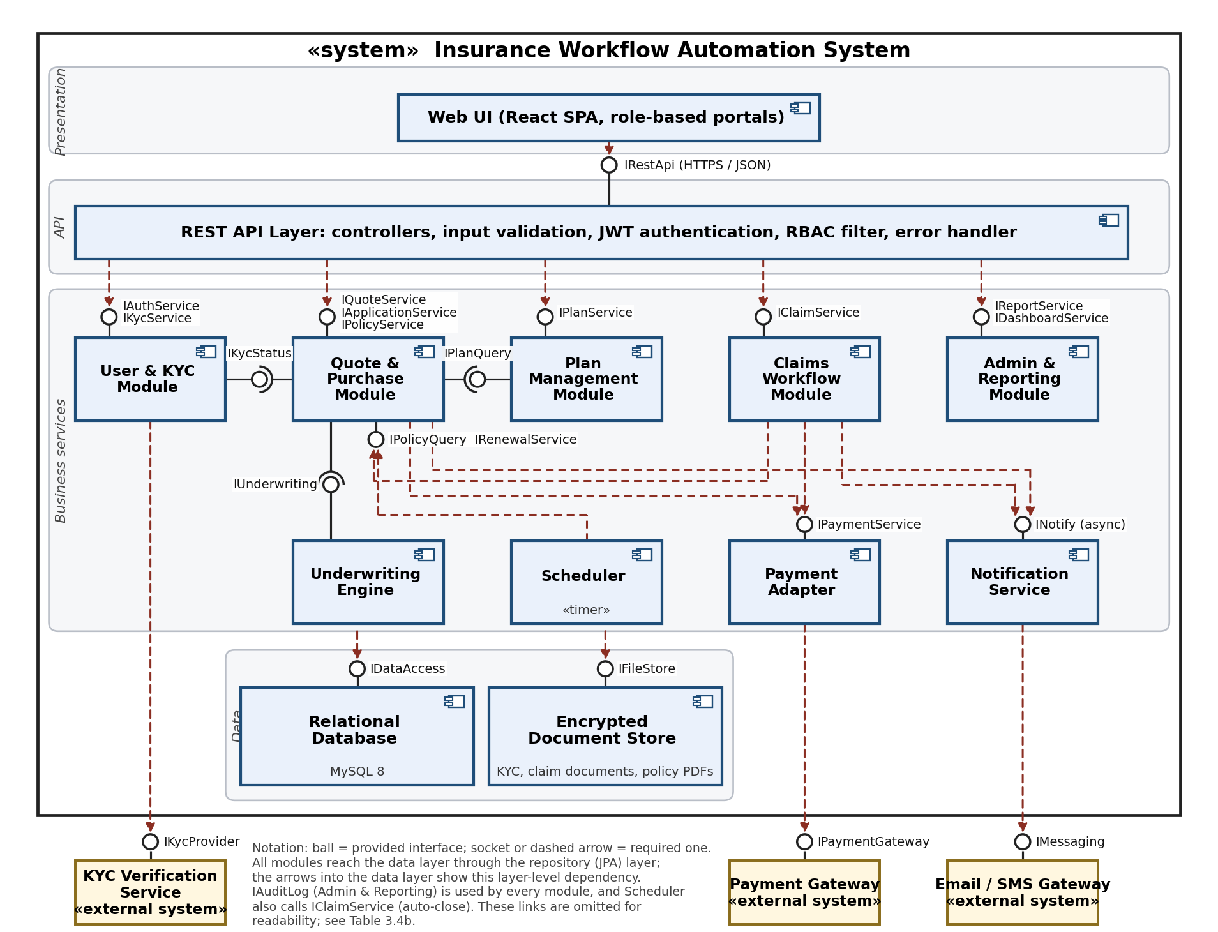

3.4 Component Descriptions
Table 3.4a: Components
ID | Component | Responsibility | Provided interfaces | Required interfaces | Requirements
C1 | Web UI | React single-page application with role-based portals (Customer, Insurer Admin, Underwriter, Claims Officer, System Admin). Shows forms, comparison tables, status timelines and dashboards. Holds no business rules; all decisions are made on the server. | - | IRestApi | INS-NF-005, INS-NF-006, INS-F-021
C2 | REST API Layer | Entry point of the server. Controllers map HTTP requests to module calls, validate input, authenticate the JWT, enforce RBAC and ownership rules (a Customer sees only own policies and claims), and convert exceptions to the standard error format. | IRestApi | IAuthService, IKycService, IPlanService, IQuoteService, IApplicationService, IPolicyService, IClaimService, IReportService, IDashboardService | INS-SR-001, INS-SR-003, INS-SR-006, INS-SR-007
C3 | User & KYC Module | Registration, login, password hashing, account lockout, server-side session records with an inactivity check, role assignment (staff users are tied to one insurer), KYC document intake and verification status (via the KYC provider). | IAuthService, IKycService, IKycStatus | IKycProvider (external), IFileStore, IDataAccess, IAuditLog | INS-F-001, INS-F-002, INS-SR-002, INS-SR-004, INS-SR-005
C4 | Plan Management Module | Insurers create and deactivate plans with premium rules, coverage, deductible, waiting period and add-ons. Customers search, filter and compare plans. | IPlanService, IPlanQuery | IDataAccess, IAuditLog | INS-F-003, INS-F-004, INS-F-022
C5 | Quote & Purchase Module | Core business module. Calculates motor and health quotes, creates applications, drives the application-to-policy flow, issues policy numbers and PDFs, handles renewal, cancellation and refunds, and serves referred-application decisions for Underwriters. | IQuoteService, IApplicationService, IPolicyService, IPolicyQuery, IRenewalService | IKycStatus, IPlanQuery, IUnderwriting, IPaymentService, INotify, IFileStore, IDataAccess, IAuditLog | INS-F-005, INS-F-006, INS-F-007, INS-F-009, INS-F-011, INS-F-019, INS-F-020, INS-F-024
C6 | Underwriting Engine | Evaluates an application against data-driven rules (SRS 4.4.1) and returns Approve, Refer or Reject with a reason; records manual decisions. A missing rule configuration produces Refer with the reason 'Missing rule configuration'. | IUnderwriting | IDataAccess (rule tables), IAuditLog | INS-F-010, INS-F-011
C7 | Claims Workflow Module | Files claims, enforces the claim state machine (no skipped states), runs the duplicate check, supports verification, assessment, decision, payout and tracking, and auto-closes claims with no reply after 15 days. | IClaimService | IPolicyQuery, IPaymentService, INotify, IFileStore, IDataAccess, IAuditLog | INS-F-012, INS-F-013, INS-F-014, INS-F-015, INS-F-023
C8 | Payment Adapter | Hides the payment gateway behind one interface for premium charges, refunds and claim payouts. Uses an idempotency key and retries (3 times) so that a retry never charges twice. Never stores card data. | IPaymentService | IPaymentGateway (external), IDataAccess | INS-F-008
C9 | Notification Service | Builds messages from templates and sends email/SMS asynchronously through an in-process queue with retry; stores a notification record for every message. | INotify | IMessaging (external), IDataAccess | INS-F-016
C10 | Scheduler | Time-based jobs: daily renewal reminders at 30, 15 and 1 day before expiry, daily auto-close of claims with no reply for 15 days, and a short-interval retry of policy issuance for applications that are paid but not yet issued. | (timer trigger) | IRenewalService, IClaimService | INS-F-017
C11 | Admin & Reporting Module | Role-specific dashboards (insurer dashboards are scoped to the staff member's insurer), reports (policies sold, claims settled, premium collected, renewals, claim approval/rejection statistics), append-only audit log (separate writer and reader database roles) and 5-year record retention. | IReportService, IDashboardService, IAuditLog | IDataAccess | INS-F-018, INS-F-021, INS-F-025, INS-NF-007, INS-SR-008
C12 | Relational Database | MySQL 8 (InnoDB). Stores users, sessions, plans, rules, quotes, applications, policies, payments, claims, notifications and audit logs. Records of insurer-owned objects carry insurerId. UNIQUE constraint on payment idempotency keys. Daily full backup. | IDataAccess | - | INS-NF-004, INS-NF-007
C13 | Encrypted Document Store | Stores KYC documents, claim documents and generated policy PDFs encrypted at rest (AES-256). | IFileStore | - | INS-SR-004, INS-SR-007

Table 3.4b: Interface catalogue
Interface | Provider | Consumers | Key operations
IRestApi | REST API Layer | Web UI | HTTPS/JSON endpoints listed in section 4.3
IAuthService | User & KYC | REST API | register, login, logout, assignRole
IKycService | User & KYC | REST API | submitKyc, getKycStatus
IKycStatus | User & KYC | Quote & Purchase | isVerified(userId)
IPlanService | Plan Management | REST API | create, update, deactivate, list, search, compare
IPlanQuery | Plan Management | Quote & Purchase | getPlan(planId), getRatingRules(planId)
IQuoteService | Quote & Purchase | REST API | motorQuote(input), healthQuote(input)
IApplicationService | Quote & Purchase | REST API | submit(application), listReferred(), decide(id, decision, reason)
IPolicyService | Quote & Purchase | REST API | list, get, getDocument, renewalQuote, renew, requestCancellation, decideCancellation
IPolicyQuery, IRenewalService | Quote & Purchase | Claims Workflow, Scheduler | getPolicy(id); findExpiringIn(days), sendReminder(policyId), retryPendingIssuance()
IUnderwriting | Underwriting Engine | Quote & Purchase | evaluate(application), recordManualDecision(id, decision, reason)
IClaimService | Claims Workflow | REST API, Scheduler | file, get, list, verify, decide, closeStale()
IPaymentService | Payment Adapter | Quote & Purchase, Claims Workflow | charge, refund, payout, getStatus
INotify | Notification Service | Quote & Purchase, Claims Workflow | send(event, recipient, params)
IReportService, IDashboardService | Admin & Reporting | REST API | generate(type, from, to); getDashboard(role, userId)
IAuditLog | Admin & Reporting | All modules | record(user, action, entity, entityId) uses the audit-writer DB role; query(filters) uses the audit-reader DB role
IDataAccess | Relational Database | All modules | repository (JPA) operations inside transactions
IFileStore | Encrypted Document Store | User & KYC, Quote & Purchase, Claims Workflow | put(file) returns id, get(id), delete(id)
IPaymentGateway | Payment Gateway (external) | Payment Adapter | createPayment, createPayout, createRefund (simulated)
IMessaging | Email / SMS Gateway (external) | Notification Service | sendEmail, sendSms (simulated)
IKycProvider | KYC Verification Service (external) | User & KYC | verify(pan, aadhaar) (simulated)

3.5 Chosen Architecture Pattern and Rationale
Pattern: layered architecture, built as a modular monolith. The server is one deployable application, internally split into business modules that may call each other only through the interfaces in Table 3.4b. The layers are Presentation (Web UI), API (REST controllers, security filter), Business services (modules) and Data (database and document store).
Why this pattern:
- Clear separation of concerns: UI has no business rules, so rules cannot be bypassed from the browser.
- Several operations need one transaction (create application, record payment, issue policy); a single database and process keeps these simple and consistent.
- A team of four can own modules in parallel and test them in isolation.
- One deployable unit is easy to run, monitor and back up.
- Because modules interact only through interfaces, any module can later be moved into its own service.
Alternatives considered:
- Microservices: rejected. Distributed transactions (payment plus policy) and operations work are too heavy for 500 users and a two-week project.
- Two-tier client-server with rules in the client: rejected. Rules in the browser can be tampered with, which violates INS-SR-003 and INS-SR-006.
- Fully event-driven: rejected as the main style, but used where it helps: notifications are asynchronous (ADR-005).
Architecture Decision Records
ID | Decision | Reason | Status
ADR-001 | Layered architecture as a modular monolith (one deployable, internal modules) | Small team and short time; ACID transactions across application, payment and policy; simple testing and deployment. Modules talk only through their interfaces, so they can be split into services later. | Accepted
ADR-002 | REST over HTTPS with JSON between UI and server | Simple, easy to test with Postman and to document with OpenAPI; works with every browser. | Accepted
ADR-003 | Relational database (MySQL 8) | Policies, payments and claims need strong consistency and transactions; data is highly relational. | Accepted
ADR-004 | Premium and underwriting rules stored as data, evaluated by code | Thresholds (for example vehicle age 15 and 20, age 60 and 70) can change without redeploying; a missing configuration is routed to manual review with a clear reason. | Accepted
ADR-005 | Asynchronous notifications through an in-process queue with retry | A slow or failing email/SMS service must not block quoting, payment or claims; retries and a failure log keep messages from being lost. | Accepted
ADR-006 | JWT access tokens plus a server-side session record (lastActivityAt) with RBAC | A JWT cannot know about inactivity, so the server keeps a small session record per login and rejects a request idle for more than 15 minutes (INS-SR-005). The session store is shared by all application instances, so scaling is not affected (INS-NF-002). | Accepted
ADR-007 | Payment Adapter with database-enforced idempotency; payment success persisted before policy issuance; card data never stored | A retry after a timeout must not charge twice (UNIQUE idempotency key); a failure after a successful payment must not lose the payment or charge again, so issuance is retryable; storing no card data keeps PCI scope minimal. | Accepted
ADR-008 | Claims, applications and policies implemented as explicit state machines | Allowed transitions are listed in one place, so a state cannot be skipped (INS-F-013). The initial state is persisted before automatic processing, and the history records every transition. | Accepted
ADR-009 | Insurer-scoped data access (insurerId on insurer-owned records and in every staff query) | The system is a multi-insurer marketplace; staff of insurer A must never see applications, claims or cancellations of insurer B. Scoping is applied in the service layer from the authenticated user, not from request parameters. | Accepted

3.6 Technology Stack & Data Stores
Area | Choice | Reason
Web UI | React 18, responsive CSS (Bootstrap) | Component-based UI, one codebase for desktop, tablet and phone
Server | Java 17, Spring Boot 3 (Spring MVC, Spring Security, Spring Data JPA, @Scheduled/Quartz) | Mature stack with built-in security, validation and scheduling; matches the template's technology choice
PDF generation | OpenPDF | Policy documents and renewal certificates
Database | MySQL 8 (InnoDB, utf8mb4) | ACID transactions, wide tool support
File storage | Encrypted files on server disk (or an S3-compatible bucket) | KYC and claim documents, policy PDFs
Authentication | JWT access tokens, bcrypt password hashes | Stateless, scalable
Async messaging | Spring events with a retrying queue (RabbitMQ later if needed) | Non-blocking notifications
Deployment | Docker, Nginx reverse proxy with TLS, cloud VM | Repeatable setup, TLS termination
Build and test | Maven, JUnit 5, Mockito, Postman/Newman, Selenium, JMeter, Jira, GitHub Actions | Same tools as the Test Plan template
Monitoring | Spring Boot Actuator, Prometheus and Grafana (or log-based dashboards) | Health, latency and error metrics
The team may substitute technologies (for example PostgreSQL or Python/FastAPI) as long as the interfaces in Table 3.4b and the APIs in section 4.3 are kept.
Data stores:
- Relational database (MySQL): all business data, configuration tables (premium rules, underwriting rules), notification records and the audit log.
- Encrypted document store: KYC documents, claim documents, generated policy PDFs and renewal certificates; the database stores only file IDs and metadata.
- In-memory cache: rating rules and underwriting rules per plan, reloaded when an Insurer Admin changes a plan.

3.7 Risks & Mitigations
Risk | Mitigation
Payment gateway is slow or down | Timeouts, retries with the same idempotency key, clear Failed state, no policy issued until success
Email/SMS service fails | Asynchronous queue with 3 retries and a failed-notification log; workflows never wait for delivery
Wrong premium or refund calculation | Unit tests using the worked examples in SRS 4.6.2 and rating rules; peer review of rules
Leak of KYC or health data | TLS, AES-256 at rest, RBAC with ownership checks, no sensitive data in logs, least-privilege DB user
Modules become tightly coupled | Access only through interfaces; package-dependency tests (for example ArchUnit); code review
Slow quotes at 500 users | Cache rating rules, index key columns, connection pool, JMeter load test before submission
Four people, two weeks | Build High-priority requirements first; Medium ones only if time remains; simulated external services
Simulated services differ from real ones | Hide each behind an adapter interface; contract tests against the interface
Payment succeeds but policy issuance fails | Payment success is persisted first; issuance is idempotent and retried by the Scheduler; application stays Paid; customer is never charged twice
Staff of one insurer see another insurer's data | insurerId on records and in every staff query, taken from the authenticated user; automated tests with two insurers
Fraudulent or duplicate claims | Duplicate rule (policy + date + amount) with manual review; audit trail of every decision
Data loss | Daily backups, restore drill, replicas not required for MVP

3.8 Traceability to Requirements
Every requirement in SRS v1.2 maps to a component and an interface. The Design Spec IDs are those used in the SRS RTM (section 8). Sequence diagrams are SD-1 to SD-4 in section 4.2.
Req ID | Requirement | Design spec | Component | Interface operation | API / sequence
INS-F-001 | Register / login with roles | DS-User-01 | C3 User & KYC | IAuthService.register, login | POST /auth/register, /auth/login
INS-F-002 | KYC upload and verification | DS-User-02 | C3 User & KYC | IKycService.submitKyc, getKycStatus | POST /kyc, GET /kyc/status
INS-F-003 | Manage plans and premium rules | DS-Plan-01 | C4 Plan Management | IPlanService.create, update, deactivate | POST /plans, PUT /plans/{id}
INS-F-004 | Browse and compare plans | DS-Plan-02 | C4 Plan Management | IPlanService.list, compare | GET /plans, GET /plans/compare
INS-F-022 | Search and filter plans | DS-Plan-03 | C4 Plan Management | IPlanService.search | GET /plans?insurer=&type=&premiumMax=&coverageMin=
INS-F-005 | Motor quote | DS-Quote-01 | C5 Quote & Purchase | IQuoteService.motorQuote | POST /quotes/motor
INS-F-006 | Health quote | DS-Quote-02 | C5 Quote & Purchase | IQuoteService.healthQuote | POST /quotes/health
INS-F-007 | Submit application | DS-Quote-03 | C5 Quote & Purchase | IApplicationService.submit | POST /applications; SD-1
INS-F-010 | Rule-based auto-underwriting | DS-UW-01 | C6 Underwriting Engine | IUnderwriting.evaluate | SD-1
INS-F-011 | Manual review of referred cases | DS-UW-02 | C5 + C6 | IApplicationService.decide; IUnderwriting.recordManualDecision | GET /applications/referred, POST /applications/{id}/decision; SD-1
INS-F-008 | Online premium payment | DS-Pay-01 | C8 Payment Adapter | IPaymentService.charge | POST /payments; SD-2
INS-F-009 | Generate policy and document | DS-Policy-01 | C5 Quote & Purchase | IPolicyService (issue); IRenewalService.retryPendingIssuance | SD-2; section 4.1.5
INS-F-024 | Download policy documents | DS-Policy-02 | C5 Quote & Purchase | IPolicyService.getDocument | GET /policies/{id}/document
INS-F-017 | Renewal reminders | DS-Ren-01 | C10 Scheduler + C9 | IRenewalService.findExpiringIn; INotify.send | daily timer job
INS-F-019 | Policy renewal processing | DS-Ren-02 | C5 Quote & Purchase | IPolicyService.renewalQuote, renew | POST /policies/{id}/renewal-quote, /renew; section 4.1.6
INS-F-020 | Policy cancellation and refund | DS-Can-01 | C5 Quote & Purchase | IPolicyService.requestCancellation, decideCancellation | POST /policies/{id}/cancellation, POST /cancellations/{id}/decision; section 4.1.6
INS-F-012 | File a claim | DS-Clm-01 | C7 Claims Workflow | IClaimService.file | POST /claims; SD-3
INS-F-013 | Claim workflow states | DS-Clm-02 | C7 Claims Workflow | state machine (section 4.1.3) | SD-3, SD-4
INS-F-014 | Verify, assess and decide claim | DS-Clm-03 | C7 Claims Workflow | IClaimService.verify, decide | POST /claims/{id}/verify, /decision; SD-3, SD-4
INS-F-015 | Track claim status | DS-Clm-04 | C7 Claims Workflow | IClaimService.get | GET /claims/{id}
INS-F-023 | Duplicate claim detection | DS-Clm-05 | C7 Claims Workflow | duplicate check inside verify | SD-3
INS-F-016 | Status-change notifications | DS-Ntf-01 | C9 Notification Service | INotify.send | event catalogue 4.1.7; all sequence diagrams
INS-F-018 | Audit log | DS-Adm-01 | C11 Admin & Reporting | IAuditLog.record, query | GET /audit
INS-F-021 | Role-specific dashboards | DS-Adm-02 | C11 Admin & Reporting | IDashboardService.getDashboard | GET /dashboard
INS-F-025 | Admin reports | DS-Adm-03 | C11 Admin & Reporting | IReportService.generate | GET /reports/{type}

Non-functional and security requirements:
Req ID | Requirement | Component | Design mechanism
INS-NF-001 | Quote within 5 s (95%) | C5, C4, C12 | Rating rules cached in memory; indexed queries; no external call during quoting
INS-NF-002 | 500 concurrent users | C2, all modules | Stateless API (JWT) so instances scale behind a load balancer; DB connection pool; async notifications
INS-NF-003 | 99% availability | Deployment, C2 | Two application instances behind Nginx, health checks, automatic restart
INS-NF-004 | Daily backup, restore in 4 h | C12, C13 | Daily full DB backup and file-store snapshot; documented restore drill
INS-NF-005 | Responsive UI | C1 | Mobile-first layout, tested down to 360 px width
INS-NF-006 | Browser support | C1 | No browser-specific APIs; cross-browser smoke tests
INS-NF-007 | 5-year retention | C11, C12 | Soft delete only; retention job never removes records younger than 5 years
INS-SR-001 | HTTPS / TLS 1.2+ | Nginx, C2 | TLS terminated at the reverse proxy; HTTP redirected or blocked; HSTS on
INS-SR-002 | Salted password hashing | C3 | bcrypt (cost 12); passwords never logged
INS-SR-003 | RBAC, deny by default | C2 | Role annotations on every endpoint, ownership checks for customers, and insurerId scoping for every insurer-staff query (section 4.1.4)
INS-SR-004 | Encryption at rest (AES-256) | C13, C12 | Files encrypted before storage; sensitive columns encrypted; keys kept outside the database
INS-SR-005 | Lockout and session expiry | C3, C2 | 5 failed logins lock the account for 15 min. Each login creates a server-side session record with lastActivityAt; every authenticated request updates it and is rejected if the idle time exceeds 15 min (section 3.9)
INS-SR-006 | Validation and injection defence | C2, all modules | Bean validation on DTOs, parameterised JPA queries, output encoding in the UI
INS-SR-007 | Secure file upload | C2, C13 | Allow-list PDF/JPG/PNG, 5 MB limit, simulated virus scan before storage
INS-SR-008 | Append-only audit log | C11, C12 | Two database roles: audit_writer (INSERT only) and audit_reader (SELECT only, used by the System Admin /audit query). No role has UPDATE or DELETE. Every payment and claim decision records the user

3.9 Security Architecture
Trust boundaries: (1) Internet to Web UI/API (untrusted to semi-trusted), (2) API layer to business modules (all calls authenticated and authorised), (3) business modules to data layer (least-privilege database user), (4) business modules to external systems (outbound over HTTPS through adapters only).
Data classification: Restricted = KYC documents, health declarations, password hashes. Confidential = policies, claims, payments, notifications. Internal = plan catalogue, reports. Restricted data is encrypted at rest and never written to logs.
Insurer isolation (multi-insurer marketplace): every User has an insurerId. Customers and System Admins have none (NULL); Insurer Admins, Underwriters and Claims Officers must have one. Insurer-owned records (Plan, Application, Policy, CancellationRequest, Claim) carry the insurerId copied from the plan. All insurer-staff queries are automatically scoped to the authenticated user's insurerId, which is read from the server-side session and never from a request parameter. Access to another insurer's record returns 403 (details in section 4.1.4).
Session management and inactivity (INS-SR-005): a JWT carries only an expiry time and cannot know whether the user was idle, so the server keeps a session record (sessionId, userId, role, insurerId, lastActivityAt, revoked) for every login. The short-lived access token (15 minutes, renewed while the session is active) includes the sessionId. On every authenticated request the API layer loads the session, rejects the request with AUTH-401 if the time since lastActivityAt is more than 15 minutes or the session is revoked, and otherwise updates lastActivityAt. A hard maximum session length of 8 hours also applies. The session store is shared by all application instances, so any instance can serve any request.
Audit log access: two database roles are used. audit_writer may only INSERT and is used by IAuditLog.record in every module; audit_reader may only SELECT and is used by the System Admin's /audit query. No role, including the application's normal user, has UPDATE or DELETE on the audit table.
Threat modelling (STRIDE):
Threat | Example in this system | Mitigation | Requirements
Spoofing | Attacker logs in as another user or forges a token | bcrypt hashes, account lockout (5 failures), signed short-lived JWT, HTTPS only | INS-SR-001, 002, 005
Tampering | Customer changes premium, underwriting outcome or claim amount in a request | Server recalculates premium and re-checks state; parameterised queries; state machines reject illegal transitions; audit log | INS-SR-003, 006, 008
Repudiation | A user denies approving a claim or cancellation | Append-only audit log with user, action, entity and time for every key action | INS-SR-008, INS-F-018
Information disclosure | KYC documents, health declarations or policies read by the wrong person, including staff of another insurer | TLS, AES-256 at rest, ownership checks, insurerId scoping of all staff queries, no sensitive data in logs or error messages | INS-SR-001, 003, 004
Denial of service | Flood of login, quote or upload requests | Rate limiting on login and quote APIs, upload size limits, connection pool limits, health checks and restart | INS-NF-002, 003, INS-SR-007
Elevation of privilege | Customer calls an Insurer Admin or Claims Officer API; staff member changes the insurer in a request | Deny-by-default RBAC on every endpoint, role and insurerId taken from the session, never from the request; ownership check in services | INS-SR-003
Security design rules for developers:
- Check the role in the API layer and ownership in the service layer for every operation (deny by default).
- Never trust values from the client: the server recomputes premium, refund and underwriting outcome, and takes role and insurerId only from the session.
- Scope every insurer-staff query by insurerId (section 4.1.4).
- Use parameterised queries only; encode output in the UI.
- Log who did what, but never passwords, PAN or Aadhaar numbers, medical details or payment details.
- Send payments and payouts only through the Payment Adapter, always with an idempotency key.

4. Design

4.1 Design Overview
The system is a stack of layers; a request flows Web UI, REST API (authentication, validation, RBAC), business module, repository, database. Four design ideas run through all modules: (1) rules are data (premium and underwriting rules are rows, not hard-coded constants), (2) long workflows are explicit state machines, (3) money movement is idempotent and goes through one adapter, (4) every status change calls the notification service and the audit log.

4.1.1 Key data model
Entity | Key attributes | Relationships
User | id, name, email, passwordHash, phone, role, insurerId (NULL for Customer and System Admin; required for Insurer Admin, Underwriter, Claims Officer), kycStatus, failedLogins, lockedUntil | 1 User : many Applications, Policies, Claims; a staff User belongs to one Insurer
Session | sessionId, userId, role, insurerId, createdAt, lastActivityAt, expiresAt, revoked | belongs to User; checked on every request
Insurer | id, name, active | 1 Insurer : many Plans, Insurer Admins
Plan | id, insurerId, type (2W, 4W, HEALTH), name, coverageAmount, deductible, waitingPeriodMonths, addOns, active | belongs to Insurer; has many PremiumRules, UnderwritingRules
PremiumRule / UnderwritingRule | planId, field, operator, threshold, factor or outcome (Approve/Refer/Reject), priority | belongs to Plan
Quote | id, userId, planId, inputs, premium, createdAt | may become one Application
Application | id, userId, planId, insurerId, quoteId, details, status, uwOutcome, uwReason | 1 Application : 0..1 Policy; insurerId copied from Plan
Policy | id, policyNo, applicationId, userId, planId, insurerId, startDate, endDate, premiumPaid, status, previousPolicyId | has many Claims, CancellationRequests; renewal links to previousPolicyId
Payment | id, kind (PREMIUM, REFUND, PAYOUT), refId, attemptNo, amount, status, idempotencyKey (UNIQUE), gatewayRef | refers to Application, CancellationRequest or Claim
CancellationRequest | id, policyId, insurerId, reason, status, refundAmount, decidedBy | belongs to Policy
Claim | id, policyId, insurerId, incidentDate, claimedAmount, assessedAmount, status, duplicateFlag, decisionReason | has many ClaimStatusHistory, Documents
Document | id, ownerType, ownerId, type, storageId, sizeBytes | belongs to User, Application or Claim
Notification | id, userId, event, channel, status, attempts, createdAt | belongs to User
AuditLog | id, userId, action, entity, entityId, createdAt (append-only) | refers to any entity

4.1.2 Application, policy and cancellation states
Object | States | Rule
Application | Submitted, Referred, Approved, Rejected, Paid | Payment is allowed only in Approved; Referred waits for the Underwriter
Policy | Active, Cancellation Requested, Cancelled, Expired | A renewal creates a new Policy linked to the old one; renewal window is 30 days before to 15 days after expiry
Cancellation request | Requested, Approved, Rejected, Refunded | Refund is calculated only after approval (SRS 4.6.2)
Submitted state and automatic transitions: the initial state (Submitted) is persisted, with a history entry, before any automatic processing starts. The service then performs the next transition inside the same workflow (for an application: underwriting gives Approved, Referred or Rejected; for a claim: Submitted moves to Document Verification). The status history records both states, so the SRS states are never skipped even though the API response already shows the later state.

4.1.3 Claim state machine
Allowed transitions (anything else is refused with error STATE-409): Submitted to Document Verification; Document Verification to Assessment, Rejected, or Closed - No Response; Assessment to Approved or Rejected; Approved to Payment Processing; Payment Processing to Settled (a failed payout stays in Payment Processing and is retried). Rejected, Settled and Closed - No Response are final. The duplicate check runs on entry to Document Verification.

4.1.4 Multi-insurer isolation
Rule: all insurer-staff queries and commands are automatically scoped to the authenticated user's insurerId. This is enforced in the service layer (not only in the UI) by adding the insurerId condition to every repository query for insurer-owned records, and by comparing the insurerId of a loaded record with the session's insurerId before any change.
Staff role | Can see and change | Cannot
Insurer Admin (insurerId = A) | Plans, premium and underwriting rules, cancellation requests, dashboard figures of insurer A only | Anything of insurer B; create plans for another insurer
Underwriter (insurerId = A) | Referred applications for plans of insurer A | Referred applications of insurer B
Claims Officer (insurerId = A) | Claims on policies of insurer A | Claims of insurer B
System Admin (insurerId = NULL) | Users, insurers, audit log and reports across all insurers | Underwriting or claim decisions (not a staff role of any insurer)
Customer (insurerId = NULL) | Own quotes, applications, policies and claims, with any insurer | Records of other customers
Result of a violation: a list endpoint simply omits records of other insurers; a direct request for another insurer's record returns 403 ACCESS-403 and is written to the audit log. Test idea for the STP: create two insurers with staff and records, and verify that no endpoint returns or accepts the other insurer's data.

4.1.5 Payment, idempotency and policy issuance recovery
- Idempotency is enforced by the database: Payment.idempotencyKey has a UNIQUE constraint. A repeated request with the same key returns the original payment result and never creates a second charge.
- The key identifies one payment attempt: key = applicationId + attemptNo. Retries after a gateway timeout and double-clicks reuse the same key. If the customer retries after a Failed result, a new attempt is created with attemptNo + 1 and a new key, so a legitimate retry is possible.
- The Payment Adapter persists the payment result (SUCCESS or FAILED) in its own transaction before any policy is issued.
- On SUCCESS the application moves to Paid and policy issuance starts (policy number, PDF, status Active). Issuance is idempotent: it first looks for a policy for this application and creates one only if none exists.
- If issuance fails (for example PDF generation), the payment stays recorded, the application stays Paid, and the customer sees 'Payment received, your policy is being issued'. The Scheduler runs retryPendingIssuance() every few minutes until the policy exists; the customer is never charged twice.
- The same rules apply to refunds and claim payouts (kind = REFUND or PAYOUT).

4.1.6 Refund and renewal calculation rules
Refund (implements SRS 4.6.2 and is the test oracle for the STP). Fee = 5% of the premium paid for the current term. All money amounts are rounded down to the whole rupee.
Case | Formula
A claim has been paid on the policy | refund = 0
Cancelled within the 15-day free-look period, no claim | refund = premiumPaid - fee
Cancelled after the free-look period, no claim | refund = max(0, premiumPaid x unusedDays / totalDays - fee)
Example 1: premium Rs 12,000, cancelled on day 10, no claim | 12,000 - 600 = Rs 11,400
Example 2: premium Rs 12,000, 365-day term, cancelled on day 100, no claim | 12,000 x 265 / 365 = 8,712.33; minus 600 = 8,112.33; rounded down = Rs 8,112
Renewal quote (implements SRS 4.6.1). IPolicyService.renewalQuote performs these steps in order:
1. Validate the renewal window: from 30 days before expiry up to 15 days after expiry; otherwise return STATE-409.
2. Load the current policy and its plan (the plan must still be active; otherwise the customer is offered similar active plans).
3. Update the risk inputs: customer age (health), or vehicle age and reduced IDV (motor).
4. Apply the insurer's current premium rules for the plan to get the new base premium.
5. Apply the 10% no-claim discount to the own-damage premium for motor policies with no claim in the previous term.
6. Return the renewal quote (premium, breakdown, renewableUntil).
7. On renew: collect payment through the Payment Adapter (section 4.1.5), then create a new Policy with previousPolicyId = old policy, a term starting at the old expiry date, and a renewal certificate.
8. Send POLICY_RENEWED.

4.1.7 Notification event catalogue
Every status change of an application, policy, renewal, cancellation or claim sends one event (INS-F-016). INotify.send takes the event name below.
Event | Sent when | Recipient
APPLICATION_APPROVED | Underwriting gives Approve, or the Underwriter approves | Customer
APPLICATION_REFERRED | Underwriting gives Refer | Customer, insurer's Underwriters
APPLICATION_REJECTED | Underwriting or the Underwriter rejects (with reason) | Customer
PAYMENT_FAILED | A payment attempt fails | Customer
POLICY_ISSUED | Policy becomes Active after payment | Customer
POLICY_RENEWED | A renewal policy is issued | Customer
RENEWAL_REMINDER | 30, 15 and 1 day before expiry | Customer
CANCELLATION_REQUESTED | Customer requests cancellation | Customer, Insurer Admin
CANCELLATION_APPROVED | Insurer Admin approves; refund amount included | Customer
CANCELLATION_REJECTED | Insurer Admin rejects | Customer
CLAIM_RECEIVED | Claim is filed (Submitted, then Document Verification) | Customer
CLAIM_DOCUMENTS_REQUESTED | Claims Officer requests additional documents | Customer
CLAIM_APPROVED | Claim approved (moves to Payment Processing) | Customer
CLAIM_REJECTED | Claim rejected (with reason) | Customer
CLAIM_SETTLED | Payout succeeded | Customer
CLAIM_CLOSED | No reply to a document request for 15 days | Customer

4.2 UML Sequence Diagrams
Four sequence diagrams (on this page and the next three) cover the two main project flows in detail. SD-1 and SD-2 show buying a policy (apply and underwrite, then pay and issue); SD-3 and SD-4 show a claim (file and verify, then assess and settle). In every diagram the Web UI and REST API are shown as one participant; the API layer checks the JWT, role and input before it calls the module.
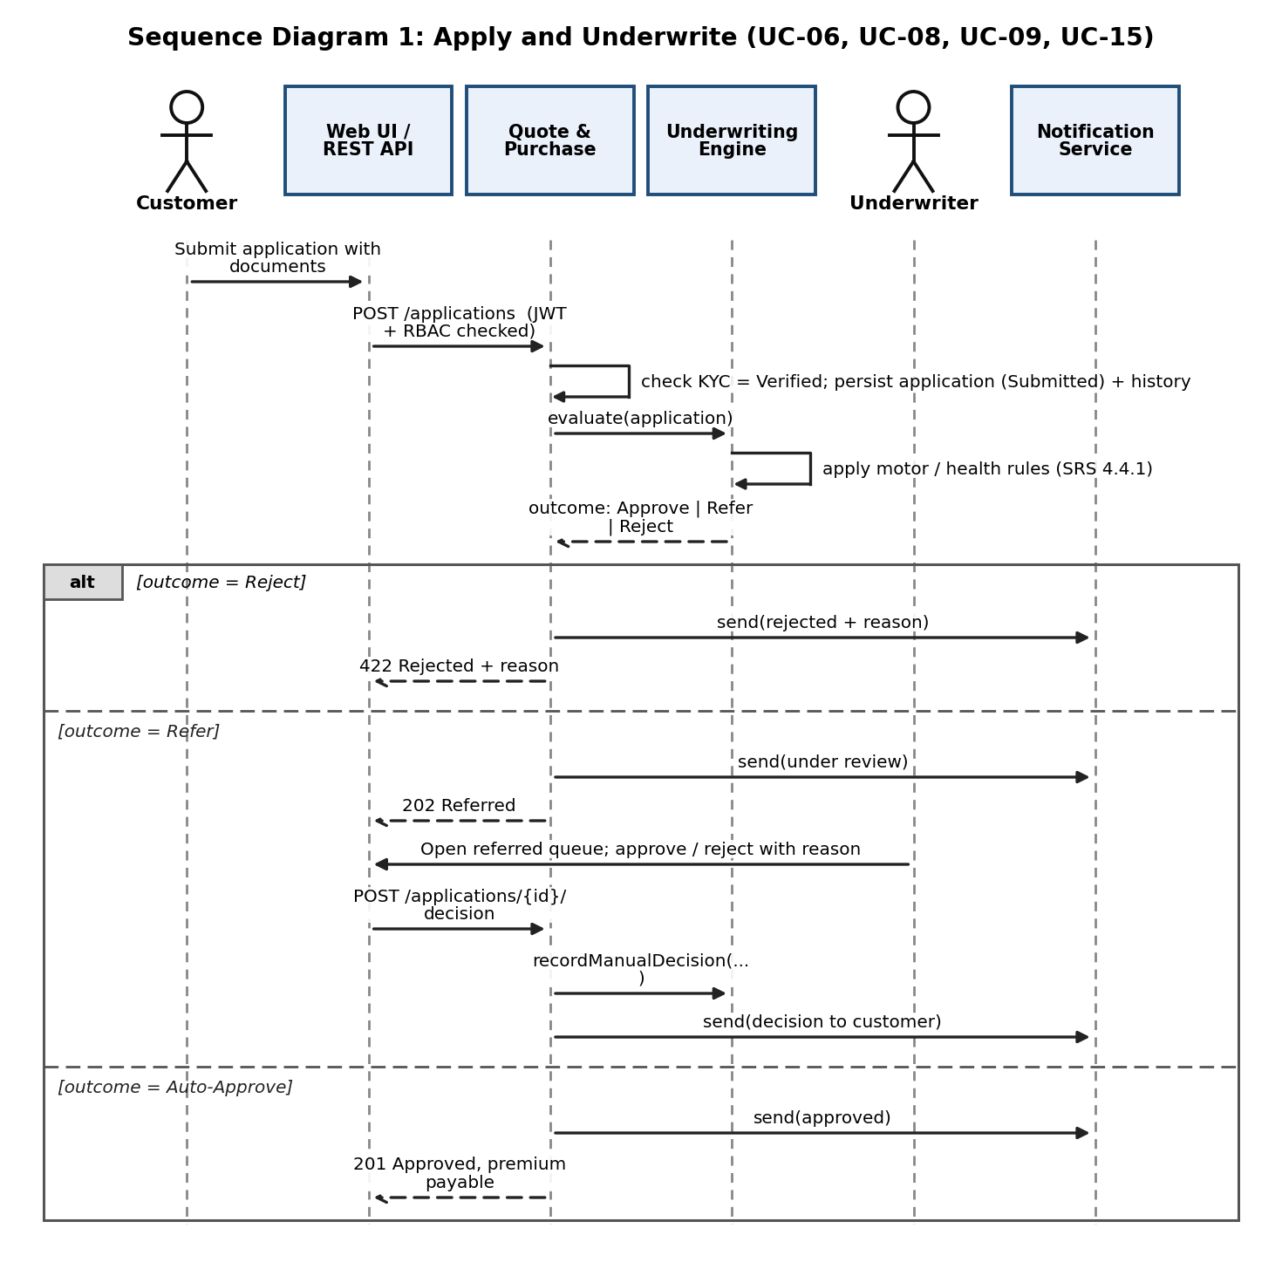
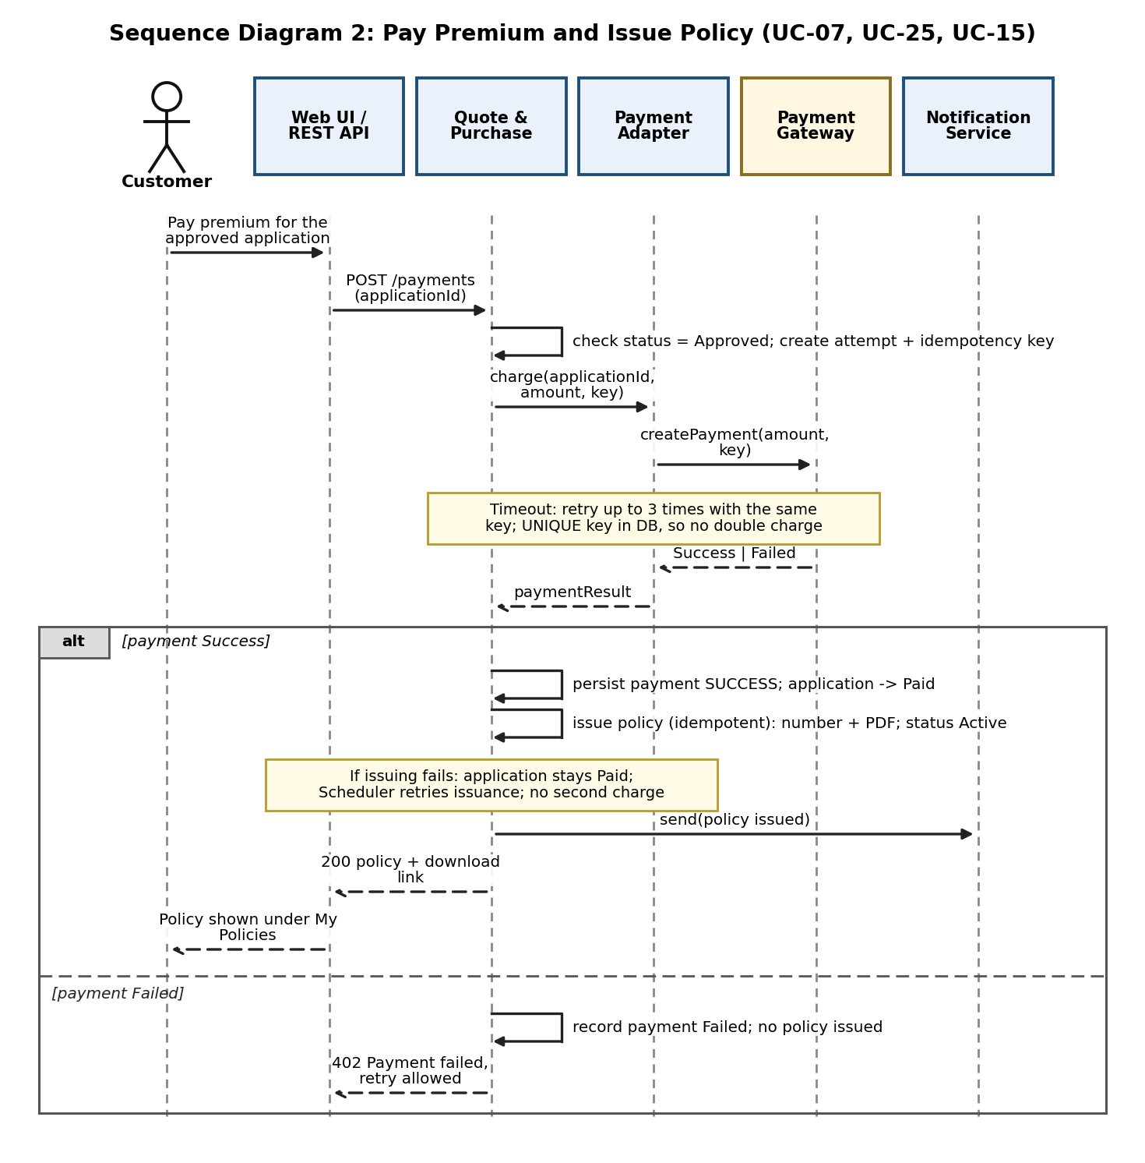
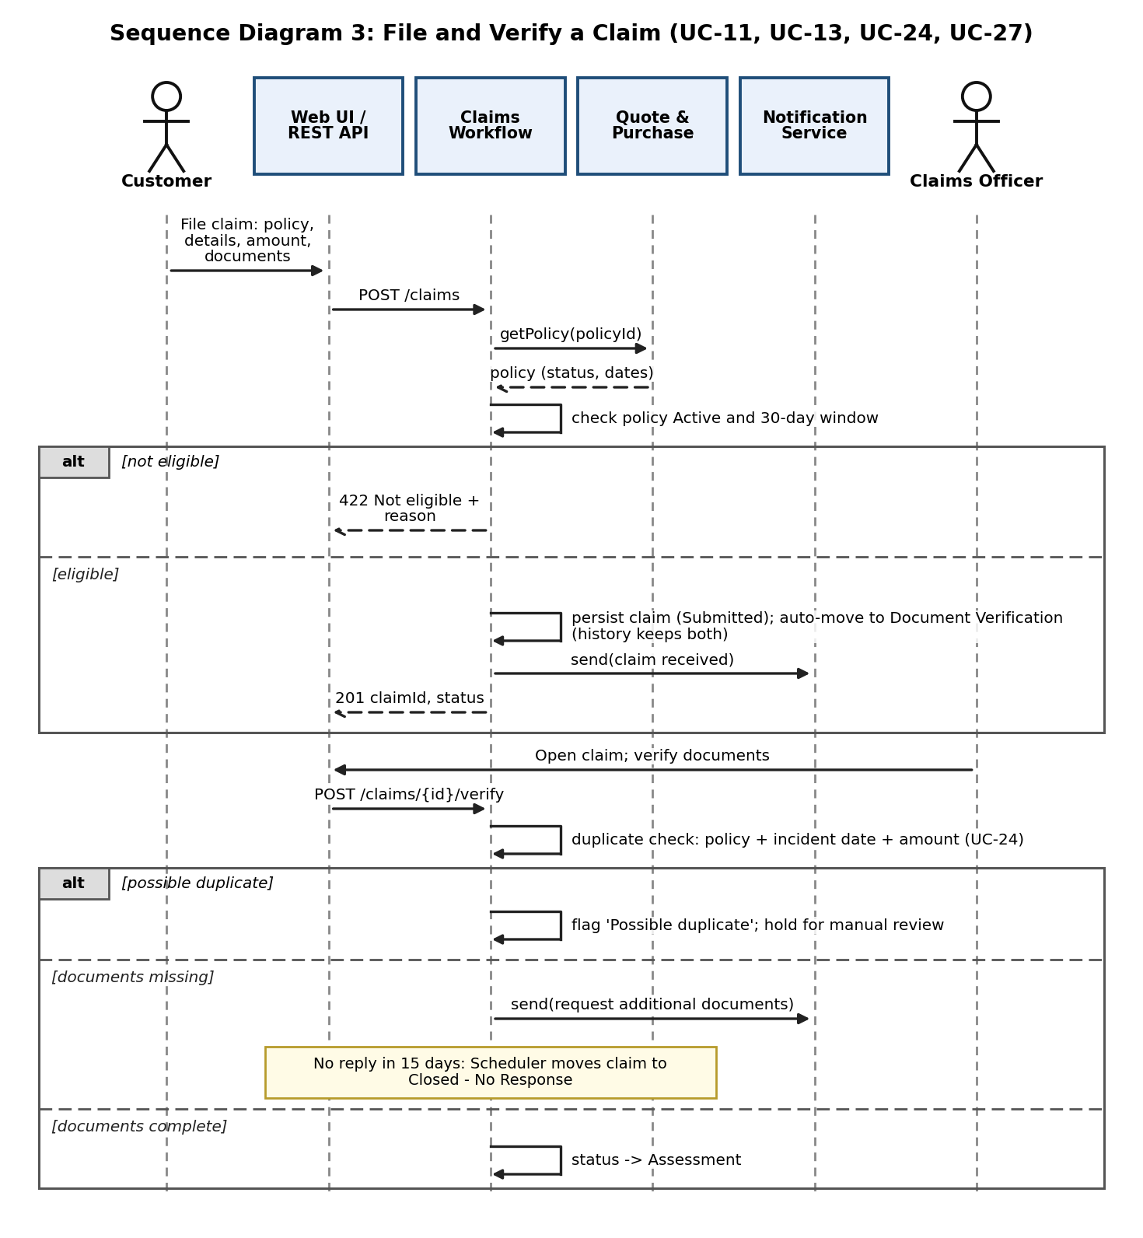
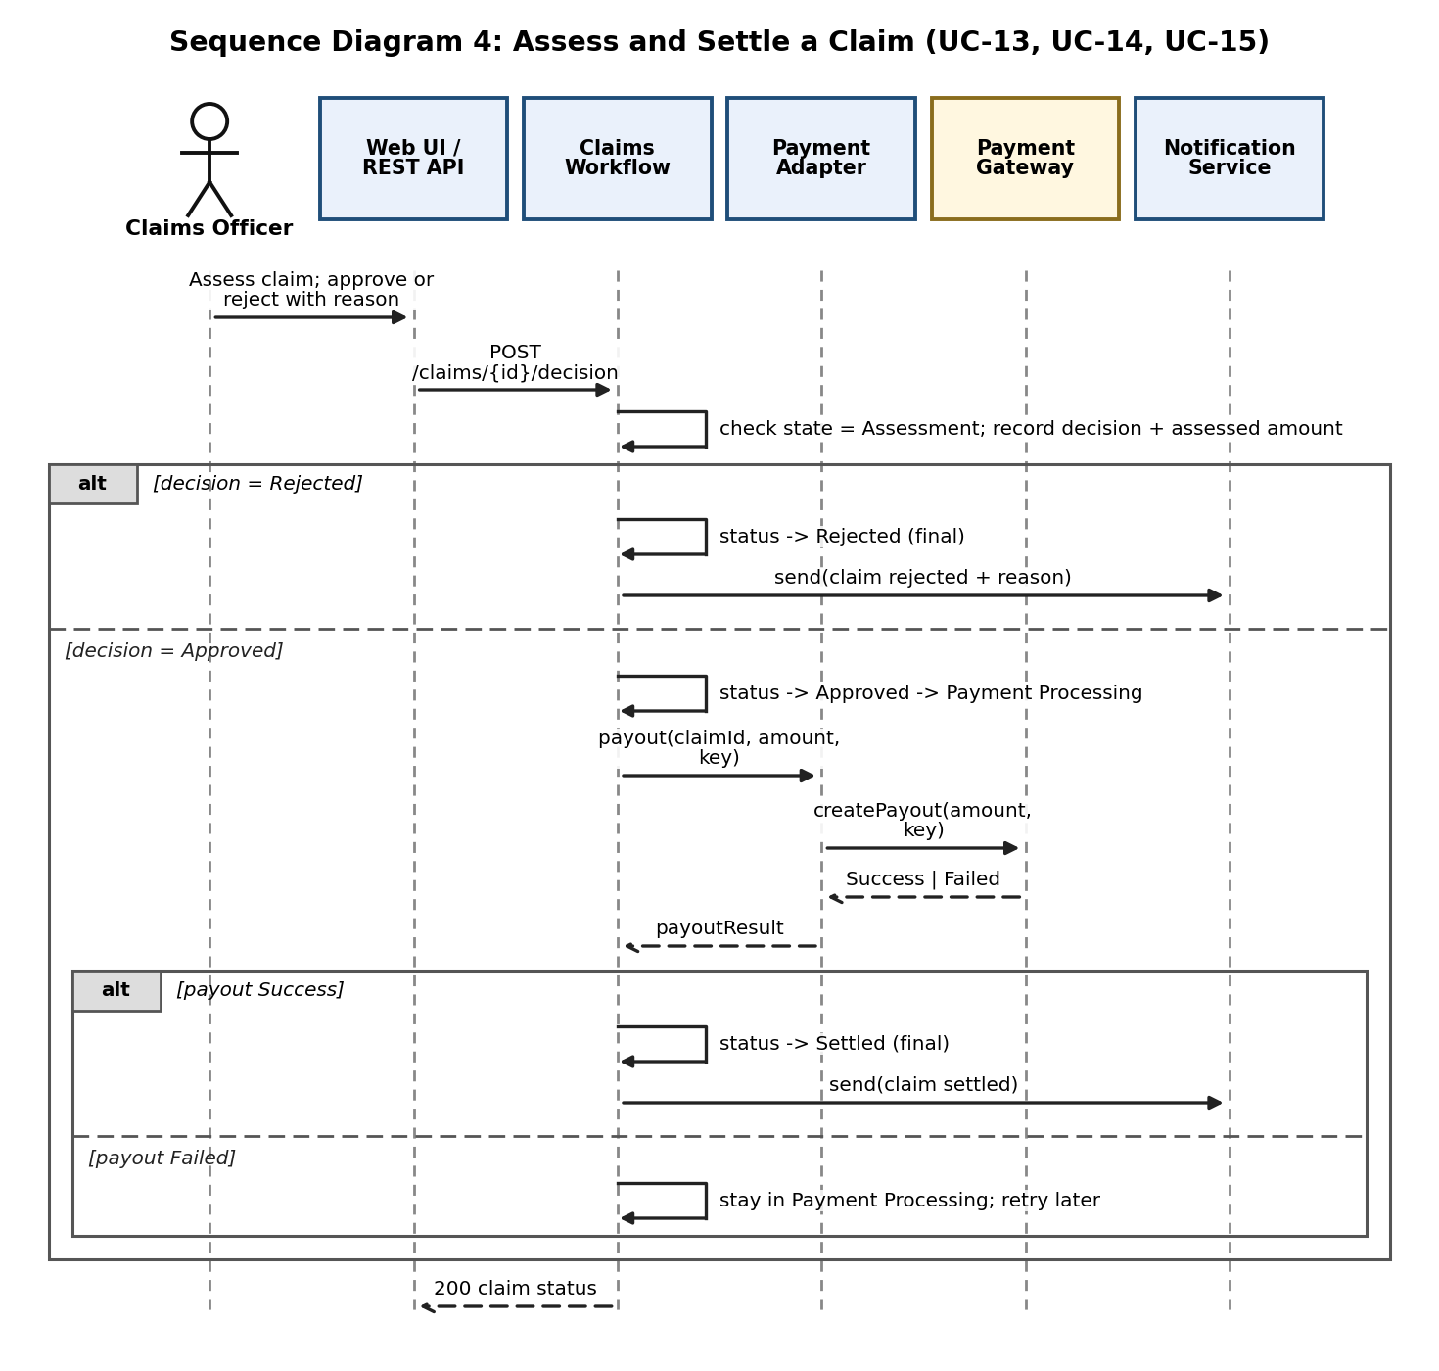

4.3 API Design
All endpoints are under /api/v1, use JSON over HTTPS and (except register, login and the public plan-browsing endpoints) need a Bearer JWT whose session is still active (section 3.9). Plan browsing and comparison are public, as in SRS use case UC-04 (no login needed to browse); quotes and everything after them need a logged-in Customer. Insurer-staff endpoints are always scoped to the staff member's insurer (section 4.1.4). Roles: C = Customer, IA = Insurer Admin, UW = Underwriter, CO = Claims Officer, SA = System Admin. Every list endpoint supports page and size. Amounts are in rupees.

4.3.1 Authentication and KYC (User & KYC Module)
Endpoint | Method | Role | Request | Response | Errors
/auth/register | POST | Public | {name, email, phone, password} | 201 {userId} | 400 invalid input; 409 email exists
/auth/login | POST | Public | {email, password} | 200 {accessToken, role, expiresIn} (creates a server-side session) | 401 invalid credentials; 423 account locked (15 min)
/kyc | POST | C | multipart {panNumber, aadhaarNumber, files[]} | 202 {kycStatus: Pending | Verified | Rejected} | 400 invalid; 413 file over 5 MB; 415 type not allowed
/kyc/status | GET | C | - | 200 {kycStatus} | 401 not logged in

4.3.2 Plans (Plan Management Module)
Endpoint | Method | Role | Request | Response | Errors
/plans | GET | Public / C | ?type=HEALTH&insurer=&premiumMax=10000&coverageMin=500000 | 200 {items:[{planId, insurer, type, coverage, deductible, waitingPeriod, addOns[]}]} | 400 bad filter
/plans/compare | GET | Public / C | ?ids=11,14,19 (max 3) | 200 {plans:[...same fields...]} | 400 more than 3 ids; 404 unknown plan
/plans | POST | IA | {type, name, coverage, deductible, waitingPeriodMonths, premiumRules[], uwRules[], addOns[]} | 201 {planId} | 403 not an Insurer Admin; 422 invalid values
/plans/{id} | PUT, PATCH | IA | {fields...} or {active:false} | 200 {plan} | 403 plan of another insurer; 404

4.3.3 Quotes, applications and underwriting (Quote & Purchase Module)
Endpoint | Method | Role | Request | Response | Errors
/quotes/motor | POST | C | {planId, vehicleType: 2W|4W, make, model, regYear, city, idv, addOns[]} | 200 {quoteId, premium, breakdown} | 422 invalid vehicle data
/quotes/health | POST | C | {planId, members:[{age}], sumInsured, preExisting: true|false} | 200 {quoteId, premium, breakdown} | 422 invalid members or sum insured
/applications | POST | C | {quoteId, details, documentIds[]} | 201 {applicationId, status: Approved | Referred} (Submitted is stored first; see 4.1.2) | 403 KYC not verified; 422 Rejected {reason}
/applications/referred | GET | UW | - | 200 {items:[...]} only applications of the Underwriter's insurer | 403 not an Underwriter
/applications/{id}/decision | POST | UW | {decision: Approve|Reject, reason} | 200 {status} | 403 other insurer; 409 application not in Referred state
Example: POST /quotes/motor with {planId: 11, vehicleType: '4W', make: 'Maruti', model: 'Swift', regYear: 2019, city: 'Belagavi', idv: 400000, addOns: ['ZERO_DEP']} returns 200 {quoteId: 5021, premium: 9480, breakdown: {...}}. The same car with regYear 2009 (age 17) returns status Referred from POST /applications, and with regYear 2005 (age 21) it returns 422 Rejected (SRS 4.4.1).

4.3.4 Payments, policies, renewal and cancellation (Quote & Purchase, Payment Adapter)
Endpoint | Method | Role | Request | Response | Errors
/payments | POST | C | {applicationId} (server builds the idempotency key from applicationId + attemptNo) | 200 {paymentStatus: Success, policyNo | policyStatus: Issuing} | 402 payment failed (retry allowed); 409 application not Approved
/policies | GET | C | ?status=Active | 200 {items:[{policyNo, plan, validTo, status}]} | -
/policies/{id}/document | GET | C | ?type=policy|renewal | 200 PDF | 403 not the owner; 404
/policies/{id}/renewal-quote | POST | C | - | 200 {premium, renewableUntil} | 409 outside the renewal window
/policies/{id}/renew | POST | C | {renewalQuoteId} | 200 {newPolicyNo} | 402 payment failed; 409 not renewable
/policies/{id}/cancellation | POST | C | {reason} | 201 {requestId, status: Requested} | 409 policy not Active
/cancellations/{id}/decision | POST | IA | {decision: Approve|Reject} | 200 {status, refundAmount} | 403 other insurer; 409 already decided

4.3.5 Claims (Claims Workflow Module)
Endpoint | Method | Role | Request | Response | Errors
/claims | POST | C | multipart {policyId, incidentDate, claimedAmount, description, files[]} | 201 {claimId, status: Document Verification} | 422 policy not Active or older than 30 days; 413/415 file errors
/claims/{id} | GET | C / CO | - | 200 {claim, statusHistory[], duplicateFlag} | 403 not the owner, or another insurer; 404
/claims | GET | CO | ?status=Assessment | 200 {items:[...]} only claims of the officer's insurer | 403 not a Claims Officer
/claims/{id}/verify | POST | CO | {documentsComplete, missing[]} | 200 {status, duplicateFlag} | 403 other insurer; 409 wrong state
/claims/{id}/decision | POST | CO | {decision: Approve|Reject, assessedAmount, reason} | 200 {status: Payment Processing | Rejected} | 403 other insurer; 409 not in Assessment; 422 reason missing

4.3.6 Administration, dashboards, reports and audit
Endpoint | Method | Role | Request | Response | Errors
/dashboard | GET | All | - | 200 role-specific widgets (for C: activePolicies, claims, renewalAlerts) | 401
/reports/{type} | GET | SA | ?from=2026-04-01&to=2026-09-30 (type: sales, claims, premium, renewals, claim-decisions) | 200 {rows[], totals} | 400 invalid period
/audit | GET | SA | ?user=&action=&from=&to= | 200 {items:[{user, action, entity, entityId, at}]} | 403
/admin/users, /admin/insurers | POST | SA | {name, email, role} or {name} | 201 {id} | 409 duplicate email

4.3.7 Internal component interfaces
Three internal interfaces are defined as Java-style signatures because other modules depend on them.
Interface | Definition
IUnderwriting (Underwriting Engine) | UnderwritingResult evaluate(Application a); // outcome = APPROVE | REFER | REJECT, reason  void recordManualDecision(long applicationId, Decision d, String reason, long underwriterId);  // Rules: motor: age>20 or active policy on vehicle -> REJECT; age>15 -> REFER; else APPROVE  // health: age>70 -> REJECT; age>=60 or preExisting -> REFER; else APPROVE  // No rule configuration for the plan -> REFER with reason 'Missing rule configuration'
IPaymentService (Payment Adapter) | PaymentResult charge(long refId, BigDecimal amount, String idempotencyKey);  PaymentResult refund(long paymentId, BigDecimal amount, String idempotencyKey);  PaymentResult payout(long claimId, BigDecimal amount, String idempotencyKey);  // Retries up to 3 times on timeout using the same key; result = SUCCESS | FAILED
INotify (Notification Service) | void send(NotificationEvent event, long recipientUserId, Map<String,String> params);  // events: see the catalogue in section 4.1.7 (16 events)  // asynchronous; 3 retries; always stores a Notification record

4.4 Error Handling, Logging & Monitoring
Standard error response (all endpoints):
{ timestamp, status, errorCode, message, details[], correlationId }
Error code | HTTP | Meaning and rule
VALID-422 | 400/422 | Input failed validation or a business rule (for example claim older than 30 days). Message names the field, never internal details.
AUTH-401 | 401 | Missing, expired or invalid token, idle session (over 15 minutes), or wrong credentials. Same message for wrong email and wrong password.
AUTH-423 | 423 | Account locked after 5 failed logins for 15 minutes.
ACCESS-403 | 403 | Role or ownership check failed.
NOTFOUND-404 | 404 | Record does not exist (or is not visible to this user).
STATE-409 | 409 | Operation not allowed in the current state (for example paying an application that is not Approved).
PAY-402 | 402 | Payment or payout failed; the message says it can be retried; no policy is issued.
RATE-429 | 429 | Too many requests on login or quote endpoints.
SYS-500 | 500 | Unexpected error. User sees a generic message and the correlationId; details go only to the log.
Logging:
- Application logs (INFO/WARN/ERROR) are structured JSON with a correlationId that follows a request through all modules.
- Never logged: passwords, tokens, PAN, Aadhaar, card or payment details, medical details. Identifiers are masked (for example PAN ABCDE****F).
- The audit log is separate from application logs: append-only, kept 5 years (INS-NF-007).
Monitoring and alerts:
Metric | Why | Alert threshold (suggested)
Quote response time (p95) | INS-NF-001 | above 5 s for 5 minutes
API error rate (5xx) | Reliability | above 2% for 5 minutes
Monthly uptime | INS-NF-003 | below 99%
Failed logins and lockouts | Spoofing attempts (INS-SR-005) | sudden increase over normal
Payment failure rate | Gateway problems | above 10% in 15 minutes
Notification queue depth and failures | INS-F-016 | queue above 100 or any message failed 3 times
Claims waiting per state | Workflow health | any claim in Document Verification over 15 days
Backup job status | INS-NF-004 | any missed daily backup

4.5 UX Design
Role | Main screens
Customer | Home dashboard (active policies, claims, renewal alerts); Browse and compare plans with filters; Motor quote and Health quote forms with premium breakdown; Application with document upload; Payment; My Policies with download, renew and cancel; File claim; Claim tracker (timeline of states)
Insurer Admin | Dashboard (policies sold, claim statistics); Plan list and plan editor (rules, add-ons); Cancellation requests
Underwriter | Queue of referred applications; application detail with the rule that caused the referral; approve/reject with reason
Claims Officer | Claim queue by state; claim detail with documents, duplicate-flag banner, request-documents, assess and decide
System Admin | Users and insurers; audit log search; reports with period selection
UX principles:
- Responsive layout from 360 px (INS-NF-005); mobile-first.
- Accessibility: sufficient colour contrast, labelled form fields, keyboard navigation, readable font sizes.
- A status timeline for applications and claims so customers always see what happens next.
- Plain-language errors that say how to fix the problem (for example: 'Your KYC is not verified yet. Complete KYC to continue.').
- Show the premium breakdown (base, add-ons, discount) so the number is understandable.

