Software Requirements Specification (SRS)
Project: Insurance Workflow Automation System (2/4-wheeler and Personal Health Insurance)

1. Introduction

1.1 Purpose
This document is the Software Requirements Specification (SRS) for the Insurance Workflow Automation System. It defines the functional and non-functional requirements, external interfaces, security requirements and verification criteria for a web application in which customers buy, renew, cancel and claim on insurance policies, and insurance companies automate underwriting and claims handling.

1.2 Scope
The system is a multi-insurer marketplace. It covers two-wheeler insurance, four-wheeler insurance and personal health insurance. It automates these workflows: plan publishing, quotation, application, rule-based underwriting, payment, policy issuance, renewal, cancellation with refund, and claim processing with duplicate detection. It also provides notifications, role-specific dashboards, reports and an audit log.
Out of scope: real payment, KYC (Aadhaar/PAN), RTO/VAHAN and hospital integrations (these are simulated); machine-learning fraud detection; agents and brokers; a native mobile application; life, travel and home insurance; cashless health claims (only reimbursement claims are supported).

1.3 Audience
Developers, QA engineers, the course instructor and evaluators, and the team members who will write the Software Architecture and Design (SAD) document and the Software Test Plan (STP) from this SRS.

1.4 Definitions
Term | Meaning
Premium | The amount a customer pays for a policy, for example Rs 6,500 per year for a car policy.
IDV (Insured Declared Value) | The current market value of the vehicle; the maximum amount paid if the vehicle is stolen or totally damaged.
Sum insured | The maximum cover of a health policy, for example Rs 5,00,000.
Deductible | The part of a claim that the customer pays before the insurer pays.
Waiting period | Time after policy start during which certain health claims are not allowed.
Add-on | An optional extra cover that increases the premium (for example zero-depreciation for motor).
Underwriting | The insurer's decision whether to accept an application, and at what conditions.
Claim | A customer's request to the insurer to pay for a loss (accident, theft, hospitalisation).
Free-look period | The first 15 days of a new policy in which it can be cancelled with a near-full refund (project rule).
KYC | Know Your Customer: verification of the customer's identity.
Acronyms | SRS, SAD, STP, RTM, UI, API, PDF, KYC, PAN, IDV, RBAC, TLS, OTP, FR (functional requirement), NFR (non-functional requirement), UC (use case), AC (acceptance criteria), TC (test case).

1.5 References
- IEEE Std 830-1998 / ISO/IEC/IEEE 29148 (requirements specification practice)
- OWASP Application Security Verification Standard and OWASP Top 10
- Insurance regulations are simplified for academic purposes (see Assumption A-05)

2. Overall description

2.1 Product perspective
The system is a self-contained web application with role-based portals. It is driven by an internal Scheduler for time-based tasks and talks to three external systems, all simulated in this project: a payment gateway, an email/SMS notification service and a KYC verification service. It is organised into eight modules that are used as architecture components in the SAD: User & KYC, Plan Management, Quote & Purchase, Underwriting Engine, Claims Workflow, Payment Adapter, Notification Service, and Admin & Reporting (dashboards, reports and the audit log); the Scheduler runs the time-based jobs.

2.2 Major product functions (detailed)
- Account and KYC (F1, F2): role-based login, KYC upload and verification.
- Plans (F3, F4, F22): insurers manage plans; customers browse, search, filter and compare.
- Quote and application (F5, F6, F7): instant motor and health quotes, application submission.
- Underwriting (F10, F11): rule-based Approve / Refer / Reject and manual review.
- Payment and policy (F8, F9, F24): online payment, policy number and PDF, downloads.
- Renewal and cancellation (F17, F19, F20): reminders, renewal with premium recalculation, cancellation with refund.
- Claims (F12, F13, F14, F15, F23): filing, workflow, verification and assessment, tracking, duplicate detection.
- Cross-cutting (F16, F18, F21, F25): notifications, audit log, dashboards, reports.
In total this SRS defines 25 functional requirements (INS-F-001 to INS-F-025), 7 non-functional requirements, 8 security requirements and 28 use cases (UC-01 to UC-28). Use cases and features are not one-to-one: UC-24 to UC-28 are supporting use cases that other use cases include or extend.

2.3 User roles and characteristics
Actor | Type | Description and characteristics
Customer | Primary | Buys and renews policies, files and tracks claims. Little insurance knowledge; expects simple screens and quick quotes.
Insurer Admin | Primary | Works for exactly one insurance company and sees only that insurer's data. Manages plans and premium rules, reviews cancellation requests, views sales and claim statistics.
Underwriter | Primary | Staff of one insurer who decide that insurer's referred applications. Domain expert who needs all application data on one screen.
Claims Officer | Primary | Staff of one insurer who verify, assess, approve/reject and settle that insurer's claims.
System Admin | Primary | Platform administrator. Onboards insurers, manages users, views the audit log and generates reports.
Payment Gateway | Secondary (external) | Processes premium payments and claim payouts (simulated).
Notification Service | Secondary (external) | Sends email and SMS messages (simulated).
Scheduler | Secondary (system trigger) | Time-based job that starts scheduled processes; currently the daily renewal-reminder run (UC-16).

2.4 Operating environment
Users access the system through a modern web browser on desktop, tablet or mobile. The server side runs on a Linux server or cloud VM with a relational database and file storage. A daily job (scheduler) sends renewal reminders.

2.5 Constraints
- Must be completed as an academic project by a team of four in two weeks; therefore external services are simulated.
- Personal data (KYC, health declarations) must be protected as described in section 5.1.
- Premium, underwriting and refund rules are configurable business rules defined in this document, not real regulatory rules.

2.6 Assumptions and dependencies
- A-01 Aadhaar/PAN verification is mocked; any PAN in a valid format is treated as Verified and a fixed 'invalid' test value is Rejected.
- A-02 The payment gateway is simulated and returns Success or Failed on request.
- A-03 Email and SMS services are simulated; messages are written to a log and to a notification table.
- A-04 Policy PDFs and renewal certificates are generated by the system itself.
- A-05 Insurance regulations are simplified for academic purposes (for example the 15-day free-look period and the 30-day claim filing window).
- A-06 Each insurer supplies its own premium rating rules; the system stores and applies them but does not verify them actuarially.
- A-07 Users have a valid email address and mobile number for notifications.

3. External interface requirements

3.1 User interfaces
A responsive web interface with a separate home page (dashboard) for each role, clear menus, form validation with plain-language error messages, and status timelines for applications and claims. Accessibility: readable font sizes, sufficient colour contrast, and labels for all form fields.

3.2 Hardware interfaces
No special hardware. End users need a device with a web browser; the server needs standard compute, storage and network resources.

3.3 Software interfaces
- Payment Gateway API (simulated, REST/JSON): create payment, get payment status, initiate payout.
- KYC Verification API (simulated, REST/JSON): verify PAN/Aadhaar number and return Verified / Rejected.
- Email/SMS API (simulated): send message to an address or number with a template.
- Relational database for users, plans, applications, policies, claims, payments, notifications and audit logs; file storage for uploaded documents and generated PDFs.

3.4 Communications
- HTTPS with TLS 1.2 or higher for all traffic (INS-SR-001).
- Payment calls use an idempotency key so that a retry never charges twice; failed calls are retried with back-off up to 3 times.
- Notifications are sent asynchronously so that a slow email service does not delay a workflow step.

4. System features (detailed)
Each requirement below includes acceptance criteria and reference test cases. IDs follow INS-F-###; the number equals the feature number F1 to F25 used in section 2.2. Priority values are High, Medium or Low.

4.1 Account, KYC and Access Control
Description: Users register and log in with role-based access. Customers must have verified KYC before an application can proceed (KYC is an identity check, not an underwriting decision).
Req ID | Requirement (shall...) | Type | Priority | Source / Stakeholder | Acceptance criteria / Test case ref | Comments / Dependencies
INS-F-001 | The system shall allow users to register and log in, and shall assign one role (Customer, Insurer Admin, Underwriter, Claims Officer, System Admin) that controls the features they can access. Insurer Admin, Underwriter and Claims Officer accounts shall be linked to one insurer. | Functional | High | All users (UC-01) | AC-INS-F-001: Valid credentials open the dashboard of the assigned role; a Customer cannot open an Insurer Admin page; a staff account without an insurer cannot be created. Test: TC-Acc-01, TC-Acc-02 | Uses INS-SR-002, INS-SR-003
INS-F-002 | The system shall let a Customer upload identity documents (Aadhaar/PAN) and shall verify them through the KYC service. An application shall not proceed until KYC status is 'Verified'. | Functional | High | Customer, Regulator (UC-02, UC-26) | AC-INS-F-002: Valid mock PAN gives status Verified; an invalid PAN gives Rejected and blocks Buy Policy. Test: TC-KYC-01 | KYC service is mocked (Assumption A-01)

4.2 Plan Management and Discovery
Description: Insurers publish plans for two-wheeler, four-wheeler and health insurance. Customers browse, search, filter and compare plans from different insurers.
Req ID | Requirement (shall...) | Type | Priority | Source / Stakeholder | Acceptance criteria / Test case ref | Comments / Dependencies
INS-F-003 | The system shall allow an Insurer Admin to create, edit and deactivate plans with these attributes: plan type (2-wheeler, 4-wheeler, health), premium rating rules, coverage amount, deductible, waiting period (health only) and optional add-ons. | Functional | High | Insurer Admin (UC-03) | AC-INS-F-003: A newly created plan appears in Browse Plans; a deactivated plan does not. Test: TC-Plan-01 | None
INS-F-004 | The system shall let a Customer browse plans from all insurers and compare up to three plans side by side on premium, coverage amount, deductible, waiting period and add-ons. | Functional | High | Customer (UC-04) | AC-INS-F-004: Selecting 3 plans shows one comparison table with all attributes. Test: TC-Plan-02 | INS-F-003
INS-F-022 | The system shall let a Customer search and filter plans by insurer, premium range, policy type and coverage amount. | Functional | Medium | Customer (UC-23) | AC-INS-F-022: Filter 'Health, premium up to Rs 10,000' returns only matching plans. Test: TC-Plan-03 | INS-F-004

4.3 Quote and Application
Description: Customers get an instant premium quote and submit an application with documents.
Req ID | Requirement (shall...) | Type | Priority | Source / Stakeholder | Acceptance criteria / Test case ref | Comments / Dependencies
INS-F-005 | The system shall calculate a motor (2-wheeler / 4-wheeler) premium quote from vehicle type, make/model, registration year, city, IDV and selected add-ons, using the insurer's rating rules. | Functional | High | Customer (UC-05) | AC-INS-F-005: Example: IDV Rs 4,00,000, plan base rate 2% gives a quote that matches the rating rule; quote shown within 5 s. Test: TC-Quote-01 | INS-F-003; INS-NF-001
INS-F-006 | The system shall calculate a health premium quote from the ages of the members to be covered, number of members, sum insured and pre-existing condition declaration (Yes/No). | Functional | High | Customer (UC-05) | AC-INS-F-006: Increasing the sum insured or the age band increases the premium as per the rating rule. Test: TC-Quote-02 | INS-F-003; INS-NF-001
INS-F-007 | The system shall let a Customer with verified KYC submit an application for a quoted plan, including the required documents, and shall record the application with status 'Submitted'. | Functional | High | Customer (UC-06, UC-26) | AC-INS-F-007: Submission creates an application ID and starts underwriting; a customer without verified KYC is blocked. Test: TC-App-01 | INS-F-002; INS-F-005/006

4.4 Underwriting Automation
Description: Every application is assessed by rules before payment. The outcome is Auto-Approve, Refer to an underwriter, or Reject. The rules in section 4.4.1 are configurable business rules.
Req ID | Requirement (shall...) | Type | Priority | Source / Stakeholder | Acceptance criteria / Test case ref | Comments / Dependencies
INS-F-010 | The system shall evaluate each submitted application against the underwriting rules in section 4.4.1 and shall set the outcome to Auto-Approve, Refer or Reject before any payment is requested. | Functional | High | Insurer Admin, Underwriter (UC-08) | AC-INS-F-010: Motor age 8 yrs gives Approve; age 17 yrs gives Refer; age 22 yrs gives Reject; health age 45 healthy gives Approve; age 62 gives Refer; age 72 gives Reject. Test: TC-UW-01, TC-UW-02, TC-UW-03 | INS-F-007
INS-F-011 | The system shall place referred applications in an Underwriter's queue and shall allow the Underwriter to approve or reject each with a reason. The Customer shall be notified of the decision. | Functional | High | Underwriter (UC-09) | AC-INS-F-011: A referred application appears only in the Underwriter queue; a decision changes its status and triggers a notification. Test: TC-UW-04 | INS-F-010; INS-F-016

4.4.1 Underwriting rules
Validation first: if KYC is not Verified the application cannot proceed at all (this is validation, not underwriting). Underwriting then evaluates risk with the rules below; the rules are checked in the order shown so that the strictest outcome wins. If the rule configuration for a plan is missing, the application is not decided automatically; it goes to the Underwriter queue with the reason 'Missing rule configuration' so that a set-up error is not mistaken for a genuine risk referral.
Outcome | Motor (2-wheeler / 4-wheeler) | Health
Reject | Vehicle age > 20 years, OR an active policy already exists for the same vehicle | Age > 70
Refer | Vehicle age > 15 years (and <= 20) | Age >= 60 (and <= 70), OR pre-existing disease declared
Auto-Approve | Vehicle age <= 15 years and no active policy on the vehicle | Age < 60 and no pre-existing disease

Motor rule (pseudo-code):
IF vehicle_age > 20 OR active_policy_exists(vehicle) THEN Reject
ELSE IF vehicle_age > 15 THEN Refer
ELSE Auto-Approve
Health rule (pseudo-code):
IF age > 70 THEN Reject
ELSE IF age >= 60 OR pre_existing_disease = Yes THEN Refer
ELSE Auto-Approve

4.5 Payment and Policy Issuance
Description: After approval the Customer pays the premium and the system issues the policy. The order is always: submit, underwrite, pay, issue.
Req ID | Requirement (shall...) | Type | Priority | Source / Stakeholder | Acceptance criteria / Test case ref | Comments / Dependencies
INS-F-008 | The system shall request payment through the payment gateway only for approved applications and shall record the payment status (Success / Failed). A failed payment shall not issue a policy. | Functional | High | Customer, Payment Gateway (UC-07) | AC-INS-F-008: Successful mock payment marks the application 'Paid'; failed payment allows retry and issues nothing. Test: TC-Pay-01, TC-Pay-02 | INS-F-010/011; gateway is simulated (A-02)
INS-F-009 | The system shall generate a unique policy number and a policy document (PDF) after successful payment and shall make the policy visible under 'My Policies'. | Functional | High | Customer, Insurer (UC-25, UC-10) | AC-INS-F-009: Policy number is unique; PDF contains customer, plan, premium, coverage and validity dates. If issuing fails after a successful payment, the payment stays recorded, the policy is issued on retry and the customer is not charged again. Test: TC-Pol-01 | INS-F-008
INS-F-024 | The system shall let a Customer view a policy and download the policy PDF and the renewal certificate. | Functional | Medium | Customer (UC-21) | AC-INS-F-024: Download returns a PDF for the customer's own policy only. Test: TC-Pol-02 | INS-F-009; INS-F-019

4.6 Policy Renewal and Cancellation
Description: Policies can be renewed before expiry or cancelled. Renewal and cancellation rules are defined in sections 4.6.1 and 4.6.2.
Req ID | Requirement (shall...) | Type | Priority | Source / Stakeholder | Acceptance criteria / Test case ref | Comments / Dependencies
INS-F-017 | The system shall automatically send renewal reminders to the Customer 30, 15 and 1 day(s) before a policy expires. | Functional | Medium | Customer (UC-16) | AC-INS-F-017: A policy expiring in 15 days triggers exactly one reminder that day. Test: TC-Ren-01 | INS-F-016
INS-F-019 | The system shall let a Customer renew an existing policy, recalculate the premium using the renewal rules in section 4.6.1, collect payment, and generate the renewed policy document. | Functional | High | Customer (UC-18) | AC-INS-F-019: Renewal creates a new term starting at expiry; premium reflects updated age and any no-claim discount. Test: TC-Ren-02, TC-Ren-03 | INS-F-008; INS-F-009
INS-F-020 | The system shall let a Customer request cancellation of an active policy, let the Insurer Admin approve or reject the request, and calculate the refund using the rules in section 4.6.2. | Functional | High | Customer, Insurer Admin (UC-19, UC-28) | AC-INS-F-020: Premium Rs 12,000, cancelled on day 10 with no claim, gives a refund of Rs 11,400 (premium minus 5% fee of Rs 600); a policy with a paid claim gives no refund. Test: TC-Can-01, TC-Can-02 | INS-F-016

4.6.1 Renewal rules
- A policy can be renewed from 30 days before expiry up to 15 days after expiry (grace period). After that a new policy must be bought.
- Premium is recalculated with the customer's updated age (health) or vehicle age and reduced IDV (motor) using the insurer's current plan rules.
- Motor policies with no claim in the previous term get a 10% no-claim discount on the own-damage premium.
- A renewal is treated like a purchase: payment is collected and a new policy document and renewal certificate are generated.

4.6.2 Cancellation and refund rules
- Administrative fee = 5% of the premium paid for the current policy term (both cases below).
- Cancellation within the 15-day free-look period with no claim made: refund = premium paid - fee.
- Cancellation after the free-look period with no claim made: refund = premium paid x (unused days / total days in the term) - fee. If the result is negative the refund is 0.
- If any claim has been paid on the policy: no refund.
- The Insurer Admin must approve a cancellation request before the refund is calculated and paid.
- Example: premium Rs 12,000 for a 365-day term, cancelled on day 100 with no claim: unused days = 265; refund = 12,000 x 265 / 365 - 600 = 8,712.33 - 600 = Rs 8,112 (rounded down to the rupee). All refund amounts are rounded down to the whole rupee.

4.7 Claims Management
Description: Customers file and track claims. Claims move through a fixed workflow (section 4.7.1) and simple rule-based duplicate detection flags suspicious claims for manual review.
Req ID | Requirement (shall...) | Type | Priority | Source / Stakeholder | Acceptance criteria / Test case ref | Comments / Dependencies
INS-F-012 | The system shall let a Customer file a claim against an active policy with incident/hospitalisation details, claimed amount and supporting documents, within 30 days of the incident or discharge. | Functional | High | Customer (UC-11, UC-26) | AC-INS-F-012: A claim on an expired policy or after 30 days is rejected with a message. Test: TC-Clm-01 | INS-F-009
INS-F-013 | The system shall move every claim through the states defined in section 4.7.1 and shall not allow a state to be skipped. | Functional | High | Claims Officer (UC-13, UC-14) | AC-INS-F-013: Attempting to settle a claim that is still in 'Document Verification' is refused. Test: TC-Clm-02 | INS-F-012
INS-F-014 | The system shall let a Claims Officer verify documents (or request additional documents), assess the claim, and approve or reject it with a reason, and shall settle approved claims through the payment gateway. | Functional | High | Claims Officer (UC-13, UC-14, UC-27) | AC-INS-F-014: Approved claim goes to Payment Processing and then Settled; rejection requires a reason. Test: TC-Clm-03 | INS-F-013; INS-F-008
INS-F-015 | The system shall let a Customer view the current status and status history of each of their claims. | Functional | Medium | Customer (UC-12) | AC-INS-F-015: Timeline shows each state with date and time. Test: TC-Clm-04 | INS-F-013
INS-F-023 | When a claim reaches Document Verification, the system shall flag it for manual review if another claim exists with the same policy, the same incident date and the same claimed amount. | Functional | Medium | Claims Officer, Insurer (UC-24) | AC-INS-F-023: A second identical claim entering Document Verification gets a 'Possible duplicate' flag and is held there for manual review. Test: TC-Clm-05 | INS-F-012

4.7.1 Claim workflow states
State | Meaning | Next state(s) | Performed by
Submitted | Customer has filed the claim with documents. | Document Verification | Customer
Document Verification | Documents are checked; the duplicate check (UC-24) runs; missing documents may be requested. | Assessment, Rejected, or Closed - No Response | Claims Officer, System
Closed - No Response | Customer did not supply requested documents within 15 days (final). | - | System
Assessment | The loss and the payable amount are assessed against the policy. | Approved, or Rejected | Claims Officer
Approved | Claim accepted for the assessed amount. | Payment Processing | Claims Officer
Rejected | Claim declined with a reason (final). | - | Claims Officer
Payment Processing | Payout sent to the payment gateway. | Settled (or retry) | System, Payment Gateway
Settled | Payout completed (final). | - | System

4.8 Notifications, Dashboards, Audit and Reports
Description: Cross-cutting features used by all roles.
Req ID | Requirement (shall...) | Type | Priority | Source / Stakeholder | Acceptance criteria / Test case ref | Comments / Dependencies
INS-F-016 | The system shall send an email/SMS notification to the affected user on every status change of an application, policy, renewal, cancellation or claim. | Functional | High | All users (UC-15) | AC-INS-F-016: Each state change in the workflows creates one notification record and one outgoing message. Test: TC-Ntf-01 | Email/SMS is simulated (A-03)
INS-F-018 | The system shall record an audit log entry (user, action, time, record ID) for key actions: login, plan changes, underwriting decisions, payments, cancellations and claim decisions. | Functional | Medium | System Admin (UC-17) | AC-INS-F-018: A claim approval creates a log entry that cannot be edited or deleted by any role. Test: TC-Aud-01 | INS-SR-003
INS-F-021 | The system shall show a dashboard for each role: Customer (active policies, claims, renewal alerts); Insurer Admin (policies sold, claim statistics); Claims Officer (pending claims); Underwriter (pending applications). | Functional | Medium | All roles (UC-20) | AC-INS-F-021: The Claims Officer dashboard lists only claims not yet Settled or Rejected. Test: TC-Dash-01 | INS-F-001
INS-F-025 | The system shall let a System Admin generate reports for a chosen period: policies sold, claims settled, premium collected, renewal statistics, and claims approval/rejection statistics. | Functional | Medium | System Admin (UC-22) | AC-INS-F-025: Totals in the report equal the totals from the underlying records for the period. Test: TC-Rpt-01 | INS-F-009; INS-F-014

5. Non-functional requirements (detailed)
NFRs below are measurable and tied to test cases. IDs follow INS-NF-###.
Req ID | Requirement | Category | Priority | Acceptance criteria / Measurement
INS-NF-001 | A premium quote shall be displayed within 5 seconds for 95% of requests under normal load. | Performance | High | 95th percentile of quote response time <= 5 s in a load test. Test: TC-Perf-01
INS-NF-002 | The system shall support 500 concurrent users without errors and without exceeding the response time in INS-NF-001. | Scalability | High | 500 virtual users run mixed browse/quote/claim scenarios with error rate < 1%. Test: TC-Load-01
INS-NF-003 | The system shall be available 99% of each month, excluding scheduled maintenance. | Availability | High | Monthly uptime report >= 99% (at most about 7.2 hours downtime). Test: TC-Avail-01
INS-NF-004 | The system shall take a full database backup every day and shall be restorable from the latest backup within 4 hours. | Reliability | High | Restore drill succeeds and data loss is at most 24 hours. Test: TC-Rel-01
INS-NF-005 | The web interface shall be responsive and usable on desktop, tablet and mobile screens (width 360 px and above), with clear labels and error messages. | Usability | Medium | All main screens render without horizontal scrolling at 360 px width. Test: TC-UX-01
INS-NF-006 | The system shall work on the latest two versions of Chrome, Firefox, Edge and Safari. | Compatibility | Medium | Smoke test of core flows passes on all four browsers. Test: TC-Compat-01
INS-NF-007 | Audit logs and policy and claim records shall be retained for at least 5 years. | Audit / Data retention | Medium | Test data back-dated by 5 years remains retrievable, and the retention job deletes no record younger than 5 years. Test: TC-Aud-02

5.1 Security

5.1.1 Security Objectives
- SO-1 Confidentiality: Protect personal, KYC and health information so that only the customer and authorised staff can see it.
- SO-2 Integrity: Prevent unauthorised change of premiums, underwriting outcomes, payments and claim decisions.
- SO-3 Accountability: Make every important action traceable to a user so that disputes and fraud can be investigated.

5.1.2 Security Requirements
Req ID | Requirement (shall...) | Type | Priority | Acceptance criteria / Test case ref
INS-SR-001 | All communication between browser and server, and between server and external services, shall use HTTPS (TLS 1.2 or higher). (Objective SO-1) | Security | High | No HTTP endpoint is reachable; TLS scan shows >= 1.2. Test: TC-Sec-01
INS-SR-002 | Passwords shall be stored only as salted hashes (bcrypt or Argon2) and shall never be logged or emailed. (Objective SO-1) | Security | High | Database inspection shows no plain-text password. Test: TC-Sec-02
INS-SR-003 | The system shall enforce role-based access control (RBAC) on every page and API, denying by default. Insurer staff (Insurer Admin, Underwriter, Claims Officer) belong to exactly one insurer and shall be able to see and change only the records of that insurer; a Customer shall see only their own records. (Objective SO-2) | Security | High | A Customer calling an Insurer Admin API gets 403. Staff of insurer A cannot view or change applications, claims or cancellation requests of insurer B. Test: TC-Sec-03
INS-SR-004 | KYC documents, medical declarations and claim documents shall be encrypted at rest (AES-256). (Objective SO-1) | Security | High | Stored files are unreadable without the key. Test: TC-Sec-04
INS-SR-005 | An account shall be locked for 15 minutes after 5 consecutive failed logins, and sessions shall expire after 15 minutes of inactivity. (Objective SO-2) | Security | High | 6th wrong password is refused even if correct; idle session redirects to login. Test: TC-Sec-05
INS-SR-006 | The system shall validate all user input on the server, use parameterised queries for all database access, and apply context-appropriate output encoding to prevent SQL injection and cross-site scripting (XSS) (OWASP Top 10). (Objective SO-2) | Security | High | No string-built SQL exists in code review; injection and XSS test strings are neither executed nor rendered as script. Test: TC-Sec-06
INS-SR-007 | Uploaded files shall be limited to PDF/JPG/PNG up to 5 MB and shall be scanned (simulated) before storage. (Objective SO-2) | Security | Medium | An .exe upload is refused. Test: TC-Sec-07
INS-SR-008 | Audit log entries shall be append-only and every payment and claim decision shall record the acting user. (Objective SO-3) | Security | Medium | No role can edit or delete a log entry. Test: TC-Sec-08

6. Quality attributes & Acceptance tests
- Exit criteria for acceptance: all High-priority functional requirements are implemented and verified, no critical NFR or security failures remain, and the RTM shows every test case passed.
- Acceptance test suites: Account & KYC, Plans, Quote & Application, Underwriting, Payment & Policy, Renewal & Cancellation, Claims, Notifications & Dashboards, Reports, Performance & Load, Security, and Usability/Compatibility.
- Quality attributes emphasised: correctness of premium and refund calculation, security of personal data, availability, and traceability of every decision (audit log).

7. System models and diagrams

7.1 UML Use-Case diagrams
Four use case diagrams follow. Solid lines are associations between an actor and a use case. Dashed arrows are <<include>> (the base use case always uses the included one) and <<extend>> (the extending use case adds behaviour only under a condition; the arrow points to the base use case). In the tables, 'Extends UC-x' means this use case is the extending one (the arrow points from it to UC-x) and 'Extended by UC-x' means UC-x adds optional behaviour to this one. The order of steps inside Buy Policy (submit, underwrite, pay if approved, generate policy) is given in the use case description UC-06, not in the diagram.
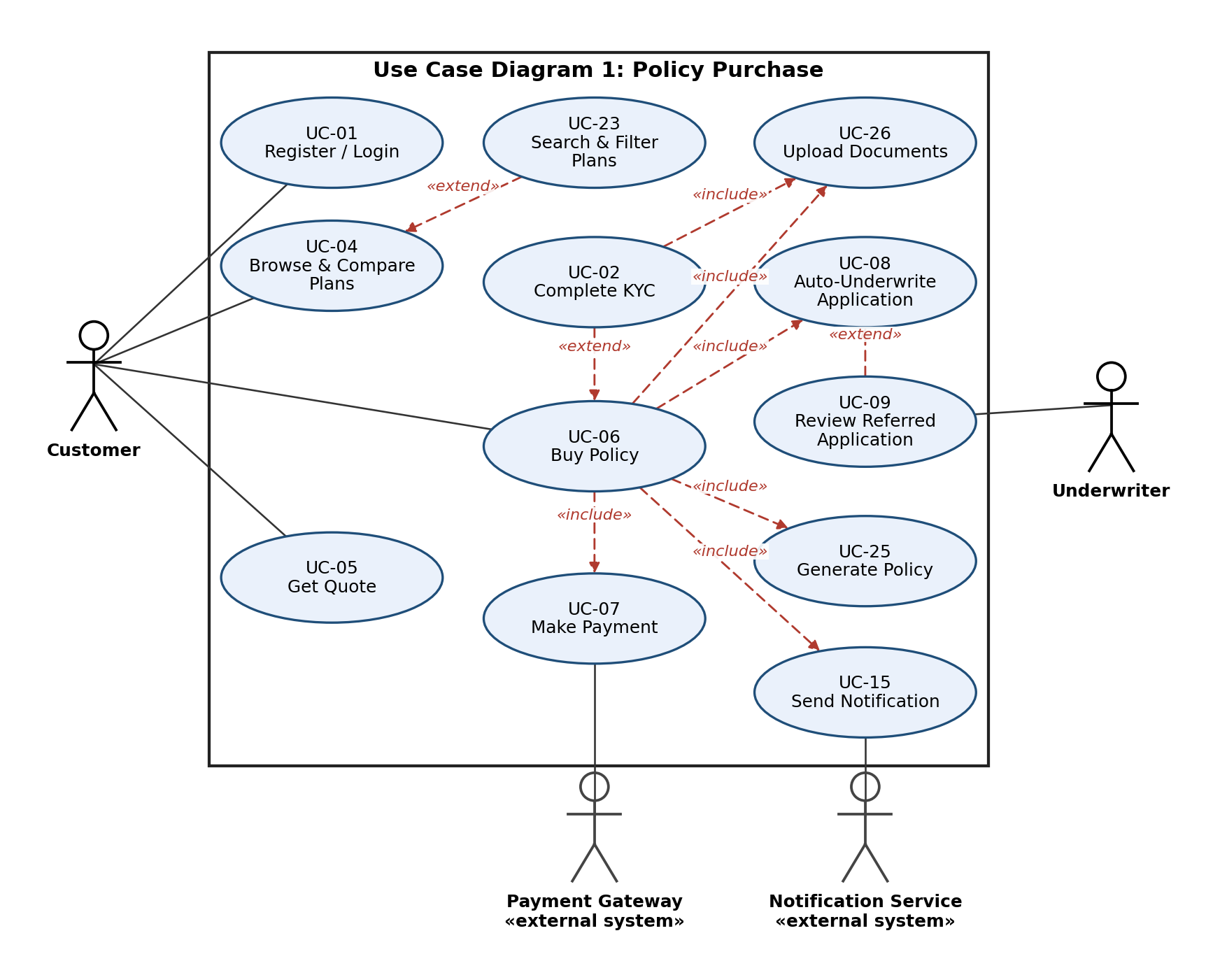
Figure 1: Policy purchase (UC-01, 02, 04, 05, 06, 07, 08, 09, 15, 23, 25, 26)
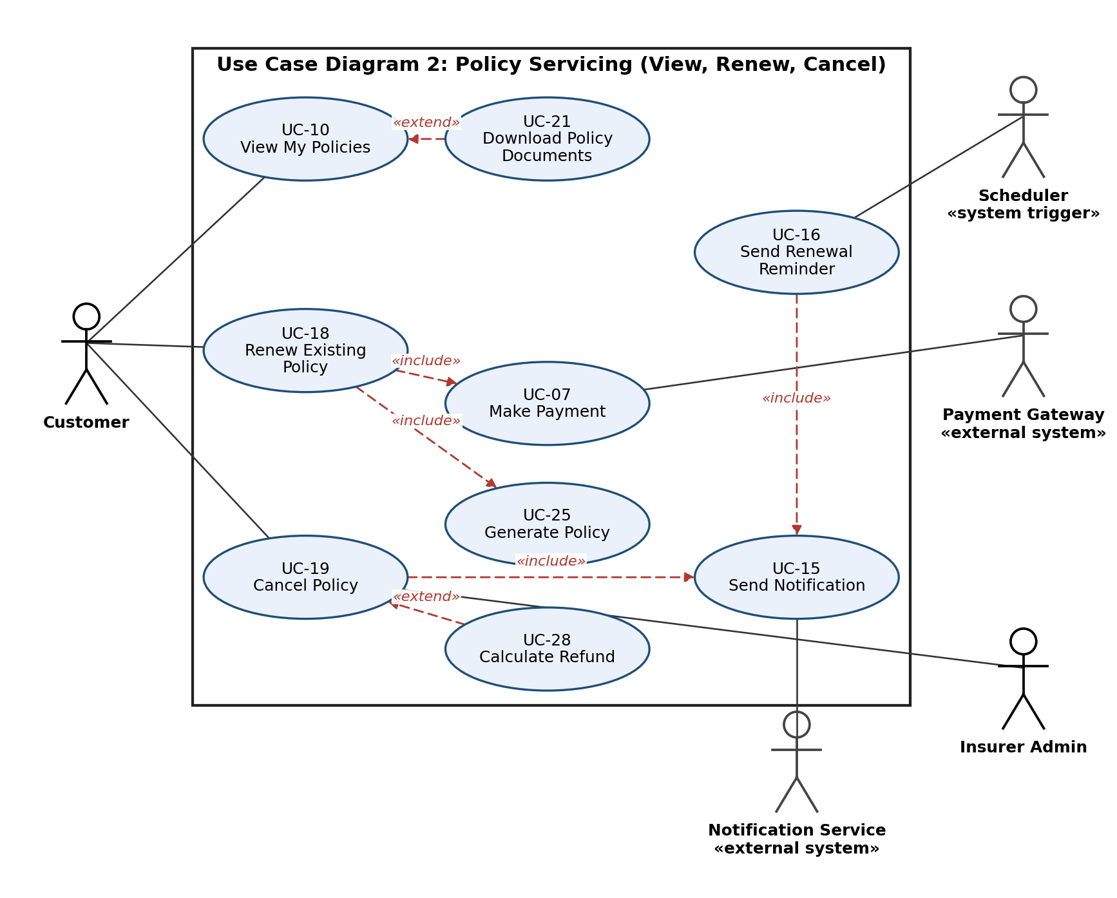
Figure 2: Policy servicing: view, download, renew and cancel (UC-07, 10, 15, 16, 18, 19, 21, 25, 28)
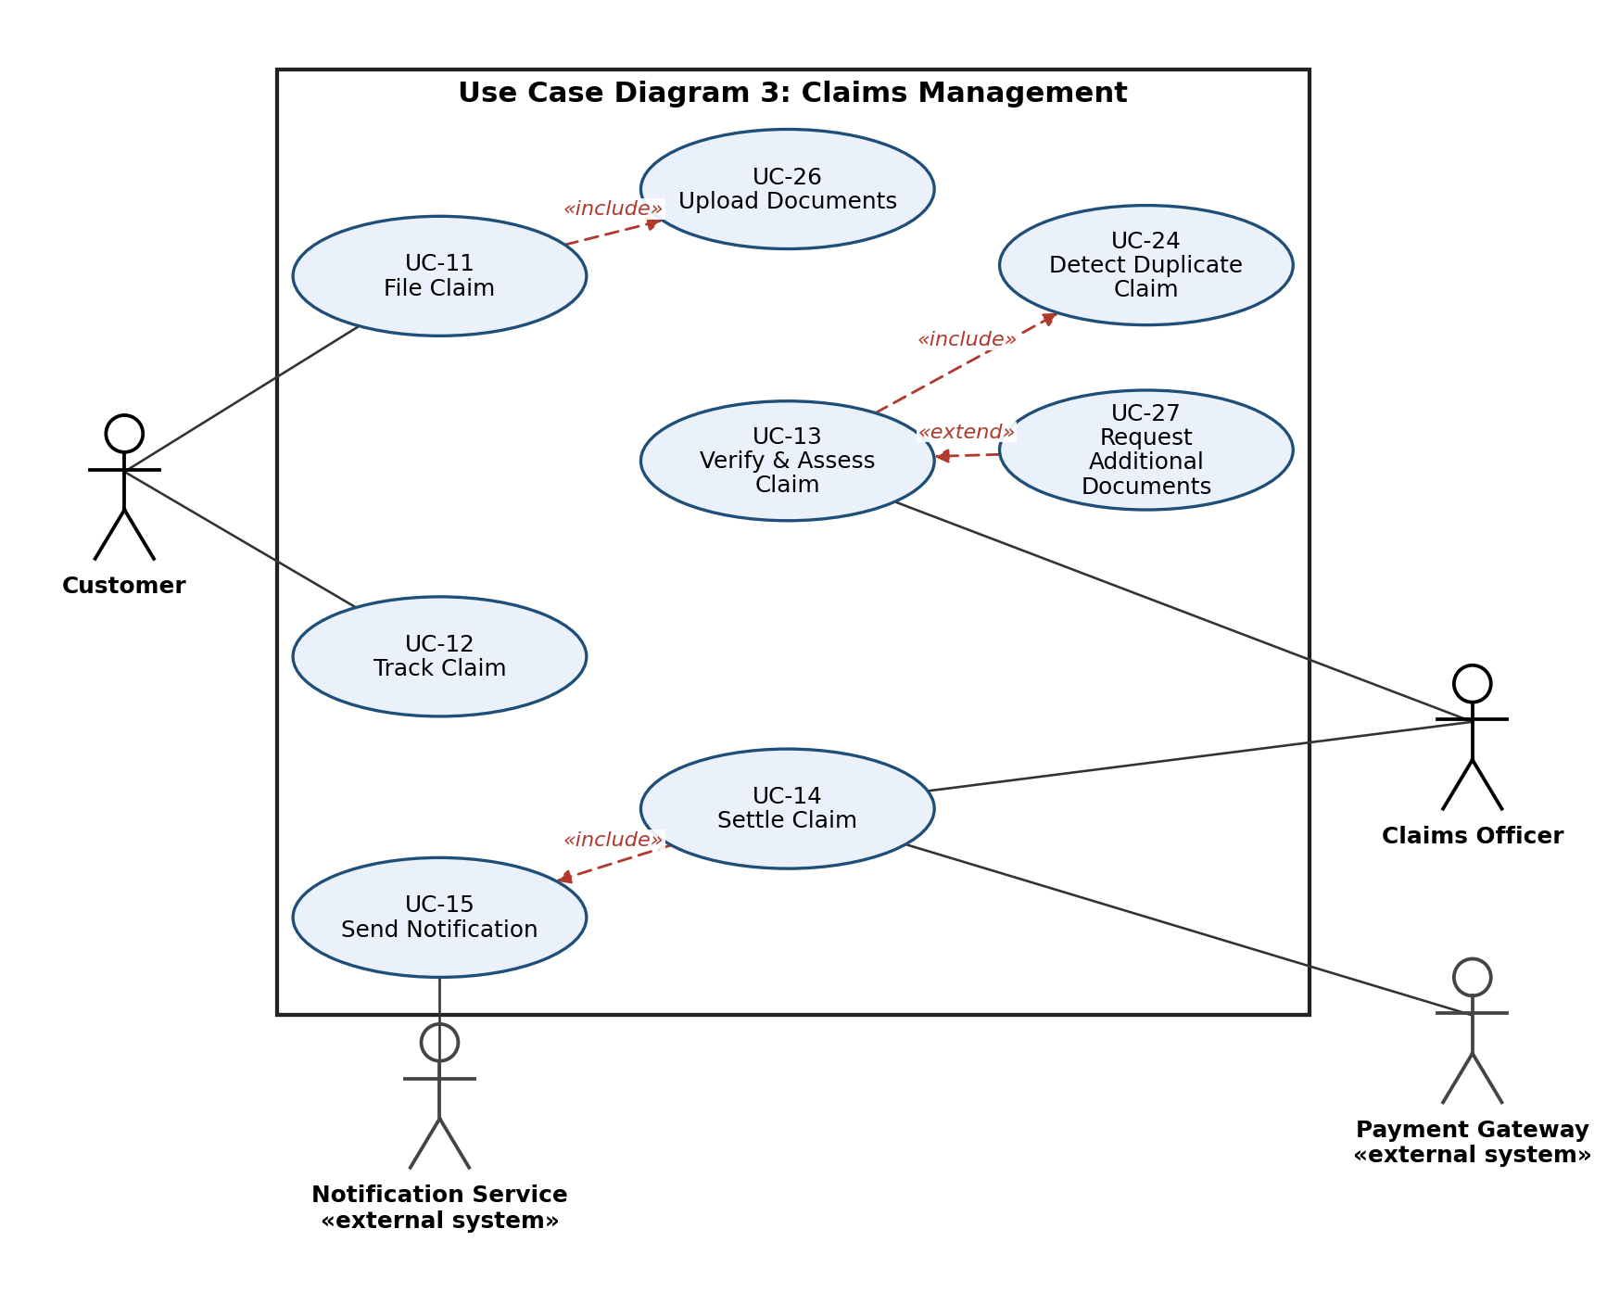
Figure 3: Claims management (UC-11 to UC-15, 24, 26, 27)
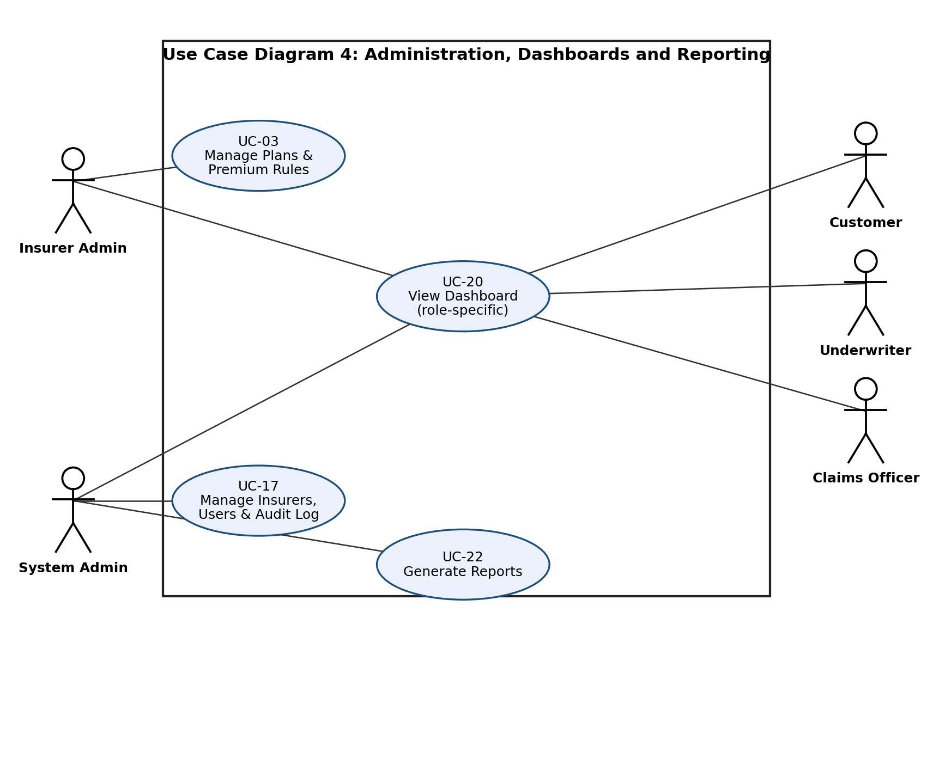
Figure 4: Administration, dashboards and reporting (UC-03, 17, 20, 22)
Note: every status change of an application, policy, renewal, cancellation or claim triggers UC-15 Send Notification (INS-F-016). The diagrams show the main links only, to keep them readable.

7.2 Use case summary
ID | Use case | Actor(s) | Relationships
UC-01 | Register / Login | All users | -
UC-02 | Complete KYC | Customer | Includes UC-26; extends UC-06 (first-time buyers)
UC-03 | Manage Plans and Premium Rules | Insurer Admin | -
UC-04 | Browse and Compare Plans | Customer | Extended by UC-23
UC-05 | Get Quote | Customer | -
UC-06 | Buy Policy | Customer | Includes UC-08, UC-07, UC-25, UC-15, UC-26; extended by UC-02
UC-07 | Make Payment | Customer, Payment Gateway | Included by UC-06, UC-18
UC-08 | Auto-Underwrite Application | None (internal; invoked by UC-06) | Included by UC-06; extended by UC-09
UC-09 | Review Referred Application | Underwriter | Extends UC-08; includes UC-15
UC-10 | View My Policies | Customer | Extended by UC-21
UC-11 | File Claim | Customer | Includes UC-26
UC-12 | Track Claim | Customer | -
UC-13 | Verify and Assess Claim | Claims Officer | Includes UC-24; extended by UC-27
UC-14 | Settle Claim | Claims Officer, Payment Gateway | Includes UC-15
UC-15 | Send Notification | Notification Service | Included by UC-06, UC-09, UC-14, UC-16, UC-18, UC-19
UC-16 | Send Renewal Reminder | Scheduler | Includes UC-15
UC-17 | Manage Insurers, Users and Audit Log | System Admin | -
UC-18 | Renew Existing Policy | Customer | Includes UC-07, UC-25, UC-15
UC-19 | Cancel Policy | Customer, Insurer Admin | Includes UC-15; extended by UC-28
UC-20 | View Dashboard | Customer, Insurer Admin, Claims Officer, Underwriter, System Admin | -
UC-21 | Download Policy Documents | Customer | Extends UC-10
UC-22 | Generate Reports | System Admin | -
UC-23 | Search and Filter Plans | Customer | Extends UC-04
UC-24 | Detect Duplicate Claim | None (internal; invoked by UC-13) | Included by UC-13
UC-25 | Generate Policy | None (internal; invoked by UC-06, UC-18) | Included by UC-06, UC-18
UC-26 | Upload Documents | Customer | Included by UC-02, UC-06, UC-11
UC-27 | Request Additional Documents | Claims Officer | Extends UC-13
UC-28 | Calculate Refund | None (internal; extends UC-19) | Extends UC-19

7.3 Use case descriptions

UC-01 | Register / Login
Actor(s) | All users
Preconditions | None
Main flow | 1. User enters details or credentials.  2. System validates and creates/opens the session.  3. System opens the role dashboard.
Alternate / exception flows | Wrong password: error shown; after 5 failures account locked (INS-SR-005).
Postconditions | User is logged in with the correct role.
Relationships | -

UC-02 | Complete KYC
Actor(s) | Customer
Preconditions | Customer is registered
Main flow | 1. Customer enters PAN/Aadhaar and uploads documents.  2. System calls KYC service.  3. System stores status Verified.
Alternate / exception flows | KYC fails: status Rejected, customer may re-submit.
Postconditions | KYC status is Verified.
Relationships | Includes UC-26; extends UC-06 (first-time buyers)

UC-03 | Manage Plans and Premium Rules
Actor(s) | Insurer Admin
Preconditions | Insurer Admin is logged in
Main flow | 1. Admin creates or edits a plan.  2. Admin sets premium rules, coverage, deductible, waiting period, add-ons.  3. System saves and publishes the plan.
Alternate / exception flows | Invalid values (e.g., negative premium): rejected.
Postconditions | Plan is available to customers.
Relationships | -

UC-04 | Browse and Compare Plans
Actor(s) | Customer
Preconditions | None (login not needed to browse)
Main flow | 1. Customer selects policy type.  2. System lists plans.  3. Customer selects up to 3 plans.  4. System shows comparison table.
Alternate / exception flows | No plans match: message shown.
Postconditions | Customer has chosen a plan to quote.
Relationships | Extended by UC-23

UC-05 | Get Quote
Actor(s) | Customer
Preconditions | Plan selected
Main flow | 1. Customer enters vehicle or member details.  2. System applies the rating rules.  3. System shows the premium in 5 s.
Alternate / exception flows | Missing/invalid data: field errors shown.
Postconditions | Quote is shown and can be saved.
Relationships | -

UC-06 | Buy Policy
Actor(s) | Customer
Preconditions | Customer logged in with verified KYC; quote available
Main flow | 1. Customer submits the application with documents.  2. System runs underwriting (UC-08).  3. If approved, system requests payment (UC-07).  4. On success system generates the policy (UC-25).  5. System sends notification (UC-15).
Alternate / exception flows | Underwriting = Refer: wait for UC-09, then continue at step 3. Underwriting = Reject: stop, tell customer. Payment fails: retry, no policy issued. KYC not verified: UC-02 extends this use case.
Postconditions | Policy is active and visible in My Policies.
Relationships | Includes UC-08, UC-07, UC-25, UC-15, UC-26; extended by UC-02

UC-07 | Make Payment
Actor(s) | Customer, Payment Gateway
Preconditions | Application approved (or renewal due)
Main flow | 1. System sends amount to the gateway.  2. Customer completes payment.  3. Gateway returns status.  4. System records the status.
Alternate / exception flows | Failure or timeout: status Failed, customer can retry.
Postconditions | Payment status recorded.
Relationships | Included by UC-06, UC-18

UC-08 | Auto-Underwrite Application
Actor(s) | None (internal; invoked by UC-06)
Preconditions | Application submitted, KYC verified
Main flow | 1. System reads application data.  2. System applies the rules of section 4.4.1.  3. System sets Approve, Refer or Reject.
Alternate / exception flows | Rule configuration missing: no automatic decision; the application is routed to the Underwriter queue with the reason 'Missing rule configuration'.
Postconditions | Application has an underwriting outcome.
Relationships | Included by UC-06; extended by UC-09

UC-09 | Review Referred Application
Actor(s) | Underwriter
Preconditions | Application outcome is Refer
Main flow | 1. Underwriter opens the queue.  2. Reviews the application.  3. Approves or rejects with reason.  4. System notifies the customer.
Alternate / exception flows | Underwriter requests more information: application stays in queue.
Postconditions | Application is Approved or Rejected.
Relationships | Extends UC-08; includes UC-15

UC-10 | View My Policies
Actor(s) | Customer
Preconditions | Customer logged in
Main flow | 1. Customer opens My Policies.  2. System lists active and expired policies with status.
Alternate / exception flows | No policies: empty state shown.
Postconditions | -
Relationships | Extended by UC-21

UC-11 | File Claim
Actor(s) | Customer
Preconditions | Active policy exists
Main flow | 1. Customer selects the policy.  2. Enters incident details and amount.  3. Uploads documents.  4. System checks 30-day rule and creates the claim (Submitted).
Alternate / exception flows | Policy expired or claim too late: refused.
Postconditions | Claim exists with status Submitted.
Relationships | Includes UC-26

UC-12 | Track Claim
Actor(s) | Customer
Preconditions | Claim exists
Main flow | 1. Customer opens the claim.  2. System shows current state and history.
Alternate / exception flows | -
Postconditions | -
Relationships | -

UC-13 | Verify and Assess Claim
Actor(s) | Claims Officer
Preconditions | Claim is Submitted
Main flow | 1. Officer verifies documents.  2. System runs duplicate check (UC-24).  3. Officer assesses the amount.  4. Officer approves or rejects with reason.
Alternate / exception flows | Documents missing: UC-27. Possible duplicate: officer reviews manually.
Postconditions | Claim is Approved or Rejected.
Relationships | Includes UC-24; extended by UC-27

UC-14 | Settle Claim
Actor(s) | Claims Officer, Payment Gateway
Preconditions | Claim is Approved
Main flow | 1. Officer starts payout.  2. System sends payout to the gateway (Payment Processing).  3. On success claim becomes Settled.  4. System notifies customer.
Alternate / exception flows | Payout fails: stays in Payment Processing, retry.
Postconditions | Claim is Settled.
Relationships | Includes UC-15

UC-15 | Send Notification
Actor(s) | Notification Service
Preconditions | A status change has happened
Main flow | 1. System builds message from template.  2. Sends email/SMS.  3. Stores a notification record.
Alternate / exception flows | Send fails: retry up to 3 times, then log.
Postconditions | User informed.
Relationships | Included by UC-06, UC-09, UC-14, UC-16, UC-18, UC-19

UC-16 | Send Renewal Reminder
Actor(s) | Scheduler
Preconditions | Policy expires in 30, 15 or 1 day(s)
Main flow | 1. Scheduler runs daily.  2. Finds matching policies.  3. Triggers a reminder to each customer.
Alternate / exception flows | -
Postconditions | Reminder sent.
Relationships | Includes UC-15

UC-17 | Manage Insurers, Users and Audit Log
Actor(s) | System Admin
Preconditions | System Admin logged in
Main flow | 1. Admin adds an insurer or user, or changes a role.  2. System saves.  3. Admin can search and view the audit log.
Alternate / exception flows | Duplicate user email: rejected.
Postconditions | Change recorded in the audit log.
Relationships | -

UC-18 | Renew Existing Policy
Actor(s) | Customer
Preconditions | Policy active or within 15-day grace period
Main flow | 1. Customer selects a policy to renew.  2. System recalculates premium (section 4.6.1).  3. Customer pays (UC-07).  4. System generates renewed policy (UC-25).  5. System notifies customer.
Alternate / exception flows | Policy expired more than 15 days ago: customer must buy a new policy.
Postconditions | New policy term starts; renewal certificate available.
Relationships | Includes UC-07, UC-25, UC-15

UC-19 | Cancel Policy
Actor(s) | Customer, Insurer Admin
Preconditions | Policy is active
Main flow | 1. Customer requests cancellation with reason.  2. Insurer Admin reviews.  3. If approved, system calculates refund (UC-28).  4. System marks policy Cancelled and notifies customer.
Alternate / exception flows | Admin rejects: policy stays active.
Postconditions | Policy Cancelled, refund recorded.
Relationships | Includes UC-15; extended by UC-28

UC-20 | View Dashboard
Actor(s) | Customer, Insurer Admin, Claims Officer, Underwriter, System Admin
Preconditions | User logged in
Main flow | 1. User opens the home page.  2. System shows the widgets for the user's role.
Alternate / exception flows | -
Postconditions | -
Relationships | -

UC-21 | Download Policy Documents
Actor(s) | Customer
Preconditions | Policy exists
Main flow | 1. Customer opens a policy.  2. Chooses policy PDF or renewal certificate.  3. System returns the PDF.
Alternate / exception flows | Document not available: message shown.
Postconditions | -
Relationships | Extends UC-10

UC-22 | Generate Reports
Actor(s) | System Admin
Preconditions | System Admin logged in
Main flow | 1. Admin selects report and period.  2. System computes totals.  3. Admin views or exports.
Alternate / exception flows | No data for period: empty report.
Postconditions | -
Relationships | -

UC-23 | Search and Filter Plans
Actor(s) | Customer
Preconditions | Plans exist
Main flow | 1. Customer sets filters (insurer, premium, type, coverage).  2. System returns matching plans.
Alternate / exception flows | -
Postconditions | -
Relationships | Extends UC-04

UC-24 | Detect Duplicate Claim
Actor(s) | None (internal; invoked by UC-13)
Preconditions | Claim is in Document Verification
Main flow | 1. System looks for claims with the same policy, incident date and amount.  2. If found, sets 'Possible duplicate' and holds the claim for manual review.
Alternate / exception flows | -
Postconditions | Flag set or cleared.
Relationships | Included by UC-13

UC-25 | Generate Policy
Actor(s) | None (internal; invoked by UC-06, UC-18)
Preconditions | Payment successful
Main flow | 1. System creates a unique policy number.  2. Generates the PDF.  3. Stores the policy as Active.
Alternate / exception flows | PDF generation fails: retry and log.
Postconditions | Policy is Active.
Relationships | Included by UC-06, UC-18

UC-26 | Upload Documents
Actor(s) | Customer
Preconditions | Customer logged in
Main flow | 1. Customer selects files.  2. System checks type and size (INS-SR-007).  3. System stores them encrypted.
Alternate / exception flows | Wrong type or > 5 MB: rejected.
Postconditions | Documents attached to the record.
Relationships | Included by UC-02, UC-06, UC-11

UC-27 | Request Additional Documents
Actor(s) | Claims Officer
Preconditions | Documents are missing or unclear
Main flow | 1. Officer lists the missing documents.  2. System notifies the customer.  3. Claim waits for upload.
Alternate / exception flows | Customer does not respond in 15 days: claim moves to Closed - No Response (final).
Postconditions | Claim resumes Document Verification, or is Closed - No Response.
Relationships | Extends UC-13

UC-28 | Calculate Refund
Actor(s) | None (internal; extends UC-19)
Preconditions | Cancellation approved
Main flow | 1. System applies the refund rules of section 4.6.2.  2. Stores the refund amount.
Alternate / exception flows | Claim already paid: refund is 0.
Postconditions | Refund amount recorded.
Relationships | Extends UC-19

8. Requirements Traceability Matrix (RTM)
Status codes: N = Not started, P = In progress, A = Accepted. Design Spec IDs (DS-...) will be defined in the SAD; test case IDs will be detailed in the STP.
Req ID | Requirement short | Section ref / Design Spec | Module | Test case(s) | Status (N/P/A) | Comments
INS-F-001 | Register / login with roles | 4.1 / DS-User-01 | User & KYC Module | TC-Acc-01, TC-Acc-02 | N
INS-F-002 | KYC upload and verification | 4.1 / DS-User-02 | User & KYC Module | TC-KYC-01 | N
INS-F-003 | Manage plans and premium rules | 4.2 / DS-Plan-01 | Plan Management Module | TC-Plan-01 | N
INS-F-004 | Browse and compare plans | 4.2 / DS-Plan-02 | Plan Management Module | TC-Plan-02 | N
INS-F-022 | Search and filter plans | 4.2 / DS-Plan-03 | Plan Management Module | TC-Plan-03 | N
INS-F-005 | Motor quote | 4.3 / DS-Quote-01 | Quote & Purchase Module | TC-Quote-01 | N
INS-F-006 | Health quote | 4.3 / DS-Quote-02 | Quote & Purchase Module | TC-Quote-02 | N
INS-F-007 | Submit application | 4.3 / DS-Quote-03 | Quote & Purchase Module | TC-App-01 | N
INS-F-010 | Rule-based auto-underwriting | 4.4 / DS-UW-01 | Underwriting Engine | TC-UW-01, TC-UW-02, TC-UW-03 | N
INS-F-011 | Manual review of referred cases | 4.4 / DS-UW-02 | Underwriting Engine / Quote & Purchase | TC-UW-04 | N
INS-F-008 | Online premium payment | 4.5 / DS-Pay-01 | Payment Adapter | TC-Pay-01, TC-Pay-02 | N
INS-F-009 | Generate policy and document | 4.5 / DS-Policy-01 | Quote & Purchase Module | TC-Pol-01 | N
INS-F-024 | Download policy documents | 4.5 / DS-Policy-02 | Quote & Purchase Module | TC-Pol-02 | N
INS-F-017 | Renewal reminders | 4.6 / DS-Ren-01 | Scheduler / Notification Service | TC-Ren-01 | N
INS-F-019 | Policy renewal processing | 4.6 / DS-Ren-02 | Quote & Purchase Module | TC-Ren-02, TC-Ren-03 | N
INS-F-020 | Policy cancellation and refund | 4.6 / DS-Can-01 | Quote & Purchase Module | TC-Can-01, TC-Can-02 | N
INS-F-012 | File a claim | 4.7 / DS-Clm-01 | Claims Workflow Module | TC-Clm-01 | N
INS-F-013 | Claim workflow states | 4.7 / DS-Clm-02 | Claims Workflow Module | TC-Clm-02 | N
INS-F-014 | Verify, assess and decide claim | 4.7 / DS-Clm-03 | Claims Workflow Module | TC-Clm-03 | N
INS-F-015 | Track claim status | 4.7 / DS-Clm-04 | Claims Workflow Module | TC-Clm-04 | N
INS-F-023 | Duplicate claim detection | 4.7 / DS-Clm-05 | Claims Workflow Module | TC-Clm-05 | N
INS-F-016 | Status-change notifications | 4.8 / DS-Ntf-01 | Notification Service | TC-Ntf-01 | N
INS-F-018 | Audit log | 4.8 / DS-Adm-01 | Admin & Reporting Module | TC-Aud-01 | N
INS-F-021 | Role-specific dashboards | 4.8 / DS-Adm-02 | Admin & Reporting Module | TC-Dash-01 | N
INS-F-025 | Admin reports | 4.8 / DS-Adm-03 | Admin & Reporting Module | TC-Rpt-01 | N
INS-NF-001 | Quote response time | 5 / DS-Perf-01 | Quote & Purchase / DB | TC-Perf-01 | N
INS-NF-002 | Concurrent users | 5 / DS-Perf-02 | All modules | TC-Load-01 | N
INS-NF-003 | Availability | 5 / DS-Ops-01 | Deployment | TC-Avail-01 | N
INS-NF-004 | Backup and recovery | 5 / DS-Ops-02 | Database | TC-Rel-01 | N
INS-NF-005 | Responsive UI | 5 / DS-UX-01 | Web UI | TC-UX-01 | N
INS-NF-006 | Browser compatibility | 5 / DS-UX-02 | Web UI | TC-Compat-01 | N
INS-NF-007 | Audit retention | 5 / DS-Adm-01 | Admin & Reporting | TC-Aud-02 | N
INS-SR-001 | HTTPS / TLS 1.2+ for all traffic | 5.1.2 / DS-Sec-01 | Deployment | TC-Sec-01 | N
INS-SR-002 | Salted password hashing | 5.1.2 / DS-Sec-02 | User & KYC Module | TC-Sec-02 | N
INS-SR-003 | Role-based access control | 5.1.2 / DS-Sec-03 | All modules | TC-Sec-03 | N
INS-SR-004 | Encryption of documents at rest | 5.1.2 / DS-Sec-04 | Database / storage | TC-Sec-04 | N
INS-SR-005 | Account lockout and session timeout | 5.1.2 / DS-Sec-05 | User & KYC Module | TC-Sec-05 | N
INS-SR-006 | Input validation and injection defence | 5.1.2 / DS-Sec-06 | All modules | TC-Sec-06 | N
INS-SR-007 | Secure file upload | 5.1.2 / DS-Sec-07 | User & KYC / Claims | TC-Sec-07 | N
INS-SR-008 | Append-only audit log | 5.1.2 / DS-Sec-08 | Admin & Reporting | TC-Sec-08 | N

