AGILE SOFTWARE DEVELOPMENT PROPOSAL & SCOPE SPECIFICATION
PROJECT PROPOSAL & AGILE SCOPE AGREEMENT
Local-First Pre-Order Billing, Cake Customization & Kitchen Production System
Built on Microsoft SQL Server | 3-Phase Agile Delivery | Strict 1-to-1 Scope Definition
■ EXECUTIVE PROJECT OVERVIEW
Client Organization: The Royal Bakery (TRB Systems - Colombo / Outlets)
System Objective: Replace Slow trbsys.net Portal with an Ultra-Fast Local System on Microsoft SQL Server
Development Timeline: Minimum 3 Months (12 Weeks) Delivered via Agile Sprints
Commercial Structure: Zero Baseline Capital Fee | LKR 100,000 Initial Non-Refundable Mobilization Advance
Combined Monthly Retainer: LKR 30,000 / Month (LKR 15,000 for 2 Existing POS Systems + LKR 15,000 for New Pre-Order System)
Inflation Adjustment Clause: Monthly Retainer Locked for 2 Years (24 Months); Indexed to Inflation Thereafter
Maintenance Period: 1-Year Comprehensive Operational Maintenance from Official Live Launch Date
Strict Scope Boundary: Exact Rebuild of 21 Screens from trbsys.net (New Features Subject to Custom Change Requests)
Database Engine: Microsoft SQL Server (MSSQL) — Natively Shared with DanuPOS Retail System

Target Client: The Royal Bakery Management & Executive Operations Team
Document Version: 2.2 — Managed Retainer & Commercial Service Agreement
Date of Submission: September 2026
Prepared By: Lead Systems Engineering Architect & Development Team

TABLE OF CONTENTS
1. Executive Summary & Purpose | Page 3
2. Strict Scope Boundary & Change Request (CR) Policy | Page 4
2.1 Complete Audit Table of the 21 Production System Screenshots | Page 4
3. Exact System Menus & Page Specification (Matching trbsys.net 1-to-1) | Page 6
3.1 Menu 1: Dashboard (/dashboard) [Screenshot #01] | Page 6
3.2 Menu 2: Main Access [Screenshots #02 - #07] | Page 6
• System Users: Create User & Manage Users [Screenshots #02 & #03] | Page 6
• Manage Product / Create Product (/add-product) [Screenshot #04] | Page 7
• Product Categories: Main & Sub Categories [Screenshots #05 & #06] | Page 7
• Customer List (/customer_list - High-Speed Directory) [Screenshot #07] | Page 8
3.3 Menu 3: Orders [Screenshots #08 - #12] | Page 8
• Create Orders (/add-order - Counter Intake & Cake Greetings) | Page 8
• Manage Orders (/manage_orders - Order Grid & Status Badges) [Screenshots #08 & #12] | Page 9
• Make Payment Modal (Counter Balance Settlement) | Page 9
• Cancelled Orders (/cancel_orders - Audit Trail) [Screenshot #09] | Page 10
• Authorize Bills (/bill_authorized - Supervisor Queue) [Screenshots #10 & #11] | Page 10
3.4 Menu 4: Chef Reports (/reports_cheff - 'Order Reports') [Screenshot #13] | Page 10
3.5 Menu 5: Delivery (/delivery - 'Today's Delivery Reports') [Screenshot #21] | Page 11
3.6 Menu 6: Reports (Invoice, Product & Payment Reports) [Screenshots #14 - #19] | Page 11
3.7 Menu 7: SMS Promotions (/Promotions - 'Promotion SMS') [Screenshot #20] | Page 12
3.8 Dual Printing Engine (Direct 80mm Slip & Formal A5 Invoice) | Page 12
4. Agile 3-Phase Delivery Framework (Minimum 3 Months / 12 Weeks) | Page 13
5. Technical Architecture: Microsoft SQL Server & DanuPOS Integration | Page 15
6. Non-Functional Quality Benchmarks (Speed, Offline, Reliability) | Page 17
7. Commercial Agreement: Mobilization Advance, Combined Retainer & Inflation Revision | Page 18
8. 1-Year Maintenance & Support Agreement, Training & Sign-Off | Page 20
Appendix: Table of Architectural Figures & Flowcharts | Page 21

LIST OF FIGURES & ARCHITECTURAL CHARTS
Figure 1 | Local-First LAN Architecture (Microsoft SQL Server & DanuPOS Shared Instance) | Page 15
Figure 2 | Microsoft SQL Server Relational Entity Relationship Diagram (ERD) | Page 15
Figure 3 | End-to-End Pre-Order Billing, Cake Customization & Kitchen Workflow | Page 13

1. EXECUTIVE SUMMARY & PURPOSE
The Royal Bakery (TRB) is one of the most respected bakeries in Sri Lanka. Every day, the bakery takes in hundreds of custom celebration cakes, daily bread orders, and catering orders from walk-in customers, hotels, and schools. Currently, TRB uses a cloud website called trbsys.net for this pre-order billing. However, this system causes severe delays: counter screens freeze, cashiers wait seconds for items to load, and if the showroom internet disconnects, billing stops completely.
This project will replace trbsys.net with a modern, ultra-fast Local-First Counter System running on Microsoft SQL Server. It runs directly on TRB's counter computers, meaning zero internet lag and 100% offline billing reliability. Furthermore, because it uses Microsoft SQL Server, it shares the exact same database engine as TRB's retail POS (DanuPOS), making future integration simple, clean, and unified.
To make this modernization financially frictionless and avoid large capital barriers, the engagement eliminates traditional large baseline development fees (LKR 0 baseline fee). Instead, the project is structured under an attractive operational partnership: a one-time initial non-refundable advance of LKR 100,000 upon contract signing, followed by a consolidated monthly retainer of LKR 30,000 per month. This monthly fee comprehensively bundles ongoing maintenance and operations for TRB's two existing POS systems (Bakery POS and Restaurant POS at LKR 15,000/mo) and this new Pre-Order Counter System (at LKR 15,000/mo).
2. STRICT SCOPE BOUNDARY & CHANGE REQUEST (CR) POLICY
To ensure that this project is delivered strictly within the minimum 3-month timeline and commercial framework, it is essential that both The Royal Bakery and the development team have a crystal-clear understanding of the project boundaries.
■ STRICT SCOPE AGREEMENT & ANTI-SCOPE CREEP CLAUSE
1. Exact Feature Copy: The scope of this project is strictly limited to rebuilding the exact functional menus, pages, and features currently present in the production trbsys.net portal as documented across the 21 production screenshots and counter intake workflows. No more, no less.
2. 1-Year Maintenance Scope: The included 1-year operational maintenance period strictly covers bug fixes, database tuning, and counter printer support for the rebuilt trbsys.net system. It does NOT include adding new features, extra screens, or novel business logic.
3. Out-of-Scope Items: Any new capability not present in the current trbsys.net portal (such as customer online ordering apps, online payment gateways, automated SMS marketing blasts, general accounting ledgers, or attendance systems) is strictly out-of-scope for this baseline contract.
4. Change Request (CR) Process: If TRB requests any new feature, extra screen, or functional change that does not exist in the current system, it must be submitted as a written Change Request (CR). Each CR will receive a separate commercial quotation and timeline, and will be developed under custom development rates.
5. Sign-Off Protection: This scope boundary protects both parties against misunderstandings, guarantees on-time delivery, and ensures the highest quality of engineering.

2.1 Complete Audit Table of the 21 Production System Screenshots (from Client PDF)
The client provided an operational walkthrough PDF containing 21 individual screen captures showing every menu, form, and table used across The Royal Bakery. Every single one of these 21 screenshots has been cataloged and verified below:
Screenshot # | PDF Page | Menu / Area | URL Route & Screen Title | Captured Elements & Key Controls
Screenshot #01 | Page 1 (Top) | Dashboard | /dashboard  Operational Dashboard | Top navbar, KPI cards: Total Orders, Total Pending Orders, Total New Customers (This Month admin & Last Month)
Screenshot #02 | Page 1 (Bottom) | Main Access > System Users | /create-users  Create User | Main Access menu hover; User Name*, Password*, Confirm Password*, User Type* (Select Level), Submit, Cancel
Screenshot #03 | Page 2 (Top) | Main Access > System Users | /manage-users  Manage Users | System Users submenu; User list table: User Name, User Role, Action (Edit pen, Delete cross)
Screenshot #04 | Page 2 (Bottom) | Main Access > Manage Product | /add-product  Create Product | FEED PRODUCT DATA form (Main Cat, Sub Cat, Name, Price, Net Weight, Description, Discount); 850+ Product Table
Screenshot #05 | Page 3 (Top) | Main Access > Product Categories | /manage-categories  Manage Main Categories | CAT ID#, Main Category, Main Category Description (Chef in charge, e.g. Cheff Premaratna); 8 Categories Table
Screenshot #06 | Page 3 (Bottom) | Main Access > Product Categories | /manage-sub-categories  Manage Sub Categories | SUB CAT ID#, Main Category dropdown, Sub Category, Sub Category Description; Sub Categories Table
Screenshot #07 | Page 4 (Top) | Main Access | /customer_list  Customer List | Customer directory table: Customer Name, Mobile, LandLine, Address, Email, Search bar
Screenshot #08 | Page 4 (Bottom) | Orders | /manage_orders  Manage Orders | Orders menu dropdown (Manage Orders, Cancelled, Authorize); Total Amount badge: 217,550; Orders Table
Screenshot #09 | Page 5 (Top) | Orders | /cancel_orders  Cancelled Orders | Orders submenu; Cancelled orders audit table: Invoice Id, Reason (CXL), Cancelled By (Admin), Date
Screenshot #10 | Page 5 (Bottom) | Orders | /bill_authorized  Authorize Bills | Orders submenu; Authorize Bills table: Invoice ID, Name, Delivery Date, Total, Balance, Print-A5, Bill Authorize
Screenshot #11 | Page 6 (Top) | Orders | /bill_authorized  Authorize Bills (Full View) | Clean full screen view of Authorize Bills queue without dropdown overlay; Pagination controls
Screenshot #12 | Page 6 (Bottom) | Orders | /manage_orders  Manage Orders (Full View) | Clean full screen view of Manage Orders table; Total Amount badge, Print 80mm & A5, Edit Order, Cancel Order
Screenshot #13 | Page 7 (Top) | Chef Reports | /reports_cheff  Order Reports | Main-Product-Type*, Sub-Product-Type, Product, Date Range, Print Reoprt, Export; Delivery Date, Product, Description (cake greeting), Qty
Screenshot #14 | Page 7 (Bottom) | Reports > By Invoice | /reports_all  All Report | Reports menu; By Invoice submenu; Print Reoprt, Export, Bill Authorized; Order list with Make Payment, Status, Due
Screenshot #15 | Page 8 (Top) | Reports > By Invoice | /overall-invoices  Overall Invoices | By Invoice submenu; Date Range filter (mm/dd/yyyy to mm/dd/yyyy)
Screenshot #16 | Page 8 (Bottom) | Reports > By Product | /reports_products_only  All Product Sales | By Product submenu; Item Category, Sub Category, Item, Time Range, Search; Table: Main Cat, Sub Cat, Name, Price, Qty, Total Sales
Screenshot #17 | Page 9 (Top) | Reports > By Product | /reports-overall  Reports Overall (Select) | Customer dropdown selector
Screenshot #18 | Page 9 (Bottom) | Reports > By Product | /reports-overall  Reports Overall (Filters) | Full filters: Customer, Item Category, Sub Category, Item, Time Range, Payment Method, Search; Print Reoprt, Export
Screenshot #19 | Page 10 (Full) | Reports > By Payment | /all-payment  Payment Reports | By Payment submenu; Date Range, All Payment Type, Search, Print Reoprt, Export; Table: Invoice ID, Cus Name, Payment Method, Paid Amount
Screenshot #20 | Page 11 (Top) | SMS Promotions | /Promotions  Promotion SMS | PROMOTION SMS template screen: Text area 'Type your message here', Submit, Cancel
Screenshot #21 | Page 11 (Bottom) | Delivery | /delivery  Today's Delivery Reports | Date of Delivery picker, Search, Print Reoprt; Table: Date of Delivery, Invoice ID, Name and Qty, Cus Name, Address, Phone

3. EXACT SYSTEM MENUS & PAGE SPECIFICATION (MATCHING TRBSYS.NET 1-TO-1)
To make it effortless for Royal Bakery management and counter cashiers to verify the scope, the modules below are organized using the exact menu structure, page names, and field titles found in the production trbsys.net portal, cross-referenced directly to the 21 screenshots verified in Section 2.1.
3.1 Menu 1: Dashboard (/dashboard) [Screenshot #01]
- • Key Performance Cards: Page heading matches 'This Month admin' and 'Last Month' cards showing TOTAL ORDERS, TOTAL PENDING ORDERS, and TOTAL NEW CUSTOMERS.
- • Alerts Banner: Notification alert banner at the top displaying real-time order intake and status updates.
- • Navigation: Navigation sidebar giving instant one-click access to all system menus.
3.2 Menu 2: Main Access [Screenshots #02, #03, #04, #05, #06, #07]
- • System Users: Create User form (/create-users) [Screenshot #02] with User Name*, Password*, Confirm Password*, and User Type* (Admin, Accountant, Cashier, Kitchen). Manage Users (/manage-users) [Screenshot #03] table with Edit and Delete options.
- • Manage Product / Create Product: Manage Product / Create Product (/add-product) [Screenshot #04] containing Product Main Category, Product Sub Category, Product Name*, Product Price*, Net Weight*, Description*, and Discount* (Discount/Non Discount). Searchable table of all 850+ items with Status filter (Show all, Available, Out of Stock).
- • Product Categories: Main Categories (/manage-categories) [Screenshot #05] managing 8 categories (Bread, Cake, Pastry, Kitchen, Restaurant, Shoteats, Showroom) with Chef in charge assignment (e.g., Cheff Premaratna, Cheff Wickramapala). Sub Categories (/manage-sub-categories) [Screenshot #06] managing sub-groups (Buns, Cake Pieces, Drawing Cakes).
- • Customer List: Customer List (/customer_list) [Screenshot #07] displaying Customer Name, Mobile, LandLine, Address, and Email. Equipped with high-speed indexing and pagination to eliminate the 60-second loading timeout of the previous system.
3.3 Menu 3: Orders [Screenshots #08, #09, #10, #11, #12]
- • Create Orders (Customer Profile): Main showroom intake screen (/add-order). Cashier enters customer mobile number or name for instant auto-fill of Title (Mr/Mrs/Miss/Dr/Rev), First Name, Mobile, Telephone, and Delivery Address. New customers registered in 1 step.
- • Create Orders (Product Selection): Cascading selector: Main-Product-Type* -> Sub-Product-Type -> Product (850+ items). Price and net weight load automatically. Cashier enters Quantity (odr_qty) and Item Notes (odr_gre_des).
- • Create Orders (Cake Customization): Milestone Greetings* (None, 1st, 2nd, ... 29th) + Occasion Greetings* (None, Happy Birthday, Happy Anniversary, Happy Holy Communion, Congratulations, Happy Valentine's Day) + Custom Icing Name/Text (Greetings info2).
- • Create Orders (Delivery & Billing): Date of Delivery (d_delivery), Time (time), Delivery Address (d_address), Ordered By cashier name. Line-item table, Discount %, Service Charge %, Delivery Charge, Gross Total (tot), Advance Paid (odr_adv), Balance Due. Payment type: Cash, Card, Cheque, Staff.
- • Manage Orders: Order management grid (/manage_orders) [Screenshots #08 & #12] with Total Amount badge (e.g., LKR 217,550), status filter tabs (Show all, Pending, Paid, Un Paid, Delivered), instant search, and columns: Invoice ID (e.g. RB-0178099), Make Payment, Name & Qty, Date of Delivery, Total, Status, Balance Due, Print (Print 80mm, Print-A5), Actions (Edit Order, Cancel Order).
- • Make Payment Modal: Quick pop-up modal triggered by 'Make Payment' button in Manage Orders. Displays Invoice ID, Customer Name, and Balance Due. Cashier inputs payment amount and method (Cash or Card), instantly updating the status to 'Paid / Delivered' and printing receipt.
- • Cancelled Orders: Cancelled Orders audit screen (/cancel_orders) [Screenshot #09] logging Invoice Id, Reason (e.g., CXL), Cancelled By username, and Date.
- • Authorize Bills: Authorize Bills queue (/bill_authorized) [Screenshots #10 & #11] for supervisor approval of high-value cakes, special catering, or credit orders with Print-A5 and 'Bill Authorize' button.
3.4 Menu 4: Chef Reports (/reports_cheff - 'Order Reports') [Screenshot #13]
- • Kitchen Filters: Dedicated kitchen screen for baking chefs. Filterable by Main-Product-Type*, Sub-Product-Type, Product, Date Range (Select two dates), and Status.
- • Production Grid: Columns: Delivery Date, Invoice ID, Product Name, Description (containing exact cake greeting & icing inscription), and Quantity. Includes 'Print Reoprt' and 'Export' buttons.
3.5 Menu 5: Delivery (/delivery - 'Today's Delivery Reports') [Screenshot #21]
- • Dispatch Run Sheet: Run sheet for delivery dispatchers and drivers. Filter by Date of Delivery, Status, and Search.
- • Dispatch Columns: Columns: Date of Delivery, Invoice ID, Name and Qty, Cus Name, Cus Delivery Address, Phone. Includes 'Print Reoprt' button.
3.6 Menu 6: Reports [Screenshots #14, #15, #16, #17, #18, #19]
- • Reports By Invoice: All Report (/reports_all) [Screenshot #14] and Overall Invoices (/overall-invoices) [Screenshot #15] filterable by Date Range, Cashier User, Payment Method, and Status. Columns: Invoice ID, Cus Name, Delivery Date, Payment Method, subTotal, Paid Amount, Due, Order Status. Export and Print.
- • Reports By Product: All Product Sales (/reports_products_only) [Screenshot #16] and Overall (/reports-overall) [Screenshots #17 & #18] displaying Main Cat, Sub Cat, Product Name, Price, Quantity, and Total Sales across custom date ranges.
- • Reports By Payment: Payment Reports (/all-payment) [Screenshot #19] filterable by Date Range and Payment Type (Cash, Card, Cheque, Staff). Shows Invoice ID, Cus Name, Payment Method, and Paid Amount for daily cashier drawer balancing.
3.7 Menu 7: SMS Promotions (/Promotions - 'Promotion SMS') [Screenshot #20]
- • Promotion SMS: Promotion SMS drafting screen with text area 'Type your message here' with Submit and Cancel options for promotional message templates.
3.8 Dual Printing Engine (Integrated)
- • 80mm POS Slip: Instant 80mm thermal receipt printed directly to counter receipt printer for advance deposits and customer pickup vouchers with barcode.
- • Formal A5 Invoice: Formal A5 cake invoice containing complete greeting text, cake artwork notes, and terms of collection.

4. AGILE 3-PHASE DELIVERY FRAMEWORK (MINIMUM 3 MONTHS / 12 WEEKS)
The project will be delivered using the Agile Methodology, structured into 3 clear monthly phases spanning a minimum duration of 3 months (12 calendar weeks). At the end of each phase, a live working milestone demonstration will be presented to TRB management for review and approval.
Agile Phase & Period | Deliverable Scope (Exact Menus Covered) | Milestone Review & Sign-Off
PHASE 1 (Month 1)  Weeks 1 - 4  Foundation & Master Setup | • Provision Local Master PC with Microsoft SQL Server (MSSQL)  • Migrate all 850+ Products, Categories & Customer Database  • Menu 1: Dashboard (/dashboard - 'This Month admin')  • Menu 2: Main Access complete suite:  - System Users: Create User & Manage Users  - Manage Product / Create Product (850+ items)  - Product Categories: Main & Sub Categories  - Customer List (High-speed indexed directory)  • Dual Hardware Printer Drivers (80mm & A5) | Milestone 1 Demo & Sign-Off:  Live demonstration of Microsoft SQL Server database, 850+ product catalog, and sub-15ms offline search.
PHASE 2 (Month 2)  Weeks 5 - 8  Counter Intake & Printing | • Menu 3: Orders core counter intake:  - Create Orders (/add-order) with Cake Customization  - Milestone Greetings* (1st-29th) & Occasions  - Custom Icing Text (Greetings info2)  - Advance Deposit & Balance Calculations  • Menu 3: Manage Orders (/manage_orders) & Filter Tabs  • Menu 3: Make Payment Modal (Balance Settlement)  • Direct Hardware Printing Engine (80mm Thermal Slip & A5 Formal Invoice) | Milestone 2 Demo & Sign-Off:  Live demonstration of end-to-end counter order creation, cake greeting configuration, and instant receipt printing.
PHASE 3 (Month 3)  Weeks 9 - 12  Kitchen, Reports & Launch | • Menu 3: Cancelled Orders (/cancel_orders) & Authorize Bills (/bill_authorized)  • Menu 4: Chef Reports (/reports_cheff - 'Order Reports')  • Menu 5: Delivery (/delivery - 'Today's Delivery Reports')  • Menu 6: Reports (By Invoice, By Product & Payment Reports)  • Menu 7: SMS Promotions (/Promotions - 'Promotion SMS')  • DanuPOS Shared Microsoft SQL Server Integration Testing  • Comprehensive Staff Training (Cashiers, Chefs, Supervisors) & Live Production Cutover | Milestone 3 Demo & Sign-Off:  Final User Acceptance Testing (UAT), staff sign-off, and live production deployment at TRB counters.
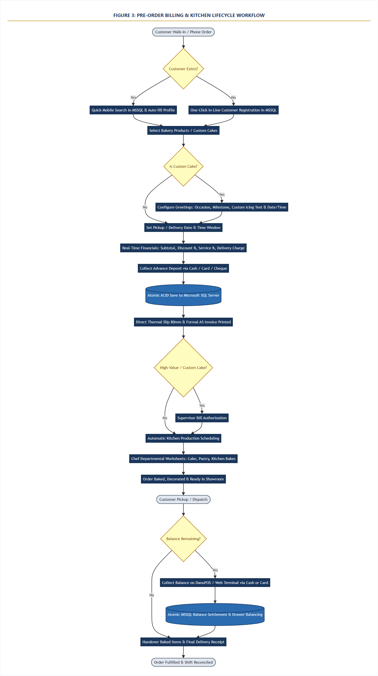
Figure 3: End-to-End Pre-Order Billing, Cake Customization & Kitchen Workflow
Illustrates the complete customer order journey from booking to kitchen baking and final balance settlement.

5. TECHNICAL ARCHITECTURE: MICROSOFT SQL SERVER & DANUPOS INTEGRATION
To ensure the new system operates with zero lag and seamlessly connects with TRB's retail POS (DanuPOS), the system is built on Microsoft SQL Server (MSSQL).
■ WHY MICROSOFT SQL SERVER IS THE STRATEGIC CHOICE FOR TRB
1. Same Engine as DanuPOS: DanuPOS runs on Microsoft SQL Server. Using the same engine allows both systems to live side-by-side on the counter PC with zero compatibility issues.
2. Shared Products & Customers: Pre-orders and DanuPOS retail counters can reference the exact same product and customer records. No duplicate entries or syncing errors.
3. Atomic Balance Settlements: When a customer pays their remaining balance at the DanuPOS counter, a single SQL transaction updates the pre-order status to 'Delivered' and balances the cashier drawer simultaneously.
4. Single Automated Backup: One daily .bak file backup scheduled at night protects both retail POS sales and pre-orders together.
5. Free SQL Server Express Edition: SQL Server Express is 100% free with a 10GB limit (over 10+ years of bakery billing capacity), avoiding expensive software licenses.

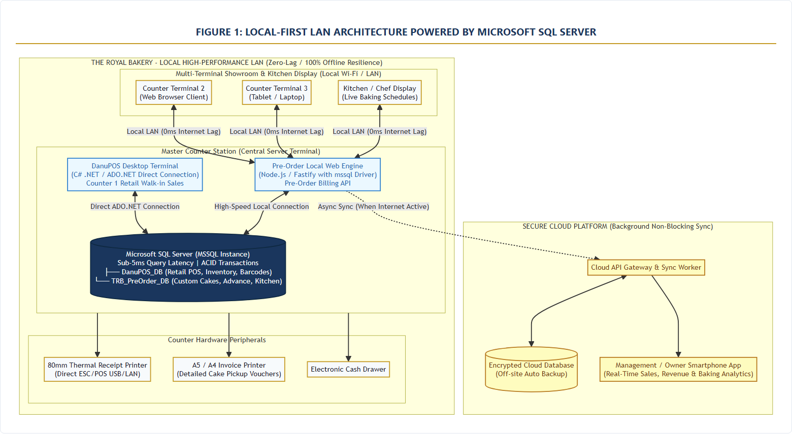
Figure 1: Local-First LAN Architecture (Microsoft SQL Server & DanuPOS Shared Instance)
Shows the Master Counter Station hosting Microsoft SQL Server, serving both DanuPOS and Pre-Order Terminals over the local LAN.

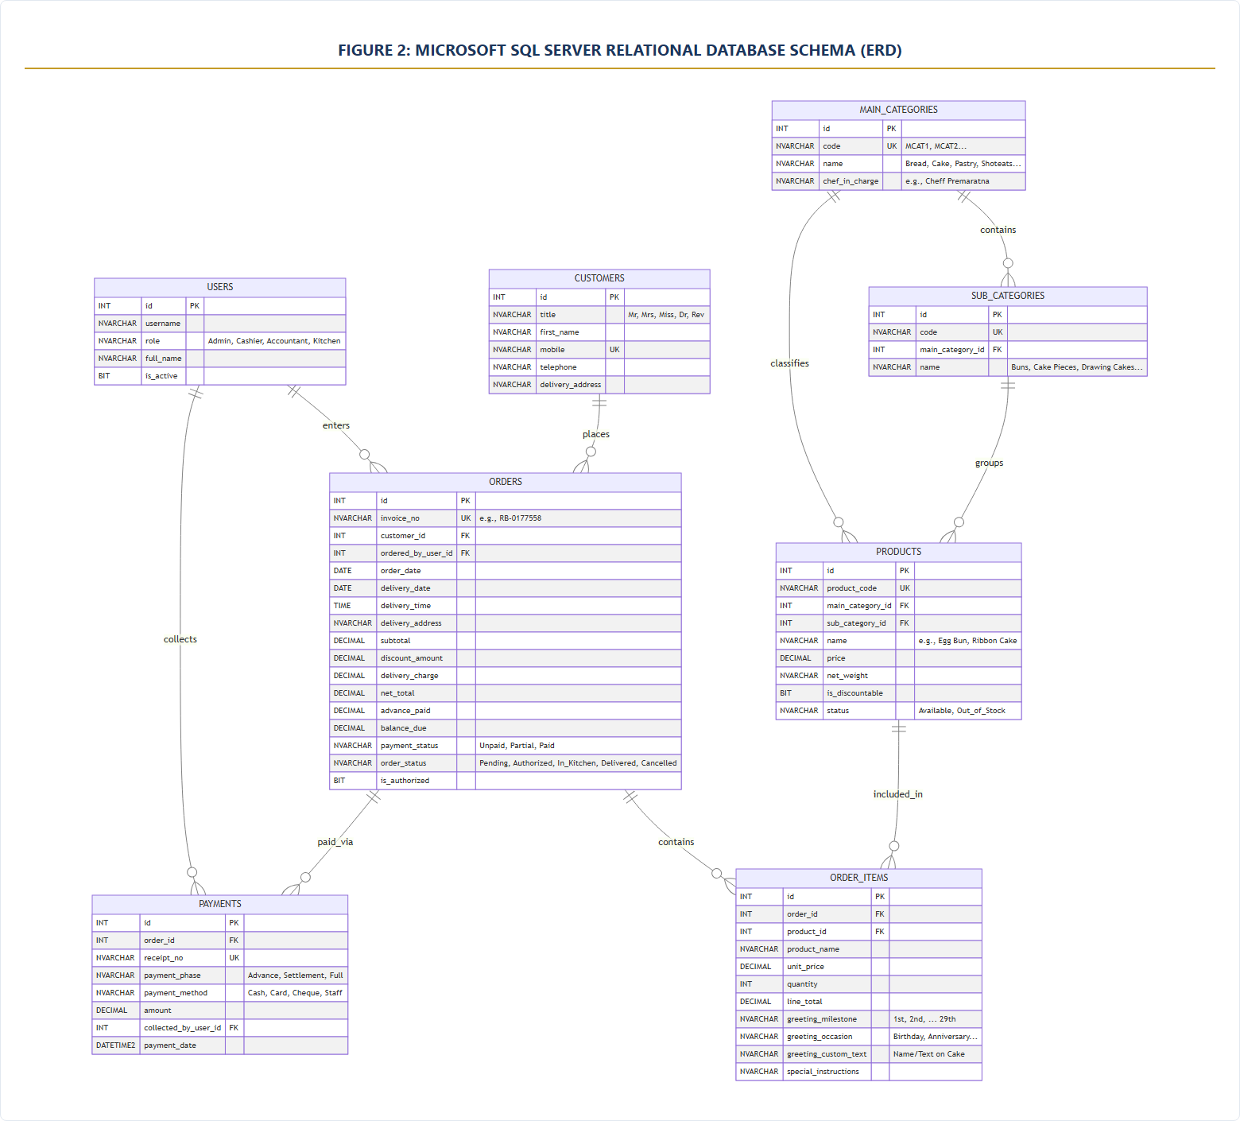
Figure 2: Microsoft SQL Server Relational Database Entity Relationship Diagram (ERD)
Depicts the 8 relational entities: Users, Customers, Main Categories, Sub Categories, Products, Orders, Order Items, and Payments.

6. NON-FUNCTIONAL QUALITY BENCHMARKS
The new system is engineered around strict performance and reliability standards:
Quality Requirement | Target Metric | How It Is Achieved
Counter Speed | Sub-50ms screen response; < 15ms search | Local Fastify API, indexed MSSQL queries, zero internet round-trips
Offline Reliability | 100% operational without internet | All billing runs on the local counter PC; internet is never required to bill
Printing Speed | < 1 second print dispatch | Direct raw ESC/POS driver spooling to 80mm printer; no browser preview wait
Data Accuracy | Zero balance discrepancies | ACID compliant SQL Server transactions with automatic rollback on error
Multi-Terminal | Up to 15 counter/kitchen devices | Local Wi-Fi/LAN sharing powered by lightweight Node.js connection pooling

7. COMMERCIAL AGREEMENT: MOBILIZATION ADVANCE, CONSOLIDATED RETAINER & INFLATION CLAUSE
To eliminate heavy upfront capital expenditure for The Royal Bakery, this project is delivered under a strategic operational partnership model. The traditional large baseline development fee is completely waived (**LKR 0 Baseline Development Fee**). Instead, the commercial agreement consists of a one-time non-refundable setup advance and a predictable, consolidated monthly service fee that covers all of TRB's retail and pre-order operational software.
■ KEY COMMERCIAL & FINANCIAL HIGHLIGHTS
1. Baseline Development Capital Fee: LKR 0 (Zero Upfront License/Development Fee).
2. Initial Non-Refundable Mobilization Advance: LKR 100,000 payable upon contract signing.
3. Consolidated Monthly Service Retainer: LKR 30,000 / month single invoice covering all 3 counter software systems:
• Existing Systems: TRB Bakery Counter POS & TRB Restaurant POS (LKR 15,000 / month)
• New System: Local Pre-Order, Cake Customization & Kitchen Production System (LKR 15,000 / month)
4. Inflation Adjustment & 2-Year Price Lock: The LKR 30,000 monthly fee is strictly locked for 2 full years (24 months); subject to annual revision based on Sri Lanka's official inflation rate thereafter.
5. Development Timeline: Minimum of 3 Months (12 Weeks) required for complete development, testing, and rollout.
6. Operational Maintenance: 1 Year (12 months) of comprehensive operational support included, commencing from the official Go-Live date.
7. Strict Scope Integrity: Maintenance covers the exact rebuilt trbsys.net system only. Any new features requested are charged separately via Change Requests (CR).

7.1 Commercial Fee Structure & Inclusions:
Commercial Component | Operational Scope & Coverage | Billing Terms | Amount (LKR)
Initial Mobilization & Setup Advance | Non-refundable setup fee covering Local Master PC provisioning, Microsoft SQL Server installation, complete migration of 850+ items and customer history, dual printer spooling driver configuration, and Agile Sprint 1 kickoff. | One-Time (On Contract Signing) | LKR 100,000  (Non-Refundable)
Consolidated Monthly Service Retainer  (All Systems Combined) | Single consolidated monthly operational & maintenance fee covering:  • TRB Existing POS Systems (Bakery Counter POS + Restaurant POS): LKR 15,000/mo  • New Pre-Order & Kitchen Production System: LKR 15,000/mo  Includes database maintenance, backup verification, and cashier technical support across all counter systems. | Monthly Recurring  (Price-Locked for 2 Years) | LKR 30,000 / month  (Consolidated Bill)
Baseline Development Investment Fee | Full 21-screen system development, MSSQL schema engineering, custom cake greeting engine, chef production sheets, and DanuPOS bridge alignment. | Capital Cost Waiver | LKR 0  (Fully Waived)

7.2 Inflation Adjustment & 2-Year Price Protection Clause:
To ensure budget predictability and peace of mind for The Royal Bakery, the agreed consolidated monthly retainer of **LKR 30,000** is subject to a guaranteed **Two-Year (24 Months) Price Lock**:
- • 24-Month Price Freeze: The consolidated monthly fee of LKR 30,000 is 100% fixed and will not increase under any circumstances for the first 24 calendar months following contract signing.
- • Inflation Indexing (Post-Year 2): Following the completion of the 2-year period, the monthly retainer fee may be reviewed and adjusted annually based on the official prevailing national inflation rate published by the Central Bank of Sri Lanka (CBSL / Colombo Consumer Price Index - CCPI).
- • Transparent Notice: Any post-2-year revision will be calculated transparently based on published economic indicators and formally communicated with at least 30 days' advance notice.
7.3 Agile Delivery Milestones (Minimum 3-Month Timeline):
System development, database integration, and counter rollout require a **minimum duration of three (3) months (12 weeks)**. Progress is linked to concrete Agile milestones:
Agile Sprint / Milestone | Target Timeline | Milestone Deliverables & Acceptance Criteria
Sprint 1: Foundation & Master Setup | Month 1 (Weeks 1 - 4) | • Contract signing & receipt of LKR 100,000 non-refundable advance  • Setup Master PC with Microsoft SQL Server (MSSQL)  • Migration of all 850+ product records & customer directory  • Delivery of Dashboard and Main Access (Users, Categories, Products)  • Live Milestone 1 working demonstration to TRB management
Sprint 2: Counter Intake & Printing | Month 2 (Weeks 5 - 8) | • Counter Pre-Order Intake screen (/add-order) with sub-15ms search  • Custom Cake Greetings engine (1st-29th milestones, custom icing text)  • Order Grid, status tabs, and Make Payment balance collection modal  • Direct hardware driver spooling for 80mm thermal slip & A5 invoice  • Live Milestone 2 counter demonstration to TRB management
Sprint 3: Kitchen, Delivery & Go-Live | Month 3 (Weeks 9 - 12)  (Minimum Delivery) | • Chef Reports, Kitchen Baking Sheets, and Daily Delivery Dispatch  • Supervisor Bill Authorization queue and Cancelled Orders audit  • Full integration testing on shared DanuPOS MSSQL instance  • Comprehensive staff training (Cashiers, Chefs, Supervisors)  • Official Go-Live Cutover (Commences 1-Year Maintenance Period)

8. 1-YEAR MAINTENANCE & SUPPORT AGREEMENT, TRAINING & SIGN-OFF
8.1 1-Year Operational Maintenance Period (From Live Launch Date)
Comprehensive operational maintenance for the new Pre-Order System is provided for a period of **exactly one (1) year (12 calendar months)**, commencing officially from the date of the live production launch (Go-Live Cutover) at TRB counter stations.
- • Defect & Bug Rectification: Immediate investigation and resolution of any software errors, runtime exceptions, or calculation bugs across the 21 rebuilt screens.
- • Database Health & Optimization: Routine query optimization, database transaction log truncation, and scheduled automated night backup verification.
- • Hardware & Printer Stability: Support for counter thermal receipt printer spoolers and A5 formal invoice printing.
- • Operational Support: Direct priority phone and remote desktop technical assistance for TRB cashiers, supervisors, and management during operating hours.
8.2 Strict Exclusion of New Features & Change Request (CR) Policy
■ CRITICAL CONTRACTUAL CLAUSE: FREE MAINTENANCE VS. NEW FEATURES
1. Boundary of 1-Year Maintenance: The 1-year maintenance included under the monthly retainer strictly covers maintaining, repairing, and tuning the exact 21 production screens rebuilt from the current trbsys.net system.
2. Exclusion of New Features: Free maintenance does NOT include adding new features, extra screens, new operational modules, or novel business logic that did not exist in the original trbsys.net system.
3. Paid Change Request (CR) Requirement: If TRB requests any new functionality (for example: customer-facing mobile apps, online payment gateway integrations, automated SMS marketing campaigns, loyalty points engines, or external accounting integrations), such work will NOT be performed under routine maintenance.
4. Commercial Quoting for CRs: Any newly requested feature will be formally documented under an independent Change Request (CR). A separate commercial quotation (scope, fee, and timeline) will be submitted to TRB management, and work will begin only upon mutual written approval.
5. Mutual Benefit: This strict boundary ensures uninterrupted system stability, protects developer availability, and guarantees transparent, predictable business operations for both parties.

8.3 Hands-On Staff Training Program
Before live production launch, complete hands-on training will be conducted for TRB personnel:
- • Counter Cashiers: Fast pre-order intake, mobile search autocomplete, cake greetings, advance deposits, and balance settlement.
- • Floor Supervisors: Order editing, bill authorization approval queue, and cancellation audit logs.
- • Kitchen Chefs: Accessing daily baking schedules, chef worksheets, and item summaries.
- • Accounts & Management: Daily sales collection reports, payment method reconciliation, and cashier drawer balancing.

8.4 Project Acceptance & Contractual Sign-Off Agreement
By signing below, both parties confirm their agreement to the complete terms set forth in this proposal: the exact 21-screen scope matching trbsys.net, zero baseline capital fee, LKR 100,000 non-refundable advance, consolidated LKR 30,000 monthly retainer (covering existing Bakery POS, Restaurant POS, and new Pre-Order system), 2-year inflation price lock, minimum 3-month development timeline, 1-year operational maintenance from Go-Live date, and the strict exclusion of new features from maintenance without separate Change Request (CR) billing.
For: The Royal Bakery (Client Organization) | For: Systems Development Team (Engineering)
Authorized Signature: _______________________  Name: ___________________________________  Title: Managing Director / General Manager  Date: ____________________________________ | Authorized Signature: _______________________  Name: ___________________________________  Title: Lead Systems Engineering Architect  Date: ____________________________________
Company Seal / Stamp: | Company Seal / Stamp:

