SECURE LOGIN SYSTEM
Full-Stack JWT Authentication System
React • Spring Boot • Spring Security • MySQL

Project Documentation
September 25, 2026

Table of Contents

1. Project Overview
Secure Login System is a full-stack reference implementation of token-based authentication. A Spring Boot backend issues signed JSON Web Tokens (JWTs) on successful login and validates them on every subsequent request; a React frontend stores that token, attaches it automatically to outgoing API calls, and blocks navigation to authenticated pages until a valid session exists.
The project demonstrates the complete authentication lifecycle end to end: user registration with hashed password storage, credential-based login that returns a JWT, stateless request validation on the server, and route protection on both the API layer and the client-side UI layer.

1.1 Goals
- Provide a working, minimal reference for JWT authentication with Spring Security 6.
- Demonstrate protected routes on both the backend (API) and frontend (React Router) sides.
- Persist users in a real relational database (MySQL) with properly hashed passwords.
- Keep the codebase small enough to read end to end, with no unnecessary abstractions.

1.2 Non-Goals
- Refresh-token rotation, multi-factor authentication, and social login are out of scope.
- The UI is intentionally minimal — this is a backend/security-flow reference, not a design showcase.

2. Technology Stack

2.1 Backend
Component | Technology
Language / Runtime | Java 21
Framework | Spring Boot 3.3.4
Security | Spring Security 6
Persistence | Spring Data JPA (Hibernate 6)
Database | MySQL 8
JWT Library | jjwt 0.12.6 (io.jsonwebtoken)
Password Hashing | BCrypt (spring-security-crypto)
Build Tool | Maven (wrapper included)
Validation | Jakarta Bean Validation (spring-boot-starter-validation)

2.2 Frontend
Component | Technology
Library | React 19
Build Tool / Dev Server | Vite 8
Routing | React Router 7
HTTP Client | Axios
State Management | React Context API (AuthContext)
Styling | Plain CSS (index.css, custom design tokens)

3. System Architecture
The system follows a decoupled client-server architecture. The React application never talks to the database directly — every data access goes through the Spring Boot REST API, which is the sole owner of the MySQL database and the sole issuer/validator of JWTs.

3.1 Request Flow
- The browser loads the React app from the Vite dev server (or a static build in production).
- React calls the Spring Boot REST API over HTTP, at a separate origin/port.
- For protected endpoints, the request carries an Authorization: Bearer <token> header.
- Spring Security's JwtAuthFilter intercepts every request, validates the token, and populates the security context before the request reaches the controller.
- The controller executes normally, using Spring Security's Authentication object to know which user is calling.
- MySQL is only ever accessed by the backend, through Spring Data JPA repositories.

3.2 Component Diagram (textual)

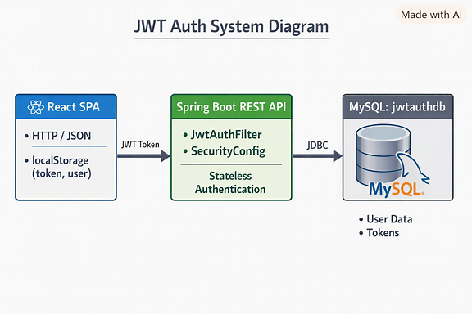

3.3 Why Stateless JWT?
- No server-side session store is needed — any backend instance can validate any token.
- Scales horizontally without sticky sessions or a shared session cache.
- The token itself carries the identity claim (username) and an expiry, signed with HMAC-SHA.

4. Project Folder Structure

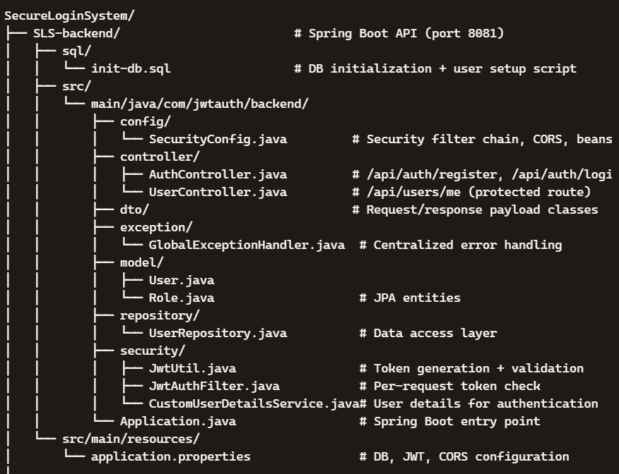

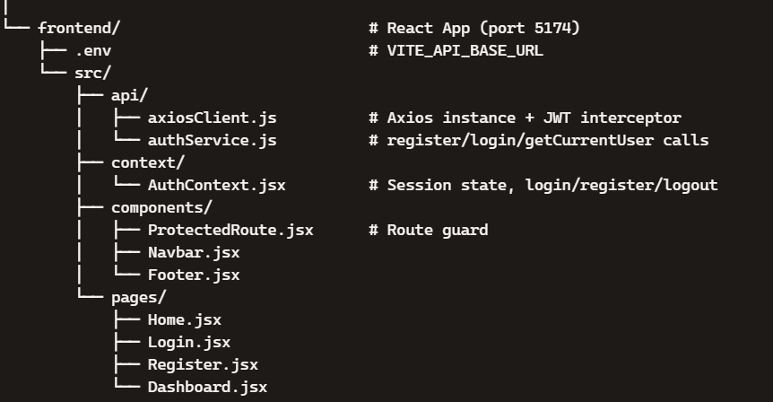

5. Database Design
The schema is generated automatically by Hibernate (spring.jpa.hibernate.ddl-auto=update) from the User entity — no hand-written migration files are needed for this starter.

5.1 Table: users
Column | Type | Constraints | Notes
id | BIGINT | PK, AUTO_INCREMENT | Surrogate primary key
username | VARCHAR(50) | NOT NULL, UNIQUE | Login identifier
email | VARCHAR(100) | NOT NULL, UNIQUE | Contact / identity
password | VARCHAR(255) | NOT NULL | BCrypt hash — never plaintext
created_at | DATETIME(6) | NULLABLE | Set at registration time

5.2 Table: user_roles
An element-collection table mapping each user to one or more roles (many-to-many by value).
Column | Type | Notes
user_id | BIGINT | FK → users.id
roles | VARCHAR | Enum string: ROLE_USER or ROLE_ADMIN

5.3 Setup Script
backend/sql/init-db.sql creates the database and a dedicated, least-privilege application user rather than using the MySQL root account:
CREATE DATABASE IF NOT EXISTS jwtauthdb CHARACTER SET utf8mb4 COLLATE utf8mb4_unicode_ci; CREATE USER IF NOT EXISTS 'jwtauth_app'@'localhost' IDENTIFIED BY 'JwtAuth_App_2026!'; GRANT ALL PRIVILEGES ON jwtauthdb.* TO 'jwtauth_app'@'localhost'; FLUSH PRIVILEGES;

6. Backend Implementation

6.1 Security Configuration (SecurityConfig.java)
- Disables CSRF — the API is stateless and not cookie-session based, so CSRF protection does not apply.
- Sets SessionCreationPolicy.STATELESS — Spring Security never creates an HttpSession.
- Registers a CORS policy restricted to the frontend's origin (http://localhost:5174), with credentials allowed.
- Authorization rules: /api/auth/** is public; /api/admin/** requires ROLE_ADMIN; everything else requires a valid JWT.
- Custom JSON error responses for 401 (unauthenticated) and 403 (forbidden), instead of Spring's default HTML error pages.
- Registers JwtAuthFilter before Spring's UsernamePasswordAuthenticationFilter in the filter chain.
- Password hashing bean: BCryptPasswordEncoder.

6.2 JWT Utility (JwtUtil.java)
- Signing key is derived from a Base64-encoded secret in application.properties (app.jwt.secret), decoded into an HMAC-SHA SecretKey.
- generateToken(UserDetails) — creates a token with the username as the subject claim, an issued-at timestamp, and an expiry (default: 1 hour, app.jwt.expiration-ms).
- extractUsername(token) / extractExpiration(token) — parse claims out of a signed token.
- isTokenValid(token, userDetails) — checks the subject matches and the token has not expired; catches malformed, expired, or invalid-signature tokens and treats them as invalid rather than throwing.

6.3 JWT Filter (JwtAuthFilter.java)
A Spring OncePerRequestFilter that runs on every request:
- Reads the Authorization header; if missing or not a Bearer token, passes the request through unauthenticated.
- Extracts the username from the token and loads the corresponding UserDetails.
- Validates the token against that user; if valid, builds an Authentication object and places it in the SecurityContext.
- Any exception during this process clears the security context, leaving the request unauthenticated (handled later by the entry point).

6.4 Domain Model
- User — JPA entity: id, username, email, password (hash), roles (Set<Role>), createdAt. Includes a manually written Builder (no Lombok — see note below).
- Role — enum: ROLE_USER, ROLE_ADMIN.
- CustomUserDetailsService — loads a User by username and adapts it into Spring Security's UserDetails, mapping roles to GrantedAuthority.

6.5 REST API
Method | Endpoint | Auth | Description
POST | /api/auth/register | Public | Creates a user; rejects duplicate username/email with 409
POST | /api/auth/login | Public | Validates credentials, returns a JWT + user profile
GET | /api/users/me | JWT required | Example protected endpoint; returns the caller's profile from the security context

Login response shape:
{ "token": "<jwt>", "type": "Bearer", "id": 1, "username": "alice", "email": "alice@example.com", "roles": ["ROLE_USER"] }

6.6 Validation & Error Handling
- RegisterRequest / LoginRequest use Jakarta Bean Validation annotations (@NotBlank, @Email, @Size).
- GlobalExceptionHandler catches MethodArgumentNotValidException and returns a field-name → message map with HTTP 400.
- Duplicate username/email at registration returns HTTP 409 Conflict with a descriptive message.

6.7 Implementation Note: No Lombok
Lombok's annotation processor did not generate code correctly under the installed JDK (25) in this environment, so all getters, setters, constructors, and builder classes are hand-written rather than generated. This removes a class of environment-dependent build failures at the cost of some boilerplate.

7. Frontend Implementation

7.1 Authentication Context (AuthContext.jsx)
- Holds the current user object and JWT in React state, initialized from localStorage on load.
- login(credentials) — calls the API, stores the token and user in localStorage and state.
- register(details) — calls the API to create an account (does not log the user in automatically).
- logout() — clears localStorage and resets state.
- Exposed via a useAuth() hook consumed anywhere in the component tree.

7.2 Axios Client (axiosClient.js)
- Request interceptor — reads the token from localStorage and attaches Authorization: Bearer <token> to every outgoing request.
- Response interceptor — on a 401 response, clears the stored session and redirects to /login, so an expired or invalid token can't leave the UI in a broken authenticated-looking state.

7.3 Route Protection (ProtectedRoute.jsx)
A wrapper component used with React Router's nested routes. It checks isAuthenticated from AuthContext; if false, it redirects to /login (preserving the originally requested location so the user returns there after signing in). Only if authenticated does it render the nested <Outlet />.

7.4 Pages
Page | Route | Purpose
Home | / | Public landing page; links to Login or Dashboard depending on session state
Login | /login | Credential form; on success, redirects to the originally requested page or /dashboard
Register | /register | Account creation form with per-field validation error display
Dashboard | /dashboard | Protected page; shows local session data and a live call to /api/users/me

8. End-to-End Authentication Flow

8.1 Registration
- User submits username, email, and password on the Register page.
- Frontend POSTs to /api/auth/register.
- Backend checks for existing username/email, hashes the password with BCrypt, and saves the user with role ROLE_USER.
- On success, the user is redirected to the Login page.

8.2 Login
- User submits username and password on the Login page.
- Frontend POSTs to /api/auth/login.
- Spring Security's AuthenticationManager verifies the credentials against the stored BCrypt hash.
- On success, JwtUtil issues a signed JWT; the response includes the token and user profile.
- Frontend stores the token and user in localStorage and React state, then navigates to /dashboard.

8.3 Accessing a Protected Resource
- React's axiosClient automatically attaches Authorization: Bearer <token> to the request.
- JwtAuthFilter validates the token and authenticates the request before it reaches the controller.
- The controller returns the requested data (e.g. the user's own profile via /api/users/me).

8.4 Unauthorized Access
- If a visitor without a valid session navigates directly to /dashboard, ProtectedRoute redirects them to /login.
- If an API call returns 401 (e.g. an expired token), the axios response interceptor clears the session and redirects to /login.

8.5 Logout
- User clicks Logout; AuthContext clears localStorage and in-memory state.
- Subsequent navigation to protected routes redirects to /login, since isAuthenticated is now false.

9. Installation & Setup Guide

9.1 Prerequisites
- Java 21 (or newer) JDK
- Node.js 18+ and npm
- MySQL 8 server, running locally or reachable over the network
- Maven is not required separately — the project includes the Maven Wrapper (mvnw / mvnw.cmd)

9.2 Database Setup
mysql -u root -p < SLS-backend/sql/init-db.sql
This creates the jwtauthdb database and a dedicated jwtauth_app MySQL user, matching the defaults read by the backend.

9.3 Backend Setup & Run
cd SLS-backend ./mvnw spring-boot:run
Starts the API on http://localhost:8081. To override database credentials without editing application.properties:
DB_USERNAME=jwtauth_app DB_PASSWORD=JwtAuth_App_2026! ./mvnw spring-boot:run
Run the test suite (uses an in-memory H2 database via the "test" Spring profile, so MySQL does not need to be running):
./mvnw test

9.4 Frontend Setup & Run
cd frontend npm install npm run dev
Starts the React app on http://localhost:5174, fixed in vite.config.js to match the backend's CORS allow-list. Set VITE_API_BASE_URL in frontend/.env if the backend runs elsewhere.

10. Configuration Reference

10.1 Backend (application.properties)
Property | Purpose | Default
server.port | API port | 8081
spring.datasource.url | MySQL JDBC URL | jdbc:mysql://localhost:3306/jwtauthdb
DB_USERNAME / DB_PASSWORD | DB credentials (env override) | jwtauth_app
spring.jpa.hibernate.ddl-auto | Schema management strategy | update
app.jwt.secret | Base64 HMAC signing key | (generated placeholder — replace in production)
app.jwt.expiration-ms | Access token lifetime | 3600000 (1 hour)
app.cors.allowed-origins | Allowed frontend origin(s) | http://localhost:5174

10.2 Frontend (.env)
Variable | Purpose
VITE_API_BASE_URL | Base URL the axios client sends requests to (default http://localhost:8081/api)

11. Security Features Summary
- Passwords are never stored in plaintext — hashed with BCrypt before persistence.
- Stateless authentication — no server-side session store; each request is authenticated independently by its JWT.
- Signed tokens — JWTs are signed with an HMAC-SHA key; tampering invalidates the signature and the token is rejected.
- Token expiry — access tokens expire after a configurable window (default 1 hour), limiting the damage of a leaked token.
- Route protection on both tiers — the API rejects unauthenticated requests with 401, and the React app independently blocks navigation to protected pages.
- Restrictive CORS — only the configured frontend origin may call the API with credentials.
- Least-privilege database access — the app connects as a dedicated jwtauth_app MySQL user, not root.
- Centralized, structured error handling — validation and auth failures return consistent JSON, not stack traces or default error pages.

12. Testing & Verification
The following flows were manually verified against a live MySQL database during development:
Scenario | Expected | Result
Register a new user | HTTP 201, user row created with hashed password | Passed
Login with correct credentials | HTTP 200, JWT + profile returned | Passed
Call /api/users/me without a token | HTTP 401, JSON error body | Passed
Call /api/users/me with a valid token | HTTP 200, profile returned | Passed
Navigate to /dashboard while logged out | Redirected to /login | Passed
Logout, then revisit /dashboard | Redirected to /login | Passed

The backend's automated test suite (BackendApplicationTests) runs against an isolated in-memory H2 database via the "test" Spring profile, so it does not depend on a live MySQL instance or mutate real data.

13. Recommendations for Production Use
- Replace app.jwt.secret with a securely generated, sufficiently long secret loaded from an environment variable or secrets manager — never commit it to source control.
- Do not reuse the local-dev jwtauth_app credentials; provision a dedicated production database user with a strong, unique password.
- Switch spring.jpa.hibernate.ddl-auto from update to validate, and manage schema changes with a migration tool such as Flyway or Liquibase.
- Serve the API over HTTPS only, and set the frontend's cookie/localStorage handling accordingly.
- Consider short-lived access tokens plus a refresh-token flow if sessions need to outlive the current 1-hour expiry.
- Add rate limiting on /api/auth/login and /api/auth/register to reduce brute-force and account-enumeration risk.
- Add centralized application logging/monitoring for authentication failures and unusual access patterns.

14. Conclusion
Secure Login System demonstrates a complete, working JWT authentication flow across a React frontend and a Spring Boot backend backed by MySQL: registration, login, stateless token validation, and protected routing enforced independently on both the API and the UI. The codebase is intentionally small and readable, making it a suitable starting point for a larger application's authentication layer, provided the production recommendations above are applied before going live.

