**WEEK-2**

**PL SQL HANDS ON**

**Exercise 1: Control Structures**

**Scenario 1**: The bank wants to apply a discount to loan interest rates for customers above 60 years old.

**Question:** Write a PL/SQL block that loops through all customers, checks their age, and if they are above 60, apply a 1% discount to their current loan interest rates.

**CODE:**

BEGIN

  FOR cust IN (

    SELECT c.customerid, TRUNC(MONTHS_BETWEEN(SYSDATE, c.dob)/12) AS age,

           l.loanid, l.interestrate

    FROM customers c

    JOIN loans l ON c.customerid = l.customerid

  ) LOOP

    IF cust.age > 60 THEN

      UPDATE loans

      SET interestrate = interestrate - 1

      WHERE loanid = cust.loanid;

    END IF;

  END LOOP;

  COMMIT;

END;

**OUTPUT:**  
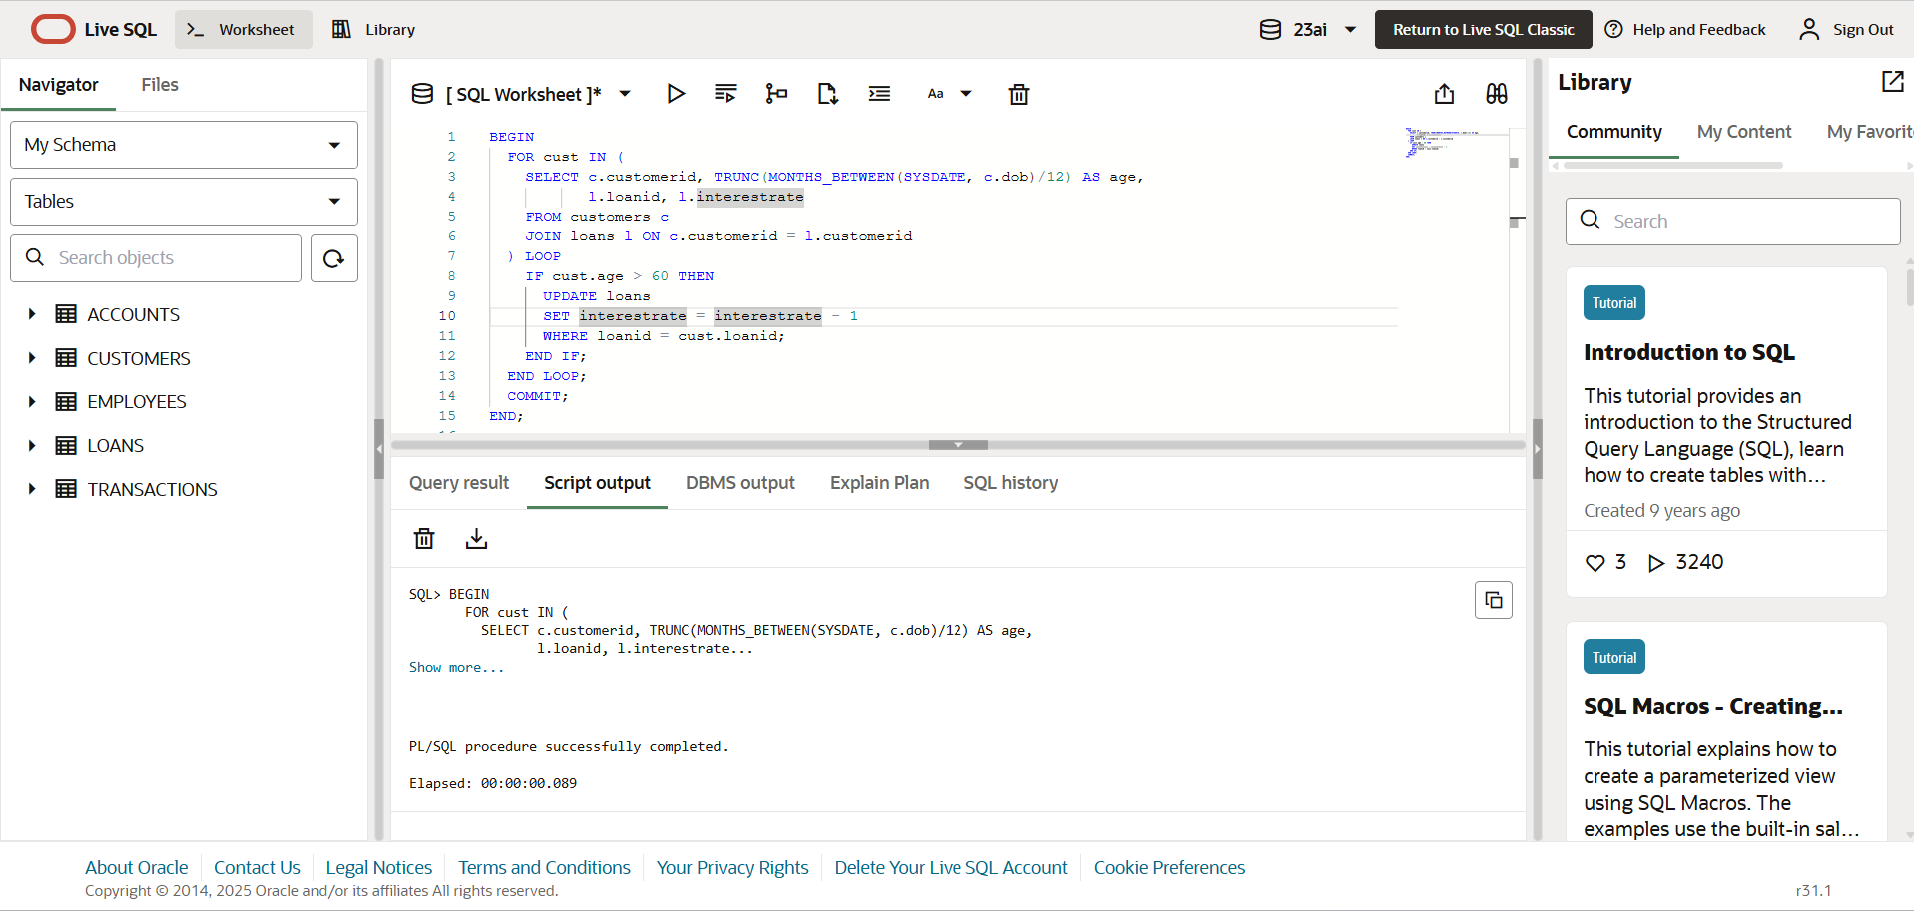

**Scenario 2:** A customer can be promoted to VIP status based on their balance.

**Question**: Write a PL/SQL block that iterates through all customers and sets a flag IsVIP to TRUE for those with a balance over $10,000.

**CODE:**

BEGIN

  FOR cust IN (

    SELECT customerid, balance

    FROM customers

  ) LOOP

    IF cust.balance > 10000 THEN

      UPDATE customers

      SET isvip = 'TRUE'

      WHERE customerid = cust.customerid;

    END IF;

  END LOOP;

  COMMIT;

END;

**OUTPUT:  
**

**Scenario 3:** The bank wants to send reminders to customers whose loans are due within the next 30 days**.**

**Question:** Write a PL/SQL block that fetches all loans due in the next 30 days and prints a reminder message for each customer.

**CODE:**DECLARE

  v_due_date DATE := SYSDATE + 30;

BEGIN

  FOR loan_rec IN (

    SELECT l.loanid, c.name AS customer_name, l.enddate AS due_date

    FROM loans l

    JOIN customers c ON l.customerid = c.customerid

    WHERE l.enddate BETWEEN SYSDATE AND v_due_date

  ) LOOP

    DBMS_OUTPUT.PUT_LINE('Reminder: Loan ' || loan_rec.loanid ||

                         ' for customer ' || loan_rec.customer_name ||

                         ' is due on ' || TO_CHAR(loan_rec.due_date, 'DD-MON-YYYY'));

  END LOOP;

END;

**OUTPUT:**

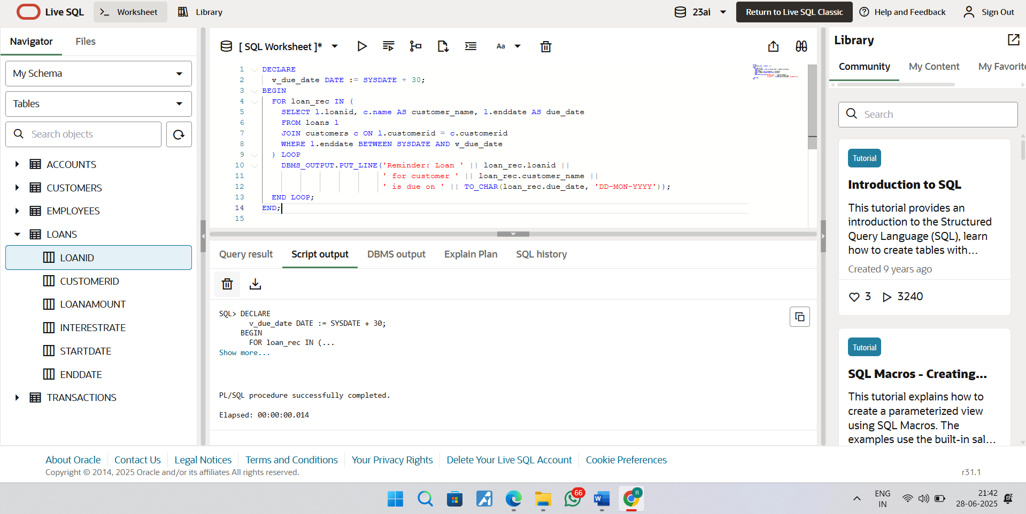

**Exercise 2: Error Handling**

**Scenario 1:** Handle exceptions during fund transfers between accounts.

**Question:** Write a stored procedure SafeTransferFunds that transfers funds between two accounts. Ensure that if any error occurs (e.g., insufficient funds), an appropriate error message is logged and the transaction is rolled back.

**CODE:**

CREATE OR REPLACE PROCEDURE SafeTransferFunds(

  p_from_acc_id IN NUMBER,

  p_to_acc_id IN NUMBER,

  p_amount IN NUMBER

) AS

  v_balance NUMBER;

BEGIN

  SELECT balance INTO v_balance

  FROM accounts

  WHERE accountid = p_from_acc_id;

  IF v_balance < p_amount THEN

    RAISE_APPLICATION_ERROR(-20001, 'Insufficient funds');

  END IF;

  UPDATE accounts

  SET balance = balance - p_amount

  WHERE accountid = p_from_acc_id;

  UPDATE accounts

  SET balance = balance + p_amount

  WHERE accountid = p_to_acc_id;

  COMMIT;

  DBMS_OUTPUT.PUT_LINE('Transfer successful');

EXCEPTION

  WHEN OTHERS THEN

    ROLLBACK;

    DBMS_OUTPUT.PUT_LINE('Error during transfer: ' || SQLERRM);

END;

EXEC SafeTransferFunds(101, 202, 500);

**OUTPUT:**

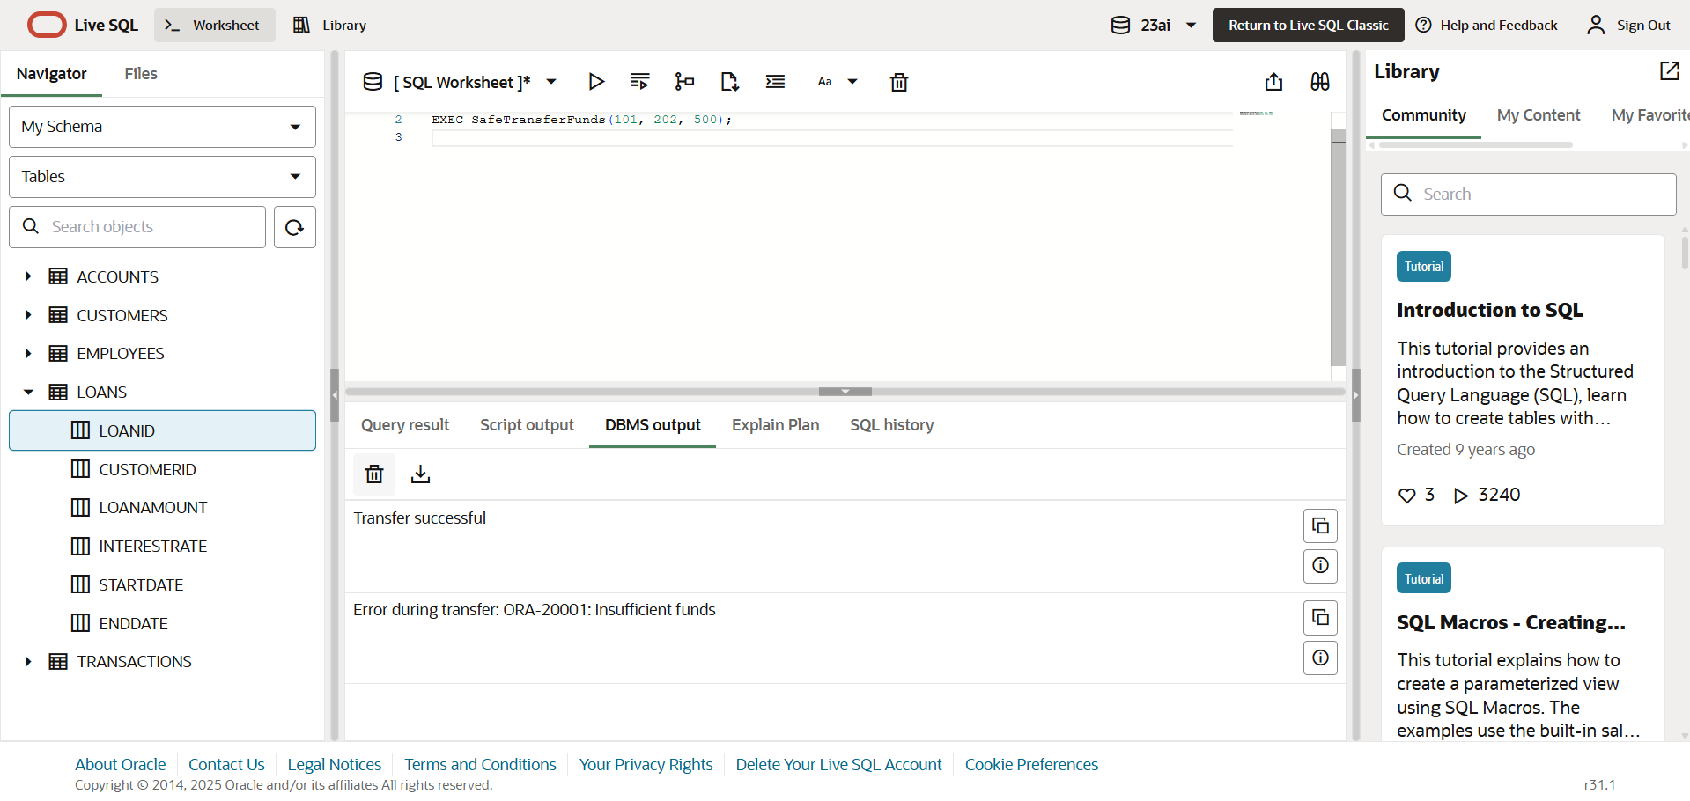

**Scenario 2:** Manage errors when updating employee salaries.

**Question:** Write a stored procedure **UpdateSalary** that increases the salary of an employee by a given percentage. If the employee ID does not exist, handle the exception and log an error message.

**CODE:**

CREATE OR REPLACE PROCEDURE UpdateSalary(

  p_emp_id IN NUMBER,

  p_percent IN NUMBER

) AS

BEGIN

  UPDATE employees

  SET salary = salary + (salary * p_percent / 100)

  WHERE employeeid = p_emp_id;

  IF SQL%ROWCOUNT = 0 THEN

    RAISE_APPLICATION_ERROR(-20002, 'Employee ID not found');

  END IF;

  COMMIT;

  DBMS_OUTPUT.PUT_LINE('Salary updated successfully');

EXCEPTION

  WHEN OTHERS THEN

    ROLLBACK;

    DBMS_OUTPUT.PUT_LINE('Error updating salary: ' || SQLERRM);

END;

EXEC UpdateSalary(101, 10);

**OUTPUT:**

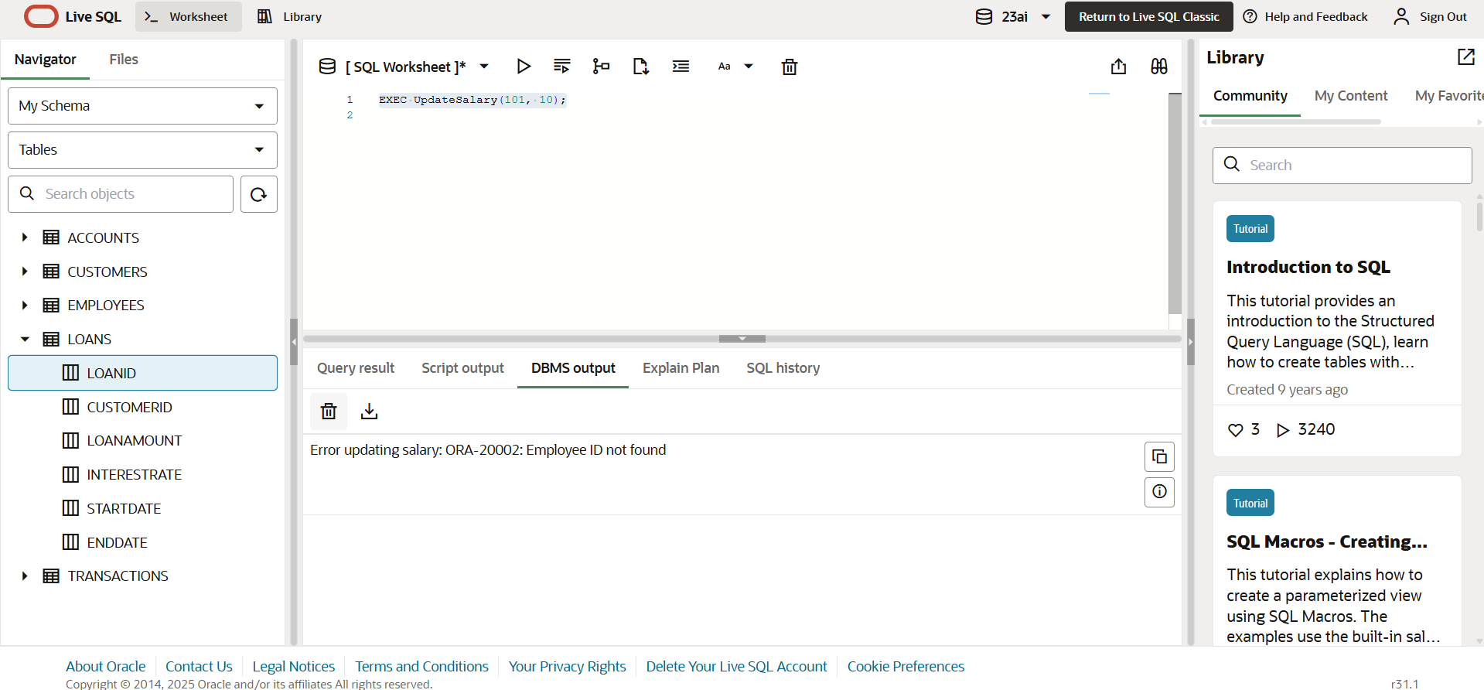

**Scenario 3:** Ensure data integrity when adding a new customer.

**Question:** Write a stored procedure AddNewCustomer that inserts a new customer into the Customers table. If a customer with the same ID already exists, handle the exception by logging an error and preventing the insertion.

**CODE:**

CREATE OR REPLACE PROCEDURE AddNewCustomer(

  p_customer_id IN NUMBER,

  p_name IN VARCHAR2,

  p_dob IN DATE,

  p_balance IN NUMBER

) AS

BEGIN

  INSERT INTO customers(customerid, name, dob, balance)

  VALUES (p_customer_id, p_name, p_dob, p_balance);

  COMMIT;

  DBMS_OUTPUT.PUT_LINE('Customer added successfully');

EXCEPTION

  WHEN DUP_VAL_ON_INDEX THEN

    DBMS_OUTPUT.PUT_LINE('Error: Customer with ID ' || p_customer_id || ' already exists.');

  WHEN OTHERS THEN

    DBMS_OUTPUT.PUT_LINE('Error inserting customer: ' || SQLERRM);

END;

SET SERVEROUTPUT ON;

EXEC AddNewCustomer(101, 'Ravi Kumar', TO_DATE('1990-05-15', 'YYYY-MM-DD'), 5000);

**OUTPUT:  
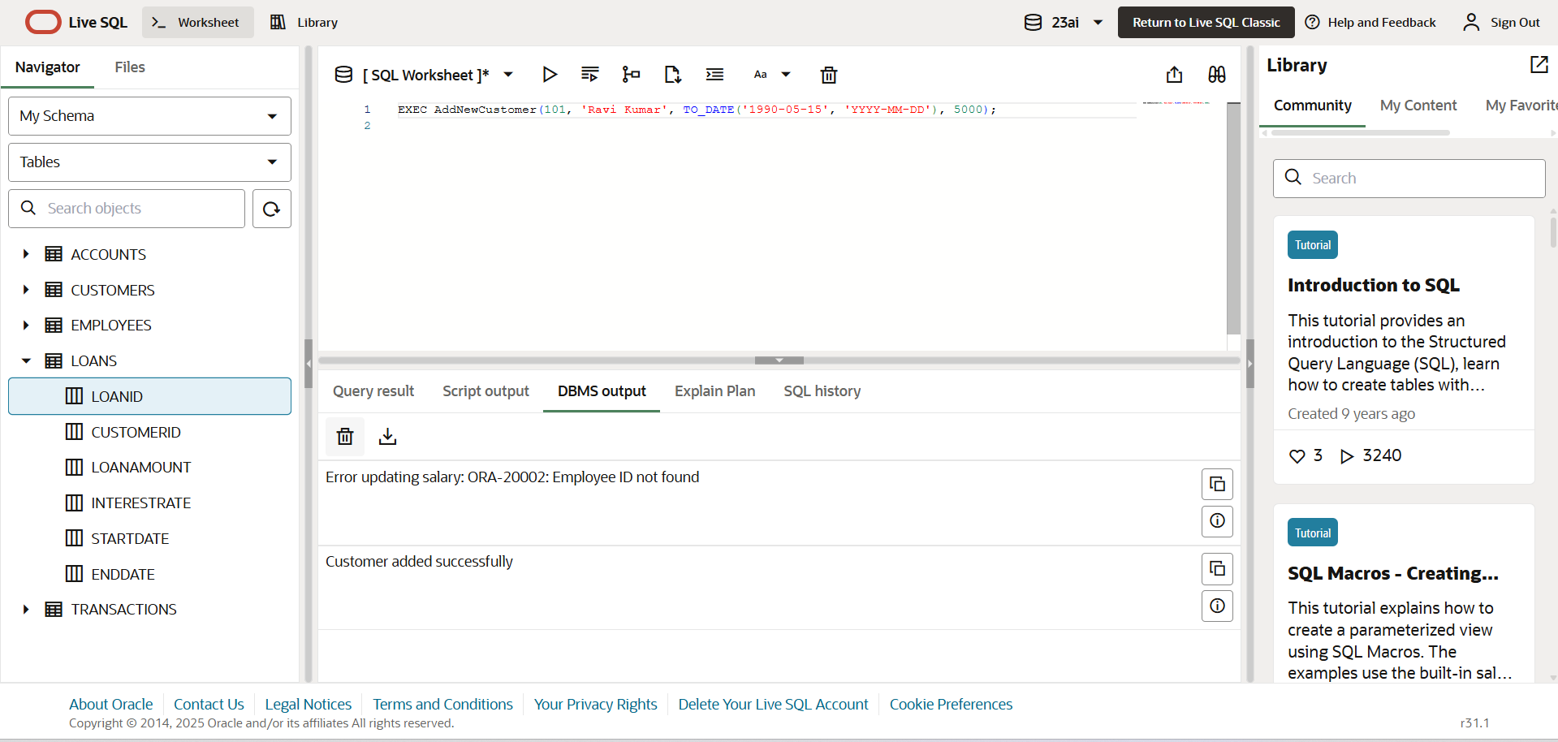**

**Exercise 3: Stored Procedures**

**Scenario 1**: The bank needs to process monthly interest for all savings accounts.

**Question:** Write a stored procedure ProcessMonthlyInterest that calculates and updates the balance of all savings accounts by applying an interest rate of 1% to the current balance.

**CODE:**CREATE OR REPLACE PROCEDURE ProcessMonthlyInterest AS

BEGIN

  FOR acc IN (

    SELECT AccountID, Balance

    FROM Accounts

    WHERE AccountType = 'Savings'

  ) LOOP

    UPDATE Accounts

    SET Balance = Balance + (acc.Balance * 0.01),

        LastModified = SYSDATE

    WHERE AccountID = acc.AccountID;

  END LOOP;

  COMMIT;

  DBMS_OUTPUT.PUT_LINE('Monthly interest processed for all savings accounts.');

END;

/

BEGIN

  ProcessMonthlyInterest;

END;

/

**OUTPUT:  
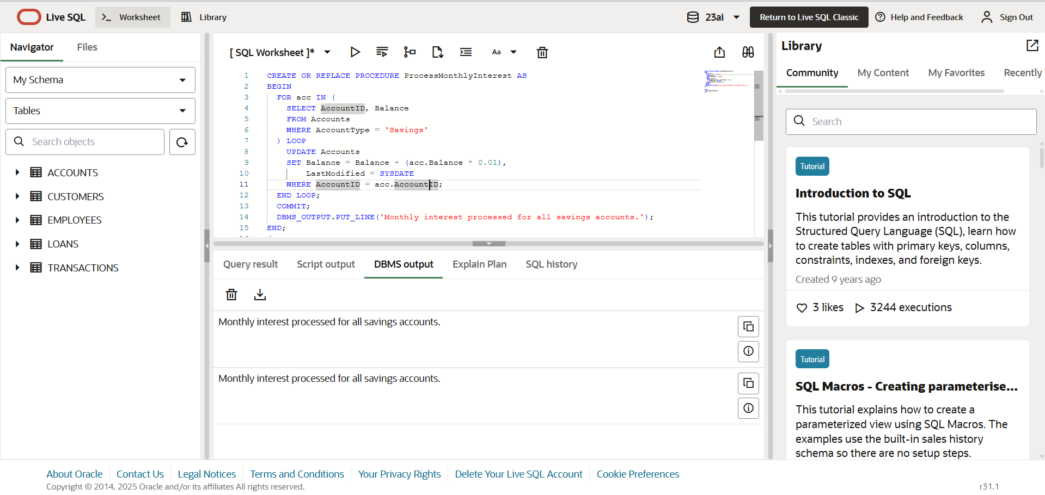**

**Scenario 2:** The bank wants to implement a bonus scheme for employees based on their performance.

**Question:** Write a stored procedure **UpdateEmployeeBonus** that updates the salary of employees in a given department by adding a bonus percentage passed as a parameter.

**CODE:**

CREATE OR REPLACE PROCEDURE UpdateEmployeeBonus(

  p_department IN VARCHAR2,

  p_bonus_percent IN NUMBER

) AS

BEGIN

  UPDATE Employees

  SET Salary = Salary + (Salary * p_bonus_percent / 100)

  WHERE Department = p_department;

  COMMIT;

  DBMS_OUTPUT.PUT_LINE('Bonus updated for department: ' || p_department);

END;

/

BEGIN

  UpdateEmployeeBonus('HR', 10);

END;

/

**OUTPUT:**

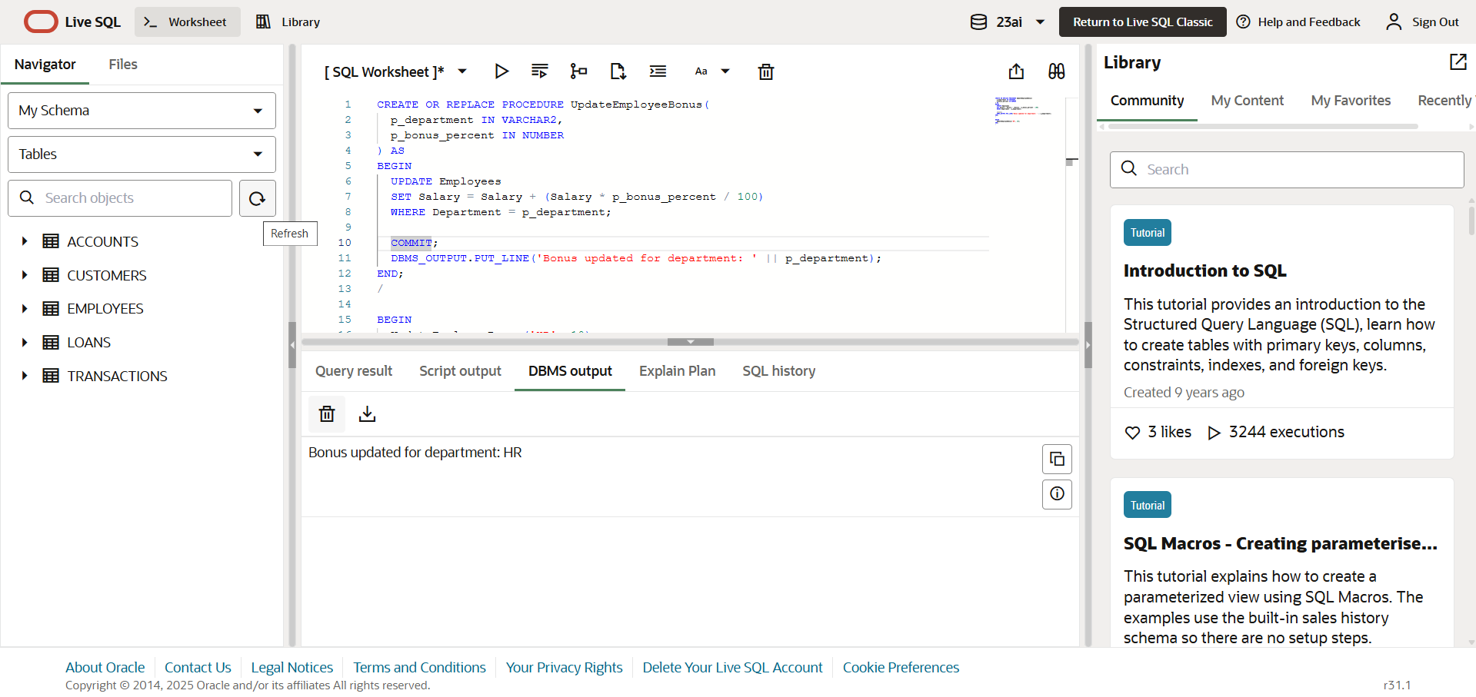

**Scenario 3:** Customers should be able to transfer funds between their accounts.

**Question:** Write a stored procedure **TransferFunds** that transfers a specified amount from one account to another, checking that the source account has sufficient balance before making the transfer.

**CODE:**

CREATE OR REPLACE PROCEDURE TransferFunds(

  p_from_account IN NUMBER,

  p_to_account IN NUMBER,

  p_amount IN NUMBER

) AS

  v_balance NUMBER;

BEGIN

  SELECT Balance INTO v_balance

  FROM Accounts

  WHERE AccountID = p_from_account

  FOR UPDATE;

  IF v_balance < p_amount THEN

    RAISE_APPLICATION_ERROR(-20001, 'Insufficient funds in source account.');

  END IF;

  UPDATE Accounts

  SET Balance = Balance - p_amount,

      LastModified = SYSDATE

  WHERE AccountID = p_from_account;

  UPDATE Accounts

  SET Balance = Balance + p_amount,

      LastModified = SYSDATE

  WHERE AccountID = p_to_account;

  INSERT INTO Transactions (TransactionID, AccountID, TransactionDate, Amount, TransactionType)

  VALUES (Transactions_seq.NEXTVAL, p_from_account, SYSDATE, p_amount, 'Debit');

  INSERT INTO Transactions (TransactionID, AccountID, TransactionDate, Amount, TransactionType)

  VALUES (Transactions_seq.NEXTVAL, p_to_account, SYSDATE, p_amount, 'Credit');

  COMMIT;

  DBMS_OUTPUT.PUT_LINE('Funds transferred successfully.');

EXCEPTION

  WHEN NO_DATA_FOUND THEN

    RAISE_APPLICATION_ERROR(-20002, 'One of the account IDs does not exist.');

  WHEN OTHERS THEN

    ROLLBACK;

    RAISE;

END;

/

**OUTPUT:**

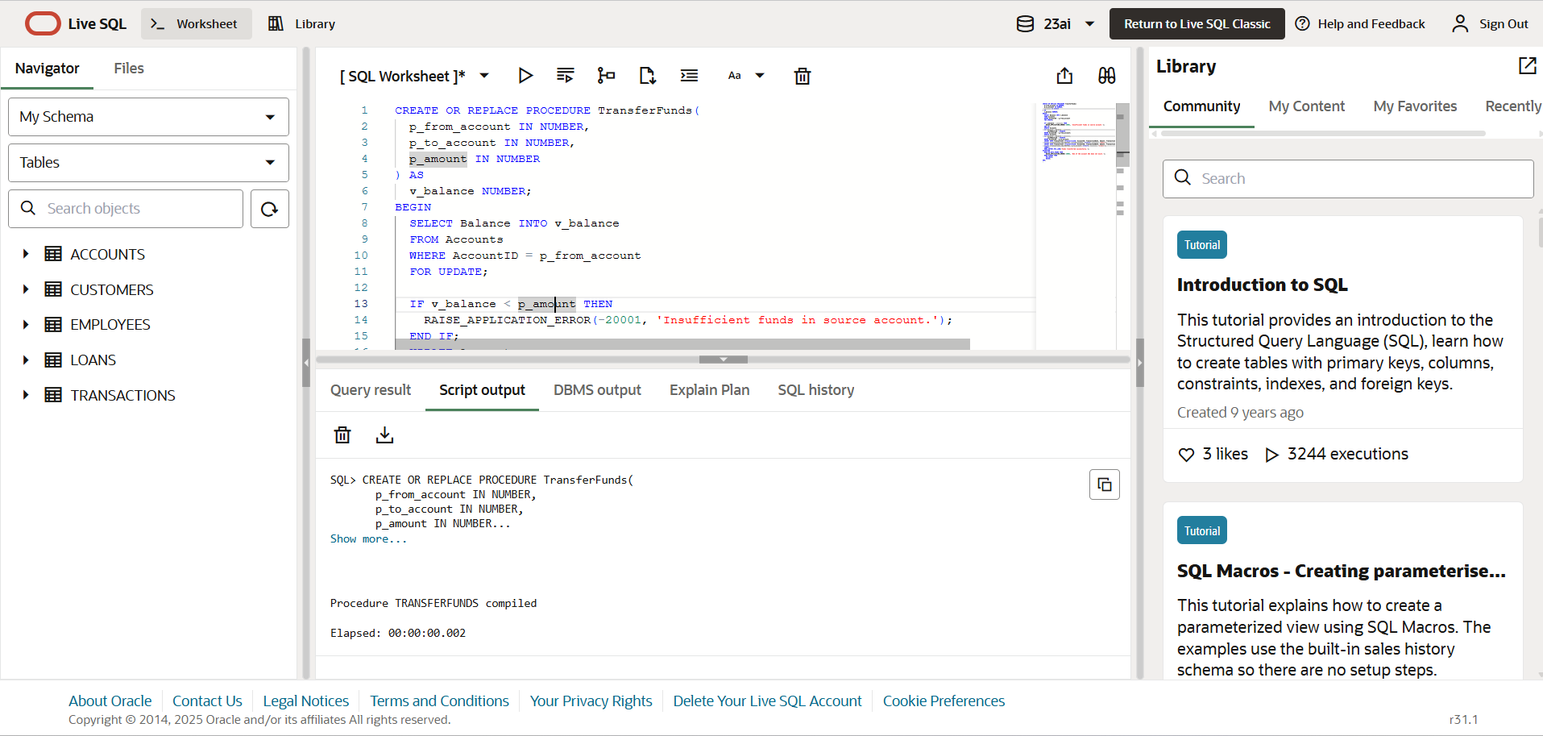

**Exercise 4: Functions**

**Scenario 1:** Calculate the age of customers for eligibility checks.

**Question:** Write a function CalculateAge that takes a customer's date of birth as input and returns their age in years.

**CODE:**

CREATE OR REPLACE FUNCTION CalculateAge(p_dob DATE)

RETURN NUMBER IS

  v_age NUMBER;

BEGIN

  v_age := FLOOR(MONTHS_BETWEEN(SYSDATE, p_dob) / 12);

  RETURN v_age;

END;

/

**OUTPUT:**

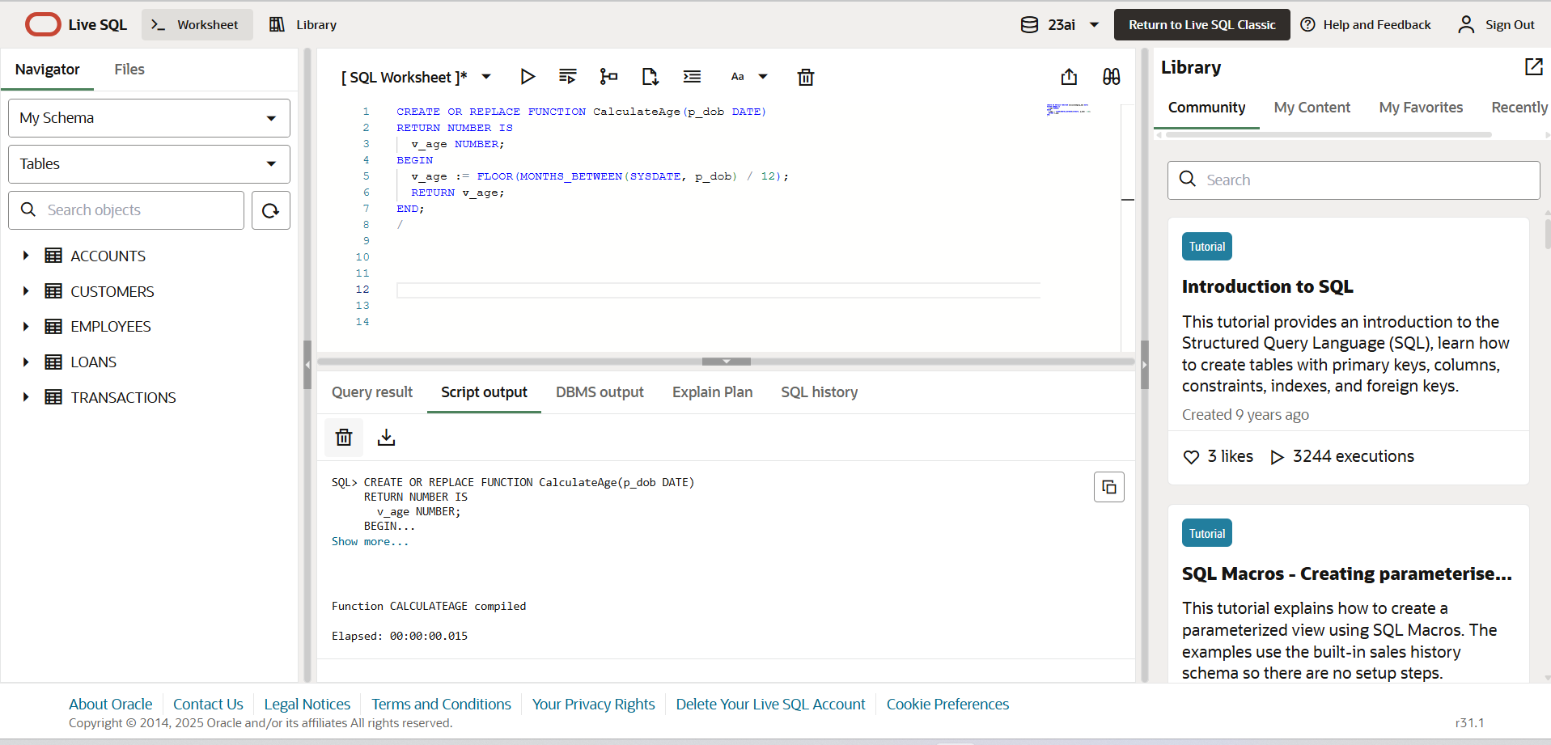

**Scenario 2:** The bank needs to compute the monthly installment for a loan.

**Question:** Write a function **CalculateMonthlyInstallment** that takes the loan amount, interest rate, and loan duration in years as input and returns the monthly installment amount.

**CODE:**

CREATE OR REPLACE FUNCTION CalculateMonthlyInstallment(

p_loan_amount IN NUMBER,

p_annual_rate IN NUMBER,

p_duration_years IN NUMBER

)

RETURN NUMBER IS

v_monthly_rate NUMBER := p_annual_rate / 12 / 100;

v_total_months NUMBER := p_duration_years * 12;

v_emi NUMBER;

BEGIN

IF v_monthly_rate = 0 THEN

v_emi := p_loan_amount / v_total_months;

ELSE

v_emi := p_loan_amount * v_monthly_rate * POWER(1 + v_monthly_rate, v_total_months)

/ (POWER(1 + v_monthly_rate, v_total_months) - 1);

END IF;

RETURN ROUND(v_emi, 2);

END;

/

**OUTPUT:  
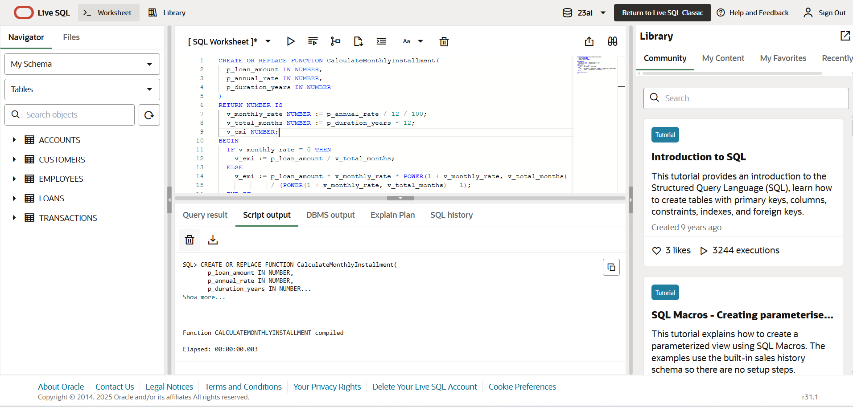**

**Scenario 3**: Check if a customer has sufficient balance before making a transaction.

**Question:** Write a function HasSufficientBalance that takes an account ID and an amount as input and returns a boolean indicating whether the account has at least the specified amount.

**CODE:**

CREATE OR REPLACE FUNCTION HasSufficientBalance(

  p_account_id IN NUMBER,

  p_required_amount IN NUMBER

)

RETURN BOOLEAN IS

  v_balance NUMBER;

BEGIN

  SELECT Balance INTO v_balance

  FROM Accounts

  WHERE AccountID = p_account_id;

  RETURN v_balance >= p_required_amount;

EXCEPTION

  WHEN NO_DATA_FOUND THEN

    RETURN FALSE;

END;

**OUTPUT:**

**Exercise 5: Triggers**

**Scenario 1:** Automatically update the last modified date when a customer's record is updated.

**Question:** Write a trigger **UpdateCustomerLastModified** that updates the LastModified column of the Customers table to the current date whenever a customer's record is updated

**CODE:**

CREATE OR REPLACE TRIGGER UpdateCustomerLastModified

BEFORE UPDATE ON Customers

FOR EACH ROW

BEGIN

  :NEW.LastModified := SYSDATE;

END;

/

**OUTPUT:**

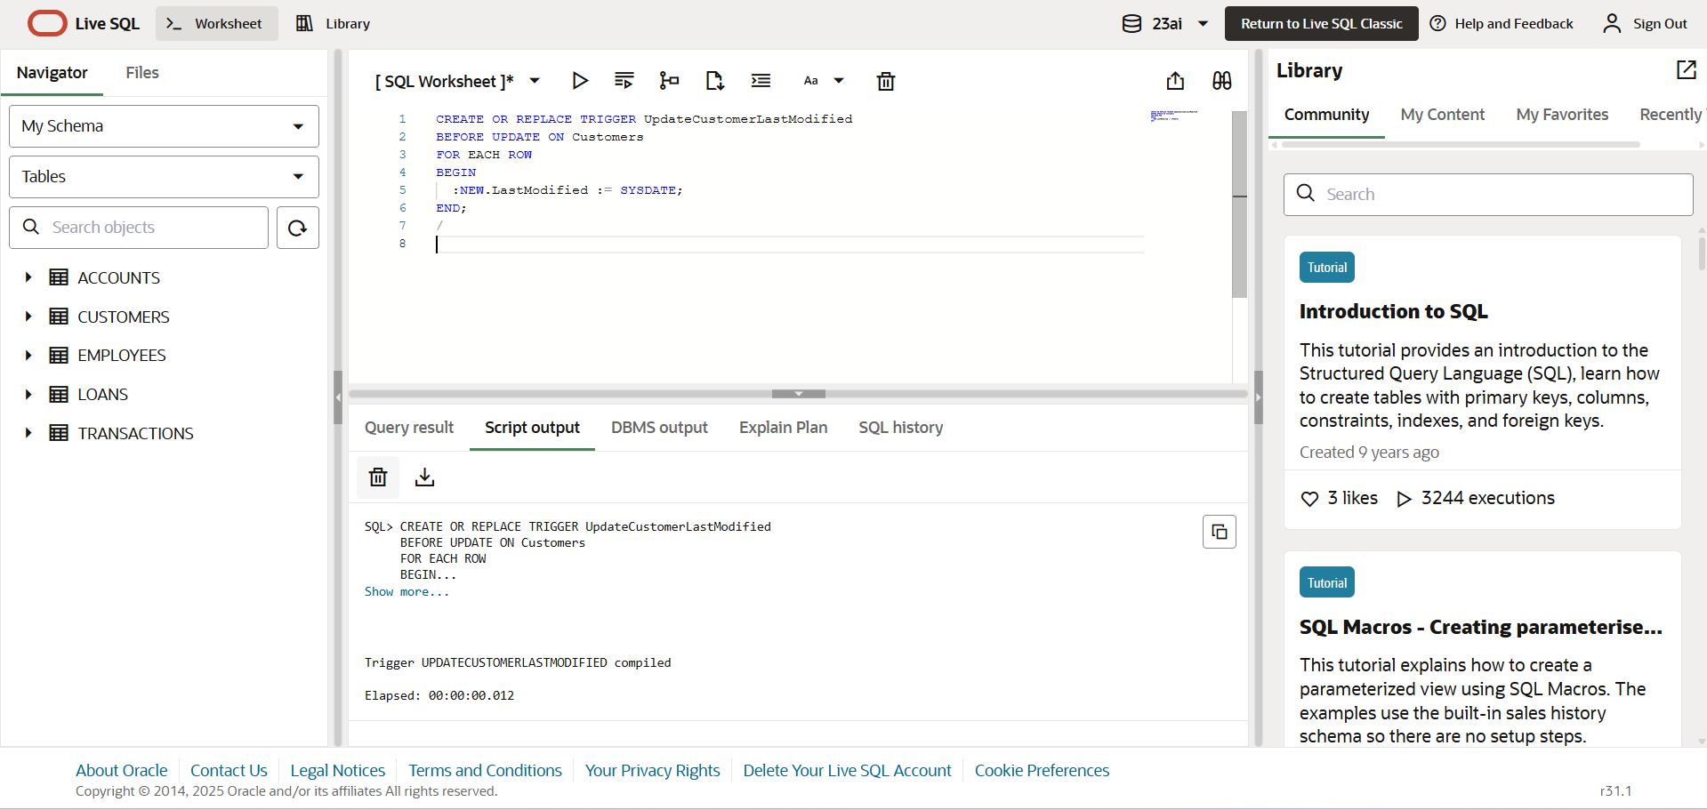

**Scenario 2**: Maintain an audit log for all transactions**.**

**Question**: Write a trigger LogTransaction that inserts a record into an AuditLog table whenever a transaction is inserted into the Transactions table.

**CODE:**

CREATE OR REPLACE TRIGGER LogTransaction

AFTER INSERT ON Transactions

FOR EACH ROW

BEGIN

  INSERT INTO AuditLog (

    AuditID, AccountID, TransactionDate, Amount, TransactionType, LoggedAt

  )

  VALUES (

    AuditLog_seq.NEXTVAL,

    :NEW.AccountID,

    :NEW.TransactionDate,

    :NEW.Amount,

    :NEW.TransactionType,

    SYSDATE

  );

END;

**OUTPUT:**

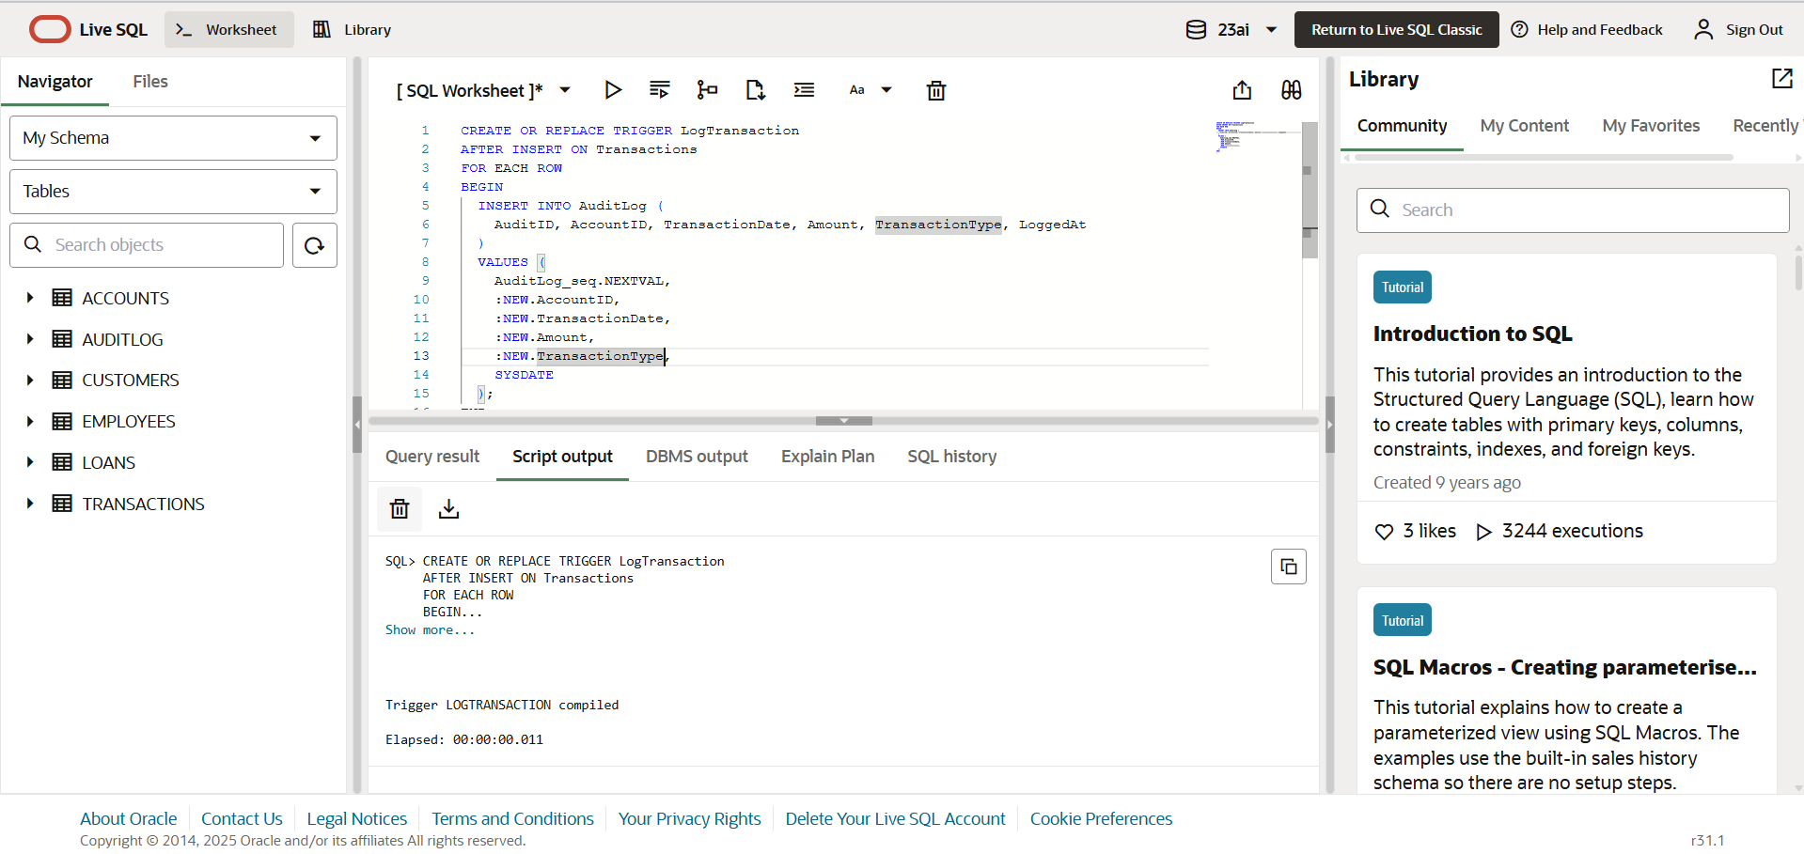

**Scenario 3:** Enforce business rules on deposits and withdrawals.

**Question:** Write a trigger CheckTransactionRules that ensures withdrawals do not exceed the balance and deposits are positive before inserting a record into the Transactions table

**CODE:**

CREATE OR REPLACE TRIGGER CheckTransactionRules

BEFORE INSERT ON Transactions

FOR EACH ROW

DECLARE

  v_balance NUMBER;

BEGIN

  SELECT Balance INTO v_balance

  FROM Accounts

  WHERE AccountID = :NEW.AccountID;

  IF :NEW.TransactionType = 'Withdrawal' THEN

    IF :NEW.Amount <= 0 THEN

      RAISE_APPLICATION_ERROR(-20001, 'Withdrawal amount must be positive.');

    ELSIF v_balance < :NEW.Amount THEN

      RAISE_APPLICATION_ERROR(-20002, 'Insufficient balance for withdrawal.');

    END IF;

  ELSIF :NEW.TransactionType = 'Deposit' THEN

    IF :NEW.Amount <= 0 THEN

      RAISE_APPLICATION_ERROR(-20003, 'Deposit amount must be positive.');

    END IF;

  ELSE

    RAISE_APPLICATION_ERROR(-20004, 'Invalid transaction type.');

  END IF;

END;

/

**OUTPUT:**

**Exercise 6: Cursors**

**Scenario 1:** Generate monthly statements for all customers.

**Question:** Write a PL/SQL block using an explicit cursor GenerateMonthlyStatements that retrieves all transactions for the current month and prints a statement for each customer.

**CODE:**

DECLARE

  CURSOR cur_monthly_txns IS

    SELECT c.CustomerID, c.Name, t.TransactionDate, t.Amount, t.TransactionType

    FROM Customers c

    JOIN Accounts a ON c.CustomerID = a.CustomerID

    JOIN Transactions t ON a.AccountID = t.AccountID

    WHERE TRUNC(t.TransactionDate, 'MM') = TRUNC(SYSDATE, 'MM')

    ORDER BY c.CustomerID, t.TransactionDate;

  v_customer_id Customers.CustomerID%TYPE;

  v_name Customers.Name%TYPE;

  v_date Transactions.TransactionDate%TYPE;

  v_amount Transactions.Amount%TYPE;

  v_type Transactions.TransactionType%TYPE;

BEGIN

  DBMS_OUTPUT.PUT_LINE('--- Monthly Statements ---');

  OPEN cur_monthly_txns;

  LOOP

    FETCH cur_monthly_txns INTO v_customer_id, v_name, v_date, v_amount, v_type;

    EXIT WHEN cur_monthly_txns%NOTFOUND;

    DBMS_OUTPUT.PUT_LINE('Customer: ' || v_name || ' | Date: ' || v_date ||

                         ' | Amount: ' || v_amount || ' | Type: ' || v_type);

  END LOOP;

  CLOSE cur_monthly_txns;

END;

/

**OUTPUT:  
**

**Scenario 2:** Apply annual fee to all accounts**.**

**Question:** Write a PL/SQL block using an explicit cursor ApplyAnnualFee that deducts an annual maintenance fee from the balance of all accounts.

**CODE:**

DECLARE

  CURSOR cur_accounts IS

    SELECT AccountID, Balance

    FROM Accounts;

  v_account_id Accounts.AccountID%TYPE;

  v_balance Accounts.Balance%TYPE;

  v_fee CONSTANT NUMBER := 500;

BEGIN

  OPEN cur_accounts;

  LOOP

    FETCH cur_accounts INTO v_account_id, v_balance;

    EXIT WHEN cur_accounts%NOTFOUND;

    UPDATE Accounts

    SET Balance = Balance - v_fee,

        LastModified = SYSDATE

    WHERE AccountID = v_account_id;

    DBMS_OUTPUT.PUT_LINE('Annual fee applied to AccountID: ' || v_account_id);

  END LOOP;

  CLOSE cur_accounts;

  COMMIT;

END;

/

**OUTPUT:**

**Scenario 3:** Update the interest rate for all loans based on a new policy.

**Question**: Write a PL/SQL block using an explicit cursor UpdateLoanInterestRates that fetches all loans and updates their interest rates based on the new policy**.**

**CODE:**

DECLARE

  CURSOR cur_loans IS

    SELECT LoanID, InterestRate

    FROM Loans;

  v_loan_id Loans.LoanID%TYPE;

  v_rate Loans.InterestRate%TYPE;

BEGIN

  OPEN cur_loans;

  LOOP

    FETCH cur_loans INTO v_loan_id, v_rate;

    EXIT WHEN cur_loans%NOTFOUND;

    IF v_rate < 6 THEN

      UPDATE Loans

      SET InterestRate = InterestRate + 0.5

      WHERE LoanID = v_loan_id;

    ELSE

      UPDATE Loans

      SET InterestRate = InterestRate + 0.25

      WHERE LoanID = v_loan_id;

    END IF;

    DBMS_OUTPUT.PUT_LINE('Updated interest for LoanID ' || v_loan_id);

  END LOOP;

  CLOSE cur_loans;

  COMMIT;

END;

/

**OUTPUT:**

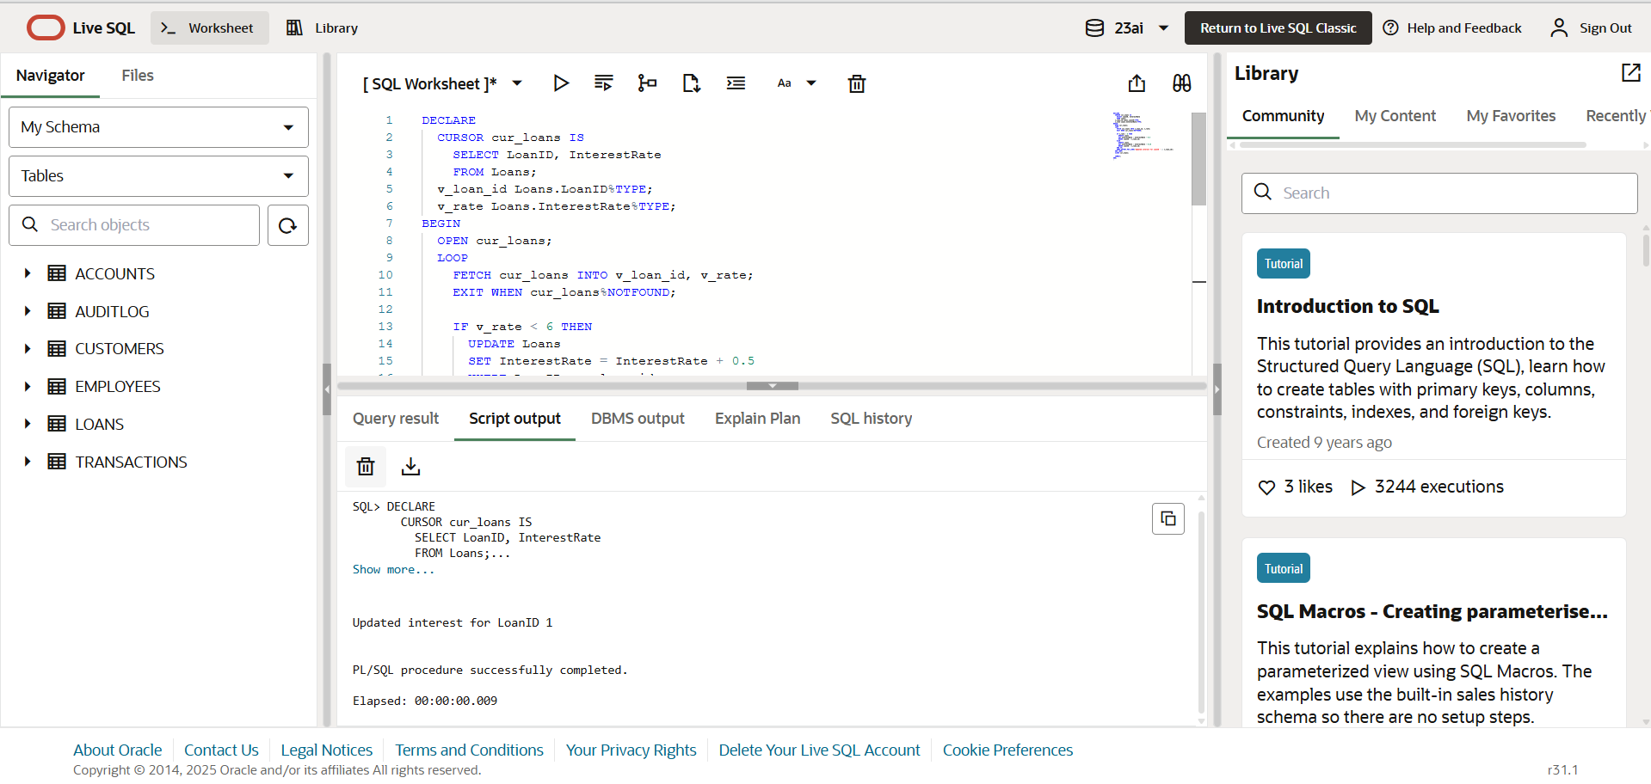

**Exercise 7: Packages**

**Scenario 1:** Group all customer-related procedures and functions into a package.

**Question:** Create a package CustomerManagement with procedures for adding a new customer, updating customer details, and a function to get customer balance**.**

**CODE:** CREATE OR REPLACE PACKAGE CustomerManagement AS

  PROCEDURE AddCustomer(p_id NUMBER, p_name VARCHAR2, p_dob DATE, p_balance NUMBER);

  PROCEDURE UpdateCustomer(p_id NUMBER, p_name VARCHAR2, p_dob DATE);

  FUNCTION GetCustomerBalance(p_id NUMBER) RETURN NUMBER;

END CustomerManagement;

/

CREATE OR REPLACE PACKAGE BODY CustomerManagement AS

  PROCEDURE AddCustomer(p_id NUMBER, p_name VARCHAR2, p_dob DATE, p_balance NUMBER) IS

  BEGIN

    INSERT INTO Customers (CustomerID, Name, DOB, Balance, LastModified)

    VALUES (p_id, p_name, p_dob, p_balance, SYSDATE);

    COMMIT;

  END;

  PROCEDURE UpdateCustomer(p_id NUMBER, p_name VARCHAR2, p_dob DATE) IS

  BEGIN

    UPDATE Customers

    SET Name = p_name, DOB = p_dob, LastModified = SYSDATE

    WHERE CustomerID = p_id;

    COMMIT;

  END;

  FUNCTION GetCustomerBalance(p_id NUMBER) RETURN NUMBER IS

    v_balance NUMBER;

  BEGIN

    SELECT Balance INTO v_balance

    FROM Customers

    WHERE CustomerID = p_id;

    RETURN v_balance;

  END;

END CustomerManagement;

/

**OUTPUT:**  
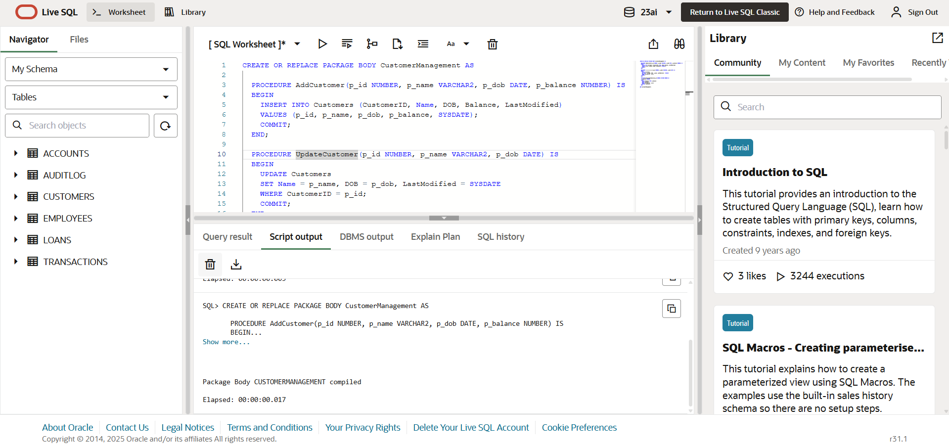

**Scenario 2:** Create a package to manage employee data.

**Question**: Write a package EmployeeManagement with procedures to hire new employees, update employee details, and a function to calculate annual salary.

**CODE:**

CREATE OR REPLACE PACKAGE EmployeeManagement AS

PROCEDURE HireEmployee(p_id NUMBER, p_name VARCHAR2, p_position VARCHAR2,

p_salary NUMBER, p_department VARCHAR2, p_hire_date DATE);

PROCEDURE UpdateEmployee(p_id NUMBER, p_salary NUMBER, p_position VARCHAR2);

FUNCTION GetAnnualSalary(p_id NUMBER) RETURN NUMBER;

END EmployeeManagement;

/

CREATE OR REPLACE PACKAGE BODY EmployeeManagement AS

PROCEDURE HireEmployee(p_id NUMBER, p_name VARCHAR2, p_position VARCHAR2,

p_salary NUMBER, p_department VARCHAR2, p_hire_date DATE) IS

BEGIN

INSERT INTO Employees (EmployeeID, Name, Position, Salary, Department, HireDate)

VALUES (p_id, p_name, p_position, p_salary, p_department, p_hire_date);

COMMIT;

END;

PROCEDURE UpdateEmployee(p_id NUMBER, p_salary NUMBER, p_position VARCHAR2) IS

BEGIN

UPDATE Employees

SET Salary = p_salary, Position = p_position

WHERE EmployeeID = p_id;

COMMIT;

END;

FUNCTION GetAnnualSalary(p_id NUMBER) RETURN NUMBER IS

v_salary NUMBER;

BEGIN

SELECT Salary INTO v_salary

FROM Employees

WHERE EmployeeID = p_id;

RETURN v_salary * 12;

END;

END EmployeeManagement;

/

**OUTPUT:**

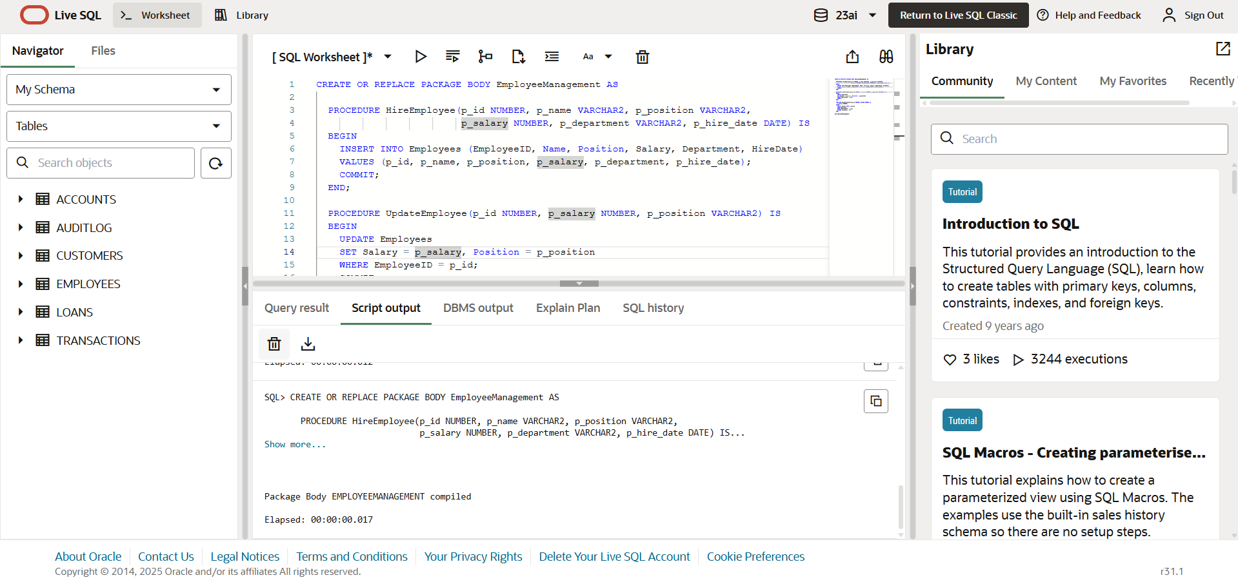

**Scenario 3**: Group all account-related operations into a package.

**Question:** Create a package AccountOperations with procedures for opening a new account, closing an account, and a function to get the total balance of a customer across all accounts.

**CODE:**

CREATE OR REPLACE PACKAGE AccountOperations AS

  PROCEDURE OpenAccount(p_account_id NUMBER, p_customer_id NUMBER, p_type VARCHAR2, p_balance NUMBER);

  PROCEDURE CloseAccount(p_account_id NUMBER);

  FUNCTION GetTotalBalance(p_customer_id NUMBER) RETURN NUMBER;

END AccountOperations;

/

CREATE OR REPLACE PACKAGE BODY AccountOperations AS

PROCEDURE OpenAccount(p_account_id NUMBER, p_customer_id NUMBER, p_type VARCHAR2, p_balance NUMBER) IS

BEGIN

INSERT INTO Accounts (AccountID, CustomerID, AccountType, Balance, LastModified)

VALUES (p_account_id, p_customer_id, p_type, p_balance, SYSDATE);

COMMIT;

END;

PROCEDURE CloseAccount(p_account_id NUMBER) IS

BEGIN

DELETE FROM Accounts

WHERE AccountID = p_account_id;

COMMIT;

END;

FUNCTION GetTotalBalance(p_customer_id NUMBER) RETURN NUMBER IS

v_total NUMBER := 0;

BEGIN

SELECT NVL(SUM(Balance), 0) INTO v_total

FROM Accounts

WHERE CustomerID = p_customer_id;

RETURN v_total;

END;

END AccountOperations;

/

**OUTPUT:**

