
Location :Develop Trees,
D.No:21-17-878
3rd Line Anjaneya,
Amaravati Road,
Guntur-522007 AP ,India.

BUGLEGAL is a software that organizations use to manage internal HR functions. From employee data management to payroll, recruitment, benefits, training, talent management, employee engagement, and employee attendance, HRMS software helps HR professionals manage the modern workforce.
BUGLEGAL
INDEX
ADMIN
Contents Page no
- Admin Control (7-21)
Dashboard Features 7------9
My Pay Slips 10------11
Attendance 12----13
Reimbursement 14----16
Documents 17----19
Help 20----21
- Admin Options (22-30)
Advance Salary 22----23
Company Details 24----24
Create Project 25----25
People 25----26
Reports 26----28
Settings 28----30

- Employee Performance (31-35)
Daily Task Report 32----32
Employees AVG Performance 32----33
Employees Project Performance 33----34
Employees Task Performance 34----35
Project List 35----35
- Monitoring Logs (36-45)
Screen Monitoring 36----38
Detailed Monitoring 39----39
Power Logs 39----40
Benefits of Power Logs 40----41
Screen Shots 41----44
Time Tracking 45----45

PROJECT MANAGER (46-50)
- Projects 46----49
- Project Status 50----50

HUMAN RESOURCES (51-55)
- Dashboard 51----51
- My Pay Slips 51----51
- Attendance 51 ----51
- Reimbursement 51----52
- Documents 52----52
- Help 52----52
- Daily Tasks 52----52
- People 52----53
- Reports 53----54
- Employee Performance 54----55

TEAM LEAD (56-64)
- Overview 56----58
- My Pay Slips 58----59
- Leave & Attendance 59----60
- Reimbursement 61----62
- Documents 62----62
- Help 63----63
- Assign Task To Team Members 63----63
- Employee Performance Task 63----63
- Daily Task 64----64
- Daily Employee Task Performance 64----64

EMPLOYEE (65-68)

- Dashboard 65----65
- My Pay Slip 65----65
- Attendance 66----66
- Reimbursement 66----67
- Documents 67----68
- Help 68----68
- Daily Task 68----68
PRICING (69-71)
1.Basic Plan 69----69
2.Gold Plan 69----70
3.Platinum Plan 70----70
4.Diamond Plan 70----71

WORK TRIDE
ADMIN CONTROL
DASHBOARD FEATURES

1. Check-In Employees
Overview:
The "Check-In Employees" feature provides a real time view of employees who have successfully checked in for the day.
Functionality:
- Displays a list of employees who have checked in.
- Updates in real time to reflect the current status.
- Provides a timestamp for each check-in.
Usage:
- Navigate to the "Check-In Employees" section on the dashboard.
- View the list of employees who have successfully checked in.
- Utilize the real time updates for accurate information.

2. Non Check-In Employees

Overview:
The "Non Check-In Employees" feature identifies employees who have not checked in for the day.

Functionality:
- List of employees who have not checked in.
- Allows for easy identification of noncompliance.

Usage:
- Access the "Non Check-In Employees" section.
- Identify employees who have not checked in.
- Take necessary actions to follow up with noncompliant employees.

Total Employees

Overview:
The "Total Employees" feature provides a count of all registered employees.

Functionality:
- Displays the total number of employees.
- Updates dynamically as new employees are added or removed.

Usage:
- Locate the "Total Employees" section.
- Observe the current count of registered employees.
- Monitor changes in the total count over time.

4. Leave Employees

Overview:
The "Leave Employees" feature shows a list of employees who are currently on leave.

Functionality:
- Presents a list of employees on leave.
- Includes details such as leave type and duration.

Usage:
- Navigate to the "Leave Employees" section.
- Review the list of employees on leave.
- Use the information for planning and scheduling purposes.

5. Pay Slips

Overview:
The "Pay Slips" feature allows employees to access their pay slips directly from the dashboard.

Functionality:
- Provides a secure and accessible location for pay slips.
- Enables employees to download or view their pay slips.

Usage:
- Access the "Pay Slips" section.
- Select the desired pay slip for viewing or downloading.
- Maintain the confidentiality and security of pay slip information.

Certainly! Below is a sample documentation template for the features related to pay slips, including the counts and detailed information about each pay slip.

MY PAY SLIPS

Employee Applying for Pay slip

Overview:
The "Employee Applying for Pay slip" section allows employees to apply for and view their pay slips. It also provides administrative insights into the status of pay slip requests.

Functionality:
Approved Pay slip Count: Displays the number of pay slips that have been successfully approved.
Pending Pay slip Count: Indicates the number of pay slips that are currently pending approval.
Rejected Pay slip Count: Shows the count of pay slips that have been rejected.
Total Pay slip Count: Provides the total count of all pay slips, including approved, pending, and rejected.

Usage:
1. Employees:
- Apply for pay slips through the "Employee Applying for Pay slip" section.
- Track the status of their pay slip requests.
2. Administrators:
- Monitor the counts to assess the overall status of pay slip requests.
- Take necessary actions based on the counts, such as reviewing pending requests or providing reasons for rejections.

Detailed Pay Slip Information
Overview:
The "Detailed Pay Slip Information" feature provides a comprehensive view of individual pay slips, including essential details.
1. Employ ID: Unique identifier for each employee.
2. Employ Name: Full name of the employee applying for the pay slip.
3. Date: Date when the pay slip request was submitted.
4. Pay slips Duration: Period covered by the pay slip (e.g., monthly).
5 . Reason: Employee provided reason for requesting the pay slip.
6. Status: Indicates the status of the pay slip (approved, pending, rejected).
7. Remarks: Additional notes or comments from administrators regarding the pay slip.

Usage:
1. Viewing Detailed Pay Slip Information:
- Access the "Detailed Pay Slip Information" section on the dashboard.
- Review individual pay slips by examining the information in each column.
2. Administrative Actions:
- Administrators can use the information to approve or reject pay slip requests.
- Provide remarks or comments as needed.

ATTENDANCE

Overview:
The "Admin Attendance" feature allows administrators to track their attendance and view attendance-related details.

Functionality:
Attendance Tracking:
- Administrators can mark their attendance with a simple check-in/check-out mechanism.
- Real-time updates on the dashboard.
Attendance History:
- View historical attendance records.
- Filter attendance records by date.

Usage:
1. Check-In/Check-Out:
- Administrators can check in and check out using the designated buttons.
- Real-time updates will reflect on the dashboard.
2. Attendance History:
- Navigate to the "Admin Attendance" section.
- Choose the date range to view historical attendance records.

Leaves:

Overview:
The "Leave" feature facilitates the application and management of leave requests for administrators.

Functionality:
Leave Application:
- Administrators can apply for leave by providing details such as start date, end date, and reason.
- Automatic notification to relevant authorities.
Leave Status:
- Track the status of leave requests (approved, pending, rejected).
- View detailed information about each leave request.

Usage:
1. Apply for Leave:
- Navigate to the "Leave" section.
- Fill in the required details for leave application.

2. Leave Status:
- Check the status of leave requests.
- Review detailed information about each request.

REIMBURSEMENT

Overview:
The "Reimbursement" feature on the administrative side allows administrators to efficiently manage and process reimbursement requests submitted by employees.

Functionality:
1. Reimbursement Request Management:
- Dashboard Overview:
- Administrators have an overview of all reimbursement requests in the system.
- Quick access to pending requests, approved requests, and rejected requests.

- Detailed Request View:
- Review detailed information about each reimbursement request, including expense details and attached documents.

2. Approval Workflow:
- Review and Decision:
- Administrators can thoroughly review each reimbursement request, verifying expense details and attached documents.
- Make informed decisions to either approve or reject the request.

- Commenting System:
- Provide a commenting system for administrators to communicate with employees about specific reimbursement requests.

3. Reimbursement History:
- Comprehensive Record Keeping:
- Maintain a comprehensive record of all processed reimbursement requests.
- Include timestamps, employee details, and approval/rejection comments.

- Filter and Search:
- Allow administrators to filter reimbursement history by date, status, or employee.
- Implement search functionality for finding specific reimbursement records.

Usage:
1. Managing Reimbursement Requests:
- Dashboard Access:
- Administrators access the "Reimbursement" section on their dashboard.
- View an overview of pending, approved, and rejected reimbursement requests.

2. Reviewing and Approving/Rejecting Requests:
- Detailed Review:
- Click on individual requests to access detailed information.
- Verify expense details, view attached documents, and make an informed decision to approve or reject.

- Commenting:
- Use the commenting system to provide feedback or request additional information from employees.

3. Viewing Reimbursement History:
- Navigating History:
- Access the "Reimbursement History" section to view processed reimbursement requests.
- Utilize filters and search functionality to find specific records.

DOCUMENTS

Overview:
The "Employee Documents" feature on the admin side provides administrators with the ability to access, manage, and organize various documents related to employees.

Functionality:
1. Document Repository:
- Centralized Storage:
- All employee documents are centrally stored in a secure repository
- Document Categories:
- Documents are categorized for easy navigation (e.g., ID proofs, certifications, contracts).
2. Document Upload and Update:
- Upload Documents:
- Administrators can upload new documents for individual employees.
- Documents may include identification proofs, certificates, contracts, etc.

b. Document Versioning:
- Versioning for documents to track changes and updates.

3. Document Access Control:
- Access Permissions:
- Implement access controls to ensure that only authorized personnel can view or modify specific documents.

- Employee Privacy:
- Safeguard sensitive documents by restricting access to confidential information.
4. Document Search and Retrieval:
- Search Functionality:
- Administrators can search for specific documents based on employee names, document types, or other relevant criteria.
- Quick Retrieval:
- Efficient retrieval of documents for review, verification, or other administrative tasks.

Usage:
1. Uploading and Updating Documents:
- Document Upload:
- Navigate to the "Employee Documents" section on the admin dashboard.
- Upload new documents by selecting the employee and the type of document.
- Versioning:
- Update existing documents while maintaining version history when necessary.

2. Accessing and Managing Documents:
- Document Repository:
- View the centralized document repository.
- Access documents based on categories or individual employee names.
- Access Controls:
- Ensure that access controls are configured appropriately to maintain document privacy.

3. Searching and Retrieving Documents:
- Search Functionality:
- Use the search functionality to quickly find specific documents.
- Filter documents based on employee names, document types, or other relevant criteria.

HELP

Overview:
The "Help" feature provides users, including administrators, with resources to navigate and understand the system more effectively. This includes "Quick Links" for easy access to key information and a "Help Video" to provide visual assistance.

Functionality:

1. Quick Links:
- Centralized Information:
- "Quick Links" offer direct access to essential information, guides, and frequently accessed sections.
- Customizable Links:
- Administrators can customize the links based on the organization's specific needs.

2. Help Video:
- Visual Assistance:
- "Help Video" provides users with a visual walkthrough of key functionalities, features, and common tasks.
- Accessible Format:
- Ensure the video is easily accessible, with options for streaming or downloading.

Usage:

1. Quick Links:
- Accessing Quick Links:
- Navigate to the "Help" section on the dashboard.
- Explore the "Quick Links" tab for a list of pre-defined and customizable links.
- Customizing Links:
- Administrators can customize links to direct users to important resources, guides, or support documentation.

2. Help Video:
- Accessing Help Video:
- Find the "Help Video" section within the "Help" feature on the dashboard.

- Navigating the Video:
- Play the video for a comprehensive visual overview of the system's functionalities.

ADMIN OPTIONS

"Admin options form a robust suite of tools designed to streamline and enhance administrative processes within an organization. These encompass a diverse array of functionalities, catering to various aspects of efficient management. Administrators can leverage advanced features to facilitate smooth handling of process, from managing the intricacies of advance salary procedures to curating and maintaining comprehensive company details. The system further enables the creation and oversight of projects, providing a centralized hub for project management. In-depth people reports offer valuable insights into workforce dynamics, aiding in strategic decision-making. Additionally, the configuration of system settings allows administrators to tailor the platform to the specific needs and nuances of the organization, ensuring a seamless and optimized operational environment."

1.Advance Salary:

- "Within the intricate landscape of organizational financial management, the dynamic interplay of advance salary provision and handling pending payments assumes a pivotal role. The strategic offering of advance salaries emerges as a noteworthy employee benefit, extending crucial financial assistance to address immediate needs, thereby fostering elevated job satisfaction and bolstering overall morale. A paramount aspect of this process lies in the administrative efficiency governing advance salary requests, disbursements, and reconciliations, necessitating a seamless orchestration.

- Simultaneously, the nuanced task of addressing pending payments unfolds through meticulous financial tracking and reporting. A methodical approach to monitor and settle outstanding payments to vendors, suppliers, or service providers becomes imperative, laying the foundation for robust business relationships and ensuring sustained financial stability. The integration of automated systems with accounting processes stands out as a key enabler, substantially mitigating manual errors and ensuring the timely discharge of financial obligations.
- The delicate balance required in harmonizing employee needs with external financial commitments demands a comprehensive approach, entailing meticulous financial planning, transparent communication, and the implementation of robust financial management systems.
The delicate balance required in harmonizing employee needs with external financial commitments demands a comprehensive approach, entailing meticulous financial planning, transparent communication, and the implementation of robust financial management systems.
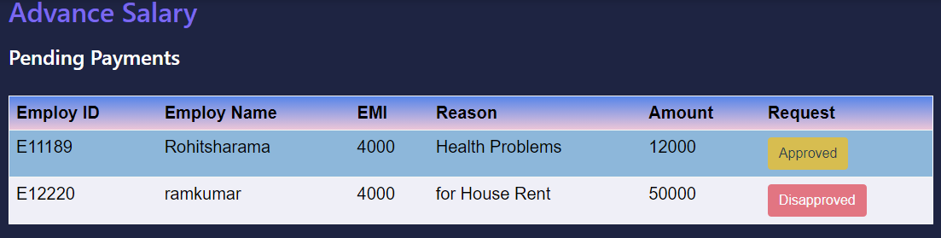

2. Company Details:
- In Company Details, foundational elements include the entity's name, registered address, and logo with an edit option for updates. The Tax Setup module is a vital hub for key financial data like PAN, TAN, and GSTIN, offering comprehensive control over tax configurations.
- This module extends its reach to cover Provident Fund, ESIC, Professional Tax, and Labour Welfare Fund, streamlining tax-related obligations.
- The External Credentials feature manages external affiliations and credentials, enhancing the organization's identity and credibility. This amalgamation reflects a commitment to holistic financial management, ensuring accuracy, compliance, and ease in navigating tax complexities for sustained growth.
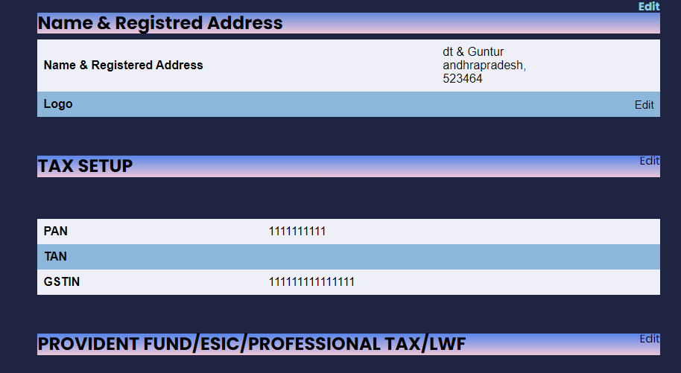

3.Create Project:
- The ability for administrators to forward projects directly to project managers is a crucial component in the field of administrative control.
- Admins can quickly obtain key project information, such as the project name, description, and manager choice, by selecting the 'Create Project' option.
- The streamlined procedure enables administrators to compile extensive project data.
- The project is automatically assigned to the assigned project manager upon submission, guaranteeing effective project allocation and execution.
- These admin control features are an excellent example of a user-friendly and effective project management strategy, promoting smooth collaboration and on-time project completion.
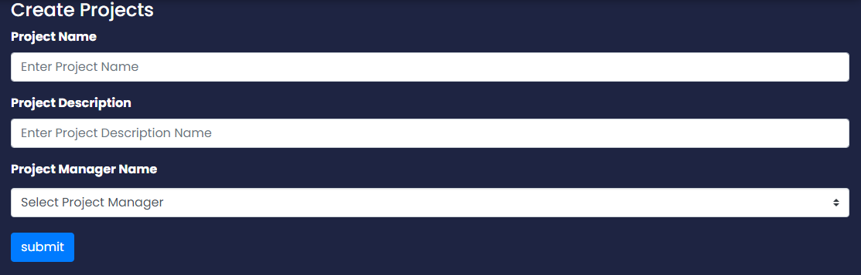

4.People:
- Employee Profiles: Each employee has a detailed profile encompassing personal and professional details, such as job title, providing a holistic view of their role within the organization.
- Active Status: The folder categorizes employees into 'Active,' 'Dismissed,' and 'All Employees,' offering a quick overview of the current workforce status
- Search Functionality: A robust search option enables users to locate specific employees swiftly. The search can be based on criteria like Employee ID, facilitating quick and precise information retrieval.
- Add Employee: Admins can seamlessly add new employees directly from the 'People' folder by clicking the 'Add Employee' button. This intuitive process involves entering all necessary details for the new hire.
- Bulk Employee Addition: The 'Add Multiple' option streamlines the process of onboarding multiple employees simultaneously. Admins can input details for several employees at once, enhancing efficiency during large-scale hiring initiatives.
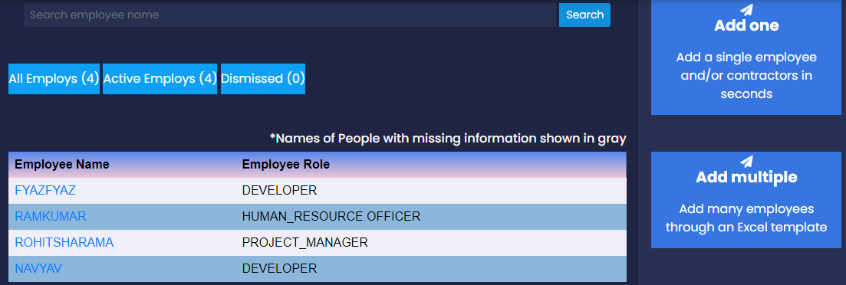

5.Reports:
- Salary Register: Provides a detailed view of past and upcoming payrolls, allowing administrators to track and manage salary-related information for each employee.
- Master CTC Report: Provides a breakdown of the CTC into various components such as basic salary, allowances, bonuses, benefits, and deductions, offering a granular view of the financial structure.
- HR Register: Offers a comprehensive overview of past and current month contracts, providing a centralized resource for managing employee contracts.
- Variance Report: Enables users to view and compare payroll-related metrics, compliance, and employee count trends, fostering informed decision-making.
- Documents: Acts as a centralized repository for accessing all documents related to current employees, ensuring easy retrieval and management of essential paperwork.
- Attendance: Allows administrators to monitor and analyze employees' attendance for better workforce management.
- Missing Information: Provides a list of employees with incomplete information, streamlining efforts to ensure data accuracy and completeness.
- Reimbursement: Offers visibility into pending and approved reimbursement requests for the current payroll period, promoting transparency in financial transactions.

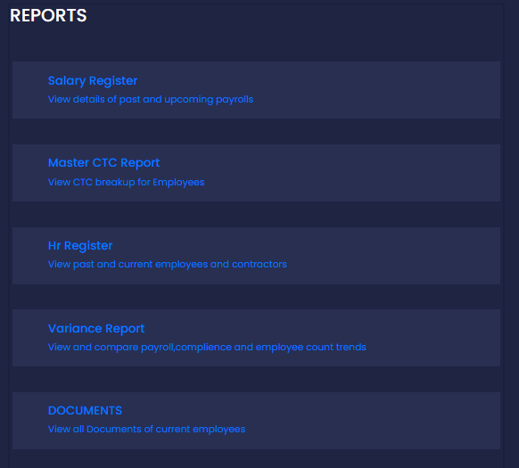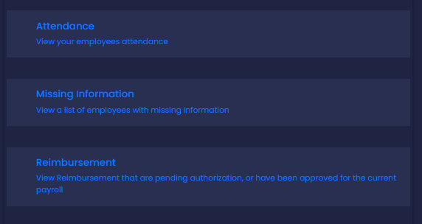

6.Settings:
- Payments and Compliance Setup:
Edit: Allows customization of payment and compliance settings to align with organizational requirements.
- Employee Data:
Edit: Enables administrators to update and modify employee data, ensuring accuracy and relevance.
- Additional Info Requested:
Edit: Provides the ability to customize and manage additional information requested from employees for comprehensive data collection.
- Holidays, Leaves, and Attendance:
Edit: Allows administrators to configure settings related to holidays, leaves, and attendance tracking for efficient workforce management.
- Reimbursements Setup:
Edit: Customization of reimbursement settings, including options such as reimbursement enablement, payment with salary, and attachment requirements.
Reimbursements Enabled: Yes/No - Determines whether the reimbursement feature is active.
Pay Reimbursements With Salary: Yes/No - Specifies if reimbursements should be paid along with the salary.
Attachments Compulsory: Yes/No - Indicates whether attaching receipts is mandatory for reimbursement claims.
- Documents Setup:
Edit: Provides the flexibility to configure settings related to document management within the system.

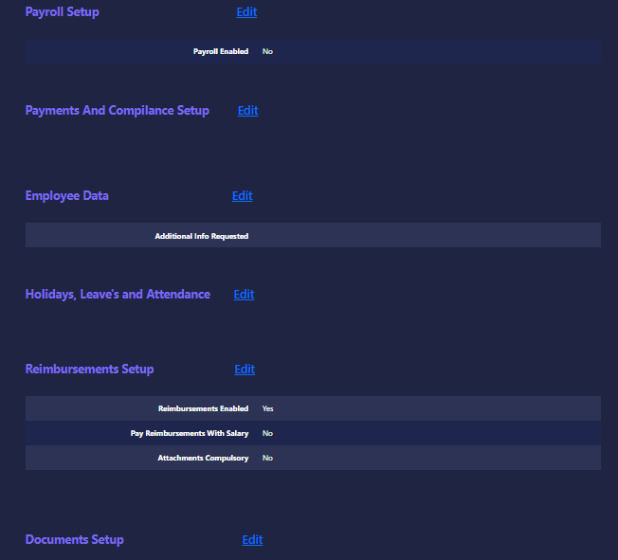

EMPLOYEE PERFORMANCE

A performance review is a formal regulated assessment mechanism in which managers and other key stakeholders evaluate an employee's work performance. The purpose is to learn more about their strengths and weaknesses, offer constructive feedback for skill development in the future, and assist with goal setting.

This project includes the Employ performance in that organization that includes the
- Daily Task Report
- Employees Average Performance
- Employees Project Performance
- Employees Task Performance
- Project List

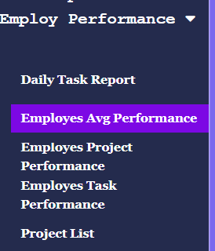

1.Daily Task Report :
Employee daily task performance reports are included in this software to know the work report.
It contents the employee name, project, team lead, date, task .
The purpose is to manger and HR checks the works completed/pending of an employee

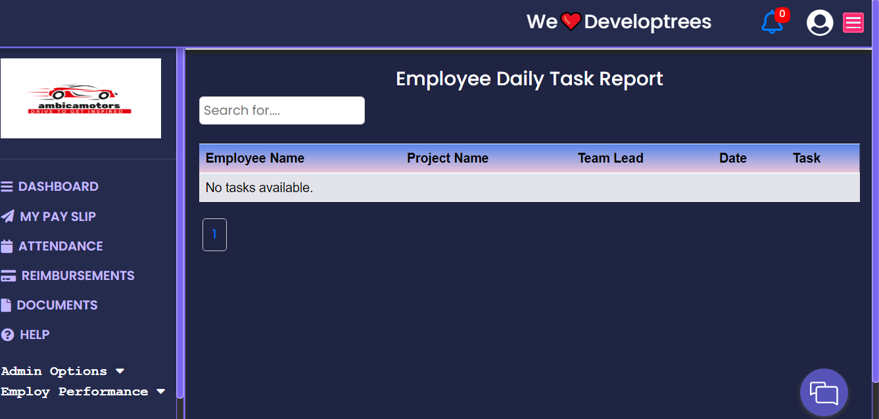

2.Employees Average Performance:
It contains employee id, employee name, project names, average performance
Function is to shows the average performance of an employee based on his/her work done
And to manager and HR checks the performance of an employee

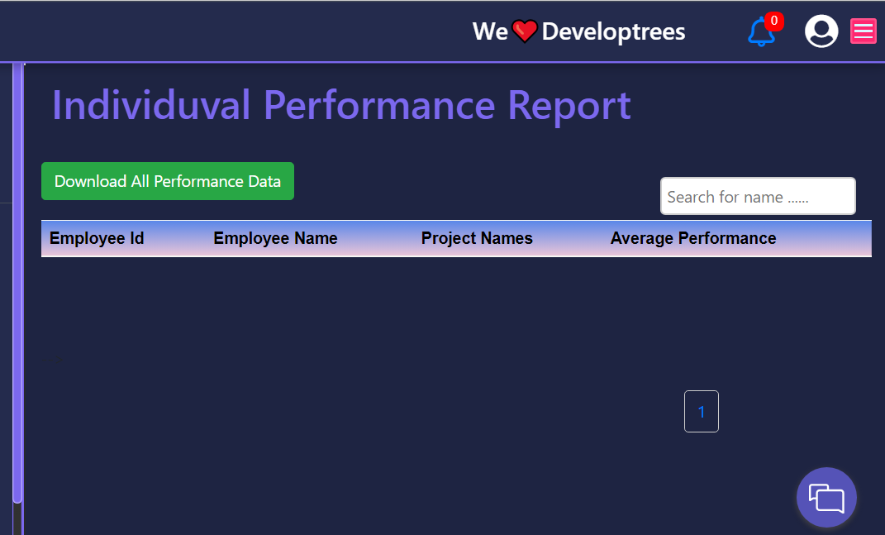

3.Employees Project Performance:
It shows the performance of an employee in a project
We can search by giving the project name on the search bar. It shows employees who included in that project and their performance on that project.

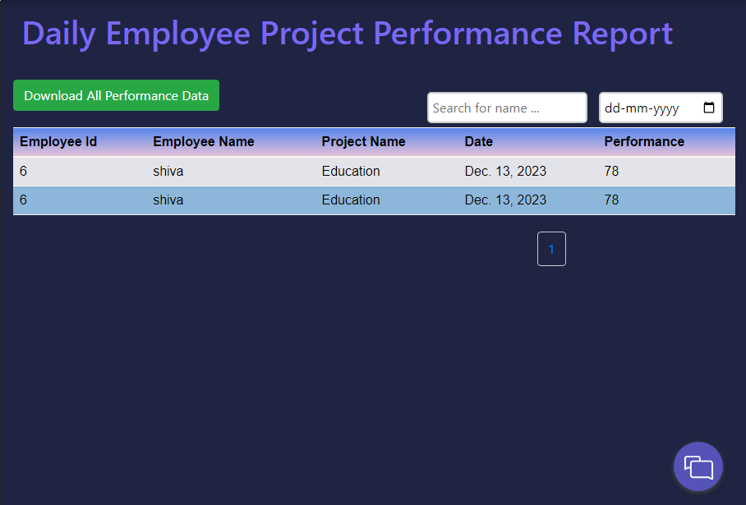

4.Employees Task Performance:
Its shows the performance of an employee in a task
We can search by giving the employee name and date on search bar and calendar respectively. It shows the employee who included in that task on that date and their performance on the task.
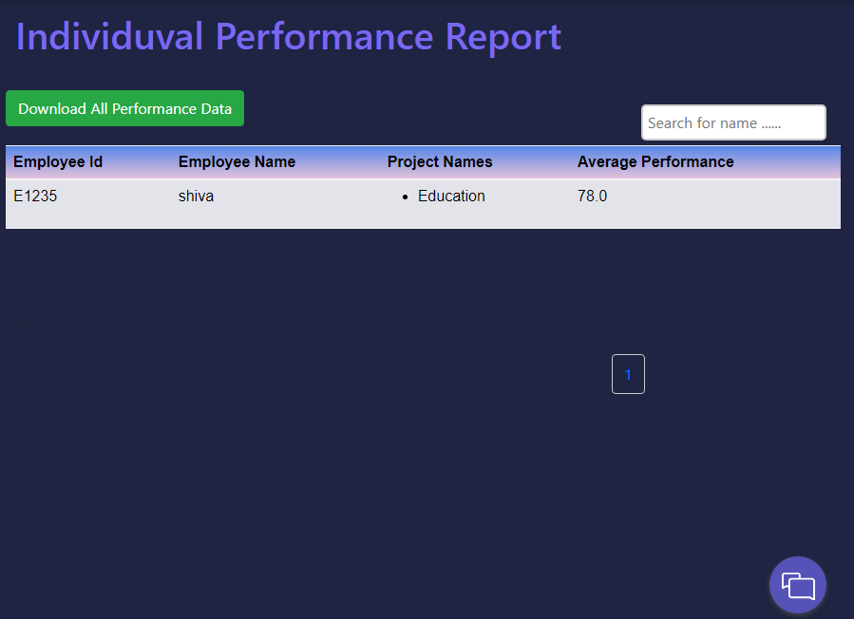

5.Project List:
It shows the list of projects with the project manager name who are head of that project.
And shows whether that project is active or inactive
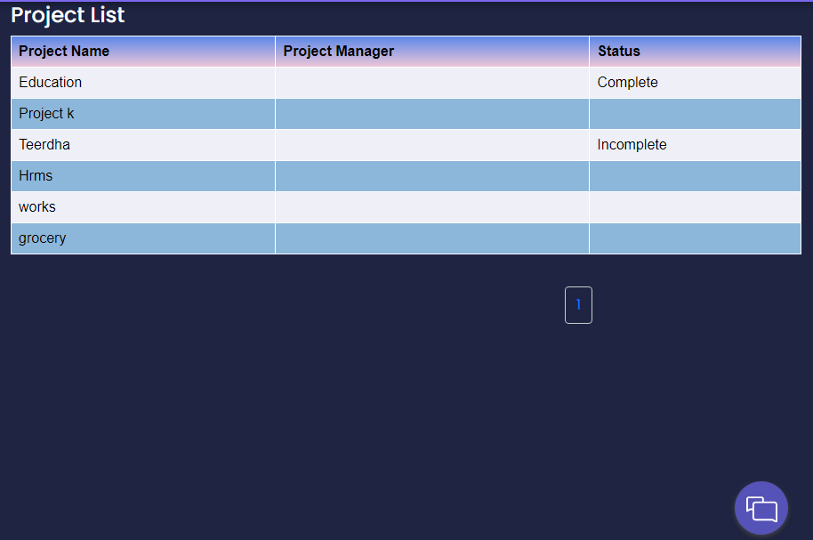
MONITORING LOGS

1.Screen Monitoring:
Screen monitoring is used to monitor a user’s activity on the computer. It determines how much time an employee spends working on the project assigned to them. It involves the process of capturing activities displayed on a computer or device screen. It is commonly used for various purposes, including:


1.Aspects of Screen Monitoring :

1. Employee Productivity and Workflow:
- Understanding how employees manage their time and tasks.
- Identifying productivity patterns and areas for improvement.
2. Policy Compliance and Security Measures:
- Ensuring adherence to company policies and regulatory requirements.
- Mitigating security risks and preventing data breaches.

3. Training and Development Support:
- Using monitoring data for training materials or knowledge sharing.
- Supporting employee skill development and onboarding.
4. Resource Allocation and Project Management:
- Data-driven insights for better resource allocation.
- Enhancing project management based on employee activities.
5. Employee Engagement and Well-being:
- Monitoring work patterns to identify signs of burnout or disengagement.
- Taking proactive measures to address employee wellness.
6. Remote Work Monitoring and Compliance:
- Ensuring productivity levels are maintained in remote work settings.
- Complying with remote work policies and regulations.
7. Legal Compliance and Dispute Resolution:
- Using monitoring data as evidence in legal or compliance matters.
- Resolving disputes based on recorded activities.

2.Features of Screen Monitoring:

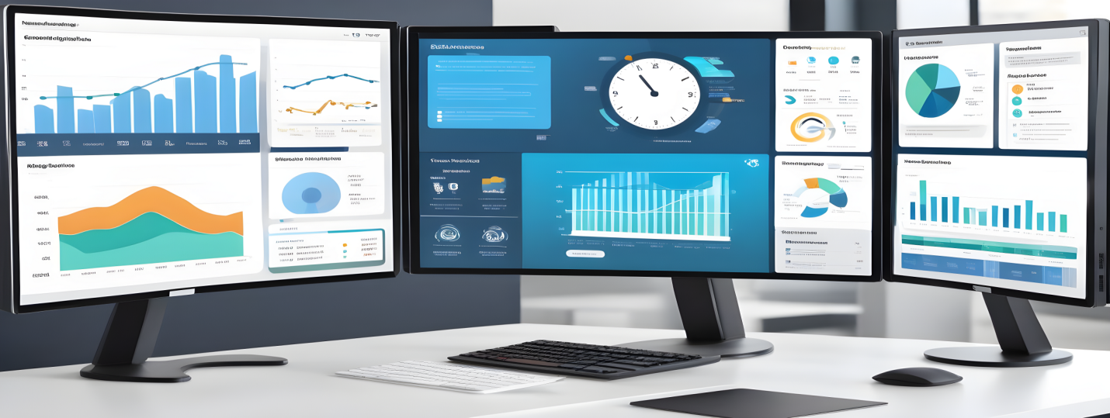

1. Activity Tracking and Recording:
- Real-time monitoring of employee computer activities.
- Capture of applications used, websites visited, and time spent on tasks.
- Screen capture capabilities.

2. Performance Analysis and Evaluation:
- Data analytics to assess employee productivity and efficiency.
- Time tracking and analysis for project/task management.
- Reporting tools for performance evaluations.
3. Compliance and Policy Enforcement:
- Monitoring to ensure adherence to company policies and regulations.
- Identification of security breaches or policy violations.
- Alerts or notifications for suspicious activities.
4. Integration and Reporting:
- Integration with other HR modules for comprehensive data analysis.
- Reporting and analytics to derive insights into employee behavior.
5. Privacy Controls and Ethical Considerations:
- Settings and controls to uphold employee privacy and data protection.
- Transparent policies and communication about monitoring practices.

2.Detailed Monitoring:

1.Employee Information: Details about employees, including personal information, contact details, job roles, departments, performance reviews, and training history.
2.Attendance and Leave Management: Tracking attendance records, including time in/out, leave requests, accrued leave, and absence patterns.
3.Performance Management: Metrics related to employee performance, such as goal setting, performance appraisals, ratings, and feedback.
4.Compliance and Regulations: Ensuring adherence to legal and regulatory requirements regarding employment laws, diversity, inclusion, and safety standards.
5.Employee Engagement and Surveys: Feedback from employee surveys, engagement levels, satisfaction ratings, and sentiments within the organization.
6.Succession Planning: Identifying and preparing potential candidates for leadership roles and higher positions within the organization.
7.Workforce Analytics and Reporting: Generating reports and analytics on various HR-related metrics to assess trends, make informed decisions, and optimize HR strategies.
The specifics of detailed monitoring content can vary based on the organization's needs, industry, and the functionalities provided by the WORK TRIDE software being used. Tracking these aspects helps HR professionals manage and optimize various aspects of the workforce, fostering productivity, engagement, and organizational growth.

3.Power logs:
In an WORK TRIDE (Human Resource Management System) application, "powerlogs" might refer to a feature or functionality designed to track and manage system access, actions, or changes made within the WORK TRIDE platform. These logs serve as an audit trail, recording various activities, user interactions, and system modifications, providing transparency, security, and accountability within the HR system. Here's a detailed breakdown:
What Powerlogs Might Include:
1. User Activity Tracking: Recording every action or operation performed by users within the WORK TRIDE, including logins, logouts, data modifications, and system configurations.
2. Data Modifications: Capturing changes made to employee records, such as updates to personal details, salary changes, position/title changes, or performance evaluations.
3. Access and Permissions: Logging access requests, user role changes, permissions granted or revoked, and any attempts to access restricted information.
4. System Alerts and Notifications: Generating alerts or notifications for unusual or critical activities within the WORK TRIDE, such as failed login attempts or modifications by unauthorized users.
5. Timestamps and User Identification: Recording timestamps for each action and identifying the user responsible for the action, ensuring accountability.
6. Compliance and Security: Supporting compliance requirements by maintaining an audit trail, ensuring data integrity, and enhancing system security.

Benefits of Powerlogs in WORK TRIDE:
1. Security and Compliance: Powerlogs help organizations meet regulatory compliance requirements by maintaining a detailed record of all system activities and user interactions.
2. Traceability and Accountability: Enables easy tracking of changes made in the WORK TRIDE, ensuring accountability for any modifications or actions taken by users.
3. Troubleshooting and Investigations: Supports investigation and troubleshooting efforts by providing a detailed history of system events, helping identify issues or errors.
4. Audit and Reporting: Facilitates audit processes and reporting, allowing administrators to generate reports on user activities, system changes, and access patterns.
5. Data Integrity and Transparency: Promotes data integrity by ensuring that all changes or accesses to employee information are logged, providing transparency and trust in the system.
6. Enhanced System Governance: Supports better governance and oversight of the WORK TRIDE platform, allowing administrators to monitor and manage system usage effectively.

The specific functionalities and details of "powerlogs" in an WORK TRIDE can vary based on the software provider, organization's requirements, and the level of customization available within the WORK TRIDE platform. These logs play a critical role in maintaining the integrity, security, and transparency of the WORK TRIDE system.

1.Screen Shots:
It seems like you are describing a feature in your BUGLEGAL application that captures screenshots at regular intervals during an employee's check in time and organizes them into a carousel format for easy viewing. If you need to provide documentation for this feature, you can create a document that explains its functionality, purpose, and usage. Below is a sample template you can use as a starting point

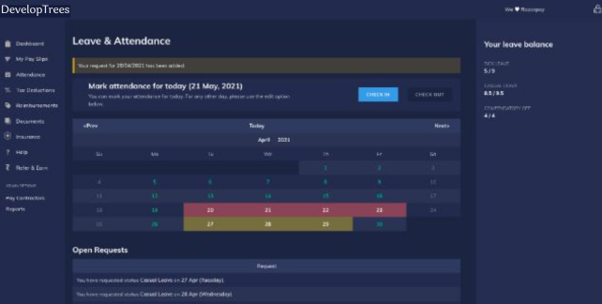
Introduction:
The Employee Check in Screenshots feature in our BUGLEGAL application is designed to capture periodic screenshots during an employee's check in time. This document provides a comprehensive guide on how to use and understand this feature.
1. Overview
2. How it Works
3. Accessing Screenshots
4. Screenshot Carousel
5. Date and Time Information
6. Admin Controls
7. Data Privacy and Security
8. Conclusion
1. Overview:
The Employee Check in Screenshots feature aims to provide admin with a visual representation of an employee's work environment during their check in period. This can assist in monitoring work activities and ensuring compliance with company policies.
2. How it Works:
Screenshots are automatically captured at regular intervals (every 1 minute) once an employee checks in.
The process continues until the employee checks out.
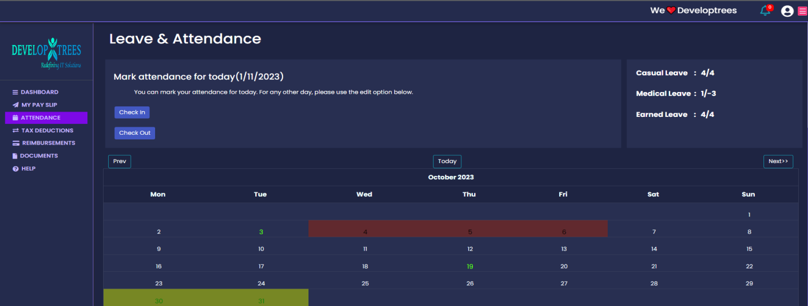
3. Accessing Screenshots:
Log in to the BUGLEGAL application with admin credentials.
Navigate to the "Check in Screenshots" section.

4. Screenshot Carousel:
Clicking on the "Check in Screenshots" section opens a carousel view of captured screenshots.
Use the navigation buttons to scroll through the screenshots.
Each screenshot is time stamped for reference.
5. Date and Time Information:
The date and time of each screenshot are prominently displayed.
This information helps in tracking activities and ensuring accuracy.

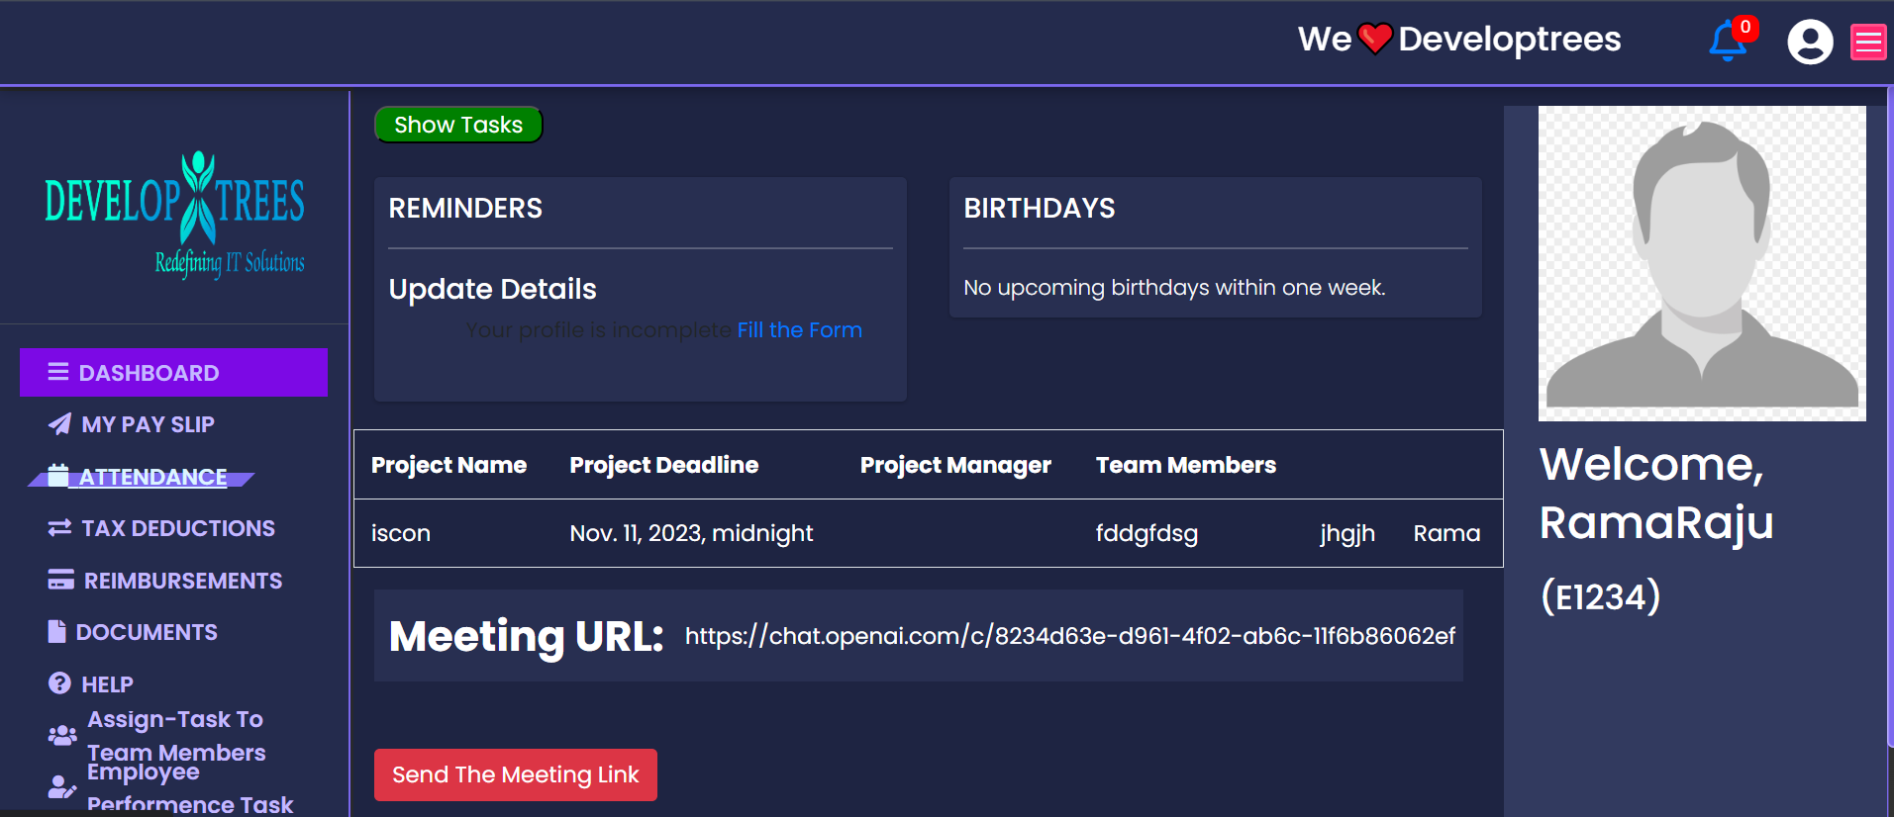

6. Admin Controls:
Admin shave the ability to manage and review all captured screenshots.
Additional controls, such as download and delete options, are available for efficient data management.

7. Data Privacy and Security:
The captured screenshots are treated with the utmost confidentiality.
The feature complies with privacy regulations and organizational data protection policies.
8. Conclusion:
This document serves as a guide to understanding and utilizing the Employee Check in Screenshots feature. For further assistance, please contact our support team.

3.TIME TRACKING :

- The Time Tracking process by recording the login time and log out time.
- The system automatically calculates time spent on between login time and logout time, then it is known as total time duration, using a connected device.
- It shows that , the idle time of an employee.
- It is useful to keep track on your employee , and it shows free time of an employee in a working hours.
- We can calculate the total working time of an employee per day.
- It shows non-productive hours also.
- It visualize the effort being spent on the working hours.

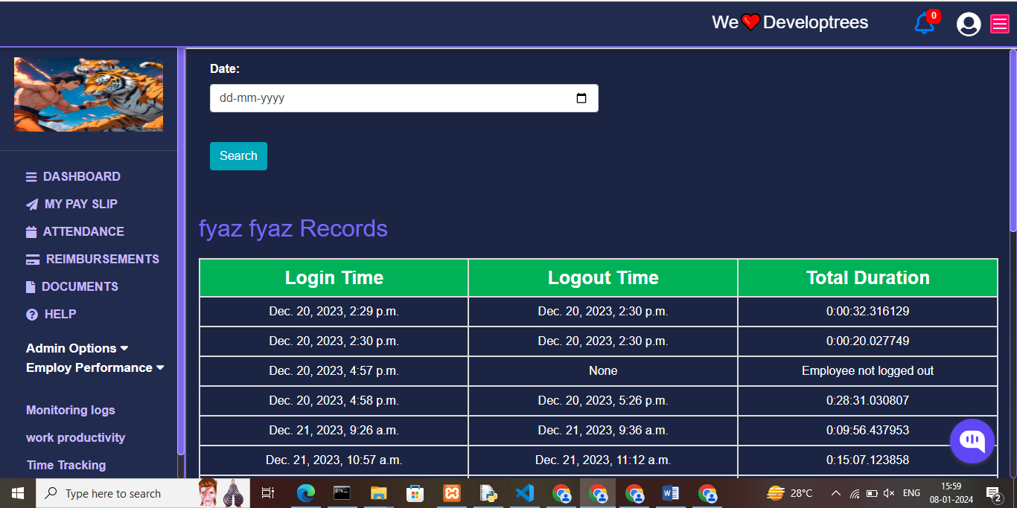
PROJECT MANAGER
PROJECTS
Add employee performance task:
In which we can easily understand performance of each employee by entering project name, employee name and their assigning Task. By clicking on submit we know that the performance of each employee.
Create New Task:
After finishing previous work, by using Work Tride for each employee we can designate new task.
Project Name:
A dropdown menu where the user can select the project for which they want to create tasks. The options in the dropdown represent the available projects.
Number of Tasks:
A field for entering the number of tasks the user wants to create for the selected project.
Enter the Task Name:
A text input where the user can provide a name or description for the task.
Team Lead:
A dropdown menu where the user can select the team lead for the task. The options in the dropdown represent the available team leads.
The final action is the user to click the submit to complete the creation of task

Create Project:
To create a new project the manager should get all details of the project and should assign the project to a team and the team members should know the project needs and project plans
Project Name:
A text input where the user can provide name to the project.
Project description:
A project description provides a project overview, including its processes, goals, and objectives. It addresses the problem that initiated the project and outlines the planned activities, timeline, and project location.
Project Team Lead: A dropdown menu where the user can select the team lead for the task. The options in the dropdown represent the available team leads.
Team members: A dropdown menu where the user can select the team members for the task. The options in the dropdown represent the available team members. The people you select must have the competencies and time for the job to be done.
Selected Team Members: Out of all the team members, the manager selects which ones will display on the Selected Team Members.
Project Deadline Date: By definition, a project deadline should be a single date that marks the end of the project. The project should be completed.
Employ Task Performance: Employ task performance is a critical aspect of the overall workplace .it involves the assigned task and responsibilities to achieve the objectives in the given time. Employ task performance assessing the individual ability to meet the deadline, high quality work and contribute to the project completion feedback on the task performance is very essential for employs to understand their strength and ability of improvement.
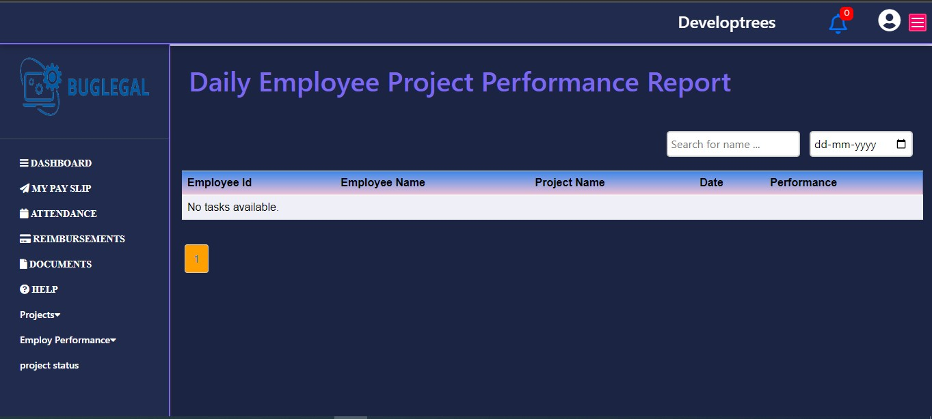

Send The Review Links: Choose which platform you use to conduct meetings and then share the meet link to the team which you want to interact about the project.
Project Name: A dropdown menu where the user can select the project name for the meeting with team.
Meet URL: User should mention meeting url and time for the team to get ready with the updates of project.
Team Lead: A dropdown menu where the user can select the team lead for the meeting. Then the team lead get alert about the meet
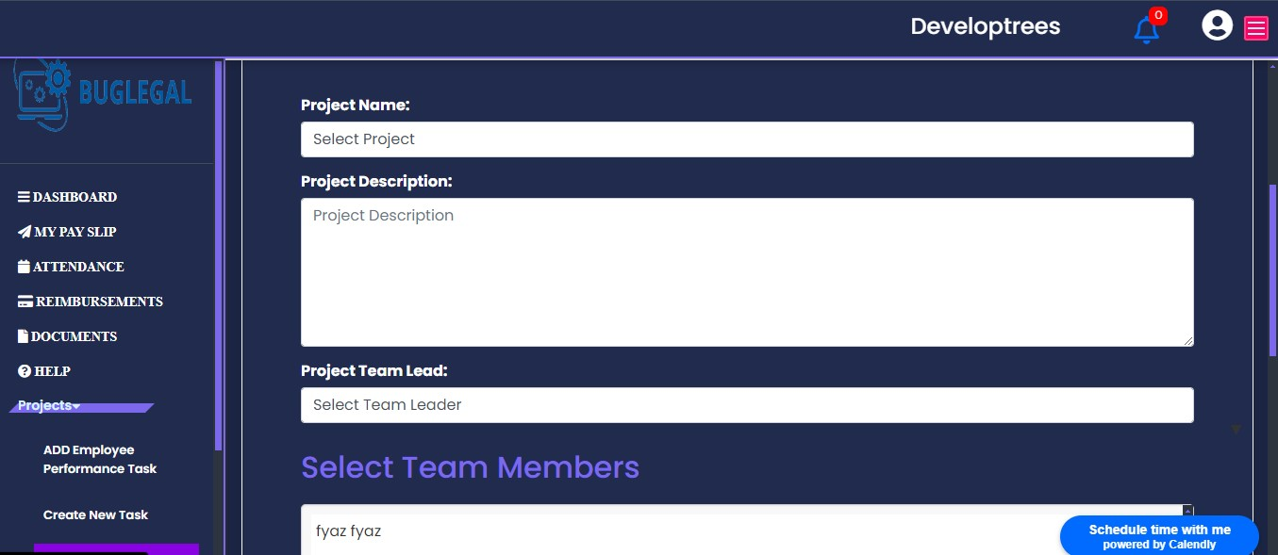

PROJECT STATUS
This Project status is represented by the project manager and the project management. It describes that the progress of a project within a specific time period and it compares the project plan. Project manager uses the project status reports to keep update the clients informed about the project progress, risks, time and work.
There are several reasons why project manger creates status reports. To help the project management team to keep the track of the current project status and it covers the status report in a short and easily snapshot of the project over a period of time. A project status report template is only a static document using this project status reporting with all your project management to make project status in minutes.

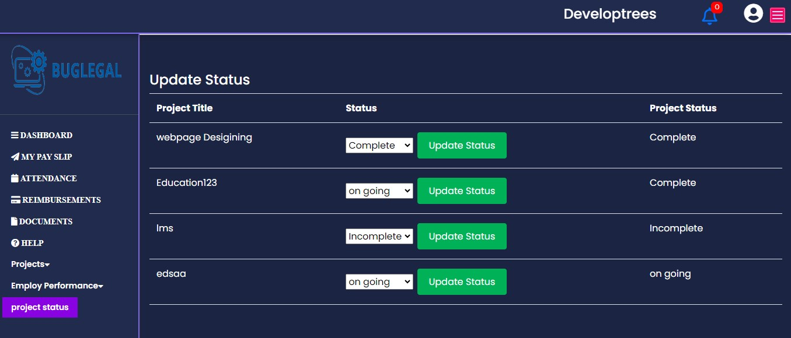

HUMAN RESOURCES
Dashboard:
Dashboard starts with a welcome followed by designation of the HR. It displays remainders and birthdays. Remainders include pending tasks and works to be finished and birthdays column shows the date of births of the fellow employees so that they can wish each other. At the bottom of the page meeting URL section is given, in which upcoming scheduled meeting links will be shared. So that a HR can join the meeting directly just by clicking on that link. At the right-side menu HR’s name, id and designation will be displayed.
MyPaySlip:
MyPaySlip starts with the display containing request for pay slips. A HR can request for his/her pay slip at anytime by mentioning the date up to the required day and with period of time with a valid reason for the same. It also shows view past payslip requests which contains the history of payslip requested. One more feature called salary advance will be displayed under mypayslip in which a HR can request for certain amount in advance from his/her salary which can be deducted from his/her month end salary. And the status of their approval will also be displayed.
Attendance:
Attendance dashboard displays the history of leave & attendance. A HR can check-in and checkout from here every day. And their casual leaves, medical leaves and earned leaves will also get displayed on the right side of the page. It also contains a calendar in which they can mark their leaves and see their active status after getting checked-in. Below that attendance column displays the total check-ins and checkouts, weekends and the duration of the working hours of a HR.
Reimbursements:
Reimbursements display starts with a claim for reimbursement. In which a HR can request for a claim by mentioning the type of reimbursement, expense date, any detail regarding that, amount spent on that and a supporting document or image of the reimbursement. It also shows view past requests option in which the history of reimbursements can be viewed.
HR Documents:
Documents page starts with the details of the documents submitted by the HR which shows the date, type and description of the documents and also attachments.
Under this a HR can submit a document at anytime again by accessing the upload new documents form which contains supporting images or documents along with description.
Help:
Help page starts with get help menu in which all the necessary quick links for the HR’s quick access incase of any difficulties in understanding the usage of the application or regarding any doubts in accessing the features of his/her menu. Simply it acts as a user guide which contains all the instructions to be followed while accessing the application in a detailed step-by-step manner.

Daily Task:
Daily Task menu displays the daily task report assigned to a HR. It includes the details regarding projects, tasks and date of those assigned. The status of these tasks will also be updated based on their completion.

People:
People page shows the list of all employees in the organization recruited with their names and designations respectively. Active employees list shows the current employees in the organization. Dismissed column shows the employees left from

the organization. A HR is given an option to add an employee/contractors or multiple employees directly to the organization in seconds.
Reports:
Reports page starts with all the links accessed by the HR to monitor the employee records. It contains salary register, master CTC report, HR register, variance report, documents, attendance, missing information and reimbursements of the employees.
Salary register contains all the past and upcoming payroll information.
Master CTC Report contains the CTC breakup for employees.
HR Register contains all the past and current employees and contractors’ details.
Variance report compares payroll, compliance and count trends of the employees.
Documents section contains all the documents uploaded by the employees respectively.
Attendance section displays the information regarding the attendance of all the employees.
Missing information section shows the information or documents which are missed by employees, so that HR can ask them to finish it accordingly.
Reimbursement column displays the reimbursement requests and status of the same applied or claimed by the employees.

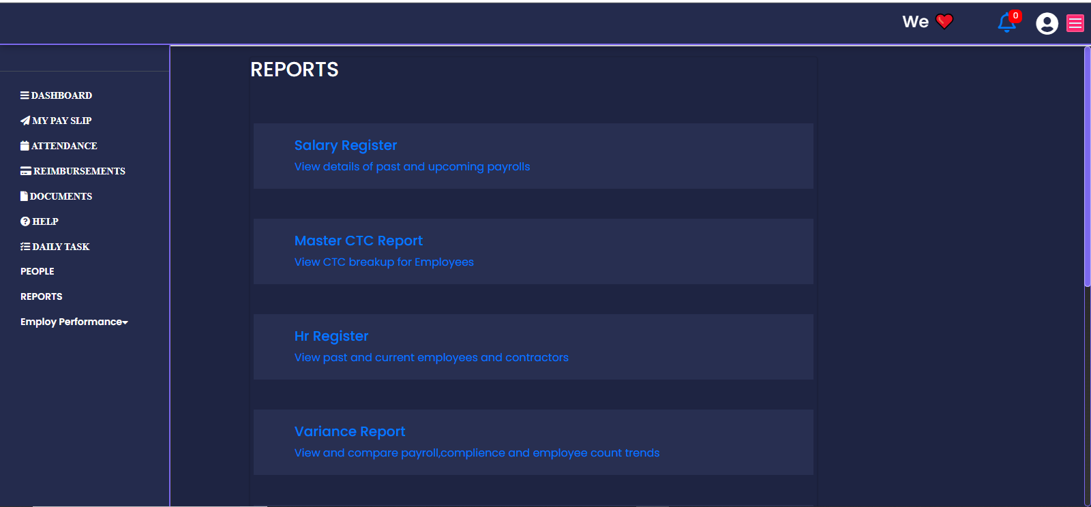

Employee performance:
Employee performance section contains three other columns. They are:
Employee Average Performance
Employee Project Performance
Employee Task Performance
Employee Average Performance displays the performance of the employee including all the parameters like overall handling, active participation and involving in group discussion etc.
Employee Project Performance is all about the tasks given for the whole project and their teams respectively.
Employee Task Performance involves the individual work and tasks assigned to employees. This shows their individual performance regarding the project.

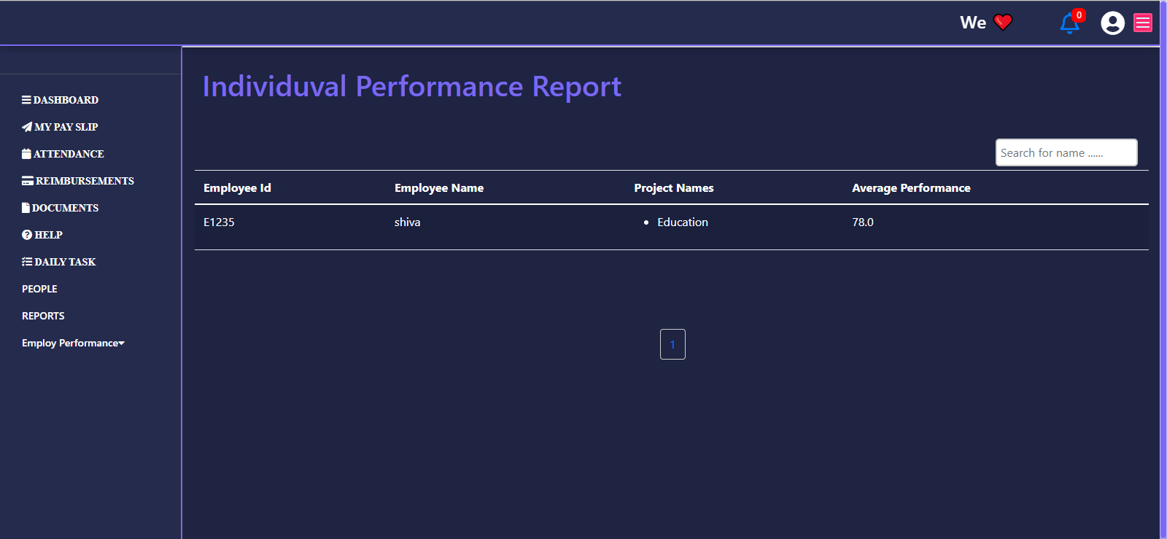

TEAM LEAD
Team Lead Dashboard
Overview:
The Team Lead Dashboard serves as a centralized hub for team leaders to manage and monitor key aspects of their projects and team activities.
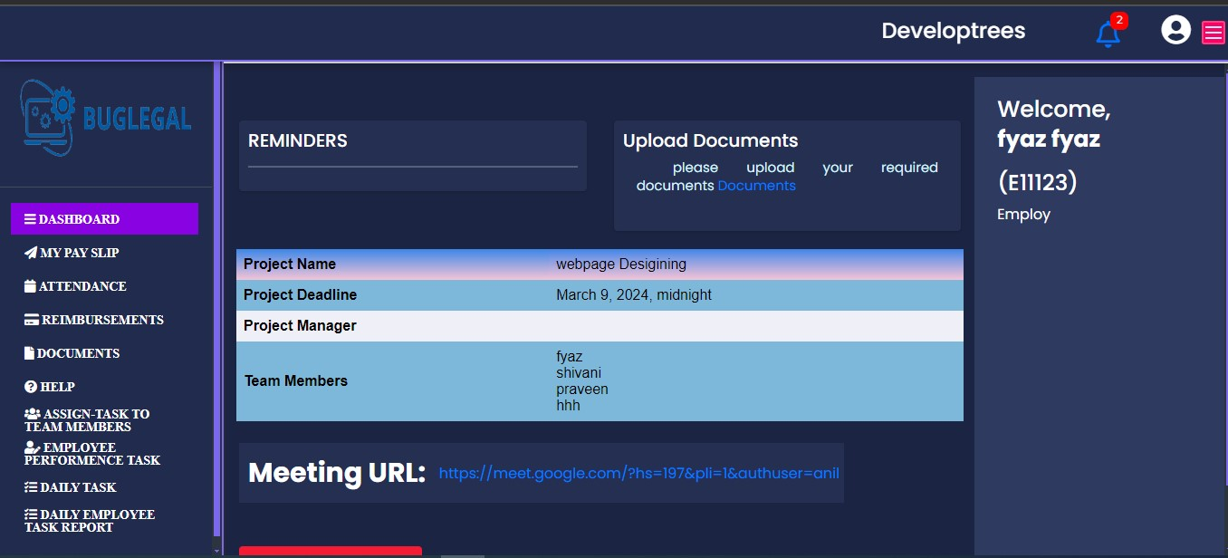
1. Project Name
- Display: Clearly presents the names of the projects being managed by the team lead.
- Quick Navigation: Allows team leads to click on a project name for quick navigation to the project details.
2. Project Deadline
- Visibility: Displays the deadline or completion date for each project.
- Color Coding: Optionally, use color coding to visually highlight approaching deadlines or overdue projects.

3. Project Manager
- Identification: Indicates the assigned project manager for each project.
- Contact Information: Optionally includes contact details for quick communication with the project manager.
4. Team Members
- List of Members: Provides a list of team members assigned to each project.
- Roles and Responsibilities: Optionally includes roles and responsibilities for clarity.
5. Reminders
- Important Dates: Displays reminders for key dates, milestones, or important events related to the projects.
- Customizable Alerts: Allows team leads to set and customize reminders based on project specific needs.
6. Birthdays
- Upcoming Birthdays: Displays a list of upcoming birthdays within the team.
- Celebration Planning: Provides an opportunity for team leads to plan celebrations or acknowledgments.
7. Meeting URL
- Meeting Access: Displays a link or space to input the URL for project related meetings.
- Integration: Optionally integrates with calendar systems or meeting platforms for easy access.

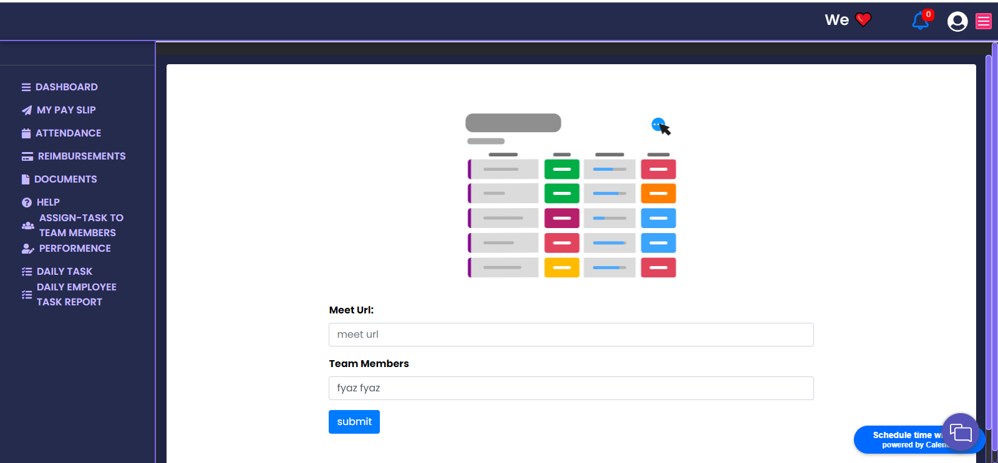

Team Lead My Pay Slip
Overview:
The "Pay Slips" feature provides employees with the ability to request pay slips, view past requests, and manage salary advances.
1. Request for Pay Slips
- Submission Form: Employees can submit requests for their pay slips through a designated submission form.
- Date Range: Specify the desired date range for the pay slips requested.
- Confirmation Notification: Provide a confirmation notification upon successful submission.

2. View past Pay Slips Requests
- Request History: Display a history of past pay slips requests made by the employee.
- Status Tracking: Include the status of each request (approved, pending, rejected).
- Download Option: Allow employees to download past pay slips directly from the history.

3. Salary Advance
- Viewing Current Advance Status: Employees can view the current status of any existing salary advance.
- Requesting a Salary Advance: Employees can submit requests for a salary advance through a dedicated form.
- Approval Workflow: Include an approval workflow for administrators to review and approve salary advance requests.

Leave and Attendance
Overview:
The "Leave & Attendance" feature provides a comprehensive solution for managing employee attendance, leave requests, and tracking overall attendance data.
1. Employee Check-In and Check-Out:
Real-time Tracking:
- Captures employee check-in and check-out times in real-time.
- Records timestamps for each entry to maintain accurate attendance data.
2. Leave Requests:
Submission Form:
- Provides employees with a leave request submission form.
- Supports various leave types (e.g., vacation, sick leave, personal leave).
- Integrates an approval system for managers to review and respond to leave requests.

3. Attendance Overview:
Dashboard Display:
- Provides team leads and administrators with an overview of attendance data.
- Allows filtering of attendance data by date, employee, or other relevant criteria.
4. Leave Balance:
Leave Balance Display:
- Shows employees their remaining leave balances.
- Updates leave balances in real-time based on approved leave requests.

Team Lead Reimbursement
Overview:
The "Reimbursement" feature allows employees to claim reimbursements for eligible expenses and view a history of past reimbursement requests.

1. Claim Reimbursement:
Submission Form:
- Employees can submit reimbursement requests through a designated submission form.
- Include fields for expense date, description, amount, and supporting documents.
Attachment Upload:

- Allow employees to upload receipts or supporting documents for each expense.

Notification System:
- Notify employees upon successful submission and keep them informed throughout the approval process.
2. View past Requests:
Request History:
- Display a history of past reimbursement requests made by the employee.
- Include details such as request date, amount, and approval status.

Filter and Search:
- Allow users to filter reimbursement history by date, status, or other relevant criteria.
- Implement search functionality for finding specific reimbursement records.

Team Lead Documents
Overview:
Employee can easily upload new documents by selecting the document type and attaching supporting images or files. Additionally, users can provide a description for clarity and reference. All uploaded documents will be displayed with details such as Date, Type, Description, and Attachment. This ensures efficient document management and easy retrieval of information.

Team Lead Help
Overview:
The "Help" feature provides users, including employees, with quick access to essential information through customizable "Quick Links."
Quick links: It offers direct access to essential information, guides, and frequently accessed sections.

Assign-task to team members
- In a Work Tride, task assignment streamlines work distribution. Admin or team leads create tasks with details like due dates and priorities. Employees access their task dashboard, viewing assignments, deadlines, and project details.
- Real-time collaboration within the platform ensures clear communication. The system includes tracking features for progress monitoring and reporting, enhancing efficiency and team productivity.

Employee performance task
- In the Employee Performance section of work tride, vital details such as employee name, project name, assigned tasks, and performance metrics are meticulously tracked.
- This comprehensive overview allows for a thorough assessment of an employee's contributions, project engagement, task execution, and overall performance within the organization.

Team Lead Daily Task
- The "Daily Task" feature allows employees to log and track their daily tasks, providing a mechanism for monitoring project progress and individual performance.
Daily Employee Task Report
- The "Daily Employee Task Report" feature enables team leads or managers to generate and review daily reports summarizing the tasks completed by individual employees.

EMPLOYEE
Employee Dashboard:
Dashboard starts with a welcome followed by designation of the employee. It displays remainders and birthdays. Remainders include pending tasks and works to be finished and birthdays column shows the date of births of the fellow employees so that they can wish each other. At the bottom of the page meeting URL section is given, in which upcoming scheduled meeting links will be shared. So that employee can join the meeting directly just by clicking on that link. At the right-side menu employee’s name, id and designation will be displayed.
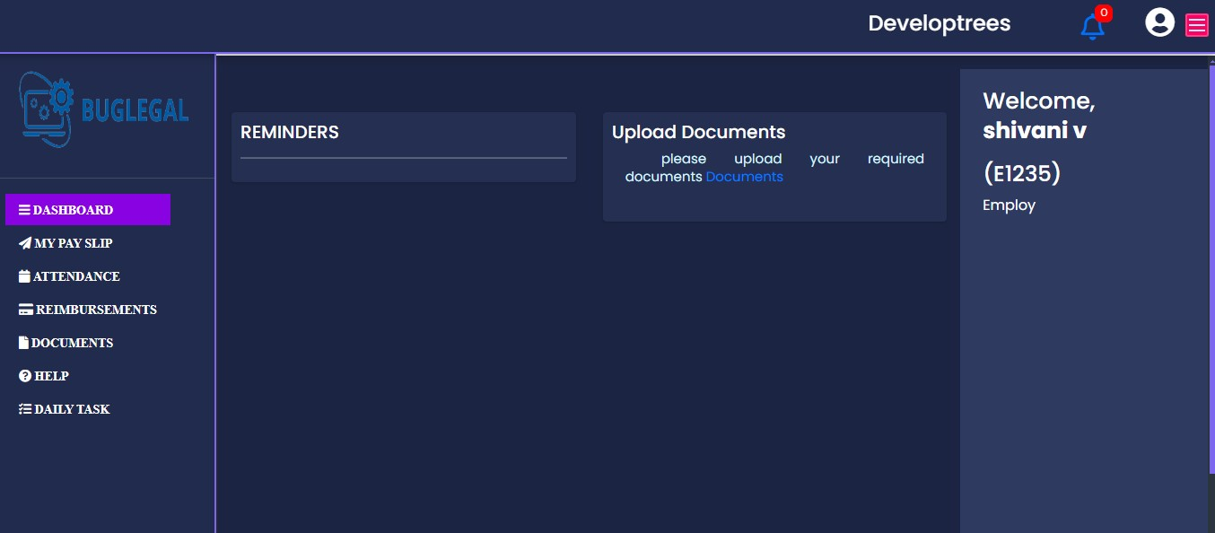
Employee MyPaySlip:
MyPaySlip starts with the display containing request for pay slips. An employee can request for his/her pay slip at any time by mentioning the date up to the required day and with period of time, with a valid reason for the same. It also shows view past payslip requests which contains the history of pay slips requested. One more feature called salary advance will be displayed under mypayslip in which an employee can request for certain amount in advance from his/her salary which can be deducted from his/her month end salary. And the status of their approval will also be displayed.
Employee Attendance:
Attendance dashboard displays the history of leave & attendance. An employee can check-in and checkout from here every day. And their
casual leaves, medical leaves and earned leaves will also get displayed on the right side of the page. It also contains a calendar in which they can mark their leaves and see their active status after getting checked-in. Below that attendance column displays the total check-ins and checkouts, weekends and the duration of the working hours of the employee.
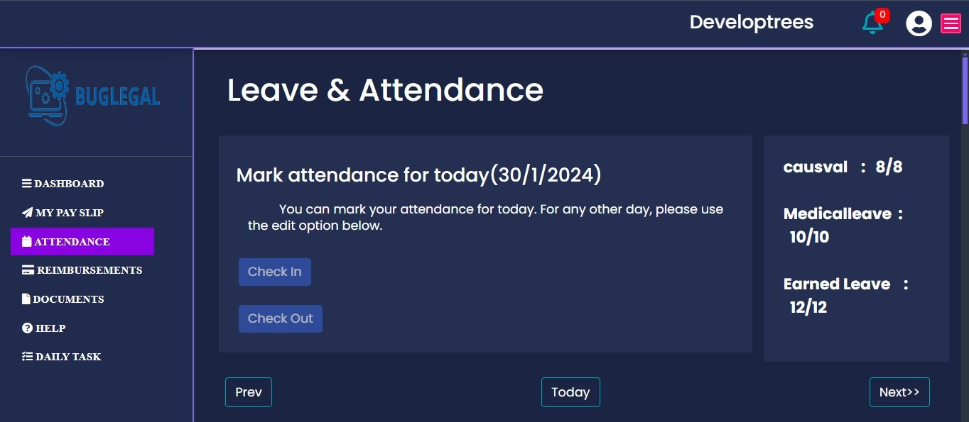

Employee Reimbursements:
Reimbursements display starts with a claim for reimbursement. In which an employee can request for a claim by mentioning the type of reimbursement, expense date, any detail regarding that, amount spent on that and a supporting document or image of the reimbursement. It also shows view past requests option in which the history of reimbursements can be viewed.

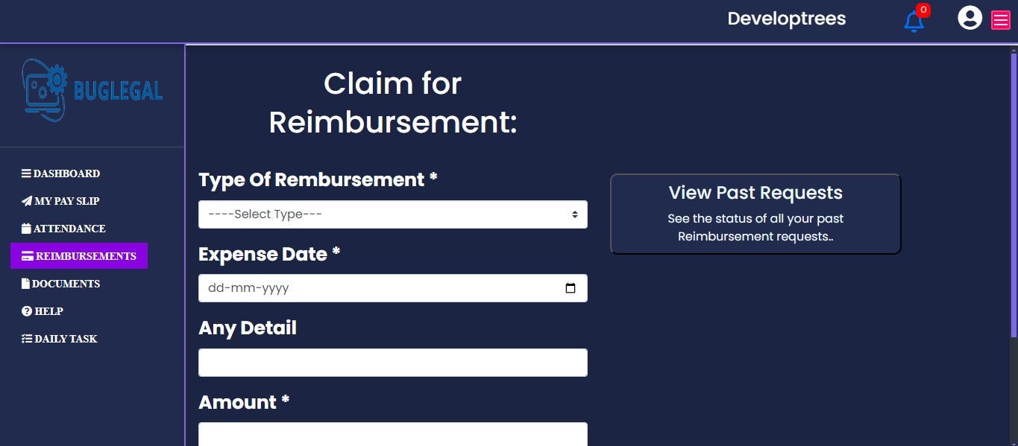

Employee Documents:
Documents page starts with the details of the documents submitted by the employee which shows the date, type and description of the documents and also attachments.
Under this an employee can submit a document at any time again by accessing the upload new documents form which contains supporting images or documents along with description.
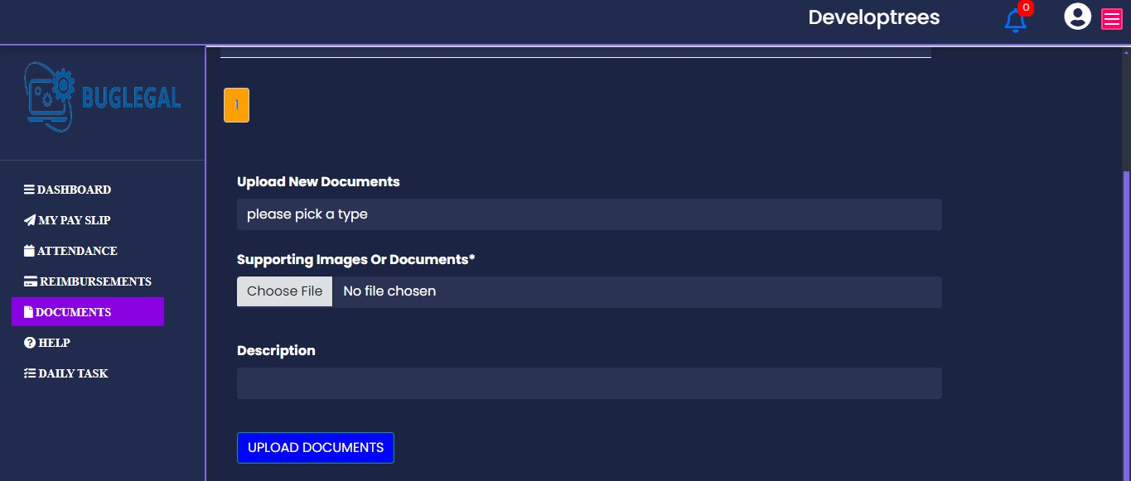
Employee Help:
Help page starts with get help menu in which all the necessary quick links for the employee’s quick access in case of any difficulties in understanding the usage of the application or regarding any doubts in accessing the features of his/her menu. Simply it acts as a user guide which contains all the instructions to be followed while accessing the application in a detailed step-by-step manner.
Employee Daily Task:
Daily Task menu displays the daily task report assigned to an employee. It includes the details regarding projects, tasks and date of those assigned. The status of these tasks will also be updated based on their completion.

PRICING
A subscription-based pricing model is when your clients pay a recurring fee to use a product or service. This is typically invoiced as an annual or monthly fee.
Monthly Plan:
It contains four different plans , in that
- Basic Plan:
In this basic plan we have some features
- Dashboard
- My pay slip
- Attendance
- Reimbursement
- Documents
- Help
- Peoples
- Settings
We include one feature has an add-on is advance salary.
The employees for this plan is up to 300.
- Gold Plan:
In this basic plan we have some features
- Dashboard
- My pay slip
- Attendance
- Reimbursement
- Documents
- Help
- Peoples
- Settings
- Employee Performance
- Time Tracking
We Include a Feature an Add-on is Monitoring Logos
Employees For This Plan is up to 700

3)Platinum Plan:
In this basic plan we have some features
- Dashboard
- My pay slip
- Attendance
- Reimbursement
- Documents
- Help
- Admin options
- Employee Performance
- Time Tracking
- Monitoring logos

Employee for this plan is up to 1000

4) Diamond Plan:
In this basic plan we have some features
- Dashboard
- My pay slip
- Attendance
- Reimbursement
- Documents
- Help
- Admin options
- Employee Performance
- Time Tracking
- Monitoring logos
Employees for this plan is above 1000
