Student Details

1. I.B.G.T.C Bowala

Index Number: [12000248](https://softengcodeofethics.wordpress.com/)

Registration Number: 2012/CS/024

1. P.M. Nadeeshanie

Index Number: [12000892](https://secodeofethics.wordpress.com/)

Registration Number: 2012/CS/089

1. K.D.C.M. Thilakarathna

Index Number: [12001406](https://softwareengineeringcodefoethic.wordpress.com/)

Registration Number: 2012/CS/140

How to run:

You can easily run this with java NetBeans.

1. First, you have to add JCalendar to your palette manager of NetBeans . (Add both JCalendar and JDateChooser)

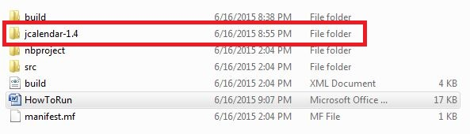

Instructions: <https://www.youtube.com/watch?v=gM3y-sgGxkQ>

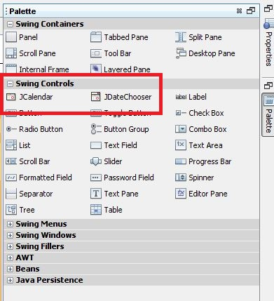

1. If you haven't already installed WAMPP or XAMPP with your machine, download and install it.
2. Then, if you haven't already added the JDBC connector to connect mysql databases, add it also. I have provided it inside jdbc_connector folder.

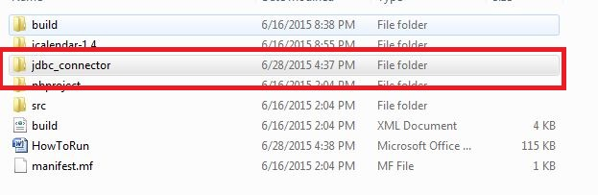

1. Then, create a database named "daham_pasala" and import the sql file to create the database.



1. Now, open this project with NetBeans.
2. Run the project. You will get a login window.

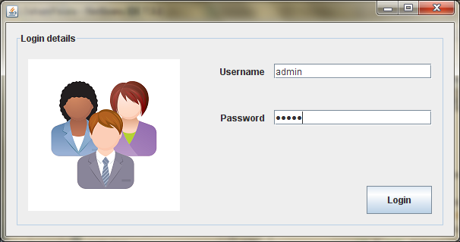

1. For security purposes, users can't create their own user accounts. So, you need to add a row to the "employeedetails" table, including your username and the password or, choose a username and a password from the table.

Default username: admin

Default password: admin

1. Now, you can see the details. You can add, edit, delete or view students. To delete, edit or view a particular student, you need to select that row, before click the button. (like below:)

