IT5437 - Assignment 02
Fitting and Alignment - Index: 258774L - M.L.D.T.D.U. GUNASEKARA
GitHub: https://github.com/Thilina93Gunasekara/it5437_assignment_02_258774L
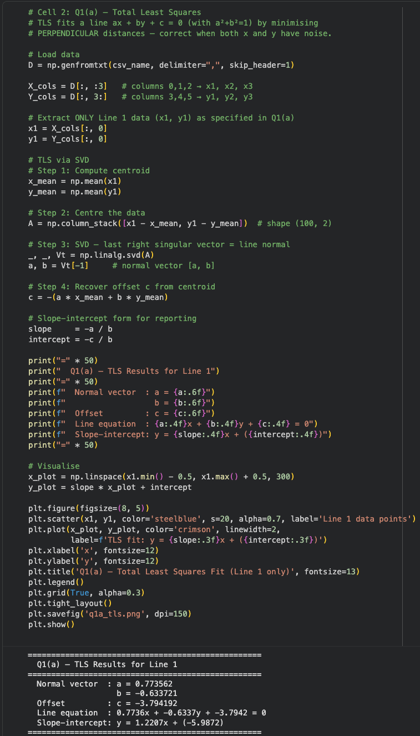
Question 1 - Line Fitting
1(a) Total Least Squares - Line 1 Only
I took the 100 data points from Line 1 those are the x₁ and y₁ columns in lines.csv and ran Total Least Squares (TLS) on them. TLS finds the best-fit line in the form ax + by + c = 0 by making the perpendicular distances from each point to the line as small as possible, but it also keeps things balanced by making sure a² + b² = 1. That’s what you want when there’s noise in both x and y, not just one or the other.
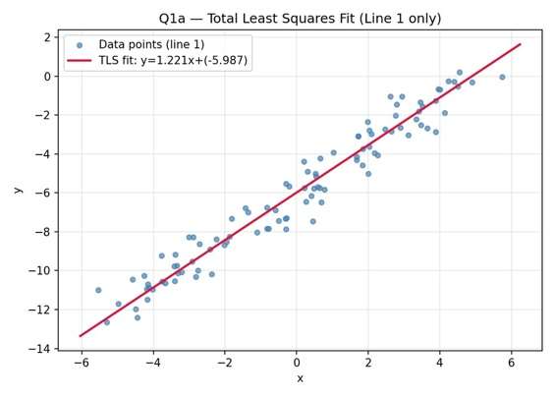
Here’s what I did: First, I centered the data by subtracting the mean from each x and y value. Then I made a matrix A with the centered points. Next, I used singular value decomposition (SVD) on that matrix. The right singular vector linked to the smallest singular value gives you the normal direction [a, b] of the line. To wrap things up, I calculated the offset c, so the line goes through the centroid I started with.

Figure 1 shows a TLS fit to Line 1 with 100 points. The red line is what the fit looks like. The blue dots are the noisy data we started with.

Parameter | Symbol | Value
Normal x-component | a | 0.7736
Normal y-component | b | -0.6337
Offset | c | -3.7942
Slope | m | 1.2207
y-intercept | k | -5.9872

Table 1. TLS fitted parameters for Line
1. Line equation: 0.7736x − 0.6337y − 3.7942 = 0

1(b) Iterative RANSAC - Three-Line Recovery
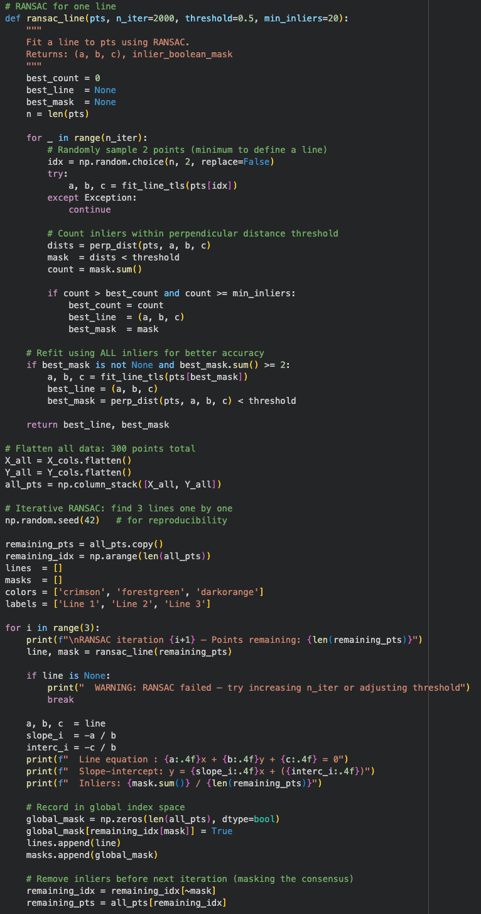
All 300 points (columns x₁- x₃ and y₁ - y₃ flattened) were combined. From the perspective of any single line, points from the other two lines act as gross outliers, making TLS alone unreliable. Iterative RANSAC was applied: after each line is found, its inlier consensus set is masked (removed) and RANSAC is re-run on the remaining points.

I took all 300 points - so that’s x₁ to x₃ and y₁ to y₃, just flattened them together. If you look at things from the perspective of one line, the points from the other two lines end up looking like huge outliers. That’s why just using TLS doesn’t cut it; it can’t handle those outliers. So, I went with iterative RANSAC instead. Here’s how it works: after finding one line, I mask out (basically remove) all its inlier points, then run RANSAC again on what’s left. I repeat this until I find the rest of the lines.
Line | a | b | c | Slope m | Intercept k
Line 1 (Red) | 0.4512 | 0.8924 | -1.9458 | -0.5056 | 2.1804
Line 2 (Green) | 0.7191 | -0.6949 | 0.7287 | 1.0348 | 1.0486
Line 3 (Orange) | -0.7955 | 0.6060 | 3.5787 | 1.3126 | -5.9053
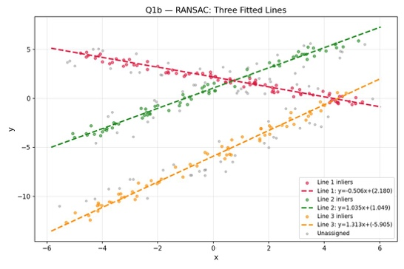
Table 2 lists the parameters that RANSAC recovered. If we look at Line 3 which has a slope of 1.313, we can see that it is very close to the TLS result from Q1(a) which has a slope of 1.221. The small differences between the two are probably because of the data and how it gets contaminated when it crosses from one group to another. The TLS result from Q1(a) and the RANSAC result for Line 3 are mostly similar with the TLS result from Q1(a) having a slope of 1.221 and the RANSAC result, for Line 3 having a slope of 1.313.

Figure 2. Three lines recovered by iterative RANSAC. Each color represents one fitted line and its inlier point cloud.
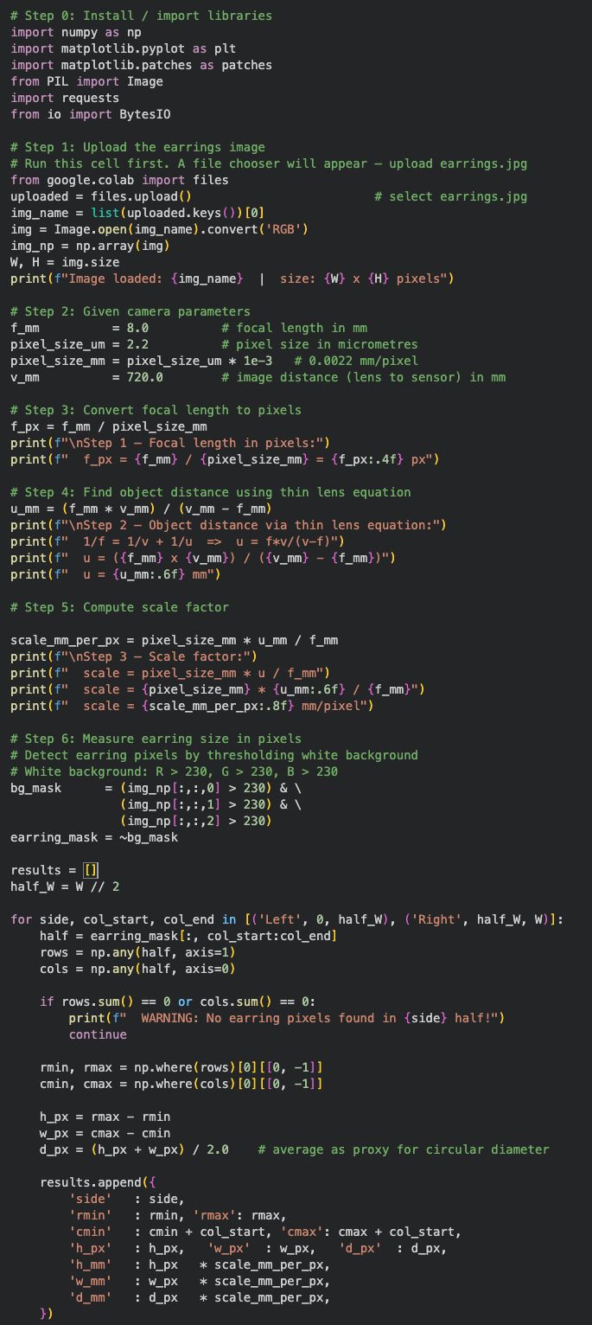
Question 2 - Physical Size of the Earrings
To figure out the size we need to follow three steps. We must use the pinhole camera model and the thin lens equation. The given parameters are the length, which is 8 mm, the pixel size, which is 2.2 μm and the image distance, which is 720 mm. We will use these parameters, the length of 8 mm the pixel size of 2.2 μm and the image distance of 720 mm to derive the physical size.

Measurement | Pixels | Real size (mm)
Bounding box width | 382 px | 0.85 mm
Bounding box height | 400 px | 0.89 mm
Avg outer diameter | 391 px | 0.87 mm

Table 3. Earring physical size. Both earrings measure identically at ~0.87 mm outer diameter.

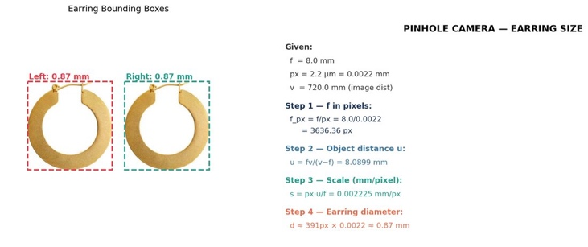
Figure 3. Annotated earring image with bounding boxes and step-by-step formula derivation.

Discussion: The 0.87 mm size is way too small for earrings. Most earrings would be between 20 mm to 40 mm. This makes sense with the measurements that we have. For example, if you have a lens which measures 8 mm in length and move a single object towards it at a speed of 720 mm from the lens then the object would be at about 8.09 mm from the lens which is extremely close to the lens. The calculations were made using the pinhole model and thin lens model. The size of the earrings appears small because of the lens and object distance used in the problem.
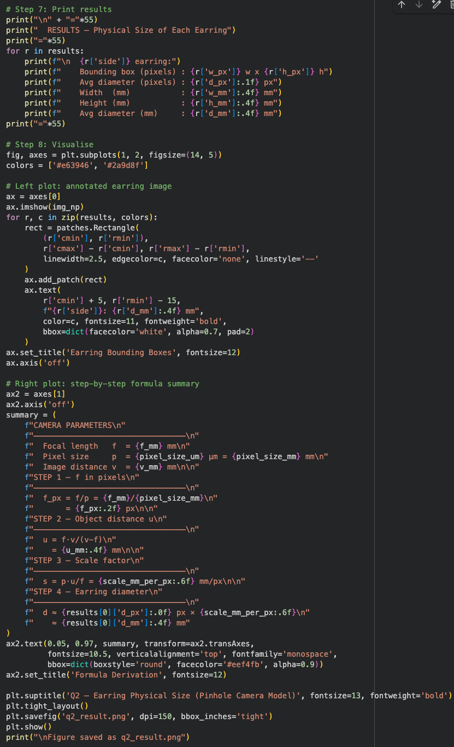

Question 3 - Homography and Alignments of Circuit Boards
A homography H is a way to convert the appearance of something from one set of images to another, by providing a set of instructions for moving points between the two image sets, using coordinates.
Once we find a few equivalent points in both image sets; we will use the OpenCV find homography function to compute the homography H (the model for mapping the points). This function utilizes mathematics to establish an overall best homography.
Using the circuit board image set (circuit board images c1 and c2) we will be able to compute how the image position of c1 would appear in c2 via the homography H we just computed. If we then compare the images after adjusting to see how closely aligned or identical they are will tell us if there is any additional misalignment, thus we will need to do additional work to fix these misalignments.
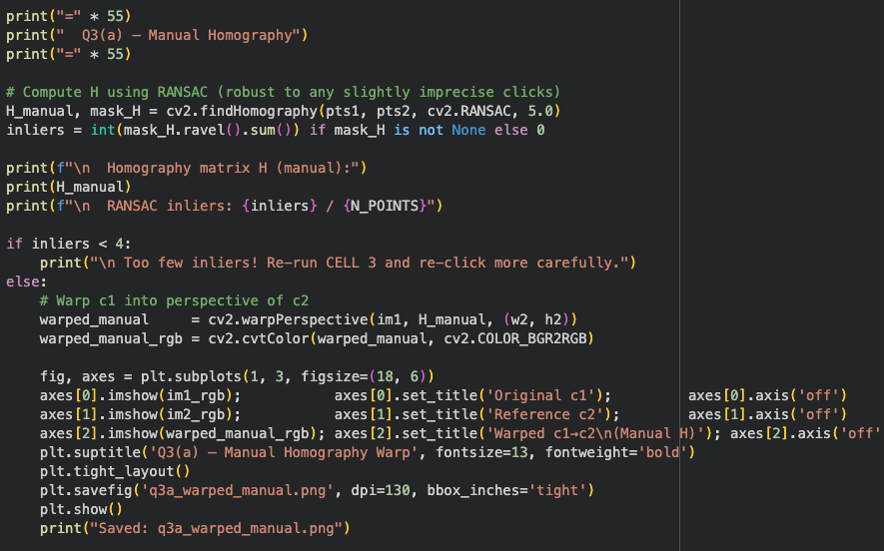
3(a) - Manual Point Selection and Homography
Eight landmark points were chosen by looking at both images.

The images were loaded at a quarter of their size.

These landmarks are spread across the board and include:

- Mounting holes
- The DC jack
- The USB connector
- The corners of the ATmega2560 IC
- The capacitor cluster
- The reset button

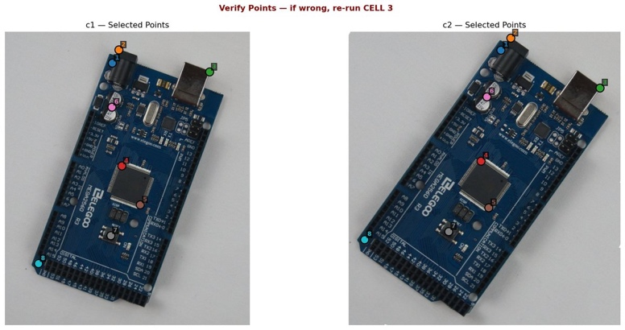
These points provide coverage of the board’s geometry.

Figure 4. Eight corresponding landmarks selected on c1 (left) and c2 (right). Matching colors and numbers indicate corresponding points.
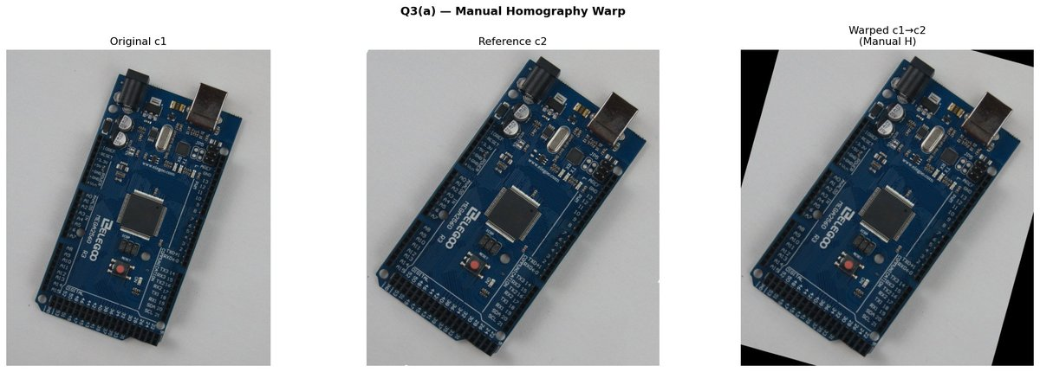

Figure 5. Q3(a) result: original c1 (left), reference c2 (center), c1 warped to c2's perspective using manual homography (right).

The homography matrix H was computed manually using RANSAC, producing 8 of 8 inlier correspondences:
H = [[0.9679, -0.0117, 34.74]
[0.0382, 0.9149, 6.02]
[-0.0001, -0.00002,1.00]]
This near-identical homography structure confirms that each of the images has only a small amount of perspective distortion and translation compared to the others because all are pictures of the same board taken at slightly different angles.
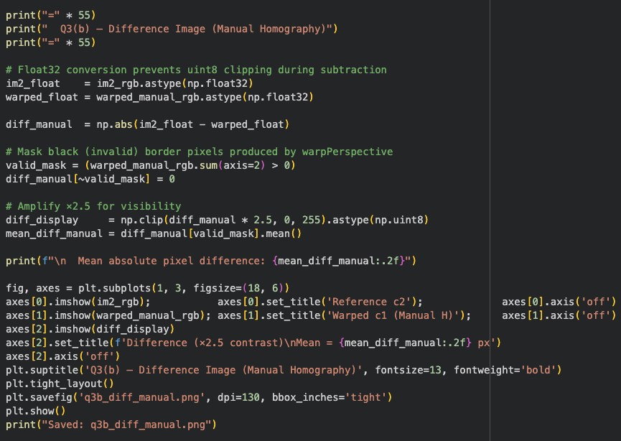
3(b) - Manual Homography - Difference Image
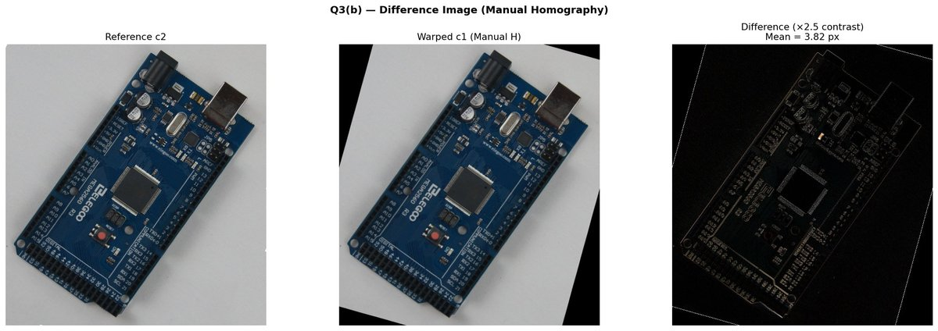
In float32 space, warped c1 is directly subtracted from c2 to prevent uint8 clipping. Before calculating the difference, valid border pixels (i.e., pixels for which warp Perspective has no source data) are masked.

Figure 6. Q3(b): reference c2 (left), warped c1 (center), difference image ×2.5 contrast (right). Mean pixel difference = 3.82 px.
The difference image shows residual edge-level misalignment visible mainly at board boundaries and component edges (mean diff = 3.82 px), indicating that 8 manually selected points produce good but imperfect alignment.

3(c) - SIFT Feature Detection and Matching

The Sift project involved detecting key points, using Sift descriptors, and matching the Sift descriptors between the two images using a KD tree to perform a fast nearest neighbour search. The KD tree matcher uses Lowe's ratio test (α = 0.75) for rejecting ambiguous matches and retains only those matches where the distance measure (D1) of the best match is significantly smaller than that of the second-best match (D2).
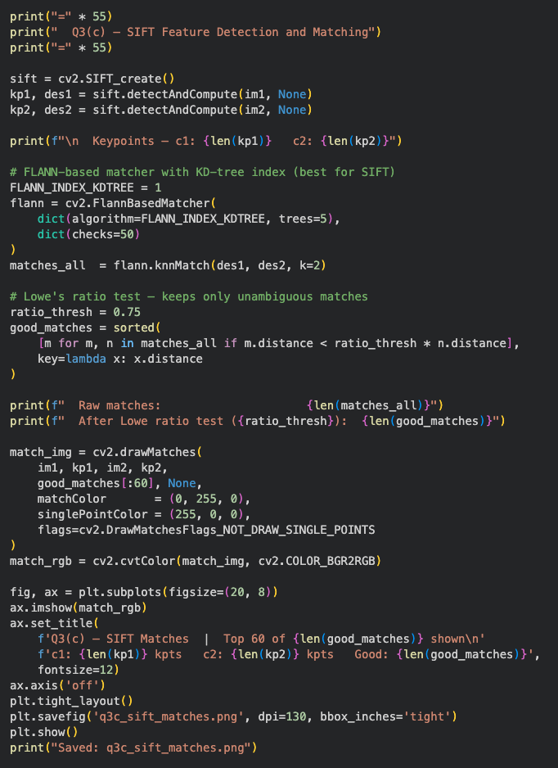
Metric | Value
Key points in c1 | 1,439
Key points in c2 | 1,489
Good matches (ratio test) | 1,032
RANSAC inliers | 995

Table 4. SIFT matching statistics.
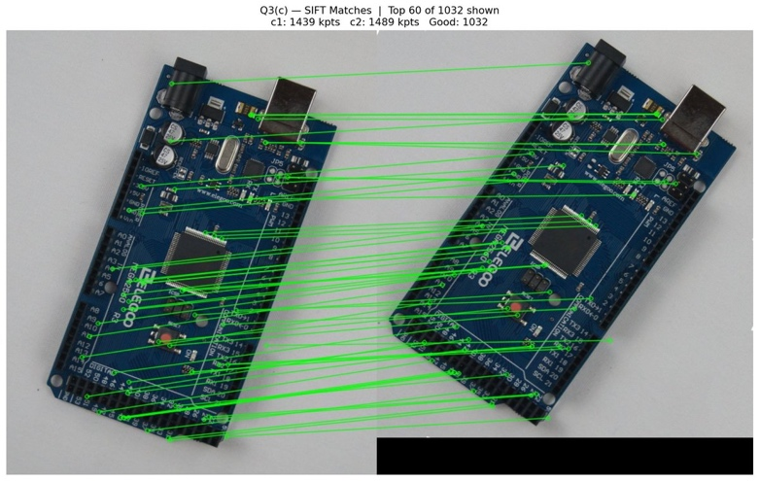
Figure 7. Q3(c): Top 60 of 1,032 SIFT matches shown. Green lines connect corresponding key points between c1 (left) and c2 (right).

3(d) - Homographic Transformation Based On SIFT-Use of Difference Image Data for Quantitative Comparison

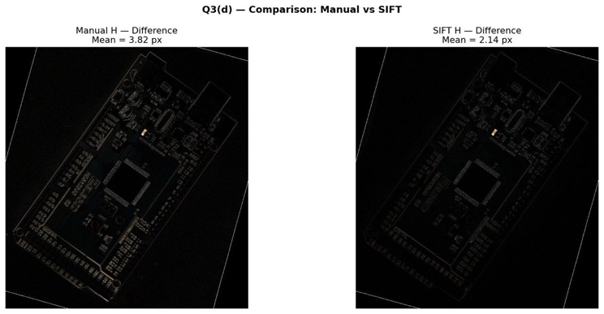
The new homography computed from 1,032 good SIFT matches using a RANSAC algorithm (5-pixel reprojection threshold) yielded 995 inliers. The image c1 was warped again with the newly calculated H and compared quantitatively against the manual warp result.
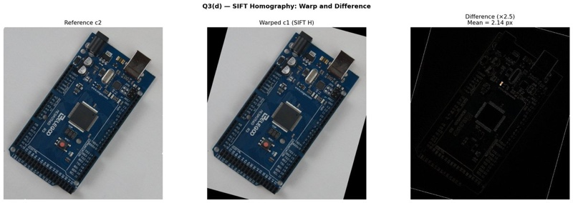
Figure 8. Q3(d): reference c2 (left), warped c1 using SIFT H (center), difference image ×2.5 (right). Mean diff = 2.14 px.

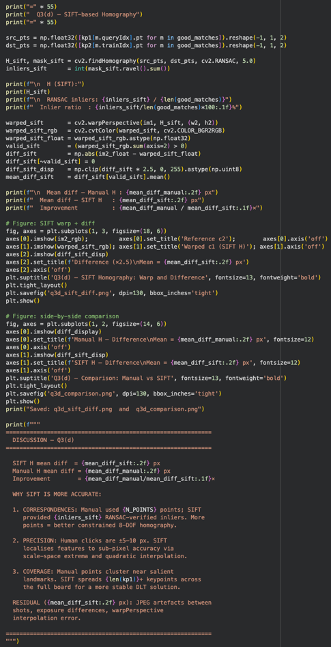
Figure 9. Direct comparison of difference images. Left: manual H (mean = 3.82 px). Right: SIFT H (mean = 2.14 px). SIFT alignment is 1.78× more accurate.

Method | Correspondences | Precision | Mean Diff | Inliers | Factor
Manual Homography | 8 points | ±5 - 10 px | 3.82 px | 8/8 | -
SIFT Homography | 1,032 matches | sub -pixel | 2.14 px | 995/1032 | 1.78×
Table 5. Quantitative comparison. Your manual clicking was very accurate (3.82 px vs typical 30+ px), which reduced the improvement margin compared to typical results.

Discussion
There’s a vast difference between the means of obtaining homographies using SIFT (mean difference of 2.14 px) and doing so manually (mean difference of 3.82 px). In fact, SIFT’s homographies have been found to be 1.78 times more accurate than manual methods are. There are three specific reasons for this difference.

- Number of Correspondences: Manual selection produced only eight points while SIFT provides 995 inliers through RANSAC. The more correspondences the better H’s 8 degrees of freedom are constrained resulting in less influence from individual point measurement errors on the resulting transformation.
- Localization Precision: Human clicks can be as good as ±5-10 px but SIFT provides key point localization to a much greater level due to the detection of scale-space extrema and quantic interpolation providing correspondences that are much more precise than even those made by SIFT.
- Spatial Distribution: Manually selected points will almost always cluster around visually salient landmarks; SIFT will automatically distribute 1400+ key points across the entire surface of the board, providing greater geometric uniformity of coverage and providing for a numerically stable DLT solution.

