Online Shopping Portal Project

QE Batch – Group 2

**Group Leader :**

Dhimanshi Jayasena

**Team Members:**

Bhagya Peiris

Thihari Wijesinghe

Vindya Hasanthi

Table of Contents

Installing and setup the project in WordPress 3

1. Installing WordPress locally 3

2. Adding Plugins in WordPress 4

3. Creating a db for our project 5

4. Upload project to WordPress 5

5. Accessing our project 6

Creating Test cases for our project 8

1. Dividing the main features 8

2. Test Case template 9

# Installing and setup the project in WordPress

## 1. Installing WordPress locally

Step 1 - Download WordPress

Visit [Download | WordPress.org](https://wordpress.org/download/) page and download the latest version.

Step 2 - Create a new folder in htdocs

Extract the downloaded folder contents to the following path:

* + xampp -> htdocs -> file name

Step 3 - Visit the created folder from localhost

Give URL as **localhost/filename**.

Step 4 - Setup the configurations

Give URL as localhost/filename/wp-admin/setup-config.php

Step 5 - Create database in phpMyAdmin

Create a database (wp etc.)

Step 6 - Continue the setup configurations in WordPress (Refer 1.4)

Give the following values for the required fields.

* 1. Database name: give the database name you created in 1.5
  2. Username: root
  3. Password: Leave it empty
  4. Database host: localhost
  5. Table prefix: wp_

Step 7 - Setup the configuration in welcome page

Give the following values for the required fields.

1. Site Title: give a preferred name
2. Username: admin
3. Password: pass
4. Email: give an email

Then click on Install WordPress.

Step 8 - Login with the credentials

## 2. Adding Plugins in WordPress

Step 1 – Go to “Plugins” and click on “Add new”.

Step 2 – Search for “WP file manager”

Step 3 – Click on “Activate”.

## 3. Creating a db for our project

Step 1 – Visit [localhost / 127.0.0.1 | phpMyAdmin 5.1.0](http://localhost/phpmyadmin/)

Step 2 – Create a database (give the same db name of the file in our project - shopping).

Step 3 – Import the shopping.sql file

## 4. Upload project to WordPress

Refer [Online Shopping Portal Project in Php|E-commerce Online Shopping Portal (phpgurukul.com)](https://phpgurukul.com/shopping-portal-free-download/) to download the project.

Step 1 – Go to WP File Manager

Step 2 – Create a new folder (preferred name like shopping etc.) in wp file manager.

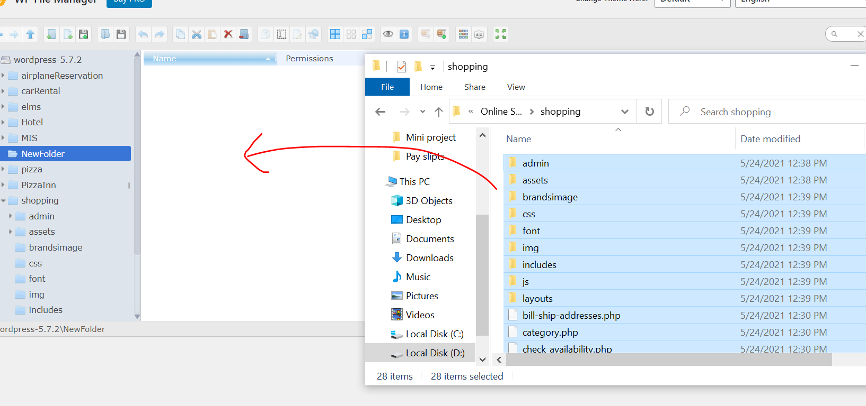

Step 3 – Double click on the created folder to enter.

Step 4 – Drag and drop the project files into the created folder.

## 5. Accessing our project

Step 1 – Click on the site title

Step 2 – Give the name of our folder to the URL as the following.

# Creating Test cases for our project

## 1. Dividing the main features

We have considered the following as the main features of our project.

**Part 1**

* User Registration
* User login system
* Forgot password
* Log out
* Track order

**Part 2**

**Profile management system:**

* My account
* Change password
* Shipping/billing address
* Order History
* Payment pending Order

**Part 3**

**Shopping cart**

* My cart
* Add to cart
* Update cart
* Update shipping address
* Proceed to checkout
* Choose payment method
* Track

**Part 4**

* Main categories
* View items
* Adding to wish lists
* Add to cart
* Search
* Wishlist
* Check availability

## 2. Test Case template

