180371K
B.A.T.L. Madusanka

RPAL Interpreter

Introduction
RPAL is functional programming language which doesn’t contains heap allocations. This project is for implement full RPAL interpreter from scratch.
It contains the following modules,
- Scanner (Tokenize the source code)
- Parser (Parse AST)
- Analyzer (Convert AST to ST)
- CSE Machine (interpret the program)

Architecture

Entry Point
Source file: src/main.cpp
- Contain entry point for the program.
- Handles command line arguments.

Scanner
Source files: src/token.hpp, src/token.cpp
- Scan the source code and create linear token list
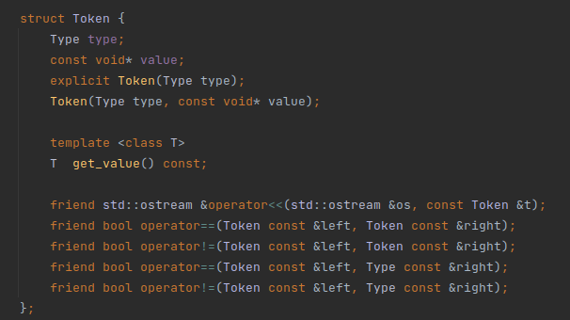

Parser
Source files: src/ast.hpp and src/ast.cpp
- Convert linear token list to AST
- Then convert AST into ST
- Use top to bottom recursive parsing algorithm to parse the tokens
- To avoid left recursion all the grammar which contains left recursion have converted to right recursive version.
  - Ex: A → A+At is converted to A → AtA’ and A’ → +A’
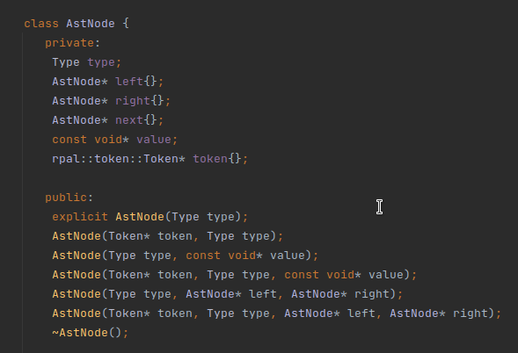
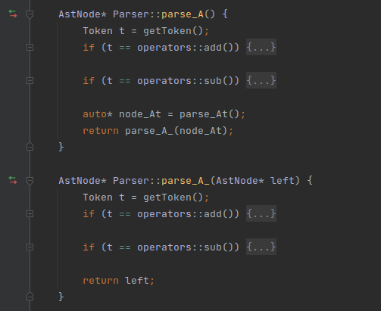

CSE Machine
Source files: src/cse.hpp and src/cse.cpp
- Contains the CSE machine
- Interpret the ST
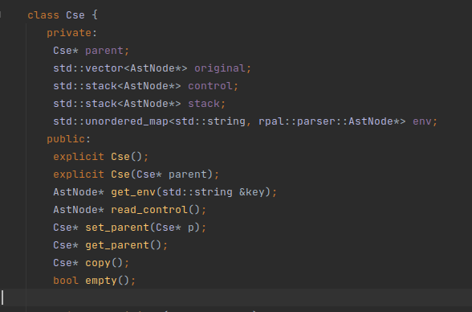

How to use

> Please Note that string literal syntax should use double quote instead of single quote.

Binary files are in "bin" directory.

Windows:
rpal.exe <source-file-path> => execute code
rpal.exe -t <source-file-path> => linear token list
rpal.exe -a <source-file-path> => abstract syntax tree
rpal.exe -s <source-file-path> => standardized syntax tree

Linux:
rpal <source-file-path> => execute code
rpal -t <source-file-path> => linear token list
rpal -a <source-file-path> => abstract syntax tree
rpal -s <source-file-path> => standardized syntax tree

Example in Linux:
Source Code:
let Sum(A) = Psum (A, Order A )
where rec Psum (T,N) = N eq 0 -> 0 | Psum(T,N-1)+T N
in Print ( Sum (1,2,3,4,5) )

Generate Token list:
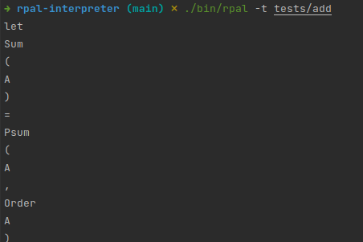

Generate AST then ST:
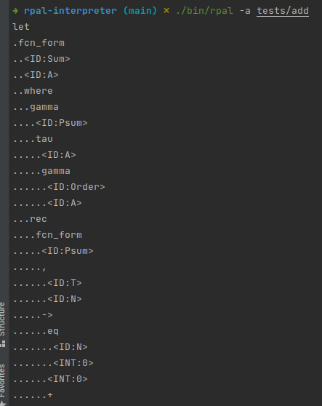
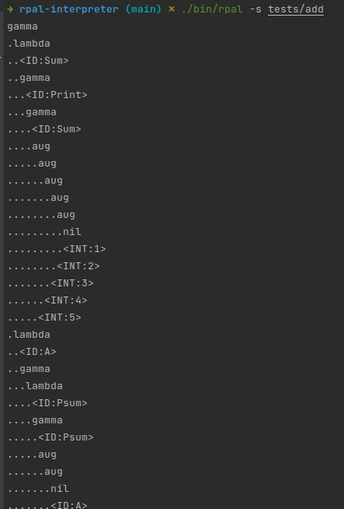
Execution:
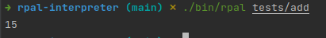

How to build from source:

Requirements
- CMake 3.2+ [https://cmake.org/download/](https://cmake.org/download/)
- Make [https://gcc.gnu.org/](https://gcc.gnu.org/)
- C++ compiler (C++ STD 20) [https://gcc.gnu.org/](https://gcc.gnu.org/)

Steps
1. Create directory named "build" `mkdir build` or `md build`
2. Go into that directory `cd build`
3. Type command `cmake ..`
4. Type command `make`
5. Binary file will be in the build directory `rpal.exe` (in windows)

