DOCTORS’ PRESCRIPTION RECOGNITION USING
DATA MINING APPROACH

Bachelor of Computer Science

D. M. T. D. DISSANAYAKE
EUSL/TC/IS/2014/COM/13

Department of Computer Science,
Faculty of Applied Sciences,
Trincomalee Campus, Eastern University, Sri Lanka

September 2020
DOCTORS’ PRESCRIPTION RECOGNITION USING
DATA MINING APPROACH

A dissertation submitted to Trincomalee Campus, Eastern University in partial fulfilment of the requirements for the award of the Degree of Bachelor of Computer Science

by

DISSANAYAKE MUDIYANSELAGE THILINI DANESHI DISSANAYAKE
EUSL/TC/IS/2014/COM/13

Department of Computer Science,
Faculty of Applied Sciences,
Trincomalee Campus, Eastern University, Sri Lanka

September 2020

DECLARATION
I do hereby declare that the work reported in this dissertation was exclusively carried out by me under the supervision of Mr. S. Thadchanamoorthy. It describes the results of my own independent research except where due reference has been made in the text. No part of this dissertation has been submitted earlier or concurrently for the same or any other degree.

Date: ………... .......................................
Signature
D. M. T. D. Dissanayake

We/I endorse the declaration by the candidate.

.......................................
Supervisor
Mr. S. Thadchanamoorthy
Senior Lecturer
Department of Computer Science
Faculty of Applied Science
Trincomalee Campus, Eastern University, Sri Lanka

Date: ………………….

ABSTRACT
It is a well-known fact that the doctors’ handwriting in the prescriptions is illegible in Sri Lanka because of the traditional prescription practice which involves doctors’ handwritten prescriptions. Pharmacy staff such as dispensers, pharmacists and master pharmacists will have the responsibility to identify the prescribed medicines and dispense them accurately and accordingly with appropriate instructions to the patients. There must be clear communication among these three parties; the patient, the doctor and the pharmacist or the dispenser so that mistakes and misunderstandings can be avoided. Misidentification of medicine names due to the illegible handwriting has been the reason for most of the dispensing errors, and it makes the dispensers struggle in identifying medicine names which waste time. Therefore, to prevent dispensing errors accurate identification of the contents in handwritten prescription is necessary. This research is focused on studying manual process and techniques used by the pharmacists in reading illegible handwritings in prescriptions and developing a program that carries out the same procedures and techniques, to assist prescription reading, and finally to automate the prescription reading process. The idea that a medicine can be uniquely identified by its partial string of starting letters (first two or three letters) and its dosage mentioned in the prescription was the base for this research, which was the same technique used by the dispensers and pharmacists to identify medicine names from the illegible handwritten prescriptions. Input data for the program are the partial strings extracted from prescriptions either by OCR technology or by the user manually. The decision tree classifier is used to predict the medicine name from the extracted features in the prescription.

ACKNOWLEDGEMENT
I would like to express my deep gratitude to my research supervisor Mr.S.Thadchanamoorthy, Dean of the faculty of Applied Science, Trincomalee Campus and Mr.M.Ramanan, Head of the Department of Computer Science, Trincomalee Campus and to my mentors Lecturer Ms. S. Khedika and Lecturer Ms. Y. Kalyani and to all other lecturers, for their patient guidance, valuable and constructive suggestions on this research work.

I would like to acknowledge the support provided by Pharmacist Mr. Prasanna, master Pharmacist Mr. Senarath Maldunnarachchi, my family and collegues and all of others helped me during the proceeding of this research work.

I would also like to thank the pharmacists and the pharmacy staff of visited pharmacies for enabling me to visit their premises to gather information and offering their valuable time for this research work.

CONTENTS
DECLARATION 2
ACKNOWLEDGEMENT 4
CONTENTS 5
LIST OF FIGURES 7
LIST OF TABLES 7
1. Introduction 8
1.1. Background 8
1.2. Problem Statement 9
1.3. Objectives 9
1.4. Project Scope and Limitations 9
2. Literature Survey 11
2.1. Introduction 11
2.2. Data Mining Techniques 11
2.3. Decision Tree Classification 12
2.3.1. Calculation of Information gain 13
3. Methodology 14
3.1. Gathering of Information 15
3.1.1. Collection of Data 15
3.1.2. Collecting Samples 15
3.1.3. Contents of the Prescription 15
3.1.4. Latin abbreviations and Medical terms 16
3.1.5. The manual process of Prescription Reading 17
3.2. Analysis of Collected Data and prescription samples 18
3.2.1. Generic name and Brand name of Medicines 19
3.2.2. Data needed for extracting medicine names 19
3.2.3. Methods and Techniques used in identifying medicine names. 21
3.2.4. Frequently used medicines and brands in prescriptions 22
3.3. Preparing Dataset 22
3.3.1. Comma Separated Values Files 22
3.3.2. Attributes 22
3.4. Selection of most suitable technique of data mining 23
3.4.1. Calculating Information Gain 23
3.4.2. Decision Tree 24
3.5. Design of program 25
3.5.1. Algorithm 25
3.5.2. Assumptions made in this research 25
3.6. Development 26
3.6.1. Development of program 26
3.6.2. Development of demo user application 26
3.7. Testing 29
3.8. Performance evaluation 29
4. Testing 30
4.1. Functional Testing for program 30
4.1.1. Testing for each type of data inputs. 30
Test cases for testing each type of data inputs 30
4.1.2. Testing for sample prescriptions 31
4.2. Testing for Demo Application 32
5. Performance Evaluation 33
5.1. Introduction 33
5.2. Percentage Accuracy 33
6. Conclusion 34
7. Future Work 35
List of References 36

LIST OF FIGURES
Figure 2-1 Process of training and predicting the target features7 13
Figure 3-1: Steps in methodology 14
Figure 3-2: Steps in demo application development 14
Figure 3-3: Sample Prescription as mentioned in BNF⁴ 16
Figure 3-4 Sample prescription received in a rural pharmacy. 18
Figure 3-5 : Descision Tree for the dataset. 24
Figure 3-7: Sample image of dataset used for classification. 24
Figure 3-6 : Calculation of Information Gain values using Decision Tree algorithm. 24
Figure 5-1 Screenshot of Spyder IDE used for program development 26
Figure 5-2 Screen one: Upload prescription image 27
Figure 5-3 Screen 2: Select prescription image 27
Figure 5-4 Screen 3: Starting window. 28
Figure 5-5 Display of results after entering starting letters. 28
Figure 5-6 Display of results after entering last letters 29

LIST OF TABLES
Table 3:1 : Dosage groups used in dataset 20
Table 3:2 : Dosage form groups used in dataset 20
Table 3:3 : Frequency groups used in dataset 21
Table 3:4 : Information Gain values for attributes 23
Table 4:4:1 Test cases and expected results 30

Chapter 1

Introduction

Background
The traditional way of medical prescription is practised by writing them on a paper or receipt and is issued to the patients. Patients buy the prescribed medicines from pharmacies. Pharmacy dispensers will have the responsibility to identify the prescribed medicines and dispense them accurately to the patients. Any step in the dispensing process can generate errors that affect badly on human life. Faults in medicine dispensing may also destroy the trust and goodwill of the professionals and pharmacies. Misidentification of medicine names due to the illegible handwriting is the reason for most of the dispensing errors and it also makes the dispensers struggle and waste time in identifying medicine names. Although the e-prescriptions and printed prescriptions with clear content were introduced, still the handwritten prescriptions are mostly being practised in Sri Lanka.
This research work is attempted to find a way to overcome the difficulty in understanding illegible handwriting in prescriptions using a data mining approach. The proposed solution is a digitized version of the prescription reading task for saving time and minimizes misunderstanding. A prototype is developed to identify the medicine names correctly using partial strings of words in the prescription as inputs with the support of decision tree classifier. The prototype is further improved as a user-friendly application tool to assist dispensers and pharmacists with additional information needed in dispensing and patient counselling.

Problem Statement
Although the e-prescriptions and printed prescriptions with clear content were introduced, still the handwritten prescriptions are being used mostly in Sri Lanka. Interviews are conducted with several pharmacists, dispensers and pharmacy owners, to identify the problems they face when reading illegible handwriting. According to that data, only an expert having much of experience can read the handwriting in the prescriptions and he/she recognize the handwriting of the doctors if he/she gets the prescriptions from the same doctor for many times. The dispensers struggle to read illegible handwriting and sometimes they have to contact the relevant doctor. Therefore this research work is aimed to deliver an application which assists the pharmacists to identify the medicine name on the prescription.

Objectives
The objectives of this research project are,
- To select the most appropriate data mining technique that can be used to identify the name of the medicines from the prescriptions accurately.
- Design a prototype by applying the selected data mining technique from the partial strings identified in the handwritten prescription.
- To develop a user-friendly application, which can be used by both the pharmacists and patients for verification.

Project Scope and Limitations
100 Prescriptions were used for studying prescription reading techniques, creating the design of the application, creating dataset and testing, which were collected from a rural hospital pharmacy in Chilaw area which are written by different doctors and consultants, and dispensed by that pharmacy in different days.
Followings were identified as limitations of the project.
- The number of medicines used in the dataset
The data set was created including most probably mentioned generic names and brand names of the medicines. The Essential Medicines List (EDL) published by Health department of Sri Lanka and a list of medicines used in rural hospital pharmacy (dispense a very low number of proprietary brands of medicines and more of generic medicines) was used in making this dataset. This is by considering the time consumption for making a dataset including all the medicine brands (more than 1000 brands) used in the country.
- The prescriptions used for testing were collected from the same pharmacy.
The prescriptions dispensed from the same rural hospital pharmacy were used for testing to avoid misleading with the use of limited medicine names in the dataset. Therefore, it is ensured that all the medicine names included in tested prescriptions are present in the dataset.
- The required number of defined features of some prescriptions would not be able to be identified clearly, due to very poor handwriting.
If at least a partial string of a medicine name was not clear to identify, then some other techniques and procedures should be followed additionally, as mentioned under the future developments of this project.
- For the commercial use of the idea followed in this research work, the features included in demo application should be developed further into a mobile application to make users convenient in using the application in a practical environment to get higher efficiency.
Chapter 2

Literature Survey

Introduction
The research paper on Medicine Box, a smartphone application that uses Conventional Neural Network (CNN) to recognize handwritten medicine names and return readable digital text ³ was referred as it was providing a solution for the same problem discussed in this research. Similar researches that are using data mining techniques for prescription reading were not found, but the research work conducted based on different data mining approaches were studied to get an idea about the data mining technique suitable for this research idea.

Data Mining Techniques
Shugufta Fatima and Dr. B. Srinivasu ¹ have mentioned that the text classification can be done in three ways as follows.
- Supervised text classification
- Unsupervised text classification
- Semi-supervised text classification
In supervised text classification, it takes labelled documents and additional knowledge is provided by an expert and in unsupervised classification, it takes unlabeled documents and additional knowledge is not provided by an expert. The semi-supervised text classification algorithms make use of unlabeled data along with few labelled data to classify new unlabeled text document. These types of text classifications are best suited when the number of classifying categories is small. For example, Support Vector Machines (SVM) which is a supervised learning technique, is suitable when classifying into two categories.
Mita K. Dalal and Mukesh A. Zaveri have proposed in their research paper ² that the process of text classification has been divided into four phases such as
1). Document pre-processing,
2). Feature extraction / selection,
3). Model selection,
4). Training and testing the classifier.
Machine learning algorithms used for feature extraction/ selection were, Naïve Bayes, Decision Tree, Neural Network, Support Vector Machine (SVM), Hybrid techniques. According to the solutions presented in the paper for selection of appropriate machine learning technique for classification, Naïve Bayesian classifier is suitable for a dataset having enough training instances of each category and having many attributes. The SVM is suitable for 2 class/ category classification. Unlike Naïve Bayesian classification, Decision Tree classification does not assume independence among its features. It represents the relationships among attributes as links.

Decision Tree Classification
Decision trees are supervised learning algorithms used for both classification and regression. Classification concept is when it has given data and relevant classes of classification, by training a model to analyze given data it predicts the relevant label or class for any provided new data of a class. In regression concept, data are given without their classification class or label and the model analyzes the patterns in given data and group of that data accordingly. For this research, decision tree classification is referred to as the class or the label is to be found according to the dataset prepared.
Decision tree classifier is built on the features of data and the Information Gain (IG) and Entropy. The main idea of decision trees is to find those attributes which contain the most "information" regarding the deciding of the target class and then split the dataset along the values of these attributes such that the sub-dataset to be analyzed become smaller and finally the tree splitting end at the target class called a leaf node. This process of finding the "most informative" attribute is done until we accomplish the stopping criteria where we then finally end up in so-called leaf nodes. The leaf nodes contain the predictions it will make for new query instances presented to the trained model. This is possible since the model has kind of learned the underlying structure of the training data and hence can, given some assumptions, make predictions about the target feature value (class) of unseen instances. A decision tree mainly contains a root node, interior nodes, and leaf nodes which are then connected by branches.

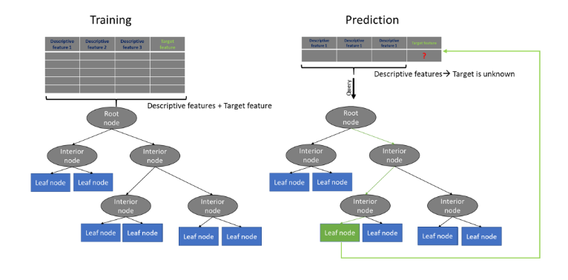
Figure 2-1 Process of training and predicting the target features7

The ID3 algorithm for creating a decision tree classification model from scratch in python was referred and the steps in the algorithm were used in this coding⁷. There are four important steps in this algorithm as follows.
- Calculation of the Information Gain
- Recursive call of the Tree Model
- The building of the actual tree structure
- Species prediction of a new unseen animal-instance

Calculation of Information gain
The formula for the Information Gain calculation of one attribute as mentioned in reference document⁷.
InforGain(featured,D)
=Entropy(D)−∑t ∈ feature(|featured=t||D|∗H(featured=t))InforGain(featured,D)=Entropy(D)−
∑t ∈ feature(featured=t||D|∗H(featured=t))

=Entropy(D)−∑t ∈ feature(|featured=t||D|∗(−∑k ∈ target(P(target=k,featured=t)∗log2(P(target=k,featured=t))))

Equation for Calculation of Information Gain⁷

Chapter 3

Methodology
This research carried out in two main processes; applying data mining techniques for classification and building an application. The research work is intended to identify suitable data mining technique to classify the medicine names and the algorithm is implemented to evaluate the performance. A user-friendly tool is developed to implement the tested algorithm. The phases of each methodology are presented below.
Gathering Information
Analyzing collected information and samples
Design of program
Preparing Dataset
Selection of most suitable data mining technique
Developing the
program
Testing and Refining code
Evaluating the Performance
Figure 3-1: Steps in methodology

Design User Interface
Developing Application
Testing Application
Figure 3-2: Steps in demo application development

Figure 3.1 describes the steps in program development for the research purposes.
Figure 3.2 describes the steps in the demo application development.

Gathering of Information

Collection of Data
Followings materials are collected.
- The British National Formulary (BNF)⁴ which is referred by doctors, pharmacists, and dispensers to get all the details of medicines used in Sri Lanka.
- Sri Lanka Student Formulary (SLSF)⁶ which is referred by apprentice pharmacists and doctors to gain their knowledge on prescribing and dispensing.
- The Essential Medicines List (EML)⁵ published by the ministry of health care & nutrition of Sri Lanka
- Inventory item list of available medicines in pharmacy
- Product list of the medicines with brand names given by distributers.
- List of common conditions/ diseases with a set of medicines usually prescribed for each condition/ disease
- Sample pictures of prescriptions dispensed.
- Document with correct medicine names mentioned on the collected sample prescriptions.

Collecting Samples
Collected 200 prescriptions of different handwriting patterns. Prescriptions are collected from a rural hospital pharmacy in Madampe, Chilaw area and are written by different doctors and consultants and dispensed by that pharmacy in different days.
At the same time, the information on collected sample prescriptions (medicine names, dose, frequency) are documented appropriately by confirming correct information from experts (experienced pharmacists) so that, to compare with the output of the program in the testing phase.

Contents of the Prescription
Prescription is a written or printed order to the pharmacist given by a doctor containing required medications and treatments recommended for the patient named in the prescription. The patient carries the prescription from the doctor to the pharmacist. A typical prescription includes the following data.
- Date of prescribing
- Name and address of the patient
- Age of the patient
- Medicines and/or medical devices to be dispensed with the relevant doses of each
- Administration route, indicating how to administer (oral, to the eye, etc.)
- Time of use (before meals, at night, etc.
- Frequency of use (three times daily, once daily, etc.)
- Time duration of treatments to be continued
- Any other instructions
- Prescriber's name, address and contact number
- Prescriber’s SLMC registration number
Doctors use Latin abbreviations and medical terms in the prescriptions to indicate the above information (5, 6, 7).
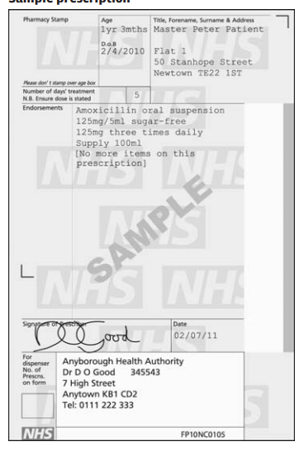

Figure 3-3: Sample Prescription as mentioned in BNF⁴

Latin abbreviations and Medical terms
Directions should be in English without abbreviation. However, Latin abbreviations have been used when prescribing. The following is a list of appropriate abbreviations. It should be noted that the English version is not always an exact translation. As mentioned in BNF ⁴.

Time of use
- a. c. - ante cibum (before food)
- p. c. - post cibum (after food)
- o. m. - omni mane (every morning)
- o. n. - omni nocte (every night)
- p. r. n.- pro re nata (when required)
- stat - immediately

Frequency of use
- b. d. - bis die (twice daily)
- o. d. - omni die (every day)
- q. d. s.- quater die sumendum (to be taken four times daily)
- q. q. h. - quarta quaque hora (every four hours)
- t. d. s.- ter die sumendum (to be taken three times daily)
- t. i. d - ter in die (three times daily)

The manual process of Prescription Reading
The techniques and resources used by dispensers and pharmacists, their comments and other details were collected using a questionnaire and interviews. The summary descriptionof the collected information is as follows.
When a prescription is given to a dispenser, he tries to identify the clearest letters in the medicine names, most probably, only the first and second letters and sometimes the last letters(such as 'l', 'n', 'r', etc.), can be identified clearly. Then he reads the dosage amount mentioned such as 250mg, 5mcg, 75mg, etc. then the frequency (tds, bd, etc.), time of use(nocte, mane, etc.) and the duration of treatment(1/52, 3 months, etc.). The dispensers must guess the medicine name with the letters or the partial string they could identify. The partial string can lead to two or more medicines, such as a partial string like 'Sal.....ol' may indicate medicines Salbutamol or Salmetarol which are having different therapeutic effects. To confirm that the medicine name is correct, they consider the dosage recommended for the particular medicine. As per their opinion, when filtering medicine names along with the dosages mentioned, they can identify the exact medicine mentioned in the prescription. For example, Salmeterol always comes with dosages of 250mg, 150mg, and Salbutamol always comes with dosages of 10mg, 20mg. Then although the partial strings are same, the correct medicine can be identified correctly by considering their dosages mentioned.

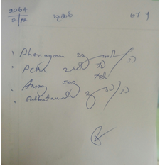

Figure 3-4 Sample prescription received in a rural pharmacy.

The purpose of information gathering is to collect any material containing information relevant to this research to fulfil the following tasks.
- To get an idea about the contents of a prescription, its purpose and legal background.
- To get a clear understanding of the procedures and techniques of the manual process of prescribing and dispensing.
- List of frequently dispensing medicines in pharmacies.
- Recordings for motion and time study of the intended process.
- Collecting samples
Information needed for this research were collected by visiting 8 pharmacies in Madampe, Chilaw area by using the following methods of information gathering.
- Interviews
- Questionnaire
Collected materials and information are discussed in detail in chapter 4.

Analysis of Collected Data and prescription samples
From the analysis of the information collected, the following facts are identified.
- Most essential data to be identified from the prescription to decide the correct medicine name.
- Steps used in manual prescription reading
- Techniques used to resolve conflicts of reading prescription in the existing environment.
- Frequently used medicine list.

Generic name and Brand name of Medicines
According to the comments and suggestions collected by dispensers and pharmacists working in the field, normally every medicine has two standard names as Brand/ Proprietary name and generic/non-proprietary name. Generic name is the name of active ingredient in the preparation, it is unique for the medicine and for its components, therapeutic effect. Generic name is given by WHO. A medicine is internationally identified using the generic name. Brand/Proprietary name is the name given by manufacturers for their product which will contain additional ingredients and medicaments other than the active ingredient. Brand name is used for the marketing purposes. For example, Paracetamol is the generic name while the same active available in different products with different brand names in the market such as “PANADOL”, “KALDOL”, “FEBRINIL”, “PANADEINE”, “RAPIDENE” which are manufactured by different companies.
According to the National Medicines Regulatory Act No.5 of 2015 of Sri Lanka, generic names of the medicines should be mentioned in the prescriptions and if needed, brand names can be mentioned within brackets. But according to the comments of dispensers and pharmacists working in the field, prescriptions may contain either of the names. Therefore, in this research work dataset, medicine names or labels which are the main data to be extracted are containing generic name and brand names of same medicine as separate labels. But the brand names are linked with generic name for the benefit of the user in dispensing.

Data needed for extracting medicine names
By studying the collected prescriptions, the factors needed for extracting medicine names from prescriptions were identified. Those are as follows.
- Partial string (first two or three letters) of medicine names that could be able to identify
- Dosage (E.g.: 500mg, 50mg)
- Dosage form (E.g.: caps, tabs)
- Frequency of administration (E.g.: tds, bd)
- Times of use (E.g.: ac, nocte)
- Age of patient
These data were used to identify the techniques used in prescription reading process in designing the workflow of the program. Each attribute data are categorized into several groups when preparing the dataset to be used for applying the selecting data mining technique. This grouping is not the standard grouping used in pharmacy field, but for this research purpose, these grouping is handeled at programming level without making any doubts in user.
- Dosage
Dosages entered into the datset are all in miligrams. The dosage groups are as follows.
Table 3:1 : Dosage groups used in dataset
Group name in dataset | Containing dosage range
0-10 | 0 < Dosage <= 10
11-100 | 10 < Dosage <= 100
101-10000 | 100 < Dosage <= 1000
1000-3000 | 1000 < Dosage < 3000

- Dosage forms
Frequently used dosage forms were identified and and prepared the data table of medicine details. Mostly used dosage forms are mentioned in basic data table are as follows.
- tab - tablet
- cap - capsule
- susp - suspension
- supo - suppository
The types of dosage forms are categorized into 3 groups to prepare the dataset. Those groups are as follows.
Table 3:2 : Dosage form groups used in dataset
Group name in dataset | Containing dosage forms
Tablet | tablet, capsule, suppo, pessary
Mixture | Syrup, solution, drops, susp
Cream | Ointment, cream, gel

- Frequency of administration
Frequency or the number of times instructed to take the medicine per day, was identified and prepared data table of medicine details. The lattin abbreviations which are mostly mentioned in presriptions are as follows.
- bd / bid - 2
- tds / tid - 3
- qds / qid - 4
The groups to be used in the dataset are as follows.
Table 3:3 : Frequency groups used in dataset
Group name in dataset | Containing frequencies
1 | 1
2 | 2
3 | 3
>=4 | 4, 6

- Times of use
The frequently mentioned times of use were identified and used in the basic data table in short forms as follows.
- ac - before meals
- pc - after meals
- mane - morning
- nocte - night
- stat - at once

Methods and Techniques used in identifying medicine names.
By analyzing the comments and answers given by the dispensers and pharmacists in questionnaire, it was identified the methods and techniques used to identify the correct data from prescription and confirm those data in manual (existing) process. Those are as follows.
- Identify the clearest letters in the medicine names, most probably, only the first and second letters and sometimes the last letters (such as 'l', 'n', 'r', etc.), if they can be identified clearly (referred as partial string in this research)
- Reads the dosage amount mentioned such as 250mg, 5mcg, 75mg, etc.
- Most of the times the partial string and dosage is enough to identify medicine uniquely.
- If the partial string or dosage is not clear, then ask patient about the condition/ disease for which the medicines were prescribed.
- Compare with the condition and other medicines listed in prescription to identify the unclear medicine.
- If there are any further doubts, they contact the prescriber and resolve.
- All the prescriptions and relevant pack of medicines to be dispensed are checked and confirmed by the pharmacist in charge, before dispensing.
The pharmacist in charge of the pharmacy has the full responsibility of reading prescription and dispensing the prescribed medicines correctly and accordingly. Above steps were studied and used in designing the workflow of the program.

Frequently used medicines and brands in prescriptions
Listed out the most frequently mentioned medicines and brands by analyzing the following materials.
- Collected sample prescription images
- The Essential Medicines List (EML) published by ministry of health care & nutrition of Sri Lanka ⁵
- Inventory item list of pharmacy
- Product lists given by distributers
These lists were used in creating the basic data tables.

Preparing Dataset
Before creating the dataset, a data table was created to present all the details of each medicine. The list of medicines created after analysis of collected data, and details of each medicine in the list from BNF ⁴ and SLSF ⁶ and other information collected such as Latin abbreviations were used to create the data table containing all the details of medicines considered in this research. The dataset used for applying selected data mining technique is created as CSV (Comma Separated Values) file since the built in functions for data mining algorithms are available for this format, mostly.

Comma Separated Values Files
CSV files are plain-text files that used to organize and store large amounts of data and as they are plain-text files, it is easier to load data from it. Since the datasets used in data mining approaches contain large amounts of data for mining, CSV files are used.

Attributes
Followings are the attributes in the basic dataset which contain all the details of each medicine cosidred in this research, and the medicine name is considered as the label of each data row for all the datasets prepared. These data are included as discussed in section 3.2.2 before.
- Dosage : Dosage amount of the medicine in milligrams, that can be mentioned in prescriptions. E.g.: 500mg, 50mg
- Administration: Routes of administration
- Dosage_form : Dosage forms
- Frequency : Frequency of administration
- Times of use : Time to use the medicine

Selection of most suitable technique of data mining
This step is to study different data mining techniques and select the most suitable technique of data mining, to fulfil the purpose of programming the steps of prescription reading process. According to the literature survey and study on data mining techniques, it is selected that Decision Tree classification technique would fit best with the process steps and nature of the project dataset and the project goals. The rule obtained by applying decision tree algorithm, is used in medicine names extraction process. The ID3 algorithm for creating decision tree classification model from scratch in python is referred and used in the coding.

Calculating Information Gain
The calculated IG values are as follows.

Table 3:4 : Information Gain values for attributes
Attribute | IG
Dosage(mg) | 4.072031141171395
Administration | 0.5408197924941316
Dosage_form | 1.7055923513968168
Frequency | 1.611298274398691
Time_of_Use | 0.6643030626230697

After analysing the IG values it was decided to remove following attributes; Second_name and Generic_name since they are partial strings of medicine name mentioned in prescription which are not consireded when applying data mining technique, and Administration, Dosage_form, Time_of_Use and Age since their IG values are low and that means they do not give much information for decision tree classification. According to the dcreesing order of IG values, the attributes are to be used in following order. This order is used to fing which attribute gives highest efficiency in dividing the dataset for searching data from dataset in the process of finding correct medicine name with partial strings and incomplete data inputs.
- Dosage
- Dosage Form
- Frequency

Decision Tree
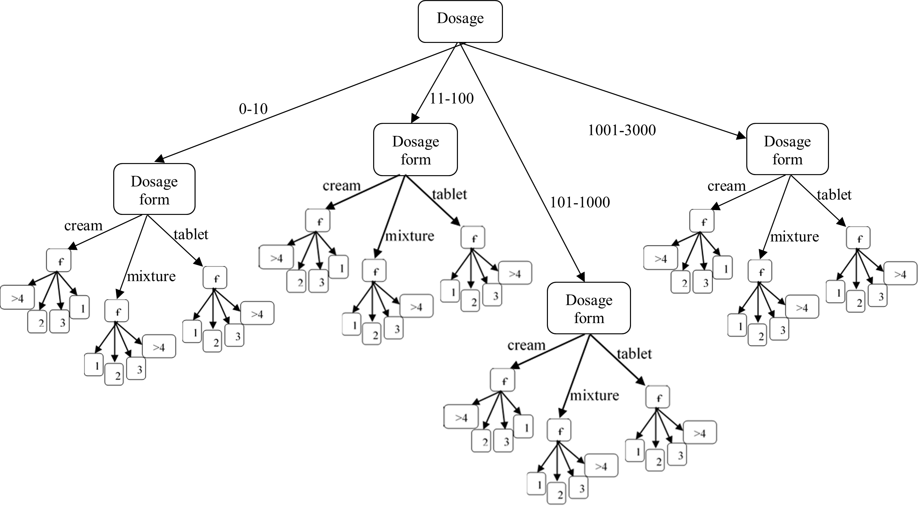f = Frequency
Figure 3-5 : Descision Tree for the dataset.
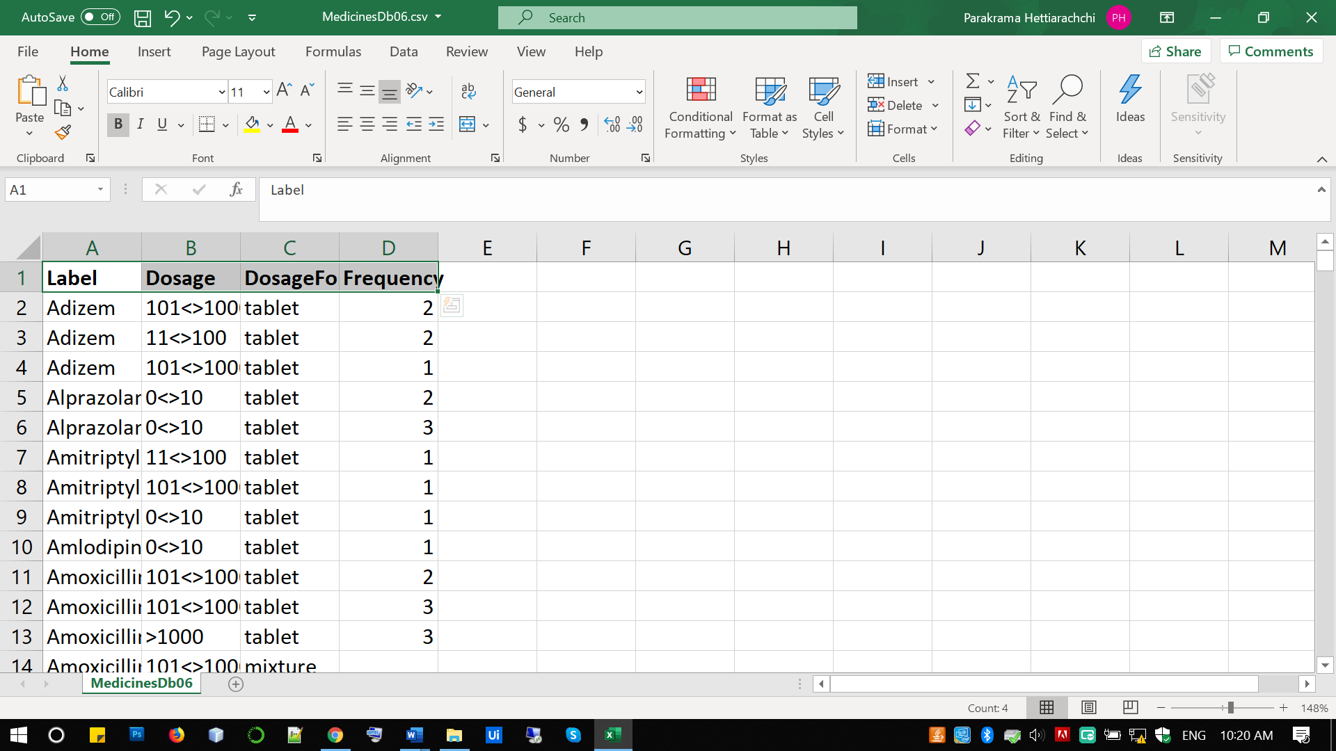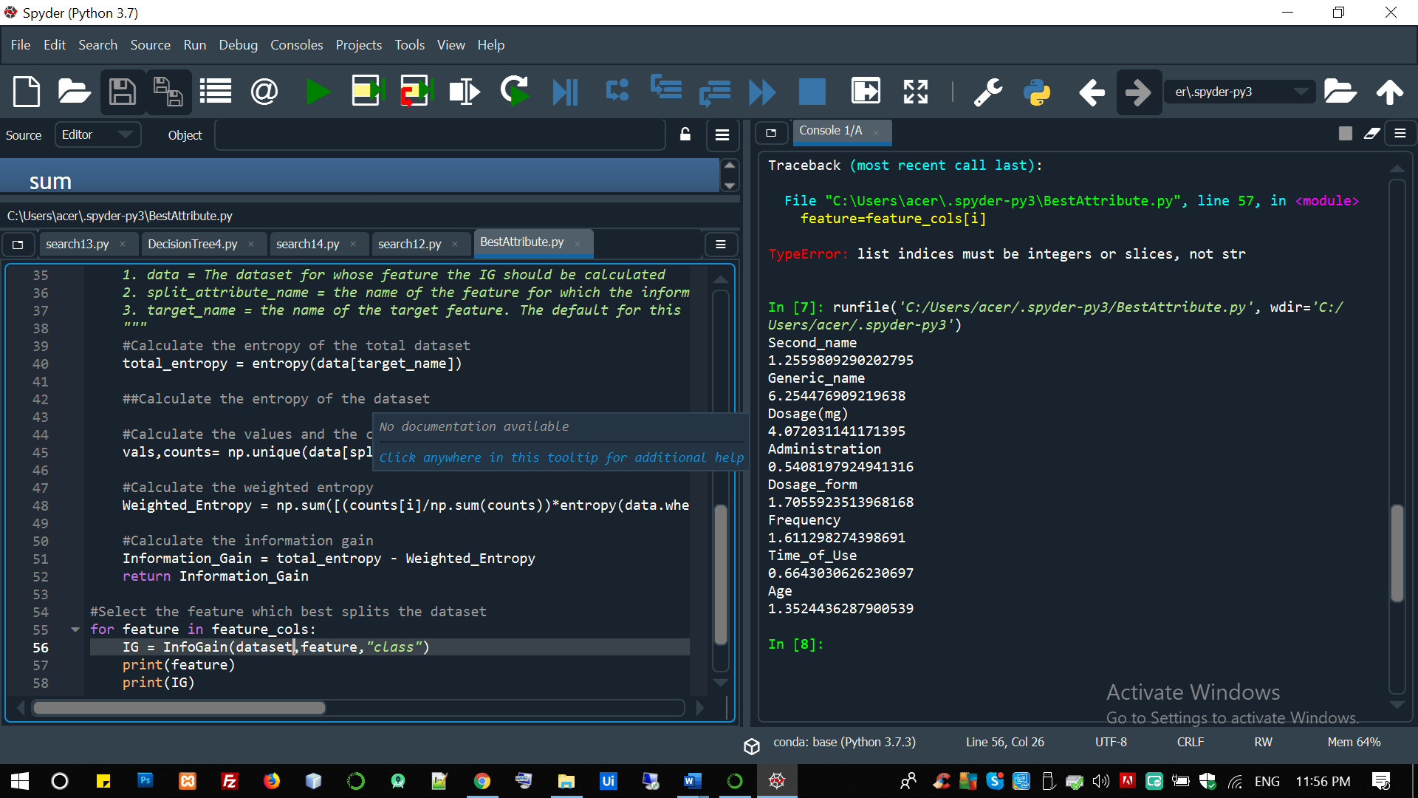
Figure 3-7: Sample image of Medicinesdb06.csv final dataset used for classification.
Figure 3-6 : Calculation of Information Gain values using Decision Tree algorithm.

Design of program
The designing tasks of the research work for developing the program and of the user application is carrid out. The comments, ideas and suggestions mentioned by users were considered in this works. The workflow for steps needed for extracting medicine name from prescription was done by studying the results of information analysis phase. The purpose was to clearly identify each step and technique in prescription reading and convert them into programmable steps arranged in order.

Algorithm
- Prompt the user for partial string of starting letters.
- Prompt the user for the ending letters string.
- Search on dataset with starting and ending letters partial strings.
- If the resulting list contain one item, then output that item, otherwise store the result in list1.
- Prompt the user for Dosage, Dosage form and Frequency.
- Check with the rule, derived from Decision Tree Algorithm.
- Store the results in the list 2.
- Match the both the lists and find the common value exisit on both lists.
- Output the common value as the predicted medicine name.

Assumptions made in this research
- It was assumed that the starting letters partial string, dose and age can be identified clearly, and those fields were treated as mandatory fields to fill.
- Assume that, program is to output one medicine name as the result or otherwise give least number of medicine names having most probability of being the correct medicine name, so that it provides suggestion for the user. This issue arises until program is upgraded for use in special scenarios mentioned in 4th and 5th facts under 3.3.2. section.
- Assume that prescriptions used for testing contain generic name of the medicines so that the dataset already contain the data of the testing medicine.
- Dataset was created with data of essential medicines list, which are the medicines most frequently used in Sri Lanka. Therefore, it is assumed that medicines included in prescriptions that are used for testing, are the essential medicines. Any brand name or generic name of a medicine not included in essential medicine list or of a new drug id considered as exception for this research’s demonstrations.
- Assume that user has the responsibility of decision making of dispensing process and program involve in extracting correct data from the prescription to assist user in decision making.

Development
The deliverables from design phase were used to drive the development while refining the code by resolving errors.

Development of program
The algorithm for extracting medicine name from prescription was coded in python programming language as it facilitates processing CSV file data. Spyder IDE of Anaconda framework was used for development of the program. Code is attached in Appendix B.
Followings are considered in the program.
- Starting letters partial string and Dosage data are mandatory.
- All attribute data of each displayed medicine name to be displayed so that user can decide which data could best suit the incomplete data in prescription.
- Remove duplicate names from selected lists of medicine names before displaying medicine names list.
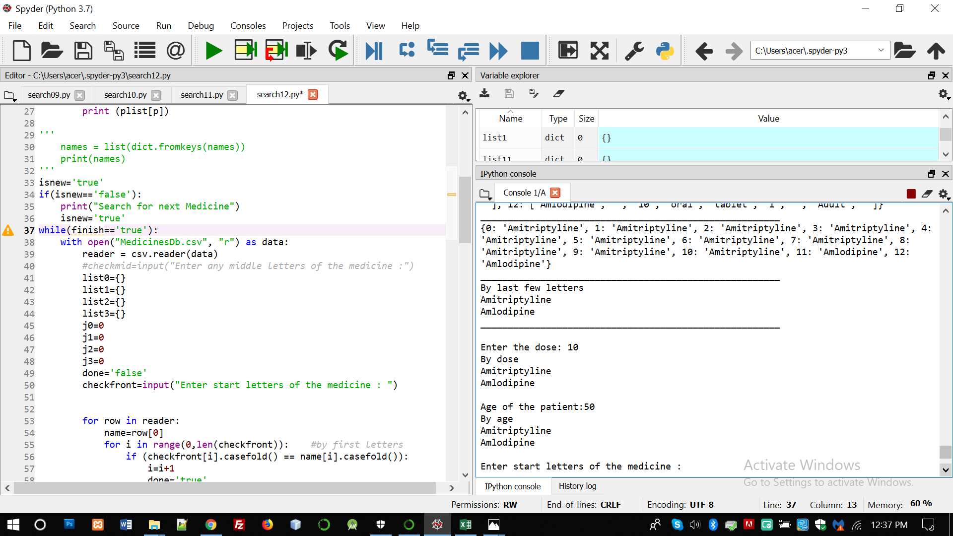
Figure 5-1 Screenshot of Spyder IDE used for program development

Development of demo user application
According to the design plans made in designing phase, user application was developed for demonstrating prescription reading program. User will have to upload image of the prescription and then it will be processed to extract data using ICR technology. In the next window, if data output by image processing is not enough, user will have to enter relevant partial strings and data that can be clearly identified from the prescription. Steps to be followed by the user are as follows.
- Uploading prescription image or proceed without uploading prescription.
- Entering partial strings and incomplete data.
- View suggestions and appropriate instructions.
- Uploading prescription image.
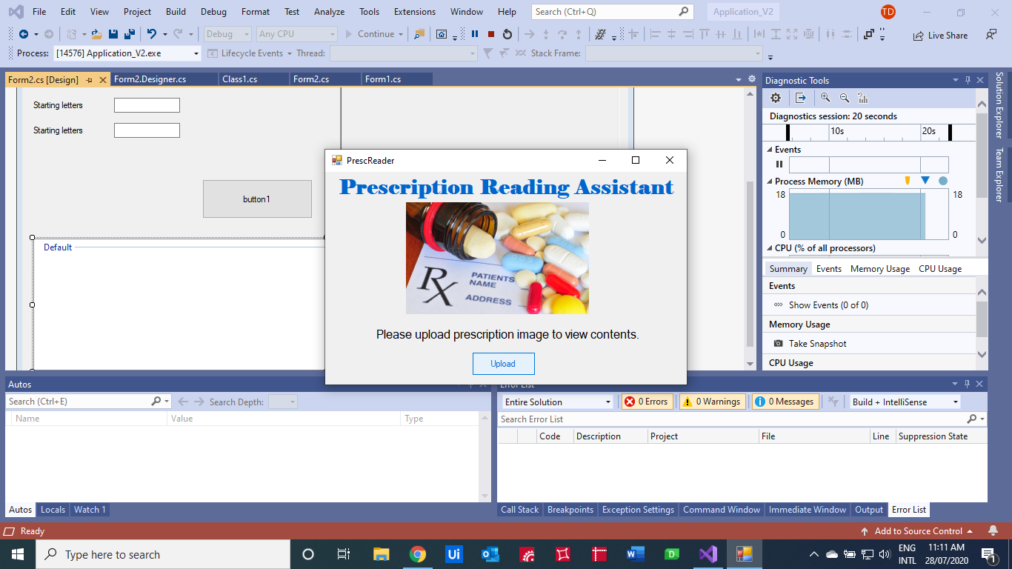Image of the prescription can be uploaded to the application and it will undergo image processing using ICR and extract possible partial strings from the image and display the results on the relevant field to make the task easy for user.
Figure 5-2 Screen one: Upload prescription image

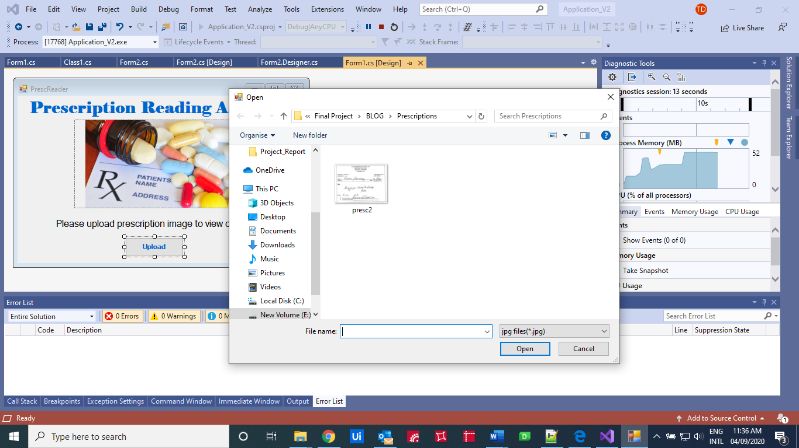
Figure 5-3 Screen 2: Select prescription image

Entering partial strings and view results
Starting letters, ending letters, dosage and other partial strings and incomplete data can be entered in the fields provided. Suggestions of medicine names and details of each suggested medicine are displayed for the user to make decision making efficient. Additional instructions that should be given for each medicine suggested are viewed so that to assist in patient counselling.
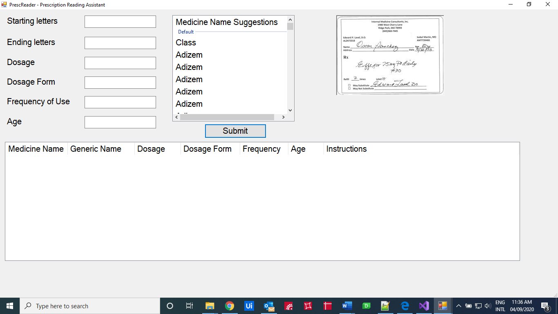
Figure 5-4 Screen 3: Starting window.

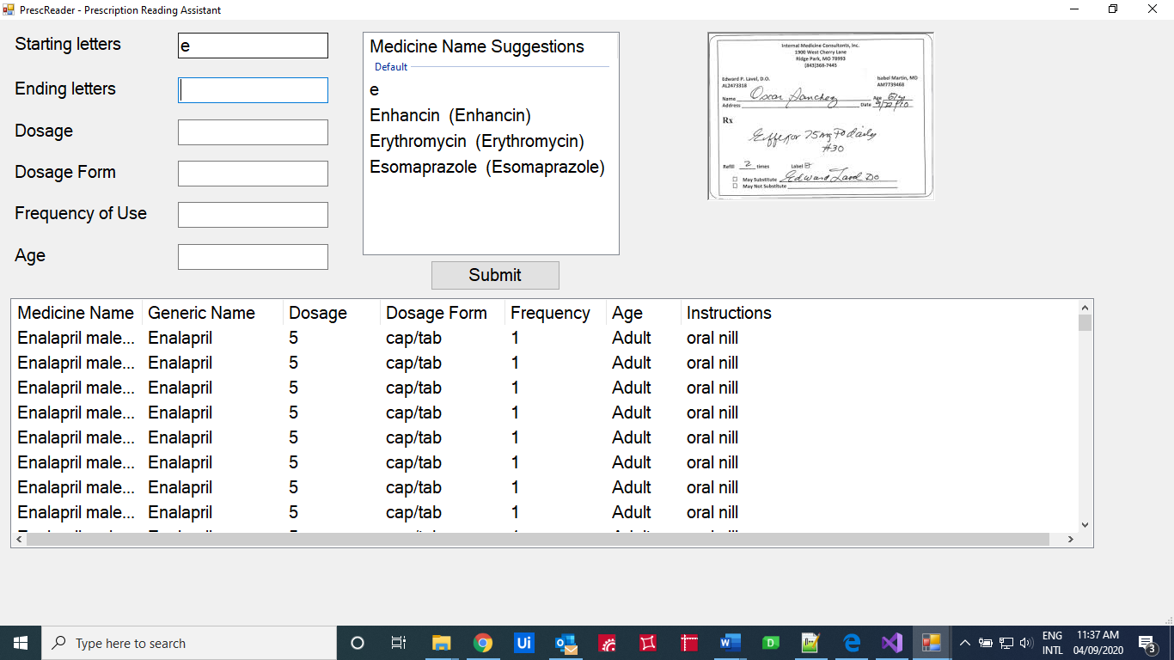
Figure 5-5 Display of results after entering starting letters.

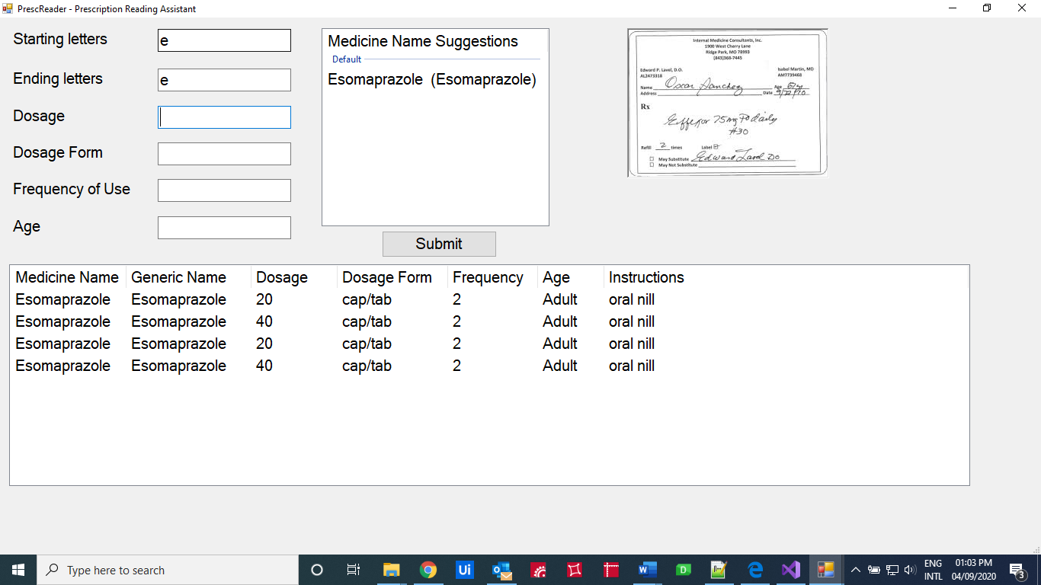
Figure 5-6 Display of results after entering last letters

Testing
The medicine names on collected prescriptions were used for testing the program and recorded the results accordingly. The developed application is tested with collected samples of prescriptions To verify the results, correct medicine names of those prescriptions are used which were already collected documented and certified by a pharmacist. The testing phase is discussed in chapter 4 in detail.

Performance evaluation
With the use of test results, the percentage accuracy of the program in developing environment was evaluated in this phase. It is discussed in detail on chapter 5.
Chapter 4

Testing
Testing related to this research are done in two aspects, for the developed program based on research purpose and for the demo application. Collected prescriptions were used for the testing of program and application both.

Functional Testing for program
Functional testing is to ensure the basic functionality of the program in the process of finding correct medicine name by matching partial strings and incomplete data inputs.

Testing for each type of data inputs.
This testing was conducted to ensure the dividing of dataset for searching data from dataset and displaying of appropriate suggestions in the process of finding correct medicine name by matching partial strings and incomplete data.

Test cases for testing each type of data inputs
Randomly selected medicines are tested for each of following types of partial strings and incomplete data.
- Starting letters
- Ending letters
- Dosage amount
- Dosage form
- Frequency of use
Table 4:4:1 Test cases and expected results
No. | Test Case | Expected result
1 | One letter for starting letters | Display all medicine names starting from input letters as suggestions.
2 | Two letters for starting letters | Display all medicine names starting from input letters out of previously suggested medicine names.
3 | Random number of letters for starting letters | Display all medicine names starting from input letters out of previously suggested medicine names.
4 | One letter for ending letters | Display all medicine names ending from input letters out of previously suggested medicine names.
5 | Two letters for ending letters | Display all medicine names ending from input letters out of previously suggested medicine names.
6 | Random number of letters for ending letters | Display all medicine names ending from input letters out of corresponding suggestions.
7 | Empty input for ending letters | Display previously suggested medicine names.
8 | Dosage of one of medicines suggested, so that more than two medicines have same dosage. | Display medicines containing input dosage out of previously suggested medicine names.
9 | Dosage of one of medicines suggested, so that more than two medicines have same dosage. | Display medicines containing input dosage out of previously suggested medicine names.
10 | Dosage form of one of medicines suggested. | Display medicines containing input dosage forms out of previously suggested medicine names.
11 | Frequency of one of medicines suggested. | Display medicines containing input dosage forms out of previously suggested medicine names.

Testing for sample prescriptions
The goal of testing program with sample prescriptions is to ensure that the program performs as per the expected requirements of reading medicine names in unclear handwriting in prescriptions. 50 Medicine names mentioned on collected 13 sample prescriptions were used for this testing and recorded the results accordingly. To verify the accuracy of results, correct medicine names of those prescriptions were used, which were already documented and certified by a pharmacist currently employed in a government hospital pharmacy. Sample prescription images and corresponding test results are documented appropriately.

Testing for Demo Application
Developed application was tested with collected samples of prescriptions while documenting the results. Functional testing was conducted against the same test cases created for functional testing of the program shown in Table 10.1.

Chapter 5

Performance Evaluation

Introduction
With the use of test results of testing for sample prescriptions, percentage accuracy of the program in developing environment was evaluated. Some of the observed results were from exception scenarios that were considered as limits of this research which were mentioned under assumptions (Section 8.6) and those results were not counted for calculating percentage accuracy of the program.

Percentage Accuracy
Out of 50 medicines that were mentioned in 13 prescriptions, 36 medicine names were suggested correctly by the program. Therefore, the percentage of the accuracy provided by this program can be mentioned as 77% for the collected samples of prescriptions under the stated assumptions.

Chapter 12

Conclusion
A simple UI tool is developed to experiment the results of predicting medicine names. The tool is predicting the medicine name correctly and the evaluation resulted that the Decision Tree Classifier for multi class is predicting 72% accurately.
Chapter 13

Future Work

Expected Further developments
- Expand and update the dataset to include all the medicines used in Sri Lanka.
- Include additional techniques and procedures for exception scenarios considered in assumptions.
- Develop a mobile application based on this research idea for commercial use.
- Combine with OCR technology to capture partial strings of medicine names.

List of References
- Shugufta Fatima, Dr. B. Srinivasu, Volume 4 Issue 2, February 2015. “Text Document categorization using support vector machine”. International Journal of Advanced Research in Computer Engineering & Technology (IJARCET)

- Mukesh A. Zaveri and Mita K. Dalal, August 2011 “Automatic Text Classification: A Technical Review”, International Journal of Computer Applications (0975 – 8887), Volume 28– No.2.

- Dr.E.Kamalanaba1, M.Gopinath, S.Premkumar, 2018. “Medicine Box: Doctor’s Prescription Recognition Using Deep Machine Learning”, International Journal of Engineering & Technology, 7 (3.34) (2018) 114-117, pp. 114-117.

- Royal Pharmaceutical Society, UK, March – September 2017. The British National Formulary (BNF). Edition 73. BMJ Group & Pharmaceutical Press of Royal Pharmaceutical Society, UK.

- Ministry of healthcare & nutrition, Sri Lanka, National List of Essential Medicines Sri Lanka (EML), fourth revision, report of the expert committee on essential medicines, 2009.

- University of Colombo, Dept. of Pharmocology; Ministry of health, nutrition and indigenous medicine, Sri Lanka, 2018, Sri Lanka student formulary (SLSF) 2018, second edition.

- Python Machine Learning Tutorial, link: https://www.python-course.eu/Decision_Trees.php

