Showing firing pattern, with 3 GreenPlayers

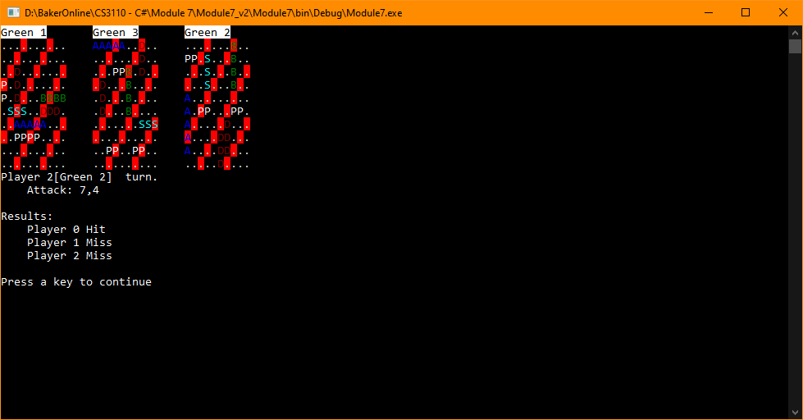

Only 2 Players, try firing pattern until a hit is recorded.

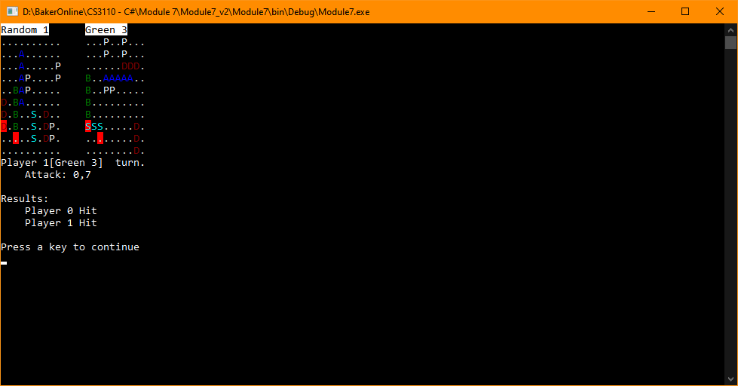

Check around hit to find ship

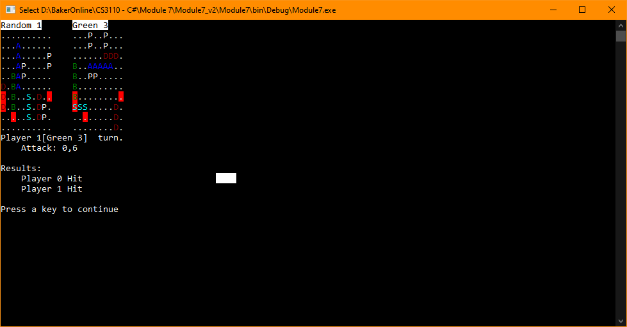

Second hit achieved, keep checking around initial hit

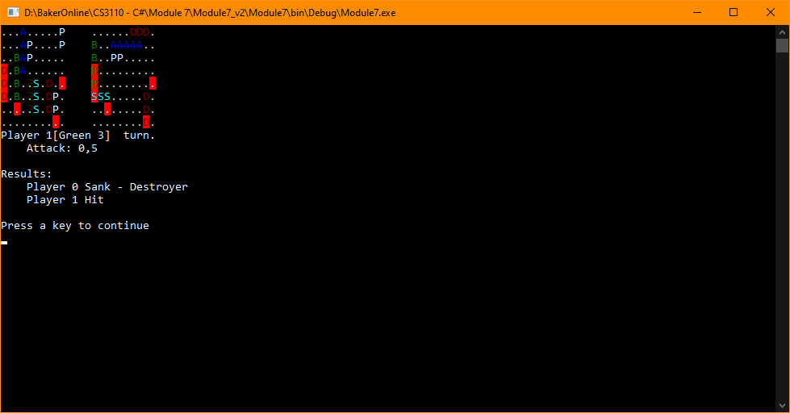

Green Player Wins

