03 – Project Design
Client Script & UI Policy in ServiceNow Incident Management
Technology Track | ServiceNow Administrator
Module | Incident Management
Design Components | Incident Form, Client Script, UI Policy

System Design
The system design describes how the ServiceNow Incident form interacts with configured Client Script and UI Policy logic. When a user opens or changes values in the Incident form, the configured conditions are evaluated and the relevant field behaviour is applied.
Layer | Component | Purpose
User Layer | ServiceNow User | Opens and works with the Incident form.
Form Layer | Incident Form | Provides Incident fields and user input.
Logic Layer | Client Script | Provides client-side behaviour based on configured events and conditions.
Logic Layer | UI Policy | Controls field properties based on configured conditions.
Output Layer | Updated Incident Form | Displays the resulting dynamic field behaviour.

Workflow Design
The workflow follows the sequence: User opens the Incident form → selects or changes a field value → configured condition is checked → Client Script and/or UI Policy applies the configured behaviour → Incident form is updated.
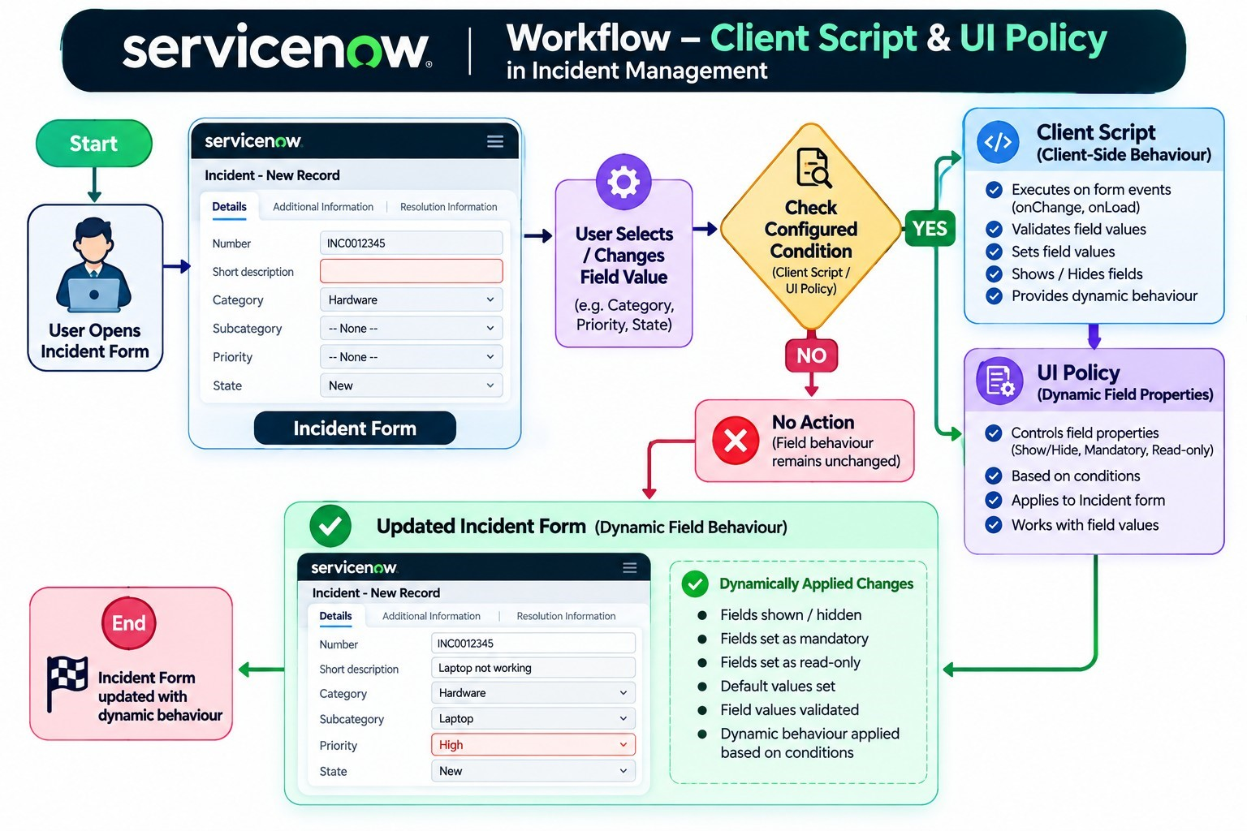
Figure 1: Workflow showing the condition-based flow from the Incident form to Client Script/UI Policy and the updated form.

UI Design
The UI design represents the Incident form in different states to demonstrate how field behaviour changes according to the configured conditions.
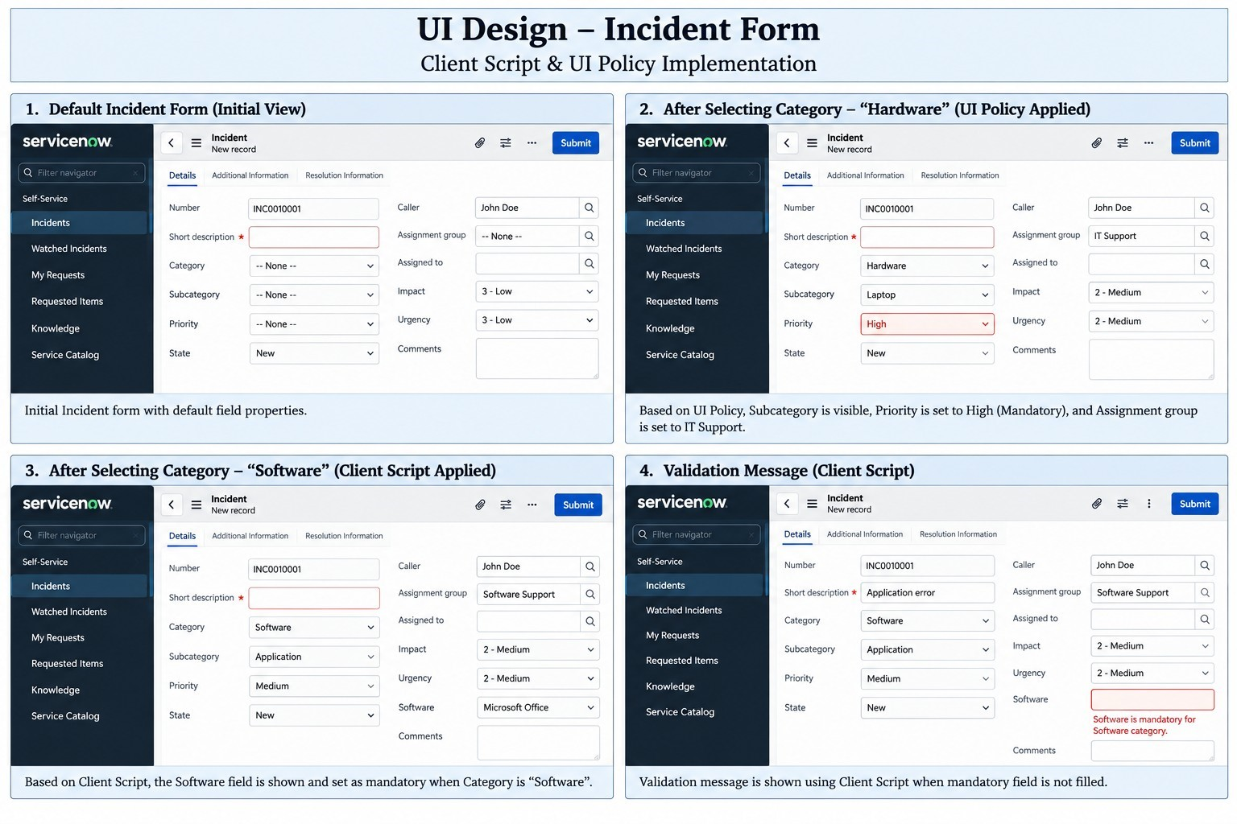
Figure 2: UI design showing the default Incident form, condition-based field changes, and validation behaviour.

Client Script Design
- The Client Script is designed to provide client-side behaviour on the Incident form.
- It can respond to configured form events or field changes.
- The design supports condition-based field behaviour such as showing, hiding, setting values, or validatingfields, according to the implemented project configuration.

UI Policy Design
- The UI Policy is designed to dynamically control field properties on the Incident form.
- The policy is applied when its configured condition is satisfied.
- UI Policy Actions are used to control the relevant field properties according to the project configuration.

Designed User Flow
Step | User / System Action | Result
1 | User opens Incident form | Initial Incident form is displayed.
2 | User selects or changes a field value | Configured condition is evaluated.
3 | Condition is satisfied | Client Script / UI Policy behaviour is applied.
4 | Field properties are updated | Relevant fields change according to configuration.
5 | User continues with the form | Updated Incident form is available for further action.

Team Members
Role | Name
Team Leader | M Thillai
Member | S Vasanthkani
Member | R Vignesh

Design Outcome
The project design provides a clear structure for implementing condition-based dynamic behaviour in the ServiceNow Incident form using Client Script and UI Policy.

