The puzzle consists of three hexagons as shown in the figure. Each vertex is painted black or white. Some of them belong to just one hexagon and some of them belong to more than one. Exactly four of them are painted black, and the other nine are white. The goal is to make the shared vertexes black by means of allowed moves: rotating a hexagon 60 degrees clockwise or counter-clockwise.

Input
Input starts with an integer T, the number of puzzles to solve (1<=T<=100). T lines follow, each one having 13 binary digits, corresponding to the top-down, left to right labeling of the vertexes in the puzzle. A '0' means the i-th vertex is painted white, while a '1' means it is painted black.

Output
For each test case output M on a single line, the minimum number of moves required to solve the puzzle. Then print M lines, each one describing a move in the following manner: two space separated integers H and C, the rotated hexagon (upper left is 0, upper right is 1, lower one is 2) and the direction (0 for counter-clockwise, 1 for clockwise).
If there is more than one solution, any will suffice.

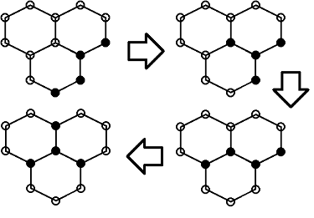

Input:
1
0000000101011
Output:
3
2 0
2 0
1 1

