Introduction

HTML, CSS JavaScript and PHP are used as programming languages to develop this web site.

PhpMyAdmin was used to operate MySQL from a web browser. Whereas HTML creates the structure of a sentence, CSS is a "language that specifies how the sentence is displayed in the browser", so it is used as a set with HTML.

From this, CSS is a language that separates the roles of "structure" and "design."

The site was developed based on Alice in Wonderland as a design. It is a site with many black, purple and dark orange. CSS is often used here.

Wireframe

Character

Name of the park

Logo

Home

Water Slides

Login

Logout

Multi-Level Play Structure

Toddler Pools

Water Basketball

Picture of the Theme park

First Page

Login

Water Basketball

Logo

Water Slides

Logo

Toddler Pools

Logo

Multi-Level Play Structure

Logo

Character

Calendar

Login details

Login details

discounts for loyalty customer

best package plans

Seasonal offers

Login details

Login page

(Homepage wireframe)

Information can be viewed from this web site without the user login. If the user wants to login, they can login from the login button above. If the user does not have a login account, they can go to the sign-in page from login page. When the user sign in, they will be taken to the login page again and login from there. When sign in occurs, the name and password are stored in a table in the MySQL database. The Logo on the upper left is the Wonderland Theme Park Logo. The design of this Logo was created with reference to the logos of other theme parks.

There is a character in the upper right figure. The official name of this theme park is in the center of the top. Lighter colors were used for the letter to make them stand out. Below these are seven buttons. The rightmost button is a menu that indicates that you are on the current page. Therefore, pressing this button will just take you to the page you are on. This button is dark orange. User can go to the attraction page from the following four buttons. These pages contain detailed information about attractions. The remaining two buttons ate login and logout. Simply press the login button if the user wants to login, or logout button if they want to logout.

This website is developed with reference to the official website of Tokyo Disney Land. For this reason, photo centered around the Multi-Level Play Structure, which is a symbol of this theme park was posted. In order to impress the user with the photo, we have taken a wide range of place to put it.

The following is a list of activities you can experience at this theme park. A logo was designed for each activity. There are 4 activities in total, and you can go to each activity page. These pages lead to the same page as the four buttons above. The reason for designing this way is that adult users can easily judge by letters, but child users can easily judge by a cute logo rather than letters.

Below these is a calendar surrounded by a blue line. The theme park is open daily, but represents a holiday in an emergency. Today’s box turns blue. HTML, CSS and JavaScript are used to create this calendar. A thin purple line is drawn under the calendar. Below that is the fun bay package. There are three packages here, all of which are linked to “reservation.php”.

“reservation.php” is connected to the database, and the name, email, phone number and package name are recorded.

Water basketball wireframe

Logout

Multi-Level Play Structure

Logo

Toddler Pools

Logo

Water Slides

Logo

Water Basketball

Logo

Multi-Level Play Structure

Toddler Pools

Water Slides

Water Basketball

Login

Character

Logo

Home

Login

Name of the park

Picture of the Water Basketball

Login details

Details about Water Basketball

Login details

Character

Calendar

Similar to the previous homepage, but without the package part. This page contains information about the activity. Users can go to this page from home page. Other activity pages like water slides, toddler pools and multi-level play structure pages are similar to this water basket page. Only picture, title and information are different.

Water Slides wireframe

Picture of the Water Slides

Login

Home

Login details

Logo

Character

Name of the park

Login

Water Basketball

Water Slides

Toddler Pools

Multi-Level Play Structure

Water Basketball

Logo

Water Slides

Logo

Toddler Pools

Logo

Multi-Level Play Structure

Logo

Character

Calendar

Logout

Login details

Details about Water Slides

Name of the park

Details about Water Toddler Pools

Login details

Logout

Calendar

Character

Toddler Pools

Logo

Water Slides

Logo

Water Basketball

Logo

Multi-Level Play Structure

Toddler Pools

Water Slides

Water Basketball

Login

Character

Logo

Login details

Home

Login

Picture of the Toddler Pools

Multi-Level Play Structure

Logo

Picture of the Water Multi-level play structure

Login

Home

Login details

Logo

Character

Name of the park

Login

Water Basketball

Water Slides

Toddler Pools

Multi-Level Play Structure

Water Basketball

Logo

Water Slides

Logo

Toddler Pools

Logo

Multi-Level Play Structure

Logo

Character

Calendar

Logout

Login details

Details about Multi-level play structure

Login form

Login form

Sign in form

Sign in form

Reservation form

Reservation form

Sitemap

Sitemap

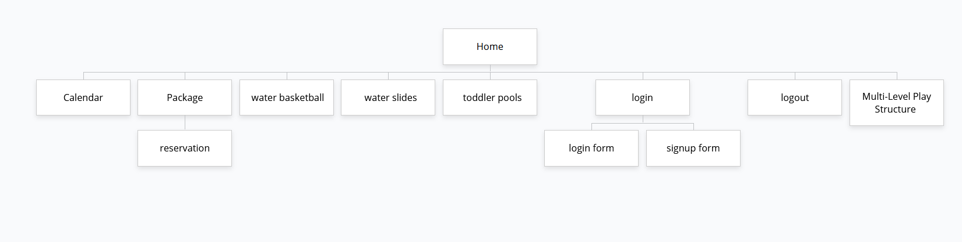

This is the sitemap of the developed site. There is a home page at the beginning. From there, it is divided into eight parts. Frist there is a calendar. Then there is the package. From there you can go to the reservation form. Everything written on the reservation form is stored in MySQL. The following water basketball, water slides, toddler pools and Multi-Level Play Structure. Form these pages us can get information about the activity.