HTML Form Controls and Methods

# A. Creating Two Different Forms Using GET and POST Methods

## 1. Form Using the GET Method

The GET method sends form data as part of the URL. It's useful for non-sensitive data such as search queries but has limitations in terms of data size and security. The data is visible in the URL, which can be accessed by anyone(W3Schools, n.d.).

Example Code:

<!DOCTYPE html>

<html lang="en">

<head>

    <meta charset="UTF-8">

    <meta name="viewport" content="width=device-width, initial-scale=1.0">

    <title>GET Method Form</title>

    <style>

        body {

            font-family: Arial, sans-serif;

            background-color: #f4f4f4;

            margin: 0;

            padding: 20px;

        }

        header, footer {

            background-color: #007BFF;

            color: white;

            text-align: center;

            padding: 10px 0;

        }

        h2 {

            color: #333;

        }

        form {

            background-color: #fff;

            padding: 20px;

            border-radius: 8px;

            box-shadow: 0 4px 6px rgba(0, 0, 0, 0.1);

            max-width: 500px;

            margin: 20px auto;

        }

        label {

            font-weight: bold;

            display: block;

            margin-bottom: 8px;

        }

        input[type="text"], input[type="email"] {

            width: 100%;

            padding: 10px;

            margin-bottom: 15px;

            border: 1px solid #ccc;

            border-radius: 4px;

        }

        input[type="submit"] {

            background-color: #007BFF;

            color: white;

            border: none;

            padding: 12px 20px;

            font-size: 16px;

            border-radius: 4px;

            cursor: pointer;

        }

        input[type="submit"]:hover {

            background-color: #0056b3;

        }

    </style>

</head>

<body>

<header>

    <h1>Welcome to the GET Method Form</h1>

</header>

<main>

    <h2>Please fill out the form below:</h2>

    <form action="get_form_output.php" method="GET">

        <div>

            <label for="name">Name:</label>

            <input type="text" id="name" name="name" placeholder="Enter your full name" required>

        </div>

        <div>

            <label for="email">Email:</label>

            <input type="email" id="email" name="email" placeholder="Enter your email address" required>

        </div>

        <div>

            <input type="submit" value="Submit">

        </div>

    </form>

</main>

<footer>

    <p>&copy; 2024 My Website. All rights reserved.</p>

</footer>

</body>

</html>

The output should look like this: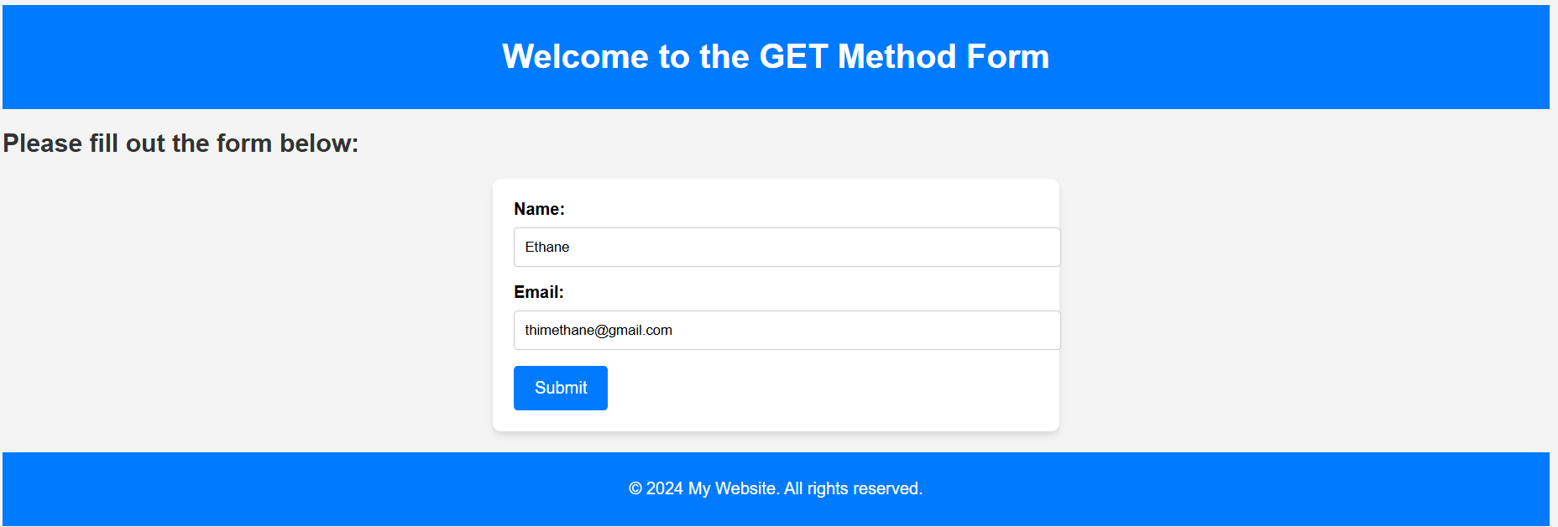



## 2. Form Using the POST Method

The POST method sends form data as part of the HTTP request body. This method is more secure and allows for larger amounts of data. Unlike GET, the data is not visible in the URL, making it more suitable for sensitive information(W3Schools, n.d.).

Example Code:

<!DOCTYPE html>

<html lang="en">

<head>

    <meta charset="UTF-8">

    <meta name="viewport" content="width=device-width, initial-scale=1.0">

    <title>POST Method Form</title>

    <style>

        body {

            font-family: Arial, sans-serif;

            background-color: #f4f4f4;

            margin: 0;

            padding: 20px;

        }

        header, footer {

            background-color: #007BFF;

            color: white;

            text-align: center;

            padding: 10px 0;

        }

        h2 {

            color: #333;

        }

        form {

            background-color: #fff;

            padding: 20px;

            border-radius: 8px;

            box-shadow: 0 4px 6px rgba(0, 0, 0, 0.1);

            max-width: 500px;

            margin: 20px auto;

        }

        label {

            font-weight: bold;

            display: block;

            margin-bottom: 8px;

        }

        input[type="text"], input[type="email"] {

            width: 100%;

            padding: 10px;

            margin-bottom: 15px;

            border: 1px solid #ccc;

            border-radius: 4px;

        }

        input[type="submit"] {

            background-color: #007BFF;

            color: white;

            border: none;

            padding: 12px 20px;

            font-size: 16px;

            border-radius: 4px;

            cursor: pointer;

        }

        input[type="submit"]:hover {

            background-color: #0056b3;

        }

    </style>

</head>

<body>

<header>

    <h1>Welcome to the POST Method Form</h1>

</header>

<main>

    <h2>Please fill out the form below:</h2>

    <form action="post_form_output.php" method="POST">

        <div>

            <label for="name">Name:</label>

            <input type="text" id="name" name="name" placeholder="Enter your full name" required>

        </div>

        <div>

            <label for="email">Email:</label>

            <input type="email" id="email" name="email" placeholder="Enter your email address" required>

        </div>

        <div>

            <input type="submit" value="Submit">

        </div>

    </form>

</main>

<footer>

    <p>&copy; 2024 My Website. All rights reserved.</p>

</footer>

</body>

</html>

The output should look like this: “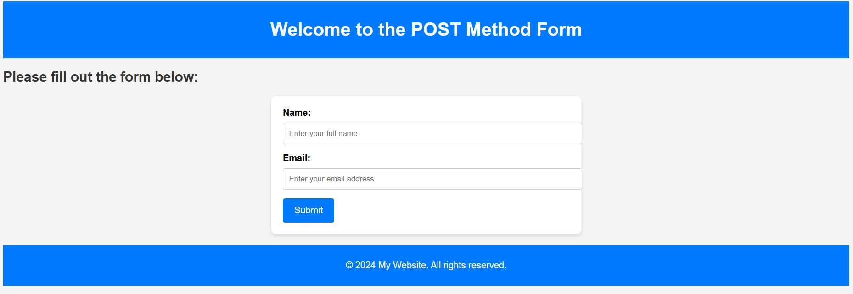

”

## Differences in Outputs from GET and POST Methods

GET Method: Data is appended to the URL, visible in the browser’s address bar. It is suitable for simple queries, like search inputs (W3Schools, n.d.).

POST Method: Data is sent in the request body, not visible in the address bar. It is more secure and allows for sending large amounts of data, suitable for form submissions like login and registration (W3Schools, n.d.).

# B. Choosing the Best Form Control Elements

## 1. Choose Your Marital Status: Single, Married, Widow, Prefer Not to Say

Form Control: <select> with <option>  
Reason: The <select> element is ideal for choosing from a set of predefined options. It’s easy to use when there are multiple options to choose from (W3Schools, n.d.).

Sample Code:

<!DOCTYPE html>

<html lang="en">

<head>

    <meta charset="UTF-8">

    <meta name="viewport" content="width=device-width, initial-scale=1.0">

    <title>Marital Status Form</title>

    <style>

        body {

            font-family: Arial, sans-serif;

            background-color: #f4f4f4;

            margin: 0;

            padding: 20px;

        }

        header, footer {

            background-color: #007BFF;

            color: white;

            text-align: center;

            padding: 10px 0;

        }

        h2 {

            color: #333;

        }

        form {

            background-color: #fff;

            padding: 20px;

            border-radius: 8px;

            box-shadow: 0 4px 6px rgba(0, 0, 0, 0.1);

            max-width: 500px;

            margin: 20px auto;

        }

        label {

            font-weight: bold;

            display: block;

            margin-bottom: 8px;

        }

        select {

            width: 100%;

            padding: 10px;

            margin-bottom: 15px;

            border: 1px solid #ccc;

            border-radius: 4px;

            background-color: #fff;

            font-size: 16px;

        }

        input[type="submit"] {

            background-color: #007BFF;

            color: white;

            border: none;

            padding: 12px 20px;

            font-size: 16px;

            border-radius: 4px;

            cursor: pointer;

        }

        input[type="submit"]:hover {

            background-color: #0056b3;

        }

    </style>

</head>

<body>

<header>

    <h1>Marital Status Form</h1>

</header>

<main>

    <h2>Please select your marital status:</h2>

    <form action="submit_marital_status.php" method="POST">

        <div>

            <label for="marital-status">Marital Status:</label>

            <select id="marital-status" name="marital-status" required>

                <option value="" disabled selected>Select your marital status</option>

                <option value="single">Single</option>

                <option value="married">Married</option>

                <option value="widow">Widow</option>

                <option value="prefer-not-to-say">Prefer Not to Say</option>

            </select>

        </div>

        <div>

            <input type="submit" value="Submit">

        </div>

    </form>

</main>

<footer>

    <p>&copy; 2024 My Website. All rights reserved.</p>

</footer>

</body>

</html>

The output should look like this:

## 2. Indicate Whether You Have a Medical History of Diabetes (Yes or No)

Form Control: <input type="radio">  
Reason: A radio button is appropriate for selecting between two options (Yes or No) and ensures only one option can be selected (W3Schools, n.d.).

Sample Code:

<!DOCTYPE html>

<html lang="en">

<head>

    <meta charset="UTF-8">

    <meta name="viewport" content="width=device-width, initial-scale=1.0">

    <title>Medical History Form</title>

    <style>

        body {

            font-family: Arial, sans-serif;

            background-color: #f4f4f4;

            margin: 0;

            padding: 20px;

        }

        header, footer {

            background-color: #007BFF;

            color: white;

            text-align: center;

            padding: 10px 0;

        }

        h2 {

            color: #333;

        }

        form {

            background-color: #fff;

            padding: 20px;

            border-radius: 8px;

            box-shadow: 0 4px 6px rgba(0, 0, 0, 0.1);

            max-width: 500px;

            margin: 20px auto;

        }

        label {

            font-weight: bold;

            margin-right: 10px;

        }

        .radio-group {

            margin-bottom: 15px;

        }

        input[type="radio"] {

            margin-right: 10px;

        }

        input[type="submit"] {

            background-color: #007BFF;

            color: white;

            border: none;

            padding: 12px 20px;

            font-size: 16px;

            border-radius: 4px;

            cursor: pointer;

        }

        input[type="submit"]:hover {

            background-color: #0056b3;

        }

    </style>

</head>

<body>

<header>

    <h1>Medical History Form</h1>

</header>

<main>

    <h2>Do you have a medical history of diabetes?</h2>

    <form action="submit_medical_history.php" method="POST">

        <div class="radio-group">

            <input type="radio" id="yes" name="diabetes" value="yes" required>

            <label for="yes">Yes</label>

            <input type="radio" id="no" name="diabetes" value="no" required>

            <label for="no">No</label>

        </div>

        <div>

            <input type="submit" value="Submit">

        </div>

    </form>

</main>

<footer>

    <p>&copy; 2024 My Website. All rights reserved.</p>

</footer>

</body>

</html>

The output should like this:

## 3. Write Feedback for a Food Delivery Service

Form Control: <textarea>  
Reason: A <textarea> allows the user to input multi-line text, making it suitable for feedback or comments (W3Schools, n.d.).

Sample Code:

<!DOCTYPE html>

<html lang="en">

<head>

    <meta charset="UTF-8">

    <meta name="viewport" content="width=device-width, initial-scale=1.0">

    <title>Feedback Form</title>

    <style>

        body {

            font-family: Arial, sans-serif;

            background-color: #f4f4f4;

            margin: 0;

            padding: 20px;

        }

        header, footer {

            background-color: #007BFF;

            color: white;

            text-align: center;

            padding: 10px 0;

        }

        h2 {

            color: #333;

        }

        form {

            background-color: #fff;

            padding: 20px;

            border-radius: 8px;

            box-shadow: 0 4px 6px rgba(0, 0, 0, 0.1);

            max-width: 500px;

            margin: 20px auto;

        }

        label {

            font-weight: bold;

            margin-right: 10px;

        }

        textarea {

            width: 100%;

            padding: 10px;

            border: 1px solid #ccc;

            border-radius: 4px;

            resize: vertical;

            font-size: 14px;

        }

        input[type="submit"] {

            background-color: #007BFF;

            color: white;

            border: none;

            padding: 12px 20px;

            font-size: 16px;

            border-radius: 4px;

            cursor: pointer;

        }

        input[type="submit"]:hover {

            background-color: #0056b3;

        }

    </style>

</head>

<body>

<header>

    <h1>Feedback Form</h1>

</header>

<main>

    <h2>Write your feedback below:</h2>

    <form action="submit_feedback.php" method="POST">

        <div>

            <label for="feedback">Feedback:</label><br>

            <textarea id="feedback" name="feedback" rows="4" cols="50" placeholder="Write your feedback here..." required></textarea>

        </div>

        <div>

            <input type="submit" value="Submit Feedback">

        </div>

    </form>

</main>

<footer>

    <p>&copy; 2024 My Website. All rights reserved.</p>

</footer>

</body>

</html>

The output should look like this:

## 4. Select Your Favorite Sport from a List of Eight Sports

Form Control: <select> with <option>  
Reason: The <select> dropdown is appropriate when there are multiple options (sports) to choose from. It saves space and presents the options clearly (W3Schools, n.d.).

Sample Code:

<!DOCTYPE html>

<html lang="en">

<head>

    <meta charset="UTF-8">

    <meta name="viewport" content="width=device-width, initial-scale=1.0">

    <title>Favorite Sport Selection</title>

    <style>

        body {

            font-family: Arial, sans-serif;

            background-color: #f4f4f4;

            margin: 0;

            padding: 20px;

        }

        header, footer {

            background-color: #007BFF;

            color: white;

            text-align: center;

            padding: 10px 0;

        }

        h2 {

            color: #333;

        }

        form {

            background-color: #fff;

            padding: 20px;

            border-radius: 8px;

            box-shadow: 0 4px 6px rgba(0, 0, 0, 0.1);

            max-width: 500px;

            margin: 20px auto;

        }

        label {

            font-weight: bold;

            margin-right: 10px;

        }

        select {

            width: 100%;

            padding: 10px;

            border: 1px solid #ccc;

            border-radius: 4px;

            font-size: 14px;

        }

        input[type="submit"] {

            background-color: #007BFF;

            color: white;

            border: none;

            padding: 12px 20px;

            font-size: 16px;

            border-radius: 4px;

            cursor: pointer;

        }

        input[type="submit"]:hover {

            background-color: #0056b3;

        }

    </style>

</head>

<body>

<header>

    <h1>Favorite Sport Selection</h1>

</header>

<main>

    <h2>Select your favorite sport from the list:</h2>

    <form action="submit_sport.php" method="POST">

        <div>

            <label for="sport">Favorite Sport:</label><br>

            <select id="sport" name="sport" required>

                <option value="soccer">Soccer</option>

                <option value="basketball">Basketball</option>

                <option value="baseball">Baseball</option>

                <option value="tennis">Tennis</option>

                <option value="rugby">Rugby</option>

                <option value="cricket">Cricket</option>

                <option value="hockey">Hockey</option>

                <option value="volleyball">Volleyball</option>

            </select>

        </div>

        <div>

            <input type="submit" value="Submit Sport">

        </div>

    </form>

</main>

<footer>

    <p>&copy; 2024 My Website. All rights reserved.</p>

</footer>

</body>

</html>

Here’s the screenshot of the output:

# References

* W3Schools. (n.d.). HTML Tutorial. https://www.w3schools.com/html/default.asp