Create Pem file in Ec2 Instance:

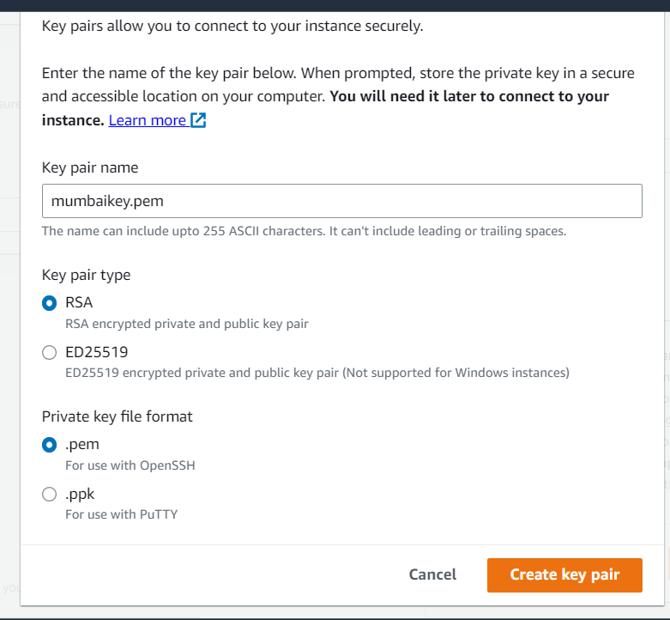

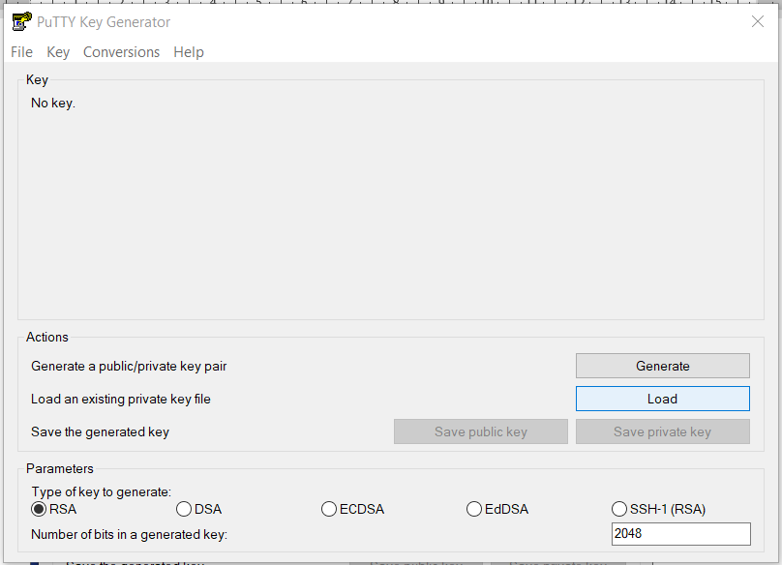Step1: Start--? Open🡪 putty gen & Click Load:

And after check the path of the pem file like below image

Select All files:

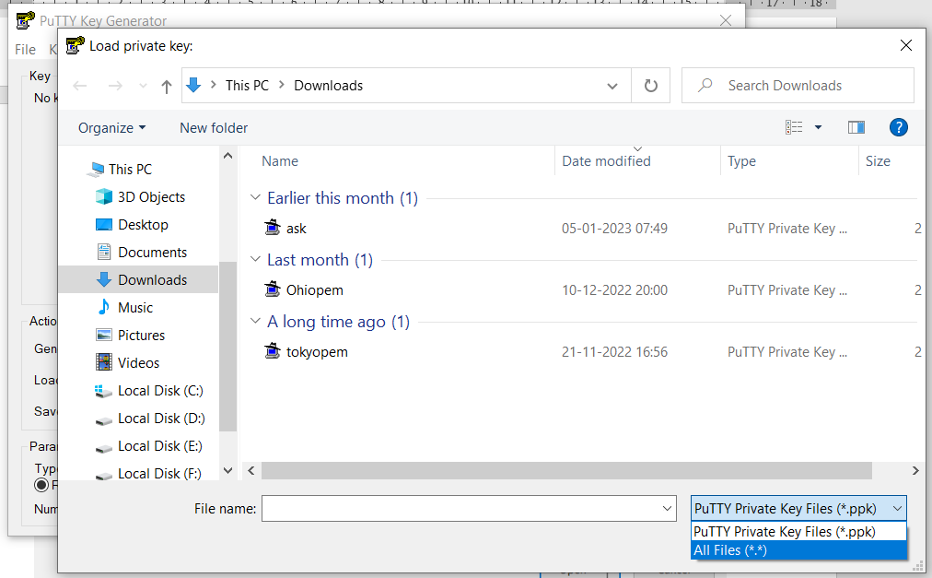

Select what did you create in EC2: & Open:

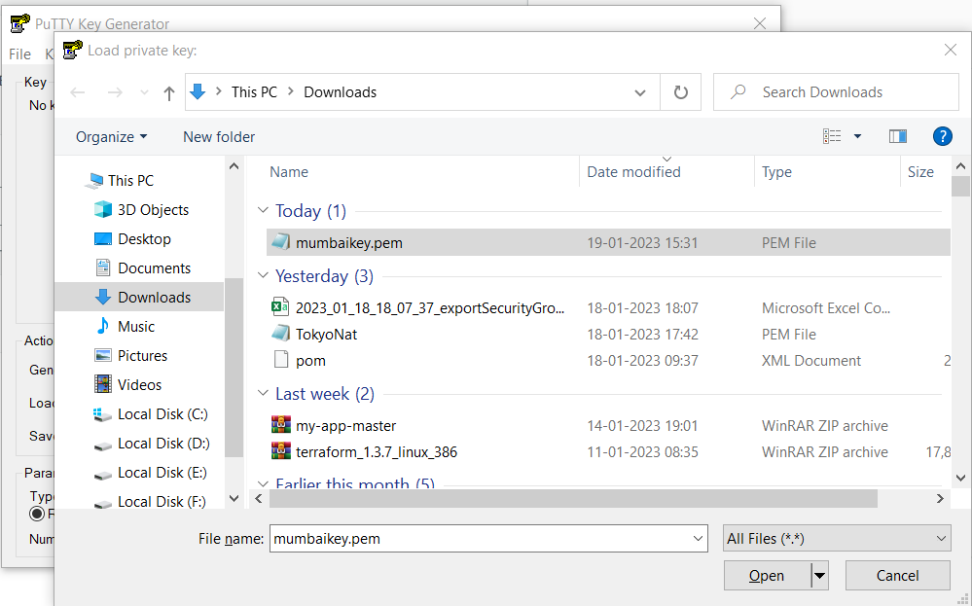

Click on Save Private Key:

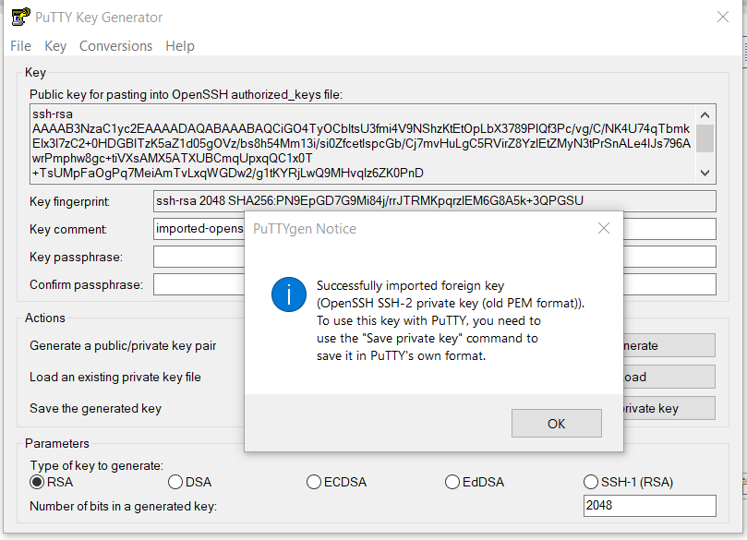

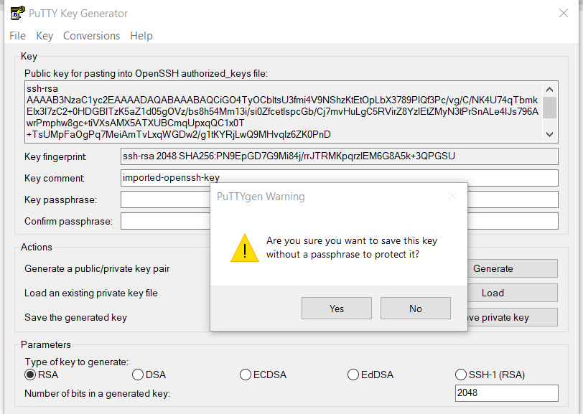

Remove ‘pem’ and type ‘ppk’ & Save.

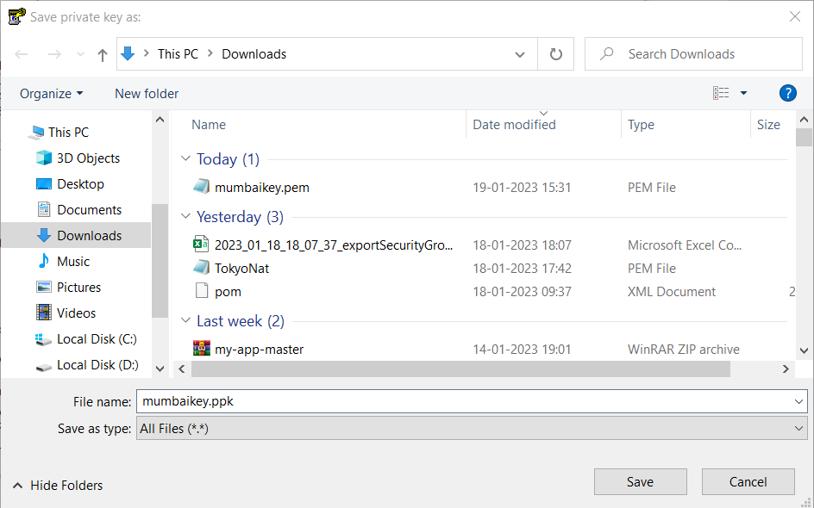

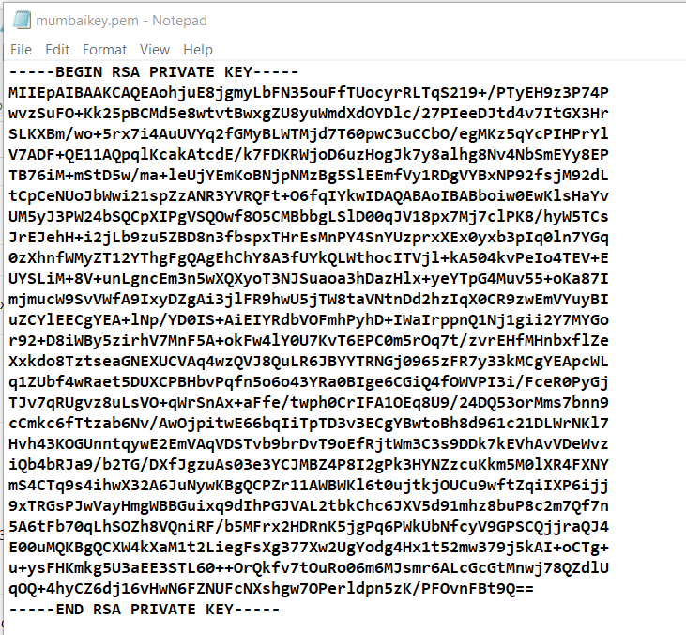

Step 10: finally save ( completed your pem file to ppk convertion )

Check ur desktop or your path

Ec2-instance connecting method:

Step 1: copy ec2-instance public ip and paste in putty tool.

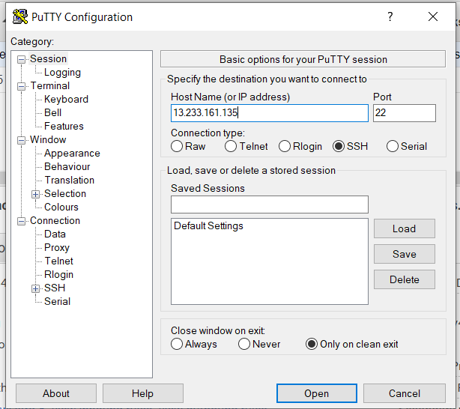

Step 2: select the SSH beside box :

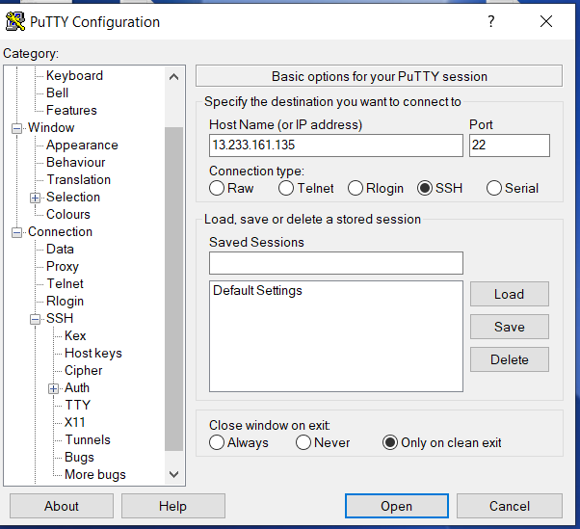

Step 3: Now select Auth

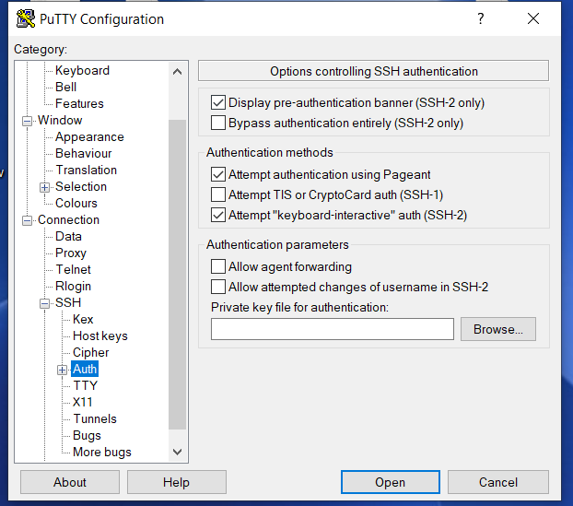

Step4: browse your ppk file

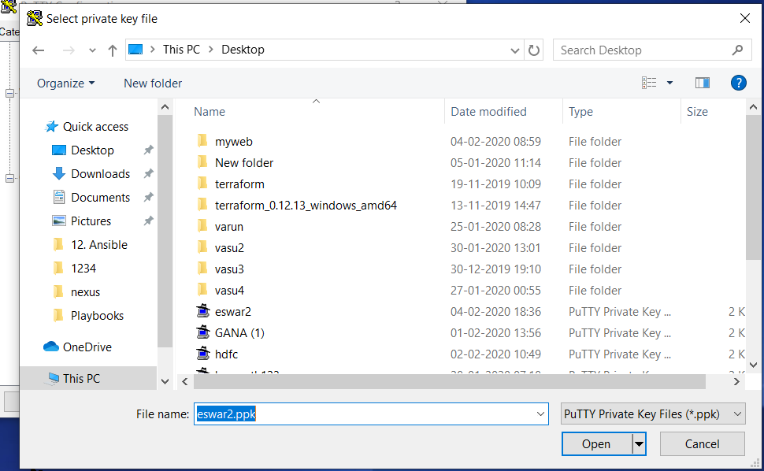

Step 5: now click on open

Step 6 : now also click on open

Step 7: Now click on yes

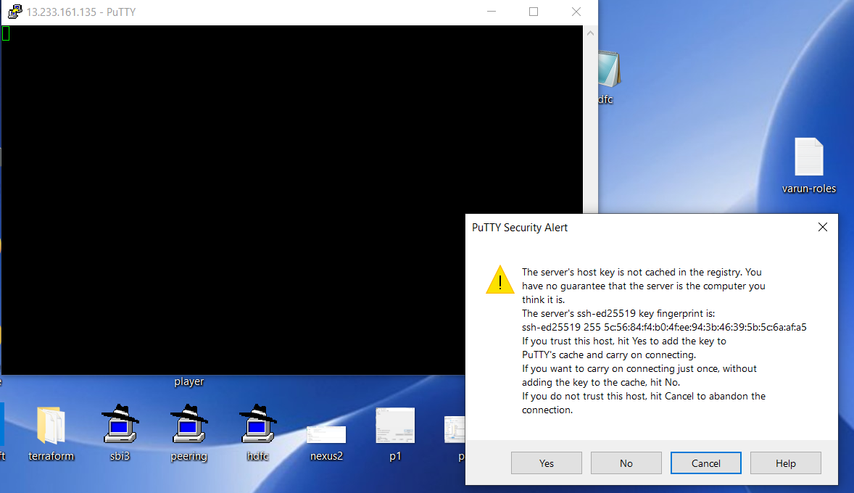

Step 8: Now login as ec2-user and then enter

And type command sudo su

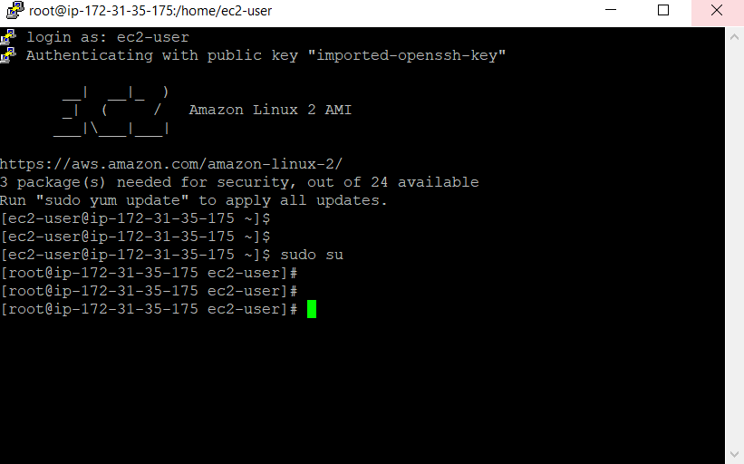

Now you are in ec2-instance.

Go with your Linux commands..