Ransomware Simulator
Cryptography Course Project Report
⚠️ Disclaimer:
This project is strictly for educational purposes only. It is designed to demonstrate how ransomware works in a controlled, offline laboratory environment. Do NOT use this project on real systems or real data.
Note: This project is designed to be approximately 70–80% similar to real ransomware behavior

I. Introduction / Background
Ransomware is one of the most common types of cyber attacks today. It works by encrypting a victim’s files and then demanding money (a “ransom”) to unlock them. Because of how powerful and damaging ransomware can be, it is important for cybersecurity students to understand how it works-especially the cryptography behind it.
However, studying real ransomware is dangerous because it can accidentally infect the computer. To avoid it, this project create a safe and controlled Ransomware Simulator. It behaves like real ransomware in terms of encryption and workflow, but it does not spread, does not harm the system, and always allows recovery.
Project Goal
The goal is just to help learn the cryptographic techniques used in ransomware without any danger by build a simple educational simulator that:
- Encrypts chosen files or folders
- Uses real cryptographic algorithms (like AES or RSA)
- Generates a ransom note for demonstration
- Allows safe decryption using a private key
- Teaches how real ransomware handles keys, encryption, and file recovery
Motivation
By building and testing this project, I hope I can:
- Understand how encryption affects real files
- Learn how symmetric and asymmetric keys work together
- See how difficult to recover files without the key
- Gain hands-on experience with secure key generation
- Understand why strong defenses and backups are important
Cryptographic concepts Involved
- Symmetric Encryption
• One key is used for both encryption and decryption
• Very fast
• Used by ransomware to encrypt large files
- Asymmetric Encryption
• Two keys: public key (encrypts) and private key (decrypts)
• Used to protect the symmetric key
• Makes sure only the attacker can decrypt files
- Hybrid Encryption
Real ransomware combines both:
• Generate a random symmetric key to encrypt files
• Encrypt that symmetric key with the attacker's public key
- Hash Functions (SHA-256)
• Used to verify file integrity
• Used to generate IDs or signatures in ransom notes

II. System Design / Architecture
The simulator is divided into 2 logical domains: the Attacker Side and the Victim Side.
This separation reflects real ransomware behavior, where the attacker controls the private key and the victim only has access to the public key.
Attacker Side Responsibilities:
- Generate RSA key pair
- Securely store the private key
- Decrypt files after ransom payment
Victim Side Responsibilities:
- Store victim data files
- Backup files before encryption
- Encrypt files using the attacker’s public key
- Unable to decrypt files without attacker intervention
Overall Ransomware Simulator Workflow:
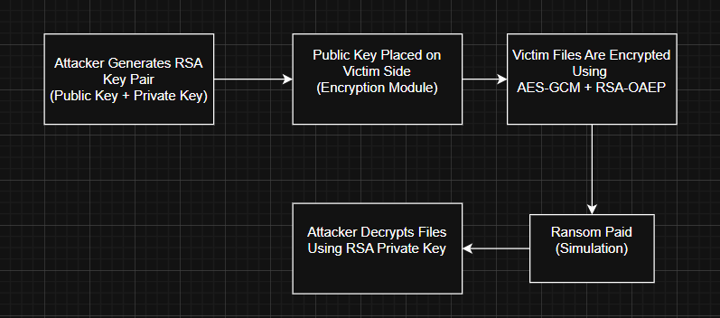
File Encryption Process (Hybrid Encryption):
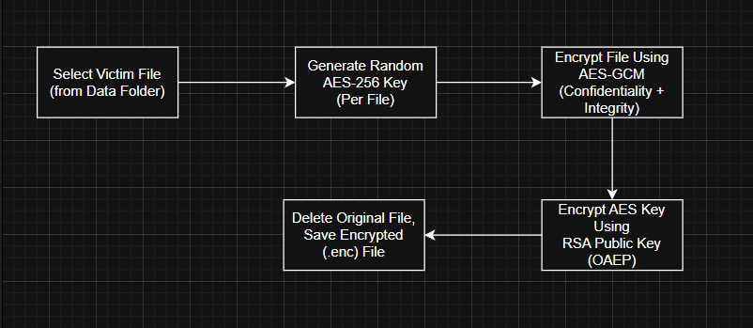
Each encrypted file follows this structure:
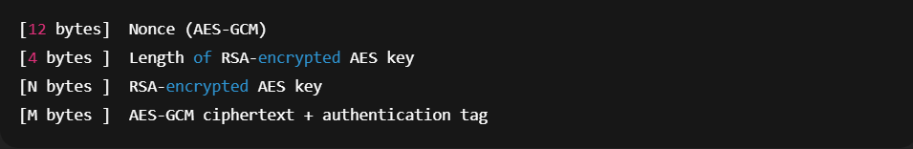
File Decryption Process (After Ransom Payment):
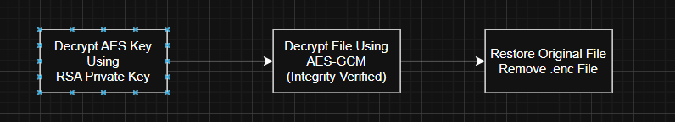

III. Implementation Details

This section describes the internal implementation of the Ransomware Simulator, focusing on the key components, cryptographic methods, program logic, and safety mechanisms used to realistically model ransomware behavior in a controlled educational environment.
The project is implemented in Python and follows a modular architecture, separating attacker-side and victim-side operations to closely reflect real-world ransomware workflows.
- Overall Architecture and Design
A central controller (main.py) manages program flow, user interaction, automatic file-state detection, and safety checks to prevent irreversible data loss.
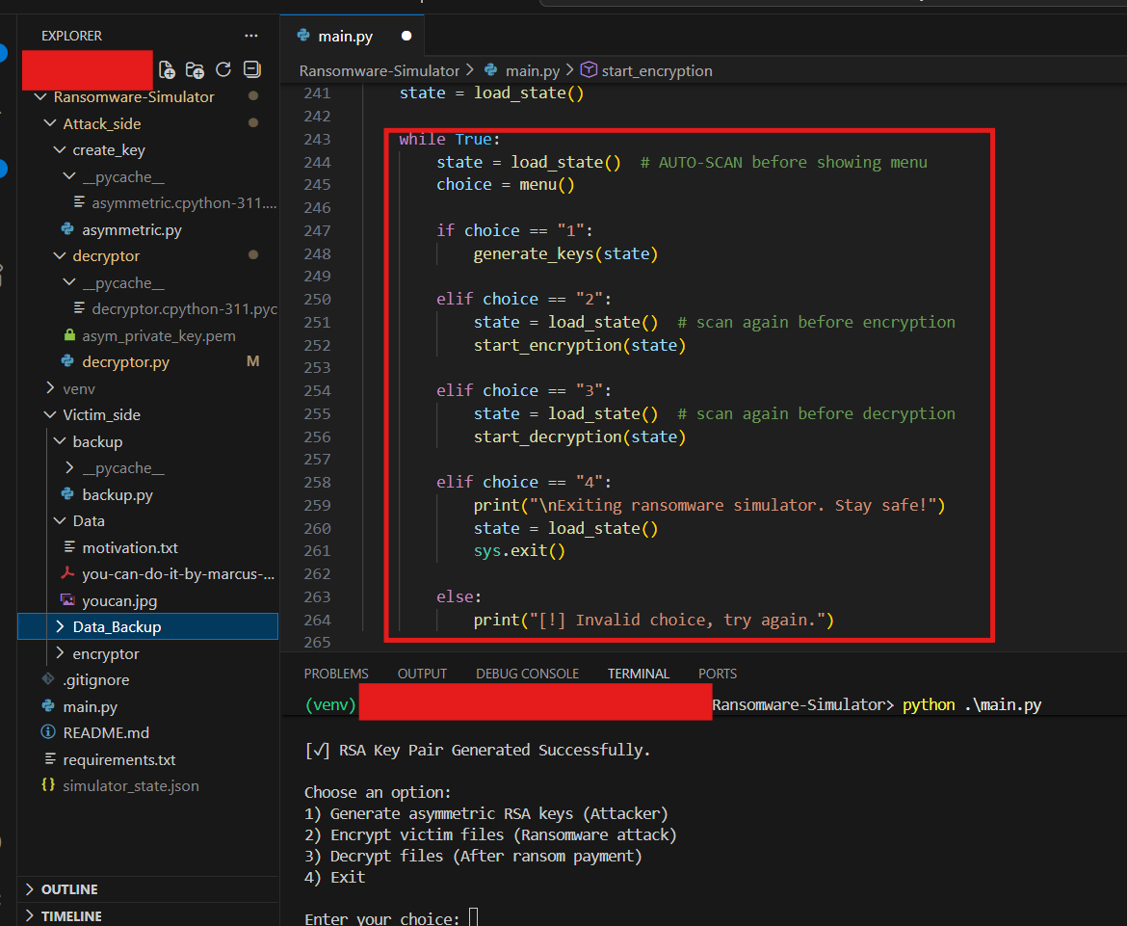
- Cryptographic Libraries Used
The project uses the Python cryptography library to implement secure cryptographic primitives such as RSA-OAEP, AES-GCM, padding, and SHA-256 hashing. Additional standard libraries such as os, json, and shutil are used for file system operations and state persistence.
Library | Purpose
cryptography.hazmat.primitives.asymmetric.rsa | RSA key generation
cryptography.hazmat.primitives.ciphers.aead.AESGCM | AES-256-GCM encryption
cryptography.hazmat.primitives.asymmetric.padding | RSA-OAEP padding
hashes.SHA256 | Hash function for OAEP
os, shutil | File system operations
json | Simulator state persistence

- RSA Key Generation (Attacker Side)
A 2048-bit RSA key pair is generated using a public exponent of 65537. The private key is stored on the attacker side, while the public key is distributed to the victim side. The simulator blocks key regeneration when encrypted files exist to prevent permanent data loss.
If no encrypted files:
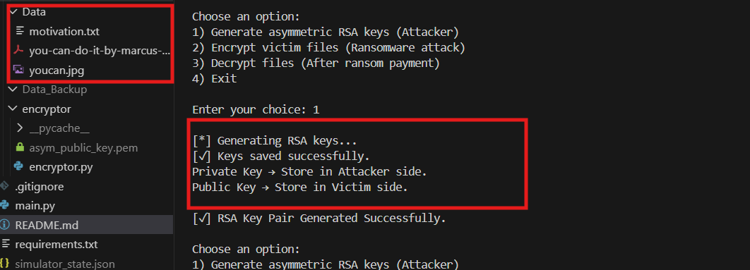
When have encrypted files:
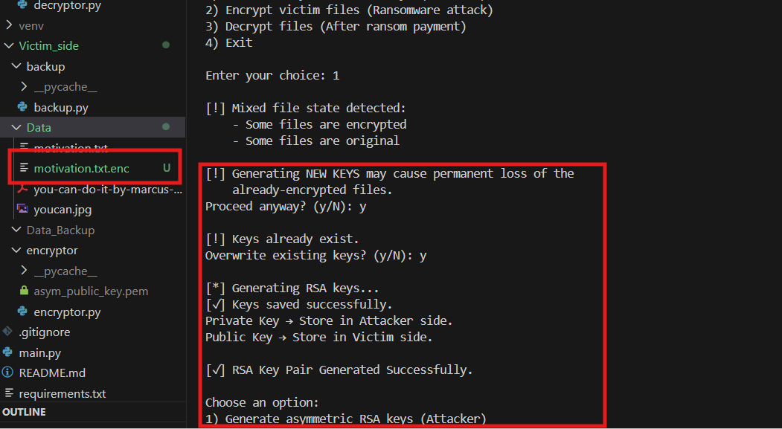

- Backup Mechanism (Victim Side)
Before encryption, all plaintext files are copied to a backup directory. Encrypted files are excluded from backup. This ensures safe experimentation while demonstrating ransomware behavior.
In real ransomware, attacker never backup victim’s data before encrypt but victims can backup their data to other place for before data destroy.
Backup process is function that call before encrypting start:
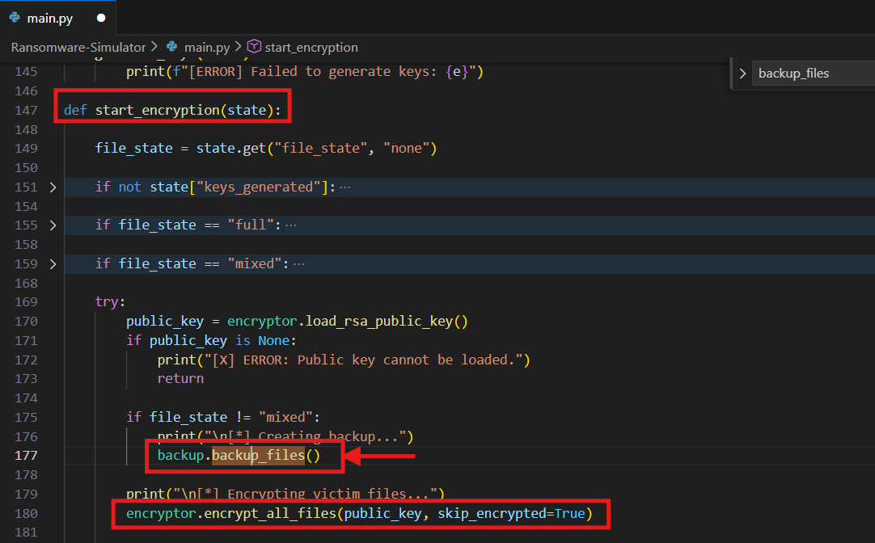
Path of function
- backup_files() : Ransomware-Simulator\Victim_side\backup\backup.py
- encrypt_all_files() : Ransomware-Simulator\Victim_side\encryptor\encryptor.py

- Hybrid Encryption Process
Each file is encrypted using AES-256-GCM with a randomly generated key. The AES key is then encrypted using RSA-OAEP with SHA-256. The encrypted file format contains a nonce, encrypted AES key length, RSA-encrypted AES key, and ciphertext.
After encrypting the AES key, the RSA public key is securely deleted (in my project). The original plain text file is also securely deleted.
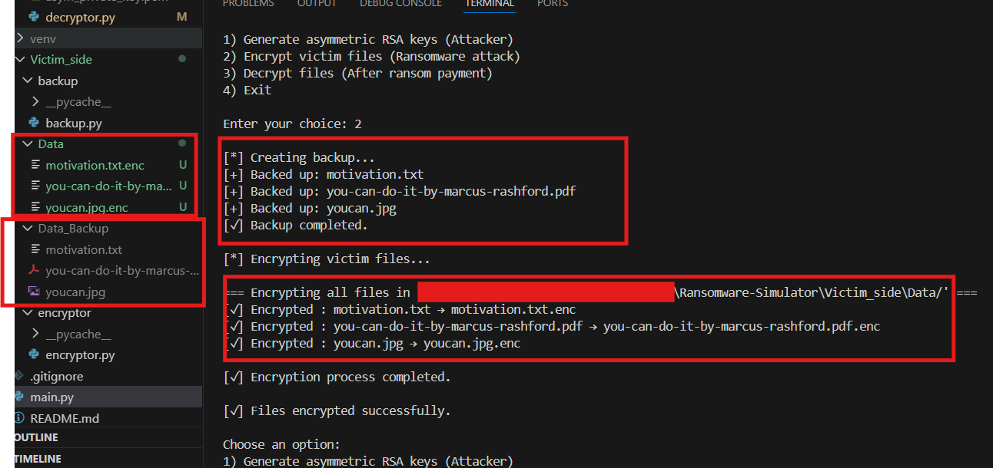

- Decryption Process
Decryption requires the attacker’s private RSA key. The AES key is first recovered using RSA, then the original file is restored using AES-GCM. Encrypted files are removed after successful decryption.
In my project, decrypting the AES key and decrypting the file using AES-GCM run direct on attacker side and the it will send decrypted data to victim_side’s Data folder.
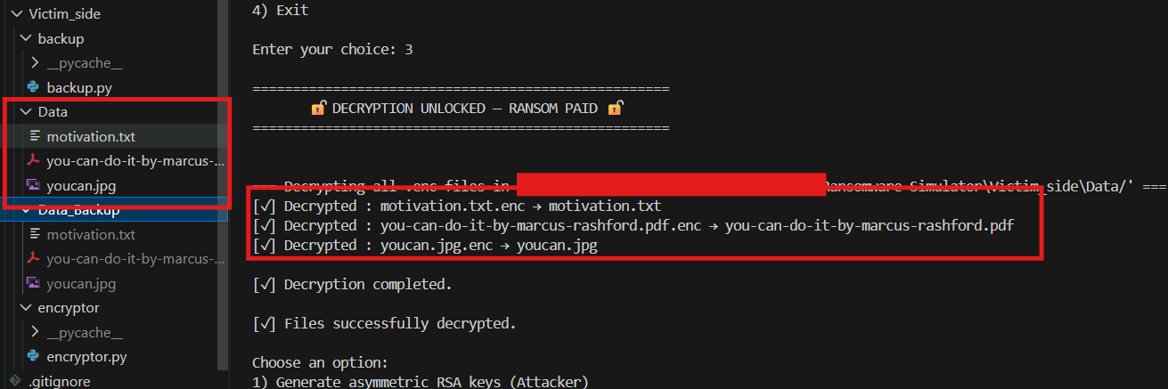
But in real ransomware, the victim can recover their data back by:
- Restore data from backup
- Use Free Decryption tools (If Available)
- Use data recovery software
- Rebuild system from scratch
- Engage professional incident response teams
- Paid ransom (not recommend, mostly attacker don’t send your decrypted data back)

- File-State Detection System
The simulator detects three file states: NONE, MIXED, and FULL. This system prevents double encryption, unsafe key overwrites
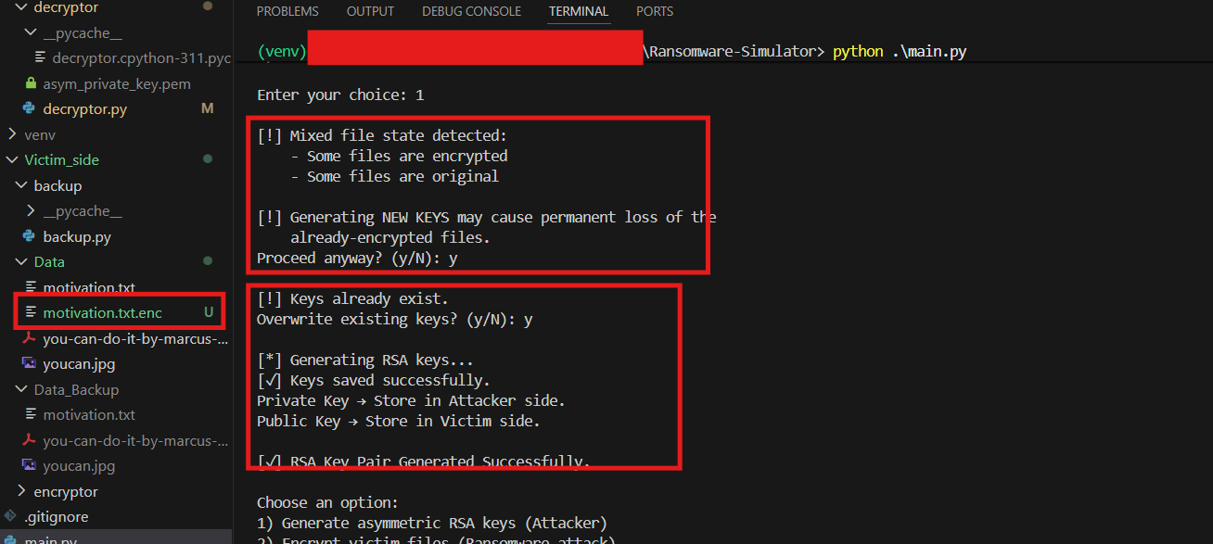
- State Persistence
The simulator state is stored in a JSON file and automatically validated against the file system at runtime.
Path: Ransomware-Simulator\simulator_state.json
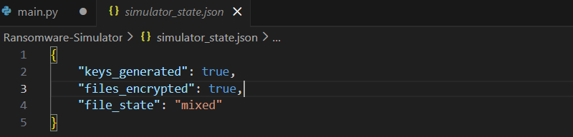
Point 7: File-State Detection System is load state from this point.

IV. Usage Guide
Step 1: Create a Python virtual environment and install dependencies using requirements.txt.
Step 2: Run the simulator using 'python main.py'. A menu-driven interface will appear.
Step 3: Generate RSA keys (Attacker). Screenshots recommended: key generation output.
Step 4: Encrypt victim files. Screenshots recommended: Data folder before and after encryption.
Step 5: Decrypt files after ransom payment. Screenshots recommended: restored files and deletion of .enc files.

V. Conclusion and Future Work
This project successfully demonstrates how ransomware relies on cryptography as its core mechanism. It highlights the importance of hybrid encryption, key separation, and authenticated encryption.
Future improvements may include simulated command-and-control behavior, ransom note generation, digital signatures, and defensive detection mechanisms.

VI. References
1. NIST SP 800-38D – AES-GCM Specification
2. NIST FIPS 186-4 – RSA Standard
3. RFC 4106 – Galois/Counter Mode
4. Python Cryptography Documentation
5. MITRE ATT&CK Framework

