AI ThinC - LG Lightwave Oven & Induction Cooktop
*Team Name : Heaven AI

An Jaejun
dept. of information System,
Hanyang Univ.
Seoul, Republic of Korea
paul1142@naver.com

Kang JaeHyeon
dept. of Information System
Hanyang Univ.
Seoul, , Republic of Korea
wol5971@gmail.com

Kim Jongrok
dept. of information System,
Hanyang Univ.
Seoul, Republic of Korea
whdfhr99@hanyang.ac.kr

So Seungsoo
dept. of information System,
Hanyang Univ.
Seoul, Republic of Korea
sss9073@naver.com

Abstract— "ThinC: The New Way of Cooking" will give LG kitchen appliance users a new experience. It applied innovative software features to LG Lightwave Oven & Induction Cooktop. The "ThinC" app automatically applies the latest recipes from other people (famous chefs, YouTubers, and Instagram) to LG kitchen appliances through numerous existing recipes and communities. Users can immediately control their home appliances and cook efficiently using AI speaker. This application allows LG kitchen appliances with many complex functions to automatically perform the right functions for the dish. We will provide users with a wonderful experience that automatically adjusts the cooking function, cooking temperature, and time of LG kitchen appliances.
TABLE I: Role Assignments
Roles | Name | Task description and etc
User | An Jaejun | It analyzes which services customers want. It analyzes recent trends which nowadays companies focus on. It reconsiders the purpose of our products and how make it feel comfortable for user.
Customer | Kim Jongrok | It is in charge of the overall planning of ideas. From the customer’s point of view, it think of what product is the good choice for customer. As the project progresses, problems are first detected.
Software Devloper | Kang JaeHyeon | Make data and program that drives the oven and construct a draft on how to induce it to work. Design and implements applications.
Devlopment Manager | So Seungsoo | Identify and lead the overall flow of planning. Check the flows of the plan from time to time to see if it meets the original plan. It mediate teammates opinion and make better choice.
I. INTRODUCTION
A. Motivation
Starting with the COVID-19 crisis, people have increased their activities at home. As prices continue to rise amid recent inflation, more and more people cook and eat at home. People are using various kitchen appliances such as induction, microwave oven, air fryer, and oven to cook food at home. In response, many companies are introducing appliances that allow one product to perform multiple functions, focusing on space minimization and home appliance efficiency.
In particular, LG's "Objet Collection Light Wave Oven" is a 9-in-1 kitchen appliance that can perform many functions compared to other kitchen appliances. Although innovative designs and functions have been steadily introduced, the reality is that single-person households do not feel the need for multi-cookers as they are not cheap. We wanted to induce purchase by making the rapidly increasing number of single-person households in Korea experience the differentiated software service of multi-cooker. If the inconvenience of encountering the existing multi-cooker is eliminated in software and convenience is emphasized more, it is expected that the company will achieve great results by purchasing multi-cookers one by one not only from single households but also from various households.
The inconvenience is that you have to directly select one of the functions and adjust the time and temperature to suit that function once or several times. To solve this inconvenience, we thought that if we input data and use AI speakers, consumers would be able to use various functions more conveniently in multi-cooker. I chose the above topic because I thought it would be great to cook food without any inconvenience while experiencing technological innovation every day by incorporating good software into a multi-cooker.

B. Problem Statement
As mentioned above, various companies strive to know the design that consumers want and to incorporate various functions into their products to meet the needs that value simplicity. Among them, electronics used to cook food originally included microwave ovens, ovens, grills, air fryers, and toasts. However, these days, the popularity of single-function electronics such as 'air fryers' is waning and 'multi-cookers' are the trend. Among the recent multi-cooking electronics, LG's "Objet Collection Light Wave Oven" and Samsung's "Bisfork Oven or Bisfork Cooker" are popular both at home and abroad. Of course, the products of the above two companies also have designs and various functions that meet the needs of various consumers.
In fact, most of our home appliances use LG, as they say, "Home appliances are LG." But only one product uses Samsung's. It is the Samsung Bisfork Cuckoo. I compared it to "LG Object Collection Light Wave Oven," but in conclusion, there were two reasons why I bought "Bisfork Cuckoo." First, if you buy a meal kit every month for two years at an appropriate amount (39,000 won), you can buy a "Bisfork Cuckoo" for only 50,000 won. Second, Samsung Card (a subsidiary of Samsung) also provided membership benefits and several free coupons (about 200,000 won). I bought the Bisfork Cuckoo for a variety of benefits, and I've been using it, but I often found several problems.
I discovered four shortcomings while writing Bisfork Cuckoo. First, the air fryer function is not as crispy as I thought, so I have to cook it for more time. The second is a 4-in-1 appliance that looks like an oven, but does not actually have an oven function, and has four functions: a toaster, microwave, air-free, and grill. Third, it is difficult to clean because there is no internal cleaning function. Lastly, it was so annoying to have one cup noodle cooked with a microwave function, and to cook it by setting the function in three times.
After experiencing the shortcomings of Samsung products in person, LG's "Objet Collection Light Wave Oven," which is expensive but has more diverse functions and excellent product quality, became noticeable. As I touched and looked for the "Objet Collection Light Wave Oven" through the "LG Signature Kitchen Suite" program, this product seemed very convenient because it had not only design but also five more functions (9-in-1) than the "Samsung Bispoke." Although the functional disadvantages of the product I thought above have already been resolved, unfortunately, the software did not relieve the user's inconvenience and provide convenience. It seemed clear that it would be a better product if we connected this functionally good product with many good ideas from our team.
We will introduce the specific inconvenience and tell you about the solution we think. First, "Objet Collection Light Wave Oven" currently uses the LG ThinQ app to capture the barcode of the previously affiliated meal kit under the name of "Artificial Intelligence Cook" and deliver information to multi-cookers to cook. In fact, only a few items were possible, and to overcome these shortcomings, we would like to provide cooking methods and cooking time for various products through AI speakers. Second, people have different tastes and tastes, and multi-cookers often provide the same solution. So, if the user sets a few things to suit the user's preferences through the "ThinC" app created by our team, AI speakers will immediately help the user make the desired cooking without any inconvenience. Third, through the "ThinQ" app, it is not widely used except for cooking methods of food or using a "smart food hall" to purchase milk kits.
We believe that meeting the instinct of homeosociologyus, where users want to cook food and share their own recipes, will increase the frequency (secondary benefit) of multiple users using the app and thus purchasing food. If this happens, 'Heaven AI' will store multi-cooker recipes through the 'User's Cookery' channel, so that you can cook them directly through the AI speaker, and store and use various recipes through the 'community' channel with others. In addition, "User's recipe" will create a system that allows more than two recipes at once to be useful in baking, not just one cooking temperature, time. ([Oven function, 200℃, 20min] -> [Oven function, 180℃, 10min]) Finally, I would like to connect LG's existing "Smart Food Hall" to "ThinC. By introducing milkits or foods that are on sale in stores on the list at the top, we want to induce access to the "Smart Food Hall" to contribute to secondary profits other than the sale of electronic products by "LG" companies.

C. Research on Related Software
Kakao
- Kakao's speakers are making a lot of progress under the name of "Kakao Mini." It is increasing its market share based on popularized cute characters such as Kakao's Ryan and Peach, and supports various functions. It is carrying out its own fitness test to filter words or pronunciations that are difficult to recognize, and is promoting various functions that can set various sensitivity in response to questions. In the field of speakers,
Samsung Bisfork
- Samsung's Bisfork is ahead of hyper-connected IOTs that can connect and set up various electronic devices such as microwave ovens, induction, and refrigerators. It continues to evolve based on customer experience and promotes various changes. The kitchen electronic device automation application we are trying to create also has a great commonality in this regard.
10,000 recipes
- 10,000 recipes are websites and applications that support various recipes. When you search for the desired food, the ingredients and cooking methods for cooking the food are specifically shown. You can also comment on the food and share it on your SNS account. In addition, cooking ingredients corresponding to the food may be purchased through the external connection button.

II. REQUIREMENTS
A. Application
a) Login
Enter the user's ID and password and press the login button. If the user information matches the information in the database, the user session is maintained and moved to the main screen. If the information does not match, send a login failure error message.
b) join
After entering the information of the user who wants to join, press the membership button. If the entered ID is an existing ID, a member registration failure error message is sent. If the ID is not duplicated and personal information is entered, membership registration is successful. Then go to the login page. In addition, during the membership registration process, voice collection authority is checked to deliver voice messages to speakers.
c) Google/Naver account link
Try to log in using the information of each account. If the information of the account is not in the database, the information of the account is registered in the database. If the account information already exists, log in using the account information.

d) Posts / Manage Recipes
When writing a post/recipe, the user must enter the contents of the title, content, etc. according to the predetermined format. If there is no part that goes against the format, add the contents of the written content, current time, and author information to the database. When modifying a post, check if there are any parts that go against the post/recipe format, as in writing, and update the information with the revised time.
e) Loading Posts / Recipe List
If a post/recipe page is requested, check the conditions of the data in the requested query. If there are no conditions, all the data in the database is imported, and if conditions such as "noodle", "salad", or "diet" exist, the data corresponding to those conditions are imported from the database.

B. AI Speaker Interaction
When a user wants to cook a recipe, cooking can be made more convenient through an AI speaker. First, the user calls the speaker to operate the speaker. After that, the user asks the speaker to cook (the name of the dish). If there are insufficient keywords to execute commands in the process of processing the request, additional keywords such as "weight of core materials" can be requested to the user. If all keywords are satisfied, the AI speaker explains the recipe cooking order. The cooking process is described with sufficient intervals in the cooking process so that the user may perform cooking according to the current situation. For example, explain "fry the eggplant" and then explain the next process two minutes after the process is over. After that, in situations where you have to use a home appliance connected to the speaker, a request such as "put the dough in the oven" If the user sends an answer that he or she is ready, such as "Done" and "I'm ready," he or she explains how and how to use the appliances and continues the cooking process. At the end of the course, "Cooking is complete. Enjoy your meal."End the speaker with a voice.

C. Non-functional requirement
a) Platform
1) Android
Our service selected Android apps that are widely used to provide more convenient services as well as requiring users to remotely manage ovens in the kitchen. We have team members who have experienced Android development, and we chose the Android app to take full advantage of the basic functionality of the Android operating system.

2) aws
The server works in the Ubuntu Linux environment of AWS EC2. Because AWS services are used, services can be distributed quickly without any cost burden. The DB used AWS RDS, and MYSQL DB enabled stable DB construction at no cost. DB can be managed remotely with the MYSQL Command Line Client on the local PC.
3) Spring
Spring is a JAVA-based framework. It is currently one of the most popular frameworks. The MVC structure can be used to write code neatly, and it is also easy to identify specific parts when a problem occurs. In addition, it can reduce unnecessary code by supporting AOP and focus on core business logic, so it can create better logic. It is up to the developer to choose the tools and libraries they want to use. There are many extensions that the community provides, making it easy to add new features.

b) Programming language
1) Kotlin
Kotlin is a language developed by Jetbrains, which created IDE tools such as intellij and pycharm. It was announced in 2011, and was selected as the official Android language by Google in 2017. In addition, Android studio was created as Jetbrains' IDE platform and became more well-known. Kotlin makes it easier and more convenient to write Android apps. It shows a perfect compatibility with the existing Java programming language and can apply the existing grammar and code writing style as it is. Kotlin is a static type designation language and has strengths in terms of execution time, reliability, and maintenance. In addition, since asynchronous programs provide various types of programming paradigms, such as functional programming and object-oriented programming, appropriate solutions can be selected for each code. Kotlin is a programming language that has been growing rapidly in the community since 2016, and has continued to be used

2) Java
Java is more than 20 years old, but it is still a popular programming language. Despite the popularity of languages such as python, node.js, it is still growing at a rapid pace. Java is an object-oriented and easy-to-learn language used to develop digital solutions. It also works on any device with Java Virtual Machine (JVM) installed, regardless of platform. Java makes it easy for developers to write and execute code and provides powerful debugging.Another advantage of Java is its security. It's perfect for use without having to worry too much about security. In this regard, it has been well received by developers and has become an essential language for application development worldwide.

c) Software in use
1) AWS EC2
EC2 is a cloud computing service provided by Amazon Web Services. Developers can quickly implement and deploy services without having to purchase real servers. Linux Ubuntu 20.04 was used as the EC2 operating system.
2) AWS S3
AWS S3 is an object storage service that delivers industry-leading scalability, data availability, security, and performance. AWS 3 enables users to store and protect the amount of data they want in a variety of use cases, including data leakage, websites, mobile applications, backup and restore, archiving, enterprise applications, IoT devices, and big data analytics.
3) AWS RDs
RDS is a distributed relational database provided by Amazon Web Services (AWS). Web services that work in the cloud designed to simplify the setup, operation, and expansion of relational databases within applications. It is difficult to set up and manage DB directly inside EC2. If you use RDS, you can easily access the DB only through the DB client.
4) Github
GitHub is Microsoft's web service that hosts source code and supports collaborative support based on distributed version control software Git. It is currently the most popular source code hosting service and software development platform.
5) NGINX
Nginx is a lightweight web server specialized in concurrent connection processing. In some cases, an HTTP web server or a WAS server that responds to static files that meet requests when received from clients is used as a reverse proxy server to reduce the load on the WAS server.

d) Developer Environment
1) Clear information of development environment
• macOS 12.6
- 16GB Memory
- CPU Cores: 8
• IntelliJ IDEA 2022.2.1 (Ultimate Edition)

2) Clear information of development environment
• window 10
- 2.80GHz, Core Intel i7
- 16GB Memory
• Intellij 2022.2.1 (Ultimate Edition)

IV. SPECIFICATIONS
A. Application
a) Initial page
1. Log-In[Fig.2]
The user can login through typing a ID and password that is registered in ThinC.
If the login is successful, the user goes to the main page. Displays a failure message if it fails.
2. Join[Fig.3]
The user presses the membership registration button to proceed with the membership registration.
Enter the ID and password, and enter the password again to check the password to make sure that the entered password is correct.
If the entered ID is an existing ID, a member registration failure error message is sent.
If the ID is available, sign up successfully and connect to the login page.
It outputs a message asking the user for permission to collect voice.

3. Google/naver linked button[Fig.3]
Users can also try to log in by pressing the Google and Naver connection buttons.
If the information of the account is in the database, the login is successful and the main page is printed.
If the account's information is not in the database, go to the login window of the site.

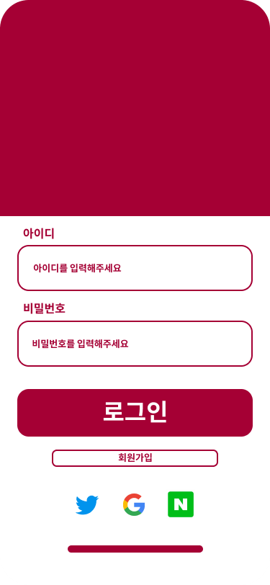

b) Main(Home) page
1. Header [Fig.4.Group3]
This part has a back button, a My Page button, and a search button. If you click the Back button, you can immediately go directly to the previous screen. Clicking the My Page button moves you to a separate My Page screen. On this screen, the user can check his or her personal information and modify his or her personal information. In addition, a list of recipes that you wrote and recipes of other users that you scrap is also displayed. Finally, when you click the search button, a space where you can enter the search word appears in the header part, and you can search for the desired information by entering the search word there.
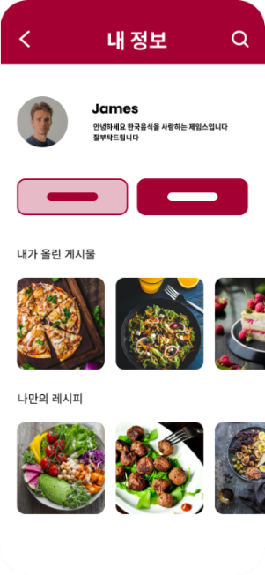
2. Body [Fig.4]
There are four buttons in this part: recipe, community, history, and shopping. By clicking each button, you can go to the corresponding page.
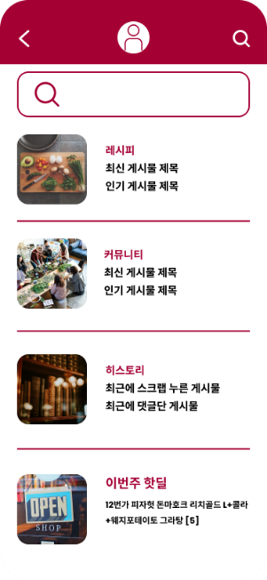

c) Recipe
1. Search [Fig.9]
A desired search word may be input in the search bar to check a search result suitable for the corresponding search word. When you press the search bar, a keyboard appears at the bottom of the screen. In addition, a search history screen is displayed under the search bar, and you can check the search history so far.
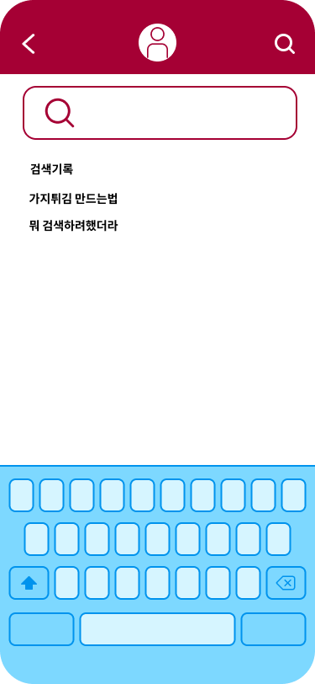
2. Category [Fig.6], [Fig.7]
A screen including multiple buttons is displayed. At the top of this part, there are buttons that say by type, situation, and material, and when each button is pressed, a detailed category suitable for the top button is displayed. For example, if you click the "By Ingredient" button, you can check various recipes by selecting the desired detailed categories such as pork, beef, and chicken at the bottom.
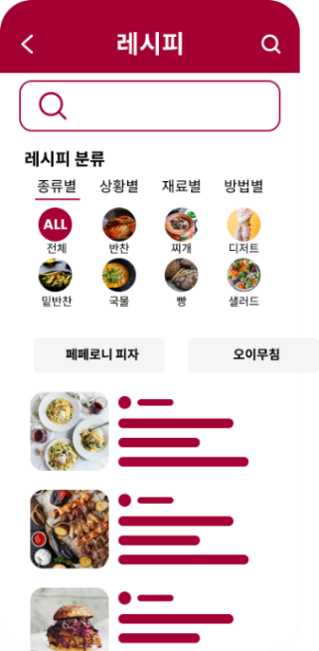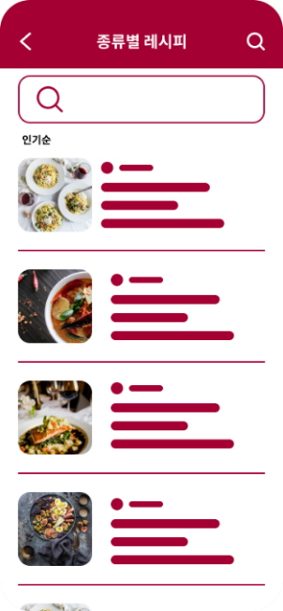
3. Inside recipe post
There are recipes for the food, who uploaded the recipe, hashtags, and necessary ingredients. In particular, the time of necessary kitchen devices such as induction, ovens, and microwaves is displayed.
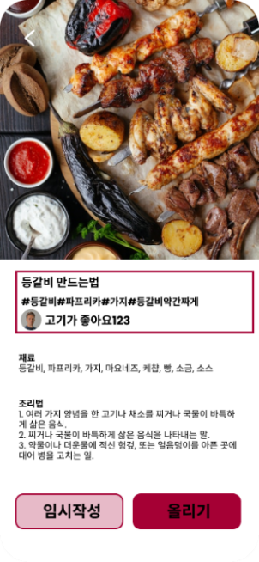
d) Community [Fig.10]
In this part, you can choose one of the bulletin boards of free bulletin boards, recipe sharing boards, and your own recipes.
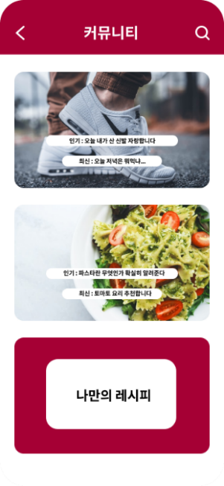

1. Free board [Fig.11]
Like other communities, you can create posts, read posts, update posts, and delete posts. Displays information such as the title, content, date of creation, author, and so on of the post. When creating or updating post, an error message is sent if there is anything not entered in the required input space. In addition, the Modify and Delete button is displayed only if the author of the post matches the current user.
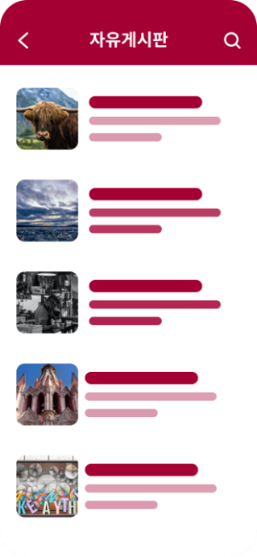
2. Sharing recipe[Fig.12], [Fig.13]
Recipes written by users are gathered, and users can check their own recipes by selecting them by category. Can store recipe by pressing the scrap button on the recipe description page.
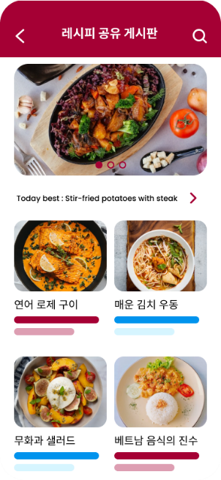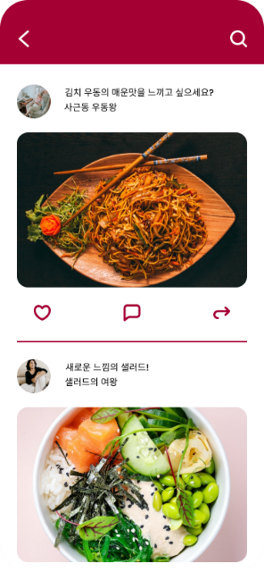

3. My recipe
1) My recipe page [Fig.14]
It is a page that allows users to post recipes themselves. You can write and register a recipe in the form of a post, and the recipe can be shown to other users on the "Sharing recipe" page.
2) A scrap recipe [Fig.15]
Can check the recipes of other users I scrap.
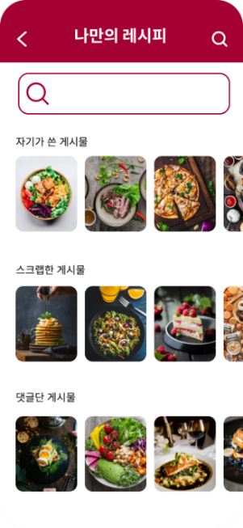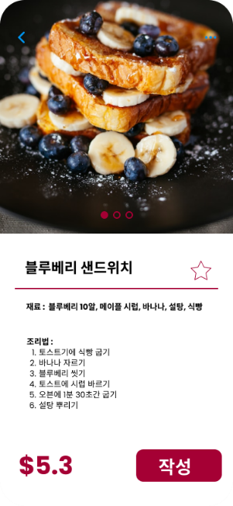

d) History
1. AI Recipe history[Fig.16]
It is a page that shows the recipes that have been requested to the speaker in order. If the recipe is not cooked by requesting a recipe, there is no recipe used The message is displayed on the screen.
2. Healthy history[Fig.17]
It is a page that shows the calories of each food after receiving the records from the recipe history. If the recipe is not cooked by requesting a recipe, there is no recipe used The message is displayed on the screen.
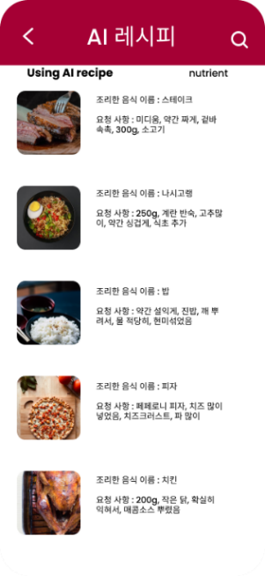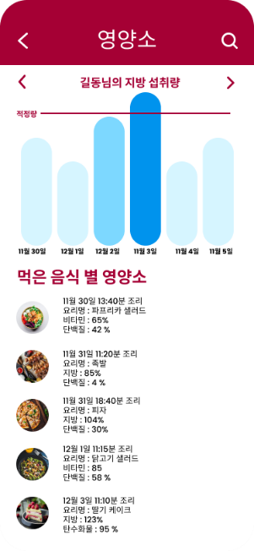
e) Shop [Fig.18]
Click the shop button to connect to an external shopping mall site.
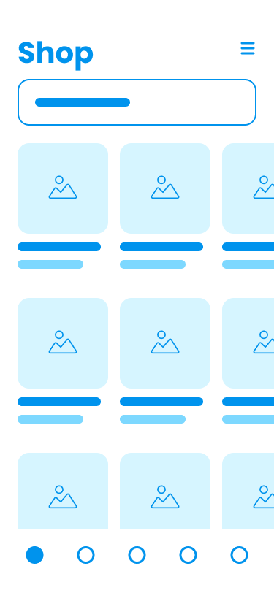

B. AI Speaker
a) Auto Cook
1. Leave a message using voice
- The speaker receives the message when the user asks the speaker to receive a voice message.
- When the user start to say with “안녕 ThinC”, then speaker recognize that it starts to receive the message.
- User send the message restricted form of “{음식이름,몇인분} 해줘”.
- Speaker checks the receipe of food what user said, and then start cooking with controlling the cooking electronics.
- If the food that it needs to pre-ready before the using cooking electronics, speaker send the message “‘지금 바로 조리가 불가능한 음식입니다. 조리 전 사전 과정의 설명을 들으시겠습니까?’., If the user say “응 말해줘”, then speaker starts to say the each once description sentence. If the user wants to go to next step, user need to say “다음”, speaker say the next sentence. If the pre-ready is done, speaker asks again to check user’s request “말씀하셨던 {음식이름,몇 인분}을 조리하겠습니다.” And then starts to cook.
b) Food Recommendation
- If the user say “오늘의 음식 추천해줘”, then speaker recommend the food “오늘의 추천 음식은 {음식이름}입니다.”, using the community recipes.

