CENTRAL UNIVERSITY OF TECHNOLOGY

Campus Coupon System

Activity 3.3: Design the User Interfaces and Finalise the System Design

Step 1 – Review the Approved Requirements

Design Artefact | What was checked for Campus Coupon
Functional requirements | Coupon discovery, coupon use/redemption, user access, events and administration functions.
Non-functional requirements | Usability, responsive presentation, security/access control, reliable data access and maintainability.
Use Case Diagram | Correct actors and system functions are reflected in mobile and web interfaces.
Sequence Diagrams | Important user actions follow the same logical order from interface to backend and back.
System Architecture | Flutter and ASP.NET operate as parts of one integrated system using the agreed backend services.
ERD | Interface fields and displayed information correspond to supported entities/attributes and relationships.

Step 2 – Identify the Required Flutter Screens

Flutter Screen | User | Purpose | Related Requirement / Use Case
Welcome | Student/User | Introduce the application and route the user into authentication or the main application. | System entry / user access
Login | Student/User | Authenticate an existing user. | User authentication
Register | Student/User | Create a new user account where registration is supported. | User registration
Home | Student/User | Provide access to coupons, events and key campus functions. | Access main functions
Coupons | Student/User | Browse and discover available coupons. | View/browse coupons
Coupon Details | Student/User | Show coupon information, conditions and the action to use/redeem it. | View coupon details / use coupon
My Coupons / Wallet | Student/User | View coupons associated with the user and their current state. | Manage/view user coupons
Redeem Coupon | Student/User | Perform the coupon redemption/use action. | Redeem/use coupon
Events | Student/User | Browse available campus events. | View events
Event Details | Student/User | Display event information and allow the user to perform supported event actions. | View event details
Notifications | Student/User | Display relevant system notifications and updates. | View notifications
Profile | Student/User | View and update supported user profile information. | Manage profile
Settings | Student/User | Provide application preferences and account actions. | Manage application/account settings

Step 3 – Identify the Required ASP.NET Screens

ASP.NET Page | User | Purpose | Related Requirement / Use Case
Staff Login | Authorised Staff/Admin | Authenticate an authorised web user. | Staff/admin authentication
Dashboard | Authorised Staff/Admin | Show high-level system information and management shortcuts. | Administrative overview
Coupon Management | Authorised Staff/Admin | Create, view, update and manage coupons. | Manage coupons
Coupon Details | Authorised Staff/Admin | Inspect a coupon and its management information. | View/manage coupon
Redemption / Transactions | Authorised Staff/Admin | Review coupon redemption/transaction information. | Monitor coupon use
Event Management | Authorised Staff/Admin | Create and manage campus events. | Manage events
Event Details | Authorised Staff/Admin | View or edit an individual event. | View/update event
User Management | Administrator | Manage authorised users and supported user information. | Manage users
Profile / Account | Authorised Staff/Admin | Manage the signed-in web user's supported account details. | Manage profile

Step 4 – Create the WireframesFlutter Mobile Wireframe Specifications

Screen | Main Components | Primary User Action
Login | Logo, email/username field, password field, Login button, Register link, Forgot Password link | Authenticate
Home | Header, search, coupon/event cards, navigation bar | Select a feature
Coupons | Search/filter, coupon cards, category information, navigation | Open coupon
Coupon Details | Coupon title, description, validity/conditions, relevant information, Redeem/Use button | Redeem/use
My Coupons | Coupon list/cards, status indicators, coupon details action | View owned/used coupon
Redeem Coupon | Coupon identifier/QR or supported redemption mechanism, confirmation action, result message | Complete redemption
Events | Event cards/list, search/filter, event dates and locations | Open event
Event Details | Event information, supported action button, back navigation | Perform event action
Notifications | Notification list, timestamps/status where supported | Read notification
Profile | Supported user information, Edit/Save controls, Logout | Update profile / logout

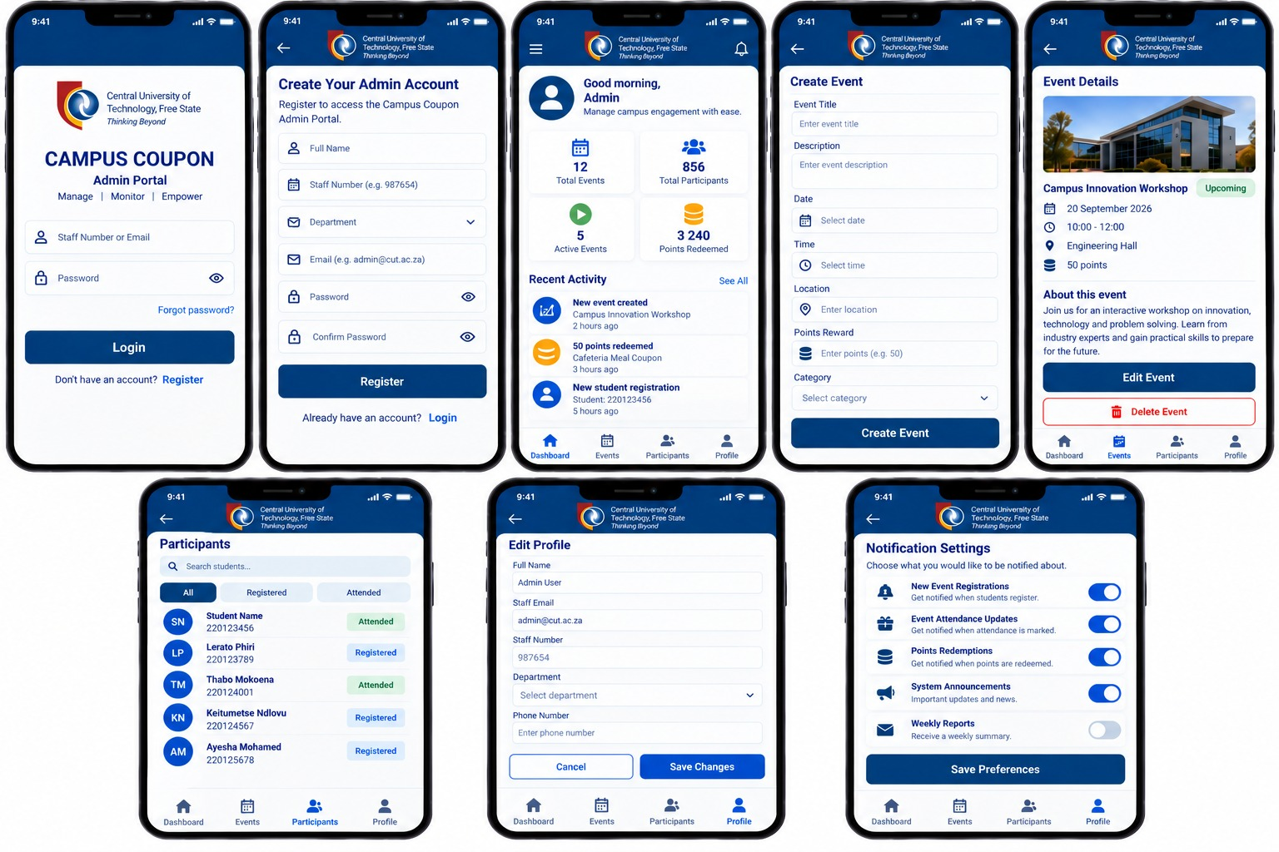

ASP.NET Web Wireframe Specifications

Page | Main Components | Primary Staff/Admin Action
Staff Login | Username/email, password, Login | Authenticate
Dashboard | Sidebar, summary cards, quick actions, recent activity | Navigate/manage
Coupon Management | Search, filters, coupon table, Add/Edit/Delete/View actions | Manage coupons
Coupon Details | Coupon information form, status/management actions | View/update coupon
Redemption / Transactions | Search/filter, transaction/redemption table, details | Monitor activity
Event Management | Search, event table/cards, Add/Edit/Delete/View actions | Manage events
Event Details | Event form, supported management actions | View/update event
User Management | Search, user table, supported account actions | Manage authorised users
Profile / Account | Account fields, Save, Logout | Manage account
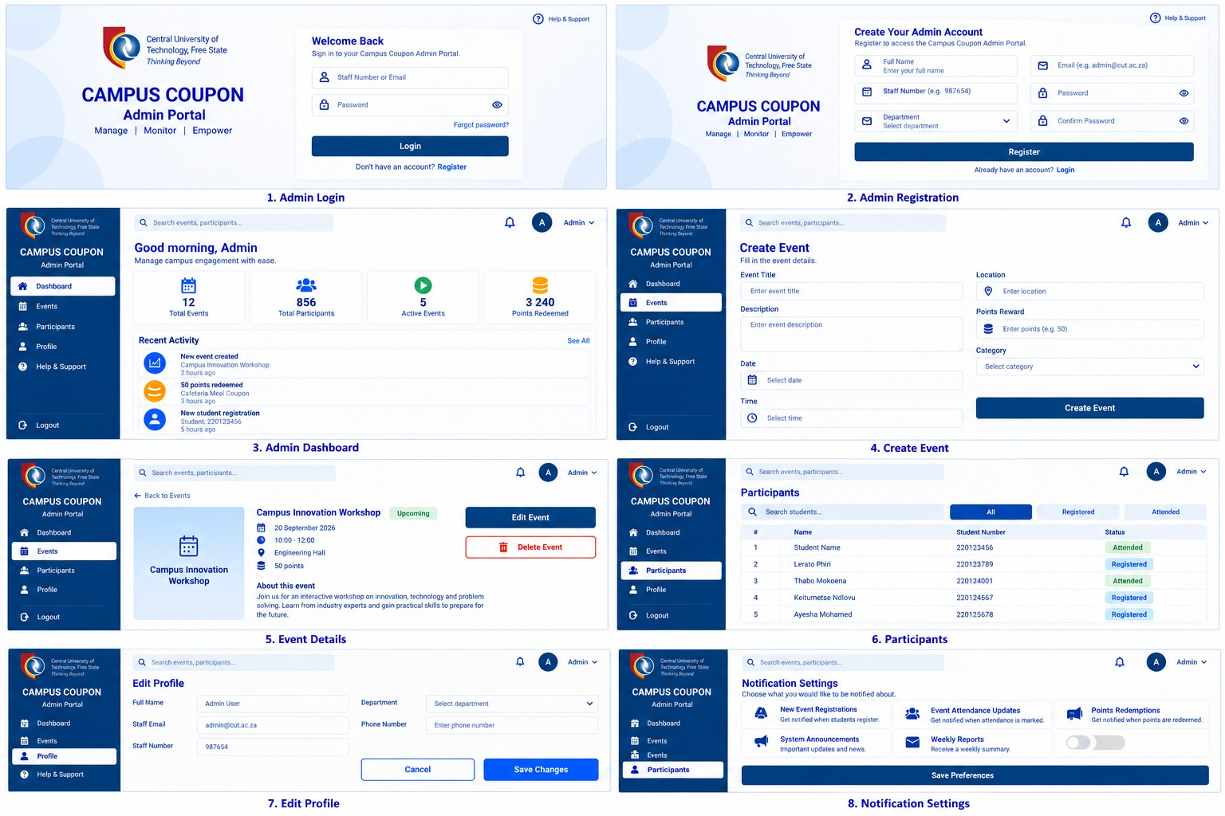

Step 5 – Show Navigation Between Screens

Starting Screen | User Action | Next Screen
Welcome | Continue or authenticated session detected | Login or Home
Login | Enter valid credentials and select Login | Home
Home | Select Coupons | Coupons
Coupons | Select a coupon | Coupon Details
Coupon Details | Select Redeem/Use | Redeem Coupon / Confirmation
Home | Select My Coupons | My Coupons / Wallet
Home | Select Events | Events
Events | Select an event | Event Details
Home | Select Notifications | Notifications
Home | Select Profile | Profile
Profile | Select Edit and Save | Profile with updated information
Staff Login | Enter valid credentials | Dashboard
Dashboard | Select Coupon Management | Coupon Management
Coupon Management | Select a coupon | Coupon Details
Dashboard | Select Event Management | Event Management
Event Management | Select an event | Event Details
Dashboard | Select User Management | User Management

Step 6 – Check the Mobile and Web Integration

Flutter Action | Shared Backend / Supabase Data | ASP.NET Action
User logs in / registers | User/authentication information | Authorised staff can view supported user information
User browses coupons | Coupon records and supported coupon attributes | Staff/admin creates or updates coupons
User opens coupon details | Selected coupon record | Staff/admin views the same coupon record
User redeems/uses a coupon | Redemption/transaction data as defined by the ERD | Staff/admin can review supported redemption/transaction information
User browses events | Event records | Staff/admin creates or updates events
User updates supported profile information | Updated user record | Authorised staff can view relevant details
User receives/view notifications | Notification data where supported | Staff/admin actions can produce relevant system updates where defined

Step 7 – Check the Design Against the ERD

Interface Information | Entity / Table | Attribute / Field
User identity/profile information | Users | Supported user attributes in the approved ERD
Coupon information | Coupons | Supported coupon attributes in the approved ERD
Event information | Events | Supported event attributes in the approved ERD
Redemption information | Redemptions / relevant transaction entity | Supported redemption attributes in the approved ERD
Transaction information | Transactions / relevant transaction entity | Supported transaction attributes in the approved ERD
User-to-coupon relationships | Relevant relationship entity/table | Supported foreign keys/relationship fields

Alignment – Redeem a Coupon
Artefact | Evidence
SRS | Coupon use/redemption is represented as a required system capability.
Use Case Diagram | Student/user performs the supported coupon redemption/use function.
Sequence Diagram | User action is sent from Flutter through the backend/data layer and the result is returned.
ERD | Redemption/transaction information is represented using the approved database structure.
Flutter Wireframe | Coupon Details and Redeem Coupon screens provide the user action.
ASP.NET Wireframe | Authorised staff/admin can review supported redemption/transaction information.

