ADD TO GIT:

Data Overview

Data description
The data contains over two decades (up until 2022) of data on each player who has been part of an NBA teams' roster.
It captures demographic variables such as age, height, weight and place of birth, biographical details like the team played for, draft year and round.
In addition, it has basic box score statistics such as games played, average number of points, rebounds, assists, etc.

- gp → Games Played (how many games the player appeared in)
- pts → Points per game (how many points they score on average)
- reb → Rebounds per game (how many times they grab the ball after a missed shot)
- ast → Assists per game (how many times they pass leading directly to a basket)
- net_rating → Team point difference per 100 possessions when the player is on the court (positive = good impact)
- oreb_pct → Offensive Rebound % (how often they grab rebounds on offense)
- dreb_pct → Defensive Rebound % (how often they grab rebounds on defense)
- usg_pct → Usage % (how much of the team’s offense runs through them)
- ts_pct → True Shooting % (a measure of shooting efficiency, factoring 2s, 3s, and free throws)
- ast_pct → Assist % (how many of the team’s baskets they assist while on court)

In super short:
- gp, pts, reb, ast → basic stats.
- net_rating → impact on winning.
- oreb_pct, dreb_pct → rebounding skill.
- usg_pct → how much they handle the ball/shoot.
- ts_pct → how efficient their shooting is.
- ast_pct → how much they create for teammates.

Purpose:
The data set can be used to explore how age/height/weight tendencies have changed over time due to changes in game philosophy and player development strategies
A longitudinal study on players' career arches can also be performed.

Multilayer Perceptron
An multilayer perceptron (MLP) is a type of ANN that has at least three layers: input, hidden, and output. Each layer consists of neurons connected to neurons in the next layer.
Layers
- Input layer
  - Receives input features from the dataset.
  - Each neuron corresponds to one feature in the input data.
- Hidden layer(s)
  - Perform computations to extract patterns and representations.
  - Two main operations happen here:
    - Forward pass – compute the output of neurons using weighted sums and activation functions.
    - Backpropagation – adjust weights and biases to minimize error using gradients.
- Output layer
  - Produces the final prediction (e.g., a class label or numerical value).

Process
- Download .csv dataset from Kaggle
- Write a simple python module to select 100 random players
- Understand what the characteristics are and how to use them to decide an optimal team of 5
  - Create a python module to select an optimal team based on key metrics from the pool of 100 players
- Understand the example ANN provided in class — how ANN model is designed
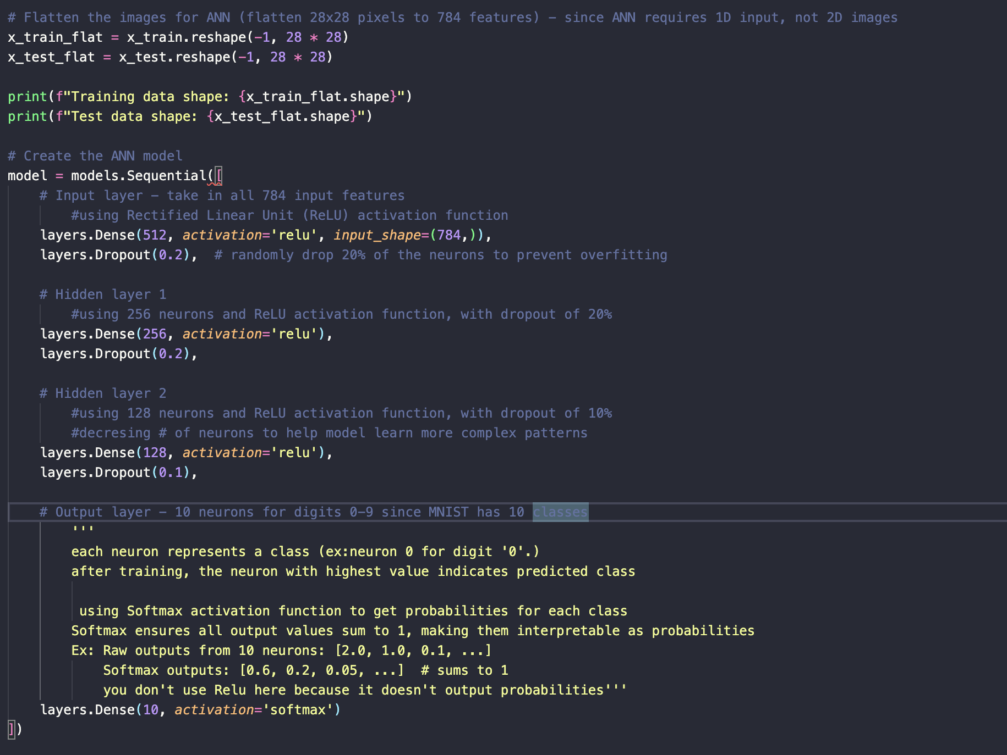

- MLP model design explain:
    - team features:

How this helps your MLP
- Input: team_vector → numeric vector representing all 5 players.
- Output / Label: team_score → numeric score representing balance and performance.
- Training: MLP learns to maximize team score by adjusting player selection combinations.

2. . MLP Architecture for Basketball Team Selection
Input Layer:
- Each player has a feature vector (as defined in team_features.py).
- For 5 players, we concatenate all features → input size = num_features_per_player × 5.
- Example: 20 features per player → 5 × 20 = 100 input neurons.
Hidden Layers:
- Multiple fully connected layers to capture complex interactions between players.
- Example architecture:
  - Hidden Layer 1: 128 neurons, ReLU activation
  - Hidden Layer 2: 64 neurons, ReLU activation
  - Hidden Layer 3: 32 neurons, ReLU activation
Output Layer:
- Single neuron representing team score (regression).
- Can be extended to multiple neurons if you want separate outputs for offense/defense/balance.

2. Forward and Backpropagation Steps
- Forward Pass:
  - Input vector → pass through hidden layers → compute output team score.
- Error Calculation:
  - Compare predicted score to target score (from calculate_team_score) → compute Mean Squared Error (MSE).
- Backpropagation:
  - Compute gradients of MSE w.r.t. all weights.
  - Update weights using gradient descent/Adam optimizer.
- Repeat for multiple epochs:
  - The network gradually learns weights that maximize team score prediction.
- Prediction:
  - Once trained, pass any 5-player combination → network predicts team score.
  - Choose the team with highest predicted score.

4. How it interprets outputs
- Each input neuron represents a player feature (shooting, defense, position, etc.).
- Hidden layers learn interactions and synergy between players.
- Output neuron gives a team score, which you use to pick the 5-player combination with the highest predicted effectiveness.

Problem Statement
Algorithm of Solution
Result Analysis

References
https://www.kaggle.com/datasets/justinas/nba-players-data

TO DO:
- Build a deep artificial neural network MLP to include the following: a) 1 input layer, b) as many hidden layers as you deem necessary, and c) an output layer fully connected to the hidden layers.
- Explain your architecture and how the basketball player characteristics are used as inputs.
Activate the MLP by performing the following steps:
- Starting at the input layer, forward propagate the patterns of the training data through the network to generate an output.
- Based on the network's output, calculate the error that we want to minimize using a cost function that we will describe later.
- Backpropagate the error, find its derivative with respect to each weight in the network, and update the model.
- Repeat steps 1 through 3 for multiple epochs and learn the weights of the MLP.
- Use forward propagation to calculate the network output and apply a threshold function to obtain the predicted class labels in the one-hot representation.
- Interpret the output of your MLP in the context of selecting an optimal basketball team.
- Provide the link to the Streamlit app, deployed on the Streamlit Community Cloud

